II. TOKAMAK Research

1. INTERPRETATION AND CONTROL OF HELICAL PERTURBATION IN TOKAMAKS

C.V. Atanasiu, A. Moraru
National Institute for Lasers, Plasma and Radiation Physics, Magurele

During the period January-December 2008, the theoretical and modelling research activity of the “Mathematical Modelling for Fusion Plasmas Group” of the National Institute for Lasers, Plasma and Radiation Physics (NILPRP), Magurele - Bucharest, Romania has been focalized on:
- Plasma models for feedback control of helical perturbations (Resistive wall modes), activity performed in collaboration with the Max-Planck - Institut für Plasmaphysik (IPP), Tokamakphysics Department, Garching, Germany, and JET, Task Force M, Culham, UK, representing a continuation of our activity from 2007.
BS1.1 Resistive wall modes stabilization [EFDA Task Agreements: ITM 08-IMP2-T4, Topical Groups WP2008-MHD-05-01]
It is known that the maximum achievable β in "advanced tokamaks" is limited by the pressure gradient driven ideal external-kink modes (10-6s). When a tokamak plasma is surrounded by a close fitting resistive wall, the relatively fast growing ideal external kink modes (EKM) is converted into the far more slowly growing "resistive wall mode" (RWM) which grows on the characteristic$τ_{w}=L/R$ time of the wall and has virtually identical stability boundaries to those of the EKM in the complete absence of a wall. Note that the stabilization of RWM in ITER, where it is probably not possible to maintain a very fast plasma rotation is still an open problem.
The objective of our common research was the Development of plasma models for feedback control of helical perturbations. To accomplish this objective, we have considered as necessary to develop a numerical model for the RWM investigation, consisting of a real axisymmetrical tokamak model with arbitrary cross-section and plasma parameters, and with 3D poloidal and toroidal disposals of wall (in its thin wall approximation).

The following milestones have been achieved:

1.1.1 Calculation of the wall response (for a real 3D geometry, with holes) to external kink mode perturbations
We have continued our approach of calculating the wall response to an external kink mode perturbation with the help of a scalar potential (current stream function) [1, 2, 3]. We have shown that such approach, necessitating the calculation of the unknown function over the wall volume only, is more convenient than other approaches using a vector potential, to be determined in the whole space.
We have chosen a new special curvilinear coordinate system (u, v, w) to describe the wall, where two of the covariant basis vectors (, ) are tangential to the wall surface and the third is normal to the same surface, the diffusion equation for the eddy current stream function U(u, v, t) in a thin wall looks like

The metric tensor has only four components: guu, guv, gvv and gww=. Note that the magnetic induction B contains both components: the perturbing external field given by the RWM Bext and the field generated by the eddy currents themselves Bind.
The initial and the boundary conditions are
U(u, v, t) = 0, F(u, v, U_{t}, U_{u}, U_{v}, t) = 0.
Preliminary results have been obtained, and the sparse matrix obtained after discretization of the parabolic equation on a toroidal domain defined by the tokamak wall with one hole, is given in Fig. 1 (test case). Note that for a real case, the sparsity pattern is much more pronounced.
By introducing some of the boundary conditions in the discretization matrix, we encountered some problems with the matrix conditioning. Therefore, in a next step, we have to investigate if the modified matrix is square, hermitian with a real positive diagonal, then an attempt to use sparse Cholesky factorization can be made, or if the sparse Cholesky factorization failed or if the matrix is not hermitian with a real positive diagonal, but still square, then to find something like Gaussian elimination with pivoting.

i/j 1234567890123456789012345678901234567890
1 ******** ** ** ** ** ********
2 ********* ** ** ** ** ********
3 ******** * ** ** ** ** ********
4 ******** * ** ** ** ** ********
5 ******** * ** ** ** ** ********
6 ******** *** ** ** ** ********
7 ******** ** ** ** ** ********
8 ********* ** ** ** ** ********
9 * *** *
10 * **** ** ** ** ***
11 * *** ** ** ** ***
12 * **** ** ** ** ***
13 * *** *
14 ******** *** ** ** ** ********
15 ******** *** ** ** ** ********
16 **** *** ** ** ***
17 **** *** ** ** ***
18 ******** ** *** ** ** ********
19 ******** ** *** ** ** ********
20 *** ** *** ** ***
21 *** ** *** ** ***
22 ******** ** ** *** ** ********
23 ******** ** ** *** ** ********
24 *** ** ** *** ****
25 *** ** ** *** ****
26 ******** ** ** ** *** ********
27 ******** ** ** ** *** ********
28 * *** *
29 *** ** ** ** **** *
30 *** ** ** ** *** *
31 *** ** ** ** **** *
32 * *** *
33 ******** ** ** ** ** *********
34 ******** ** ** ** ** ********
35 ******** ** ** ** *** ********
36 ******** ** ** ** ** * ********
37 ******** ** ** ** ** * ********
38 ******** ** ** ** ** * ********
39 ******** ** ** ** ** *********
40 ******** ** ** ** ** ********
Figure 1. Discrete sparse matrix resulted from a parabolic equation applied to a test case with boundary conditions included. For a real case, the sparsity pattern is much more pronounced.

The following input data: d = 10-3 m, μ = 4π10-7 H/m, σ = 107 1/Ω/m, have been considered in our calculations for a toroidal wall geometry with holes [6-7]. The arbitrary wall cross-section has been introduced in our curvilinear coordinate system with the help of Chebyshev orthogonal polynomials.
In the frame of the same milestone, we have improved our approach to remove the singularity in the time-dependent parabolic equation due to the presence of the hole corners. To check our results, we have developed an approach to avoid such singularities with the help of conformal transforms but for the stationary case only (elliptic equations) [4].

1.1.2 Coupling of a moment equilibrium code with a linear MHD stability code (to calculate the external kink modes)
The metric coefficients necessary to express the potential energy given by an external kink perturbation are given by our momentum equilibrium code [5]. Some special aspects concerning the presence of the separatrix will be underlined. The position vector with respect to the magnetic axis is given by a classical coordinate transformation through Fourier series

where is the toroidal flux and is the magnetic field at the magnetic axis. We have improved our cast function method to determine the moments from the equilibrium equation. These moments are determined by the difference between the real flux surface contours and those described by the cast function f only
,
where
and the position vector is given now by the relation
simplifying in an essential manner the determination of the equilibrium moments.

    - Drawing in our semi-analytical RWM model and code the linearized ideal MHD eigenmode equations by considering the following edge dissipation mechanisms): (1) due to charge-exchange with cold neutrals, (2) due to neoclassical flow-damping, (3) due to sound-wave damping (presently, in our model, the dissipation mechanism is due to the anomalous viscosity)
For this task, we have continued to consider the seminal Fitzpatrick plasma model [7’], presented in Fig. 2, with the geometrical disposal of plasma, walls, feedback coils and sensor coils given in Fig. 3.
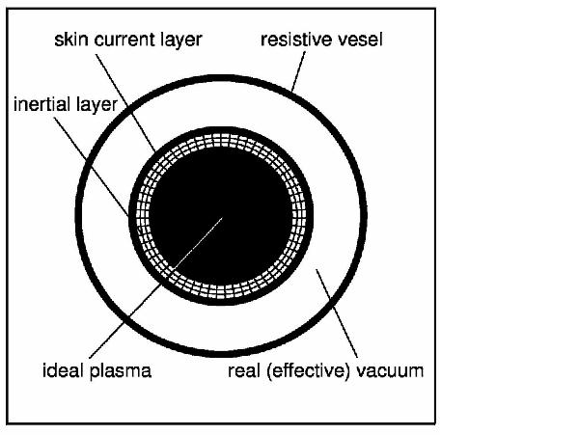Fig 2. Fitzpatrick plasma model

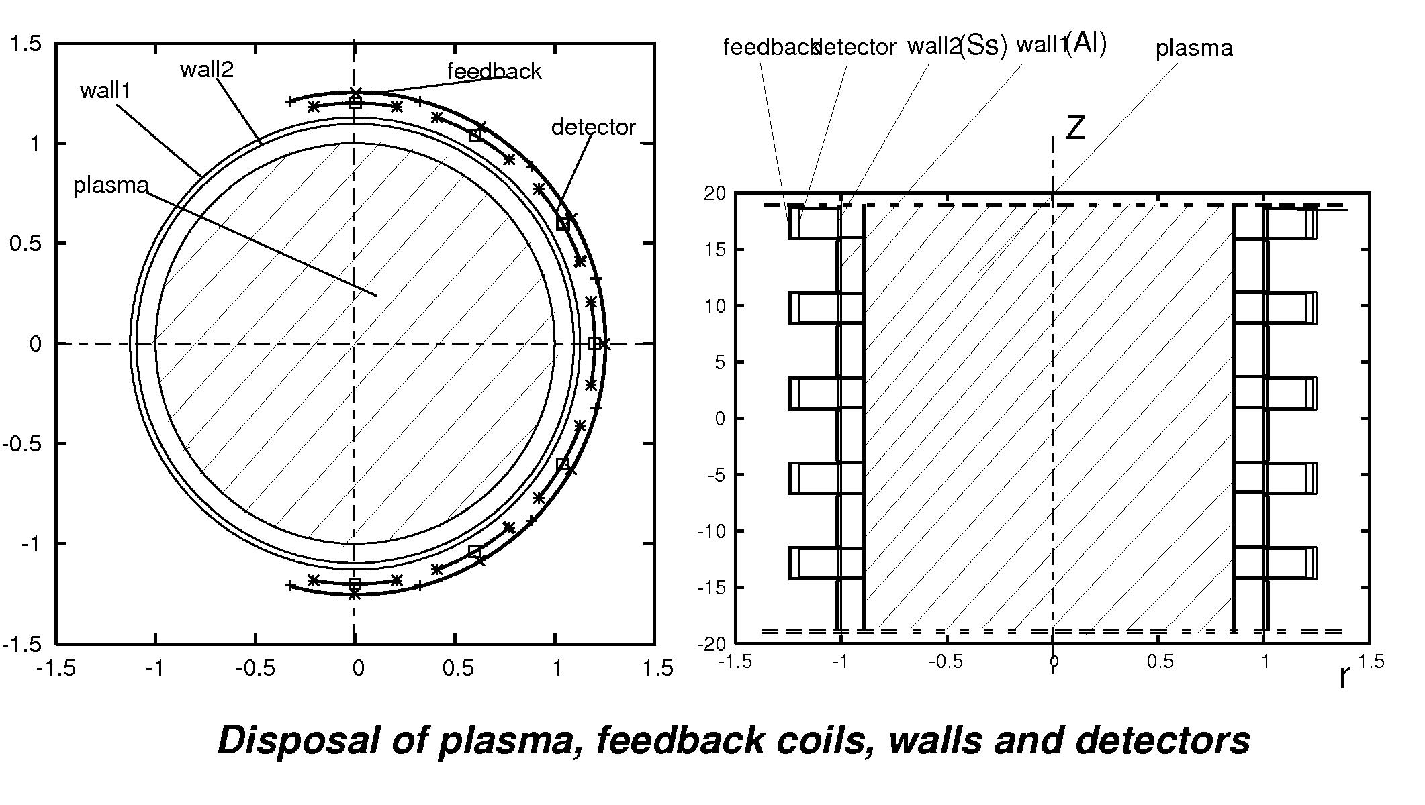
Fig. 3 Disposal of plasma, walls, feedback and detector coils in a multimode cylindrical model (Fitzpatrick model is a single mode model).

Considering the same standard large-aspect ratio, low β, circular cross-section tokamak plasma [8, 9], we have drawn the linearized ideal MHD equations, by considering the following perturbed quantities: magnetic field, current density, plasma velocity, plasma pressure, plasma parallel stress tensor, polarization current and the neoclassical current [10, 11]. The perturbed quantities have to be in the frame of the standard assumptions in single-mode neoclassical theory.
Even if in practice, the ideal external kink modes are driven by plasma pressure gradients, in this model, for sake of simplicity, these modes will be considered driven by current gradients. The central figure of merit considered in the following will be

where is the no-wall beta limit, is the perfect wall beta limit, while is the current beta. (if κ=1, then the RWM is stabilized, if κ=0 the RWM is not stabilized) The following simplifying assumptions have been made: the magnetic field is expressed in second order approximation of the aspect ratio, the plasma equilibrium is force free (no diamagnetic current), and as safety profile the well known Wesson profile [12] has been used.
The friction due to charge exchange with cold neutral atoms in the edge is indeed a candidate to govern the poloidal rotation in the edge of tokamak plasma. The Hirshman – Sigmar neoclassical moment approach [13] can be used to determine the rotation velocities of the main plasma ions and one impurity species when charge exchange friction is included. The impurity ion poloidal rotation is governed by the balance between the impurity viscous force and the main impurity ion friction force. But the charge-exchange acts as dissipation mechanism first under toroidal rotation if its term is greater then the neoclassical one. Neglecting the neoclassical flow-damping in the ideal eigenmode equation, the flow-damping parameter is a consequence of charge-exchange between ions and cold neutrals close to the edge of the plasma.
In addition to the anomalous viscosity, plasma flows are damped by the magnetic surface averaged symmetry breaking plasma viscosity induced by the distorted magnetic surfaces due to the presence of the RWMs. We have applied the perturbed neoclassical plasma viscosity to our model of the normalized mode growth rate at edge, by taking into account the ratio of the total magnetic field over the poloidal magnetic field and the ion-ion collision frequency [14].
Bondeson has shown that sonic rotation complicates the stability problem by coupling to sound waves, and that the MHD equations predict an unphysical resonant behaviour of the sound waves [15]. For realistic temperature ratios, the sound waves are strongly damped by ion Landau damping and an accurate calculation requires a description that is kinetic along the field lines. However, reasonable approximations of the kinetic behaviour can be obtained by adding dissipative terms to the fluid equations [16].
Developing the full set of linearized ideal MHD equations, by using two phenomenolgical plasma flow damping rates to represent both damping due to charge exchange with neutrals and damping due to sound waves, expressing the perpendicular perturbed neoclassical current via the perturbed plasma parallel tensor, the perturbed velocity with the help of a velocity stream function and a parallel flow, an eigenmode equation has been obtained. By matcing the plasma and vacuum solutions of the perturbed flux function across the the plasma boundary, a resistive wall mode dispersion relation can be obtained. Thus a real plasma stability parameter can be defined in function of the plasma response index in place of its beta expression (in this model, the external kink modes are due the current gradients rather then to the pressure gradients)
On the left side of Fig. 4, the RWMs stability boundaries in function of the toroidal plasma rotation for different plasma flow damping rates (due to charge exchange with neutrals) are given, while on the right side of the same figure, the RWMs stability boundaries in function of the toroidal plasma rotation for different plasma neoclassical flow damping parameters are presented. The dissipation due to the sound wave damping (at the edge) is neglegible as stabilization effect.

Dissipation via charge exchange
Dissipation via neoclassical flow damping
Figure 4. Stability boundaries for the RWM as a function of the plasma toroidal

Conclusion to this milestone: by using a model with phenomenoligal damping parameters, there is no evident what kind of dissipation mecanism really are taking place. A numerical 3D MHD simulation with kinetic effects will be necessary.

This work (BS1.1) has been carried out in close collaboration with our colleagues from the Tokamak Physics Department of the Max-Planck-Institut für Plasmaphysik, during the mobility 01.09.08-29.12.08 at IPP Garching and at our home institute NILPRP.

Next steps:
- to introduce, like in our semi-analytical model, feedback coils and detector sensors;
- to continue the investigation of different dissipation mechanisms in the plasma;
- investigation of the error field penetration in tokamak, based on a Fiztpatrick model [17,18,19]

BS1.2. Modelling of the Resistive Wall Modes in the diverted tokamak configuration of JET [EFDA JET notification (JET-TF-M)]

The following milestones have been achieved:

1.2.1 Determination of the boundary conditions of the external kink mode equation at the separatrix of JET
In contrast to the usual ideal MHD treatment with the extended energy principle, the present analysis is generally non-selfadjoint and includes the necessary perturbed magnetic pressure for satisfying pressure balance. One solving method could be to found a new basis of orthogonal eigenvectors to ensure the self-adjointness property of the energy operator - the normal mode approach [20-21], or to replace a perfect conducting wall with one of finite conductivity and to deduce a modified energy principle [22]. Numerical MHD stability studies in the presence of toroidal rotation, viscosity, resistive walls and current holes, by using the CASTOR FLOW code are presented in Ref. [23]. Modelling of RWMs has been made by using the VALEN code [24] with an equivalent surface current model for the plasma. Extensive study and theoretical development has also been presented by Bondeson and his co-workers [25-26] by using the MARS code. In a first stage, we have adopted the second approach [22], where the assumption that the plasma displacement trial function, in the situation where a conducting wall is located at finite distance from the plasma is considered to be identical to that used in the evaluation of the potential energy when the conducting wall is moved infinitely far away has been made. We considered such assumption too limiting and have developed an other approach.
Writing the expression for the potential energy in terms of the perturbation of the flux function, and performing an Euler minimization, we have obtained a system of ordinary differential equations in that perturbation [27]. This system of equations describes a tearing mode or an external kink mode, the latter if the resonance surface is situated at the plasma boundary. Usually, vanishing boundary conditions for the perturbed flux function at the magnetic axis and at infinity are considered. From single layer potential theory, we have developed an approach to fix "natural" boundary conditions for the perturbed flux function just at the plasma boundary, replacing thus the vanishing boundary conditions at infinity [27]. Now, in the presence of a resistive wall, the boundary conditions of the external kink mode at the plasma boundary are determined by the reciprocal interaction between the external kink perturbation of the plasma and the toroidal wall (in its thin wall approximation). A general toroidal geometry has been considered. By using the concept of a surface current [28], the description and calculation of the influence of the modes outside the plasma were greatly simplified. The normal component of the magnetic field perturbation, at the plasma boundary, has been considered as excited by toroidally coupled external kink modes and it is that component that gives the normal to the wall component of the exciting field causing the wall response via the induced eddy currents.
By writing, in a coordinate system with straight field lines (a, θ, ζ) the general expression of the potential energy W in terms of two test functions u(a, θ, ζ) and λ(a, θ, ζ)
instead of the displacement ξ, one obtains the expression of the potential energy [8]:
where ψ is the perturbation of the flux function Ψ, are the metric coefficients, is the toroidal flux, u and correspond to the perpendicular and parallel displacements, respectively, whileare the pressure, poloidal and toroidal current densities, respectively. After developing the perturbed values in Fourier series, performing an Euler minimisation of the energy functional and then integrating with respect to the angles θ and ζ the result of that minimisation, one obtains a system of coupled ordinary differential equation of the form
where f , V and G are matrices, and Y is the flux function perturbation vector, with the non-diagonal terms representing both toroidicity and shape coupling effects. Close to the magnetic axis (a→0), we have found the following behaviour of the amplitude of the flux function perturbation
where am/n is the resonance radius corresponding to the wave numbers m and n. We have to consider a "natural" boundary condition just at the plasma boundary [27]. To our knowledge, this methodology to consider, in a flux coordinates system, the boundary conditions just at the separatrix, has been developed by us first. From potential theory we know that a continuous surface distribution of simple sources extending over a not necessarily closed Liapunov surface ∂D and of density σ(q), generates a simple-layer potential at p, in ∂D. After some tedious calculations, the boundary condition becomes

with I the unit matrix and h the "radial" integration mesh, D and F [M x M] complex matrices, with the elements given by the metric coefficients, normal and tangential magnetic field components. is a known [M x M] coefficient matrix and a known [M] coefficient vector, both resulting from a forth-order Runge-Kutta integration scheme. For a unit perturbation Y2/1 (m = 2, n = 1) the corresponding surface charge distributions are given in Fig.4.

Figure 4. The surface charge distribution along the plasma boundary for unit flux perturbation Y2/1

1.2.2 Determination of the vacuum field due to a helical perturbation
The perturbation field =grad Φ outside of the plasma can be assumed to be produced by the surface current equations
where [ ] means the jump across the plasma surface. κ(θ, ζ, t) being the time-dependent stream function of the surface current, and g an arbitrary vector. In terms of the external and internal magnetic scalar potentials (with respect to the plasma boundary) one has
The normal component of the perturbed magnetic field has been considered as excited by a flux function perturbation ψ of unit amplitude Y(1) on the plasma boundary and resulting from an external kink mode. Bn can be calculated with the relation
This work (BS1.2) has been carried out during the secondment at JET (TF-M) during Campaigns C20-C25, 20.04.08-22.05.08 and at our home institute NILPRP.

References
[1] Atanasiu C.V., Günter S., Moraru A., Zakharov L.E., “Resistive Wall Modes stabilization, in the presence of 3D wall structures”, EPS34, Warsaw, Poland, 2-6 July 2007.
[2] Atanasiu C.V., Günter S., Moraru A., Zakharov L.E., “Resistive Wall Modes Investigation in the Presence of 3D Wall Structures”, EFTC12, Madrid, Spain, 24-27 September 2007.
[3] Atanasiu C.V., Moraru A., Zakharov L.E., “The investigation of Resistive wall modes in diverted tokamak configurations’’, EPS35, Hersonissos, Crete, Greece, 9-13 June 2008.
[4] Moraru A., Rev. Roum. Sci. Techn-Electrotechn. et Energ., 52, 3 (2008).
[5] Atanasiu C.V., Moraru A., Subbotin A., Computer Physics Communications 98 (1996).
[6] Atanasiu C.V., Günter S., Lackner K., Moraru A., Zakharov L.E., Rom. Report. Phys. 60, 3, 635 (2008).
[7] Atanasiu C.V., “Resistive wall modes stabilization in diverted tokamak configurations », invited paper at the Hungarian Plasma Physics and Fusion Technology Workshop, 26-28 March 2008, Györ, Hungary.
[7’] Fitzpatrick R., Aydemir A.Y., Nuclear Fusion, 36, 11 (1996).
[8] Atanasiu C.V., Miron I.G., "An analytical model for resistive wall modes stabilization", 11th European Fusion Theory Conference, 26-28 September 2005, Aix-en-Provence, France.
[9] Atanasiu C.V., Miron I.G., “A model for resistive wall mode control”, EPS30, 7-11 July 2003, Sankt Petersburg, Russia.
[10] Bondeson A., Ward, Phys D.J., Rev. Lett. 72, 2709 (1994).
[11] Hammett G.W., Perkins F.W., Phys. Rev. Lett. 64, 3019 (1990).
[12] Wesson J.A., Tokamaks, (Oxford University Press, Oxford, UK, 2004).
[13] Hirshman S.P., Sigmar D.J., Phys. Fluids 20, 418 (1977).
[14] Shaing K.C., Phys. Plasmas 11, 5525 (2004).
[15] Bondeson A., Iacono R., Phys. Fluids B 1, 1431 (1989).
[16] Ward D.J., Bondeson A., Phys. Plasma 2, 1570 (1995).
[17] Fitzpatrick R., “Error field induced electromagnetic torques in a large aspect ratio, low beta, weakly shaped tokamak plasma”, Physics of Plasmas 16, 032502 (2009).
[18] Fitzpatrick R., “Drift magnetohydrodynamical model of error field penetration in tokamak plasmas”, Physics of Plasmas 13, 032503 (2006).
[19] Fitzpatrick R., “Effect of an error field on the stability of resistive wall modes”, Physics of Plasmas 14, 022505 (2007).
[20] Chu M.S., Chan V.S., Chance M.S., et al., “Modelling of feedback and rotation stabilization of the resistive wall mode in tokamaks”, Nuclear Fusion, 43, 196 (2003).
[21] Chu M.S., Chance M.S., Glasser A.H. and Okabayashi M., “Resistive wall stabilization of high-beta plasmas in DIII–D”, Nuclear Fusion, 43, 441 (2003).
[22] Haney S.W. and Freidberg J.P., “Variational methods for studying tokamak stability in the presence of a thin resistive wall “, Physics of Fluids B 1, 1637 (1989).
[23] Strumberger E., Günter S., Merkel P. et al, “Numerical MHD stability studies: toroidal rotation, viscosity, resistive walls and current holes”, Nuclear Fusion 45, 1156 (2005)
[24] Bialek J., Boozer A.H., Mauel M.E. and Navratil G.A., “Modeling of active control of external magnetohydrodynamic instabilities“ Physics of Plasmas 8, 2170 (2001).
[25] Bondeson A., Ward D., “Stabilization of external modes in tokamaks by resistive walls and plasma rotation”, Physical Review Letters, 72, 718 (1994).
[26] Liu Y.Q. and Bondeson A., “Active Feedback Stabilization of Toroidal External Modes in Tokamaks“, Physical Review Letters 84, 907 (2000).
[27] Atanasiu C.V., Günter S., Lackner K., et al., “Linear tearing modes calculation for diverted tokamak configurations”, Physics of Plasmas 11, 5580 (2004).
[28] Atanasiu C.V., Boozer A.H., Zakharov L.E. et al., “Determination of the vacuum field resulting from the perturbation of a toroidally symmetric plasma”, Physics of Plasmas 6, 2781 (1999).
[10] Atanasiu C.V., Günter S., Moraru A., et. al., “Resistive Wall Modes Stabilization in the Presence of 3D Wall Structures”, EPS34, Warsaw, Poland, 2-6 July 2007.

