4. INTEGRATED TOKAMAK MODELLING TASKFORCE

PROVIDING ACCESS TO EXPERIMENTAL AND THEORETICAL DATA

[ITM-07-ISIPCP-T7, ITM-07-ISIPRA-T3, ITM-08-TFL-T1]

V.F. Pais, V. Stancalie, A. Mihailescu, N. Borontis
National Institute for Laser, Plasma and Radiation Physics, Magurele, Bucharest, Romania

4.1. Introduction
In the context of the Integrated Tokamak Modeling Taskforce (ITM), the Infrastructure and Software Integration Project (ISIP), task ITM-07-ISIPCP-T7 (“Define and build a portal for access to the ITM applications and databases”), a software Portal was developed, providing a unique service point to identify the user (single sign-on authentication) and to access resources offered by the ITM Gateway.
Hosting codes and projects on the Gateway requires both an interface, provided through the Portal, and a version handling tool, allowing collaborative development for every project and the ability to access previous versions. This was investigated for the task ITM-07-ISIPRA-T3 and an appropriate tool was identified and installed.
The ITM-TF has identified a broad need for data relating to atomic, molecular, nuclear and surface physics data (AMNS). Since the uses of the data within the ITM are quite wide-ranging, a consistent approach taking into account the specific requirements of the ITM, while maintaining the effort aligned with other European efforts in this area, is required. The work associated with the task ITM-08-TFL-T1 was needed to investigate various strategies for implementing an ITM (software) capacity for AMNS data.

4.2. Results and discussions
Hosting codes and projects on the Gateway requires both an interface, provided through the Portal, and a version handling tool, allowing collaborative development for every project and the ability to access previous versions.
After a study of the various aspects related to a working web portal and its foreseen integration with the Gateway, it was decided on the following organization for the Portal:
- Public access part, available without authentication and dedicated to non-ITM members; basically this is a regular web site offering access to public information about ITM, publications, conferences and screenshots of ITM applications
- Private part, accessible only to ITM members, based on their account on the Gateway. This part is further divided into sections dedicated to each project, with the ability to have read-only or read-write access to sections based on user rights. Also, authentication in the private area gives the user access to all zones and applications requiring user credentials (single sign-on). Furthermore, access to ITM applications is foreseen through this private part of the Portal.
The structure of the Portal is presented in the following diagram:
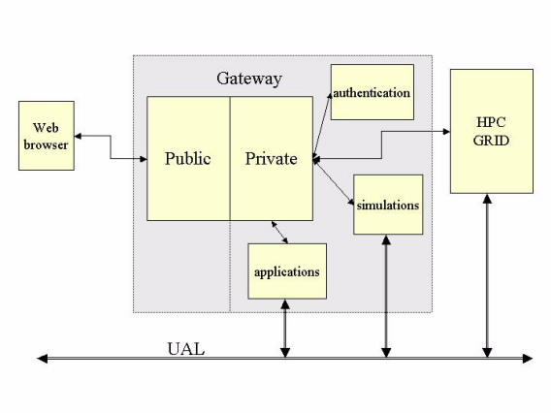
Several technologies and middleware software products were investigated for the various parts of the Portal and for the version handling tools. The selection was made based on the maturity of the code, the availability for the Gateway platform and the possibility of interconnection with the rest of the software and codes. Of course, security plays an essential role, therefore well documented software was preferred in order to secure it both from inside, by configuration directives, and from outside, using other security mechanisms. After careful consideration of the alternatives, it was agreed upon the following:
- Shibboleth [1]: single sign-on mechanism, with Java-based identity provider (IdP) and native service provider (SP).
- Apache Tomcat [2]: servlet container for the Shibboleth IdP.
- JBoss Application Server [3,4]: portal server and servlet container.
- Apache HTTPD [5]: front-end server, exposing the various services offered by Shibboleth and JBoss to the external world.
- OpenLDAP [6]: directory solution for managing user accounts and user groups, with information exported from the Gateway network information system.
- GForge with Subversion: version handling tool and collaborative environment.
- JBoss Wiki: wiki based collaborative environment, based on Java servlets deployed in the JBoss AS servlet container.
These applications were installed on the Gateway and they are co-operating in order to offer the entry point for users. GForge is not currently integrated in the Portal, but integration is foreseen for next year.
For the underlying file system, the Gateway’s OpenAFS [7] was used, with proper access control lists. Technical difficulties, due to OpenAFS “tokens”, were encountered and solved in order to give access to these resources, using the Portal.
Acess to ITM applications is envisaged through the Migrating Desktop project. It is able to use the Portal related authentication mechanisms through a proxy, thus respecting the single sign-on goal for the ITM Portal. Several integration scenarios were studied, the most promising one being described in the following diagram:
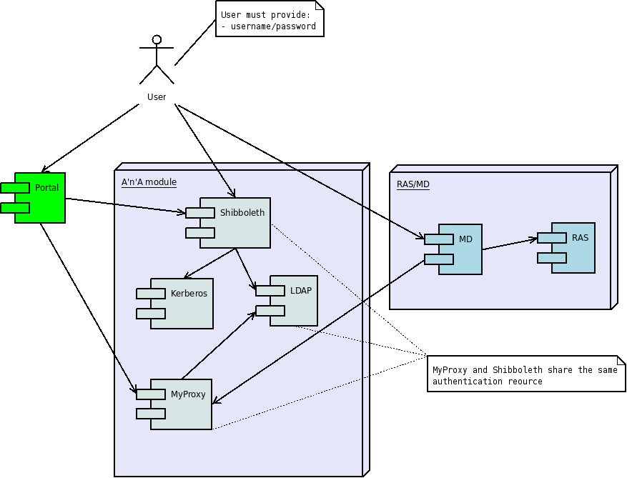
This diagram shows the various technologies involved in the access and authentication process for the Portal and Migrating Desktop integration.

A crucial aspect for the ITM-TF is to provide AMNS data in a standardized form to different codes. In contrast to code modules running in the ITM-TF code platform, the interface modules for AMNS data are not expected to appear explicitly in the workflow. Instead, they should be available as libraries to be included in the link stage of an ITM-TF module. This means that one has to consider different versions that can communicate with codes in Fortran, C and other languages supported by the ITM-TF infrastructure. Any set of data released via the ITM will have its own version number, and will be stored in the ITM database. Information allowing trackback to the original ADAS release number will also be stored in the ITM database. New release of ITM data should be issued as often as data providers indicate that updates are recommended.
The possibility of having partial data from e.g. Atomic Data and Analysis System (ADAS) [8] in combination with data from other sources can be accommodated in the ITM. However, all data must be saved in the ITM database and the provenance specified.
A procedure needs to be worked out on how assure that the most relevant data is transferred to the ITM database, and for notification that updates of data are recommended. This should be the principal activity of the coordinator for interfacing of ADAS data to the ITM –TF.
As member of ADAS team, the main objective refers to the calculation of atomic data and to provide results in adfxxx format. Electron-impact collision strengths and corresponding effective collision strengths are of crucial importance in the interpretation of spectra of low-ionisation stages of the iron peak elements Fe, Co and Ni. In electron-impact excitation of Fe-peak atoms, large number of target states is required both to allow for coupling between levels, and to obtain accurate atomic structure via a large configuration –interaction basis. The main difficulty in treating open d-shell targets is the large number of terms. This means that even at low energy scattering calculation has to include many target states in the expansion of the total wave function before accurate results are obtained. The complexity of the resonance structure for low energy electron scattering means that the cross sections must be determined at typically tens of thousands of energy values in order to yield accurate effective collision strengths.
However, accurate calculation of these quantities is complicated by the open d-shell structure of these ions, which give rise to many low-lying target states that are strongly coupled. This, in turn, leads to a large number of coupled channels which must be retained in the model, posing a formidable computational challenge. With this respect, current theoretical methods and computational tools place more emphasis on the accurate representation of target electron wave functions than the study of other processes. This in turn has lead to the following milestones:
- The accuracy of a series of models for the target terms of Fe-peak element Co IV, which form the basis of further R-matrix collision calculations.

In the present investigation, we include all of the 136 LS-coupled states which arise from three manifolds of the Fe-peak element Co IV: 3d⁶, 3d⁵4s and 3d⁵4p in the R-matrix expansion The 136 target states have been represented by elaborate configuration interactions in an attempt to account for electron correlation effects where it is essential to include the 3p² → 3d² core excitation in both the target and scattering wave functions. The internal region solution is obtained using the RMATRXII [9] program package. In the external region, the program FARM[10] has been used for comparison at some scattering energies. This work provides a firm foundation on which larger calculations may be based.
The increasingly sophisticated e⁻ - Co³⁺ calculations that have been carried out are summarized below:
- 3-state LS –coupled R-matrix calculation. First, we have included in the R-matrix expansion all 136 LS coupled states which arise from the three target configurations 3d⁶, 3d⁵4s and 3d⁵4p. In the present level of approximation, in order to have a balanced configuration interaction representation for the 136 LS-coupled Co IV target states and the associated scattering wave functions, we will employ the Hartree-Fock orbitals of the 1s²2s²2p⁶3s²3p⁶3d⁶ ⁵D ground state configuration augmented with two spectroscopic orbitals, namely, the 4s and 4p.
- 4-state LS –coupled R-matrix calculation. The above three-state calculation has be extended including the fourth state: 3d⁵4d, 3p⁵3d⁷, 3d⁴4s4p and 3d⁴4s², respectively. To allow for the accurate representation of terms of 3d⁵4d we have optimized 4d physical orbital on ⁷D level.
- 6-state LS –coupled R-matrix calculation. We have included in the R-matrix expansion all 136 LS coupled states which arise from six target configuration 3d⁶, 3d⁵4s, 3d⁵4p, 3p⁴3d⁸, 3p⁴3d⁷4s and 3p⁴3d⁷4p looking at the effect of configuration interaction.
- 9-state LS –coupled R-matrix calculation. Starting with the 136-level model, we have included in the R-matrix expansion all 136 LS coupled states which arise from nine target configuration 3d⁶, 3d⁵4s, 3d⁵4p, 3p⁴3d⁸, 3p⁴3d⁷4s, 3p⁴3d⁷4p, 3p⁵3d⁷, 3p⁵3d⁶4s and 3p⁵3d⁶4p. Table 1 summarizes the configurations included in the target representation corresponding to 9- state LS coupled R-matrix calculation.
Table 1.
Single excitation  from 3d | Double excitation from 3d | Single excitation  from 3p | Double excitation from 3p
3d⁵4s | 3d⁴4s² | 3p⁴3d⁸ | 3p⁵3d⁷
3d⁵4p | 3d⁴4s4p | 3p⁴3d⁷4s | 3p⁵3d⁶4s
3d⁵4d |  | 3p⁴3d⁷4p | 3p⁵3d⁶4p

The present theoretical results are consistent with detailed calculations for electron collisions on Fe III [11] demonstrating that allowing double electron promotion from 3p-shell into the 3d-shell and single electron promotion into the 4s, 4p and 4d shell, gives a compact and adequate configuration interaction representation for all 136 levels. The inclusion of the 3p² → 3d² core excitation in multi-configuration wave functions for structure calculations strongly influences both the energy levels and f-values for Fe-peak elements.

Table 2 gives the number of LS-coupled scattering channels for even and odd parity associated with the total angular momentum value L = 2 in e⁻ - Co³⁺ collisions using the three configuration model for specific spin symmetries in the present 136-state calculation. In Table 3 is given the total number of coupled channels associated with the total angular momentum value L = 2 in electron - collision of Co IV states of particular spin (S_{i}) belonging to 3d⁶, 3d⁵4s, 3d⁵4p configurations

Table 2.
 | Singlets | Triplets | Quintets | Septets
L | S =0 | S = 1 | S = 2 | S = 3
 |  | Even parity
2 | 117 | 147 | 41 | 3
 |  | Odd parity
 | 105 | 144 | 38 | 1

Table 3.
S_{i} = 1/2 |  | S_{i} = 3/2 |  | S_{i} = 5/2 |  | S_{i} = 7/2
Even parity | Odd parity | Even parity | Odd parity | Even parity | Odd parity | Even parity | Odd parity
264 | 269 | 188 | 182 | 44 | 39 | 3 | 1

Finally, the comparisons between calculated and experimental energies and oscillator strengths of the target are important indicators of the quality of the target representation and the overall accuracy of the cross sections and collision strengths.
The next step of the work will be conducted to model these atomic data on the use of the recently developed R-matrix package, PRMAT [12], in collaboration with the Queen’s University of Belfast.

[1] Shibboleth, http://shibboleth.internet2.edu
[2] Apache Tomcat, http://tomcat.apache.org
[3] JBoss, http://www.jboss.org
[4] “JBoss 4.0 – The Official Guide”, The JBoss Group, Sams, April 30, 2005, ISBN: 978-0672326486
[5] Apache HTTPD, http://httpd.apache.org
[6] OpenLDAP, http://www.openldap.org
[7] OpenAFS, http://www.openafs.org
[8] http://www.adas.ac.uk
[9] K.A. Berrington, W. B. Eissner, P.N. Norrington, Comput. Phys. Commun. 92 (1995) 290.
[10] V. M. Burke, C. J. Noble, Comput. Phys. Commun. 85(1995) 471.
[11] B. M. McLaughlin et. Al., Atomic Data and Nuclear Data Tables 93(2007)55.
[12] A. G. Sunderland, C.J. Noble, V.M. Burke, P.G. Burke, Comput. Phys. Commun. 145 (2002)311.

