5. SHEATH PROPERTIES AND RELATED PHENOMENA OF THE PLASMA WALL INTERACTION IN MAGNETISED PLASMAS. APPLICATION TO ITER

C. Agheorghiesei, V. Anita, C. Costin, G. Popa, M. L. Solomon
“Al. I. Cuza” University, Faculty of Physics, Iasi

5.1. Introduction
The report focuses on several subjects, corresponding to the main objectives assumed in our work-plan for 2008. As a continuation of the previous works, our activity covered two main directions: i) experiments and data processing; ii) modeling.
Experiments and data processing. The experiments were made on Pilot-PSI machine at FOM-Institute for Plasma Physics “Rijnhuizen”, The Netherlands and in the Plasma Laboratory of “Alexandru Ioan Cuza” University (UAIC), Iasi, Romania. The measurements were performed with a Katsumata probe and a multi-channel analyzer. The main components used for plasma diagnostics were designed and manufactured in UAIC. The data acquisition system is also the property of UAIC.
Modeling. The modeling activity was concentrated on two numerical codes, a 2D fluid model and a 2D PIC-MCC one, for magnetized plasma devices, with application to Pilot-PSI.

5.2. Real Time Measurement and Control
Specific objective 1: Development of advanced remote control and data acquisition system for diagnostic of high-density magnetized plasma
A data acquisition system from National Instruments, already acquired from other financial sources, was prepared to simultaneously register the electrical signals from the 61 collectors of the multi-channel analyzer. The acquisition system consists of:
- 8 acquisition boards NI PXI 6133 with 8 channels each and 32MSamples memory;
- one NI PXI 8105 controller with Intel Core Duo T2500 processor, 2 GHz frequency, DDR2 2GB memory, Windows XP;
- NI LabView Software for Windows, version 8.5 Full.
This system allows the simultaneous acquisition of 64 signals, at a maximum acquisition speed of 3 MSample/sec/channel and 14 bits resolution. The allowed input signal can vary in 4 voltage ranges, from ±1,25 to ±10 V. The system was used for the simultaneous acquisition of the 61 signals registered from the multi-channel analyzer, in order to obtain the spatio(2D)-temporal variation of the electric current flowing from the plasma column to the Pilot-PSI target. The acquisition process was programmed and controlled under LabVIEW platform software.
5.3. Theory and modeling
Specific objective 1: Development of a 2D fluid model for the simulation of Pilot-PSI device
Milestone: Providing steady state results concerning neutrals flow in Pilot-PSI
The neutrals flow was neglected in the 2D fluid model that was previously developed for the charged particles. This approach proved to fail on the proper description of the charged particle fluxes at the plasma source boundary. That is because both electrons and ions that are produced inside the plasma source are injected in the vessel by the neutral gas flow. As a consequence, a module to describe the neutrals flow was necessary.
The fluid model for the neutrals flow consists of two equations:
- continuity equation
$\frac{∂n}{∂t}+∇⋅\left(n u\right)=0$
- momentum transfer equation
$\text{mn}\left(\frac{∂u}{∂t}+\left(u⋅∇\right) u\right)=−∇\left(\text{nkT}\right)$,
where m is the neutral particle mass, n is the neutral density, u is the vector of the fluid velocity, k is Boltzmann’s constant, T is the neutral gas temperature and t is the time.
We suppose that the total neutrals mass in the vessel is conserved. The only source for the neutrals is the inward gas flow which is equal with the outward gas flow. Gas dynamics is dictated only by the pressure’s gradient (non-viscous fluid).
The vessel’s geometry has azimuthal symmetry, thus only radial and axial treatment is considered. The spatial domain chosen for modeling has four types of boundary: the chamber walls, the target, the entrance of the gas in the vessel (which corresponds with the exit of the cascaded-arc source) and the gas exit to the pumping system. Solving the fluid equations requires proper choice of the boundary conditions. At the chamber walls and at the target both parallel and perpendicular fluxes are zero. The inward flux is imposed according to the experimental values while the outward flux is calculated according to the mass conservation. An example of argon map flow is shown in figure 1. The vectors’ length in the figure is proportional with the neutral flux. The color is related with the angle between the flux vector and z axis (large angles – red, small angles – blue).
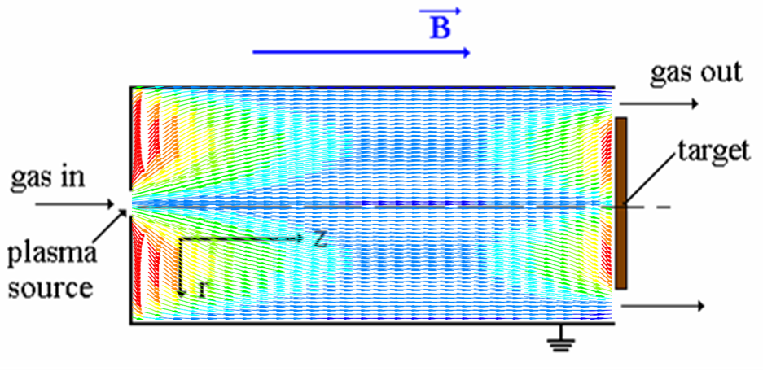
Figure 1. Argon map flow in Pilot-PSI.
The next step is the coupling of the two codes, neutrals and charged particles.
Specific objective 2: Development of a 2D PIC-MCC model for magnetized plasma devices (application to Pilot-PSI)
Milestone: Development of a code module for solving the equation of motion for the plasma particles
A code module for solving the equation of motion for a charged particle moving in a combination of electric and magnetic fields has been developed as a part of the future 2D PIC-MCC model that will be used for the simulation of magnetized plasma devices (application to Pilot-PSI). The geometry of most fusion plasma devices as well as Pilot-PSI require at least 2D PIC model. Considering specific small regions for plasma devices (e.g. divertor and/or plasma column in Pilot-PSI) we can reduce PIC model to just 2 geometrical dimensions either orthogonal x-y or cylindrical r-z. Hence the moving equation (Lorentz equation) for a charge particle:
$F=ma=q(E+v×B)$,
where m is the charged particle mass, a is the acceleration vector of the moving particle, q is the electric charge of the charged particle, E is the local electric field intensity, v is the velocity vector of the charged particle and B is the local magnetic field vector, is integrated in two steps to obtain:
- all velocity components (x-y-z or r -φ-z) of the particle at a specific time moment
- particle space position in x-y or r-z coordinates.
The method applied in this programming module for moving charged particles for a $Δ$t time step is leap-frog algorithm that consist of translation in electric field for $Δ$t/2, rotation induced by magnetic field and again translation for the remaining $Δ$t/2 time period [1,2].
The moving equations written for different charge particles species (e.g. ions, electrons) are totally independent from each other as long as E and B are constant (at least for $Δ$t time step) it has been used parallel multiprocessor programming by Message Parsing Interface (MPI) standard. This made possible to speed-up the code module having independent parallel processes for every kind of charge particles species [3].

5.4. Collaborative actions
The following results were obtained in the framework of the collaborations that we had with other groups, members of the EURATOM program:

Theoretical Plasma Physics Group, Innsbruck University, Association EURATOM/ÖAW, Austria
- FOM Institute for Plasma Physics “Rijnhuizen”, Association EURATOM/FOM, The Netherlands.
Secondments:
- Drd. M. L. Solomon at FOM for 69 days (15/10/2008 – 23/12/2008)
- Dr. V. Anita at FOM for 35 days (18/11/2008 – 23/12/2008)
- Dr. G. Popa at FOM for 4 days (19/10/2008 – 23/10/2008)
- Dr. C. Costin at FOM for 4 days (19/10/2008 – 23/10/2008).
5.5. Plasma diagnostics
Objective 1: Characterization of Pilot-PSI plasma beam by electrical methods (different types of probes, electrostatic analyzers, etc)
The experiments were performed on Pilot-PSI linear device, during our team-members mobility at FOM Institute for Plasma Physics “Rijnhuizen”, The Netherlands.
Milestone 1: Katsumata probe measurements for diffusion coefficient
The Katsumata probe was inserted in Pilot PSI device at about 2 cm in front of the target, perpendicular to the magnetic field lines. Probe’s position was radially adjustable and it was moved in the range of 0 ÷ 2 cm radius from the center of the plasma column. This radial range was chosen because the usual diameter of the plasma column is about 1-2 cm [4]. The experimental measurements were performed under the following discharge conditions: 3 slm hydrogen gas flow, two different values of the magnetic field strength (0.4 and 0.8 T) and two values of the discharge current intensity in the cascaded arc plasma source (90 and 110 A).
For different radial positions of the probe, the floating potential fluctuations measured on the probe’s collector were recorded when the collector was retracted inside the shielding tube (h measures the collector’s position inside the tube). The amplitude spectrum of these fluctuations shows that the signal amplitude corresponding to a certain frequency (in the range of tens-hundreds of kHz) decreases when the collector is retracted in the tube. In figure 2 is plotted the natural logarithm of the signal amplitude as a function of h for different frequencies (for a magnetic field of 0.4 T, discharge current 90 A, radial position of the probe 0.4 cm).
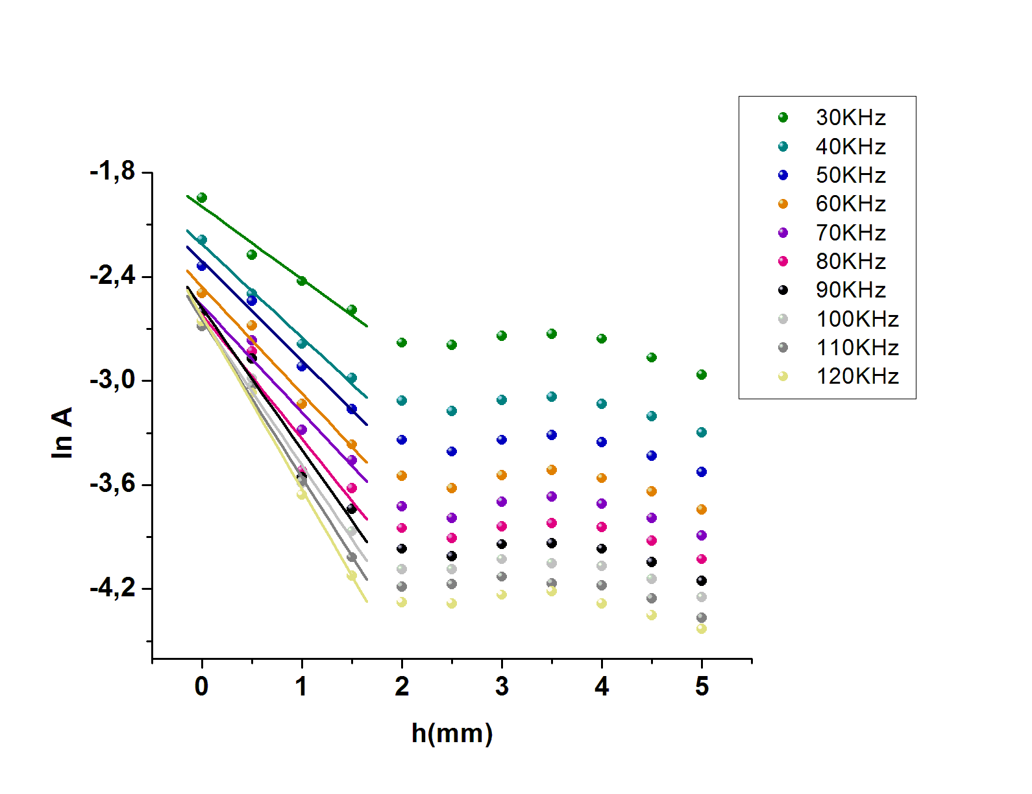
Figure 2. Radial decay of amplitude spectrum for different frequencies.
It can be noticed that for h lower than 2 mm, each curve can be linearly fitted. This behavior is specific to a plasma diffusion process inside the ceramic tube, perpendicularly on the magnetic field lines. The transverse diffusion coefficient can be deduced form the frequency-diffusion length dependence [5]. For each curve (frequency), the slope of the linear fit is equal with 1/L, where L is the diffusion length. The diffusion length and the frequency are linked by the relation 1/L² = πf/D. This dependence is shown in figure 3.
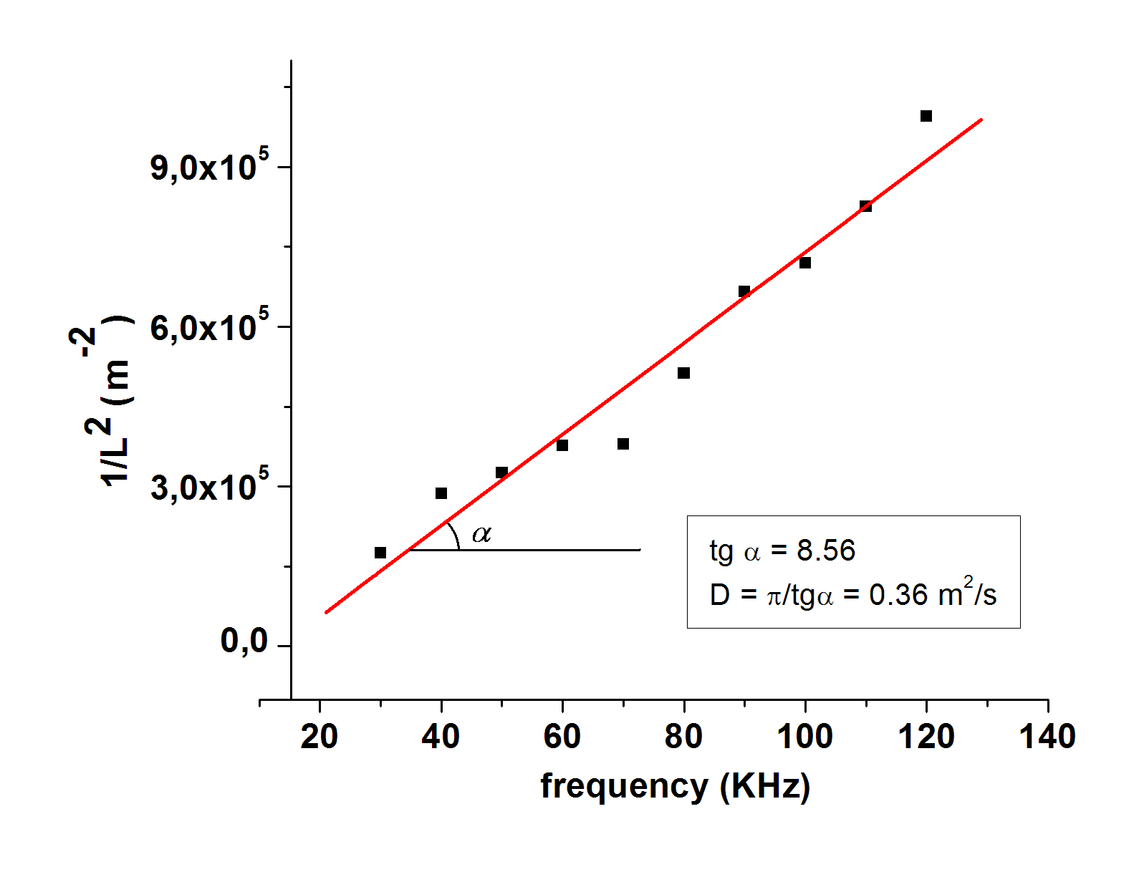
Figure 3. Dependence of 1/L² on the frequency.
The transversal diffusion coefficient estimated from the slope of this dependency was found 0.36 m²/s. For a magnetic field of 0.4 T, the obtained diffusion coefficient varied between 0.23 m²/s (in the centre of the plasma column) and 0.74 m²/s (at the edge of the plasma column). This coefficient has the same order of magnitude as Bohm diffusion coefficient. For an electron temperature of 2 eV (which is commonly found in Pilot-PSI) and for a magnetic field of 0.4 T, Bohm diffusion coefficient is 0.31 m²/s.
Milestone 2: Multi-channel analyzer – radial distribution of the ion flux
The multi-channel analyzer presented in figure 4 was fixed in the center of Pilot-PSI target. Using an electronic circuit, each of the 61 collectors could be biased in the range of – 20 ÷ +10 V. The functionality of the electronic circuit, of the data acquisition system (National Instruments) and of the acquisition software was tested step by step using low power discharges.
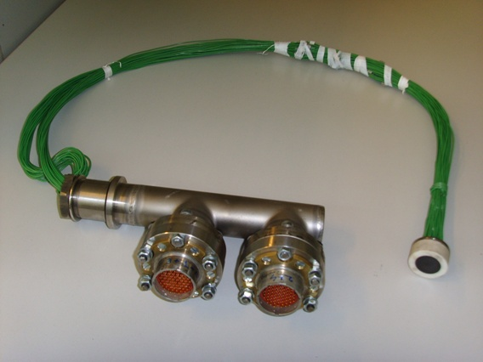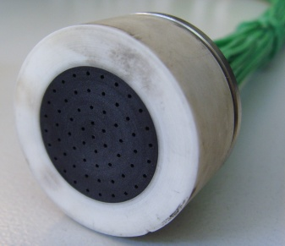
Figure 4. Multi-channel analyzer with 61 channels.
Preliminary measurements on each of the 61 collectors placed behind a hole of 0.5 mm in diameter pierced in the front plate, registered very weak electron or ion currents. It has to be specified that the front plate was floating during these measurements. Removing the front plate, the registered currents strongly increased (in the range of mA). In this new arrangement, current-voltage characteristics of different collectors were acquired. An example of such characteristics, obtained in argon and hydrogen, is shown in figure 5. The experimental conditions for these measurements in argon were B = 0.4 T, I = 80 A, p = 4.5 Pa, Q_{Ar} = 3 slm and in hydrogen were B = 0.4 T, I = 100 A, p = 6.4 Pa, Q_{H} = 3 slm. The collectors are disposed on concentric circles, each collector having an identification number (e.g. ch102). The first figure in the identification number specifies the circle position and it increases with the circle radius. Thus, ch000 is the central collector while ch400 is a collector placed on the most outer circle.
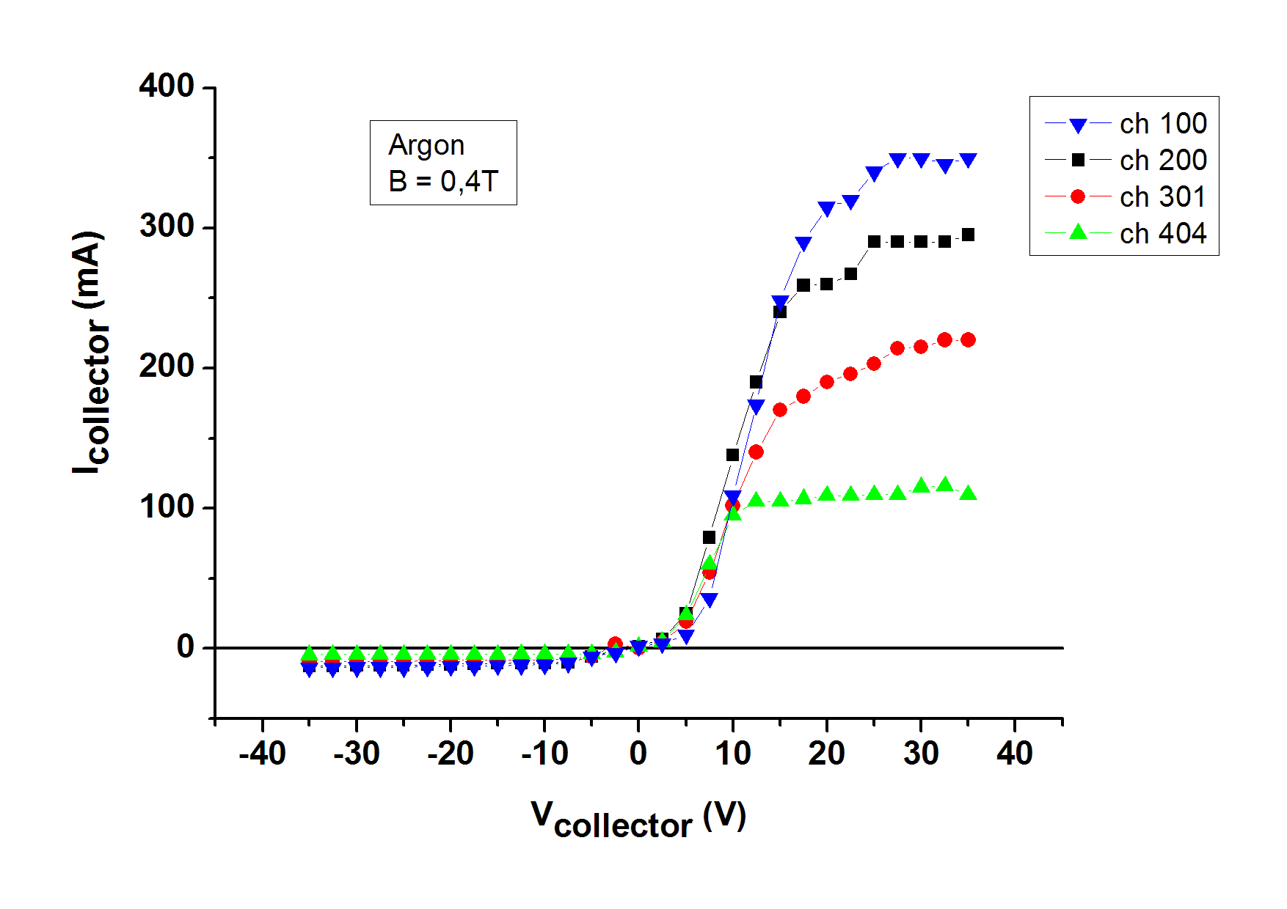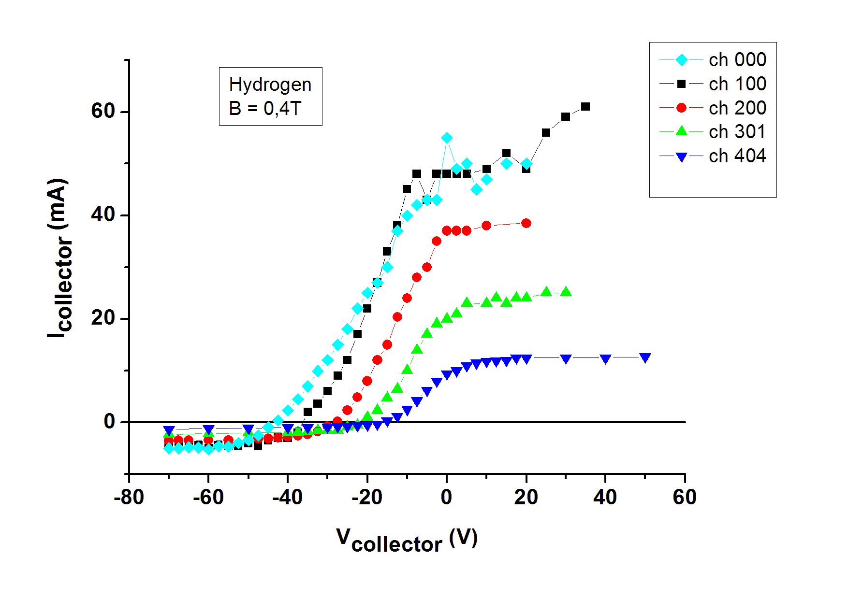
Figure 5. Current–voltage characteristics of different collectors (in argon and hydrogen).
It can be noticed that both electron and ion saturation current decrease radially from the center of the analyzer. The lowest plasma potential was found in the center of the analyzer. This result is in good agreement with previous measurements realized with probes in the plasma beam in front of the target [6]. From the ion saturation region of these characteristics it was possible to determine the radial distribution of the argon and hydrogen ion fluxes (single charged) reaching the target. These radial distributions are plotted in figure 6 and they correspond with the radial profile of the plasma column measured by probes or Thompson scattering.
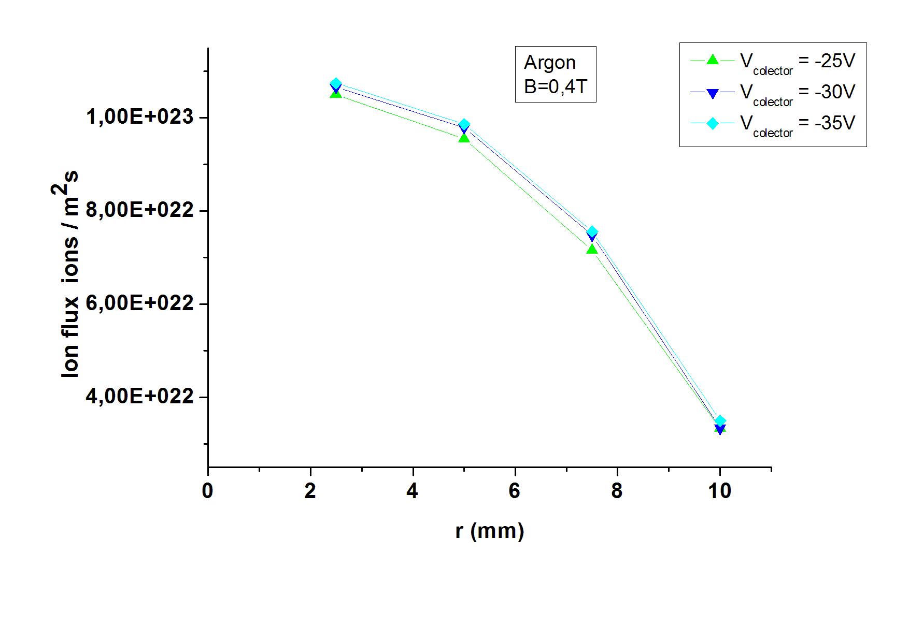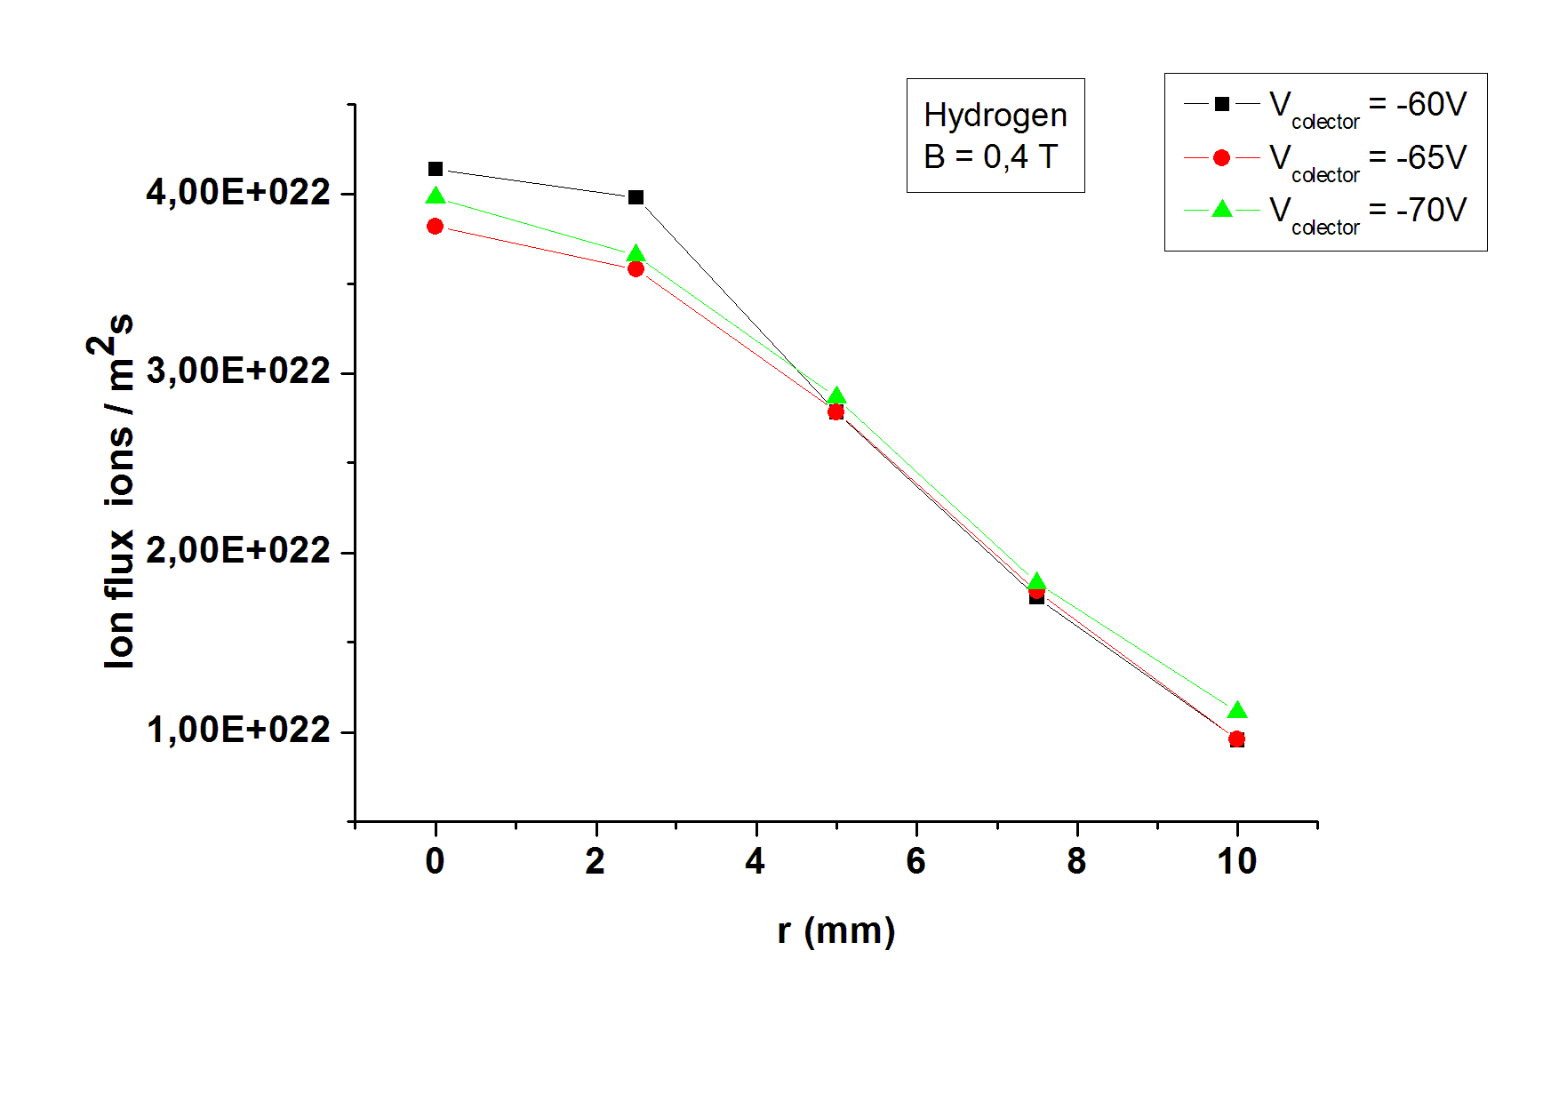
Figure 6. Radial distribution of argon and hydrogen ions flux on the target.
Further systematic measurements with the analyzer will allow us to obtain the time resolved distribution of the electron/ion flux in the cross section of the plasma column and also information about rotation of the plasma column.

References
[1] C. K. Birdsall and A. B. Langdon, Plasma Physics via Computer Simulation, McGraw-Hill New-York, 1991
[2] R. W. Hockney and J. W. Eastwood, Computer simulation using particles, McGraw-Hill New-York, 1981
[3] Sanguthevar Rajasekaran (editor), Handbook of Parallel Computing Models, Algorithms and Applications, Chapman & Hall/CRC, London, 2008
[4] G. J. van Rooij, V. P. Veremiyenko, W. J. Goedheer, B. de Groot, A. W. Kleyn, P. H. M. Smeets, T. W. Versloot, D. G. Whyte, R. Engeln, D. C. Schram, and N. J. Lopes Cardozo, “Extreme hydrogen plasma densities achieved in a linear plasma generator”, Appl. Phys. Lett. 90 (2007) pp. 121501
[5] J. Brotankova, E. Martines, J. Adamek, J. Stockel, G. Popa, C. Costin, C Ionita, R. Schrittwieser and G. Van Oost, “Novel Technique for Direct Measurement of the Plasma Diffusion Coefficient in Magnetized Plasma”, Contributions to Plasma Physics 48(5-7) (2008) pp. 418-423
[6] C. Costin, V. Anita, R. S. Al, B. de Groot, W. Goedheer, A. W. Kleyn, W. R. Koppers, N. J. Lopes Cardozo, H. J. van der Meiden, R. J. E. van de Peppel, R. P. Prins, G. J. van Rooij, A. E. Shumack, M. L. Solomon, W. A. J. Vijvers, J. Westerhout, G. Popa, “On the power balance at the end plate of the plasma column in Pilot-PSI”, 34th EPS Conference on Plasma Physics, Warsaw, Poland, 2-6 July, 2007 (poster P5.084)

Publications and Conferences
[1] I. Mihaila, C. Costin, M. L. Solomon, G. Popa, C. Ionita, R. Stärz, R. Schrittwieser, J. Rapp, N. J. Lopes-Cardozo, H. J. van der Meiden, G. J. van Rooij – “Probe investigations of the Pilot-PSI plasma”, 35th European Physical Society (EPS) Conference on Controlled Fusion and Plasma Physics, Hersonissos, Crete, Greece, 9-13 June, 2008 (poster P4.093)

