7. Development on small-scale plasma torch for fuel removal, in conjunction with CEA, Cadarache
Assessment of detritiation with Ar plasma torch

G. Dinescu, B. Mitu. S. Vizireanu, E.R. Ionita, I. Luciu, C. Stancu
National Institute for Lasers, Plasma and Radiation Physics, Magurele, Bucharest

7.1. Introduction
For approaching the problem of removal of co-deposited layers and detritiation in gaps and voids a small size plasma torch [1] and a gap discharge generator [2-4] were proposed. The plasma torch was tested on flat surfaces of graphite and CFC tiles, but not on inside of gaps surface. Experiments are necessary in order to prove the effectiveness of such devices for removal of co-deposited layers in the gaps. In addition, the nature of the deposit is important; there are not yet easy available materials which can be used as models for the co-deposited layers and techniques to measure the cleaning effectiveness inside gaps. The project focuses on the applicability of the plasma torch for cleaning inside gaps of hydrogenated amorphous carbon.

7.2. Results
Flat surfaces (silicon wafer, polished aluminum) were covered with layers of amorphous hydrogenated carbon by Plasma Enhanced Chemical Vapor Deposition. The used set-up consisting of a parallel plate RF discharge configuration enclosed in a vacuum chamber and fed with Ar/acetylene gas mixture. A special shower type electrode was designed and built-up allowing a quasi-uniform injection of gases in the discharge. The two parallel electrodes were separated by 4- 6 cm distance. The RF power was in the range 30-80 W. In this condition amorphous hydrogenated carbon layers were deposited onto substrates with a deposition rate of about 1mm/hour. The deposition rate was calculated from ellipsometric and AFM step-profile measurements, on samples deposited for different deposition times.

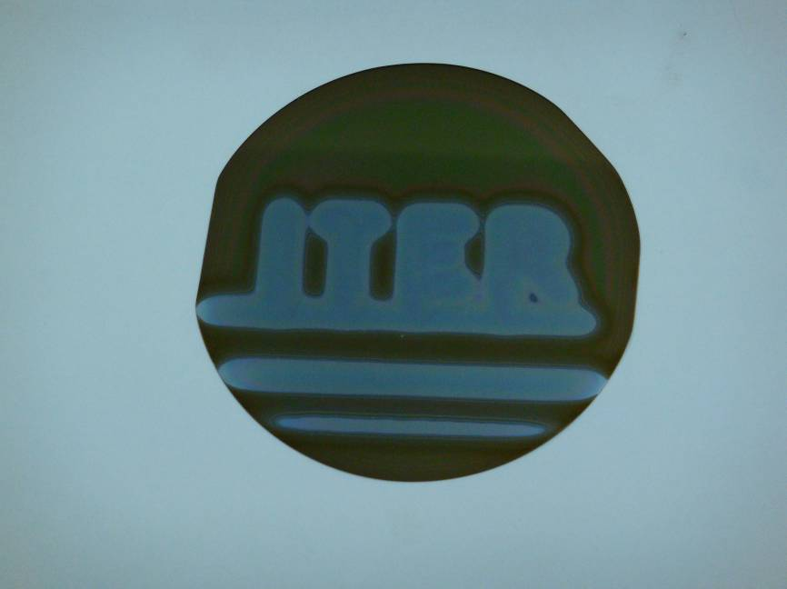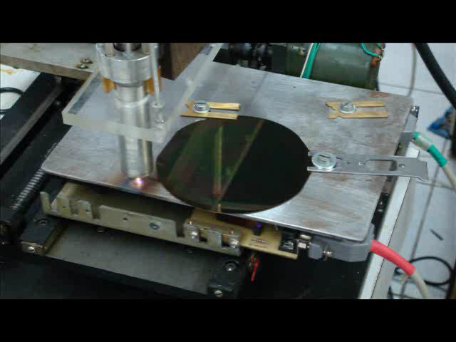
Figure 1a). Image of the plasma torch during cleaning a layer of amorphous hydrogenated carbon deposited on a flat substrate; b) A wafer (10 cm diameter) on which the word ITER was written by removal of the carbon layer with the plasma torch (scanning speed 1.66 mm/sec, power 350 W, nitrogen 7500 sccm)

7.2.1 Experiments on flat surfaces.
In Fig. 1 is presented a sample of a silicon wafer covered with amorphous carbon submitted to scanning. The cleaning experiments consisted of scanning of the sample with a plasma torch working in nitrogen. The removal of the film of about 1 micron thickness is fast, when the torch tip was positioned perpendicular, al 5-10 mm distance. In a demonstrative experiment a wafer was scripted with the word ITER in about 1 minute (Figure 2).
7.2.2 Experiments on castellated surfaces.
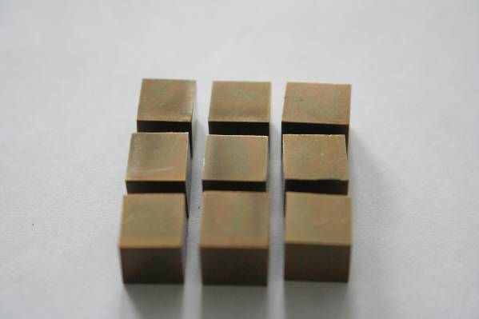
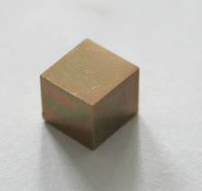
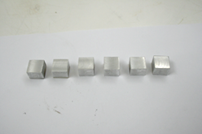
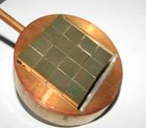
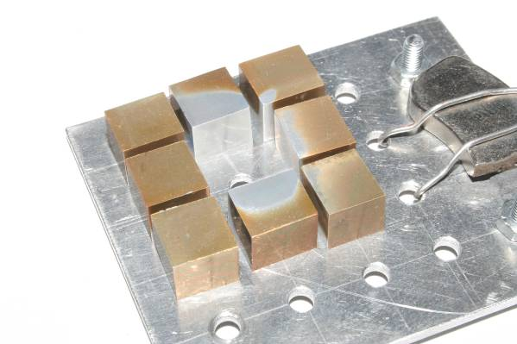
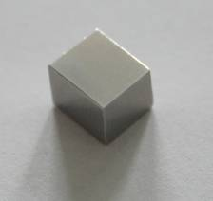
Castellated surfaces were assembled from machined aluminium cubes a with all cubes faces deposited by amorphous carbon. The obtained castellated surface contain regular rectangular gaps of at least 9 mm depth and 1.5 mm width, coated inside by carbon deposits. An image on cubes, their assemblage and the resulted coated castellated surface is presented in Figure 2.
a) separate cubes
c) coated castellated surface
b) faces of cubes coated with carbon
Figure 2. Model of the castellated surface coated with amorphous hydrogenated carbon
Scanning speed: 2 mm/s
Number of scans: 5
Gap width: ~1.5 mm
Nitrogen, 7500 sccm
Power: 350 W
Distance tip surface: 5mm
Plasma diameter: 2 mm

Fgure 3. The cleaning inside gaps
Figure 4. Spectra recorded at the exit of the plasma jet after interaction with a carbon ring
This surface was scanned with plasma torch along the castellation (the movement of the torch along the gaps limiting the central cube was computer programmed). The removal of the material from the inside gap was observed as can be seen in Figure 3, which shows the image of the central cube dismounted after 5 scans.
7.2.3 Diagnostic of cleaning
Figure 3 suggests that plasma jet cleaning occurs on surfaces much larger than the plasma beam diameter. This advantageous behavior was explained by imaging diagnostic. The images (not shown here), taken by a CCD camera, of the plasma jet penetrating inside a channel show that the plasma jet spreads also around the castellation margins producing additional cleaning on the flat frontal face on the specimen.
The intimate processes of carbon removal in open atmosphere by an nitrogen plasma beam were investigated by emission spectroscopy. In a first set of experiments the spectra taken at the incidence of the plasma jet with a carbon surface were recorded. In this set of experiments the carbon emitting features (lines or bands of carbonic radicals) were not clearly observed, presumably being hidden by the very large signals coming from nitrogen and NO bands. A second set of experiments were realized with a devoted configuration in which the plasma jet passes across a carbon ring, with an inner diameter of 1 mm, allowing the interaction of plasma with the ring surface. Spectra were recorded at the exit of plasma jet from the ring. The comparative spectra obtained with and without the interaction with the carbon are presented in Figure 4. They clearly show the presence of the CN bands emission in the case of interaction with carbon surface. The most probable mechanism of carbon removal is via carbon chemical erosion by nitrogen excited species (radicals and metastables). The mechanism is possible similar to that responsible for CN bands excitation during the interaction of expanding thermal plasma with a graphite nozzle [5].
A part of these results were obtained in colaboration with CEA-Cadarache.

7.3. Conclusions
An experimental model surface for the co-deposited layer, consisting of an amorphous hydrogenated carbon film, was designed and realized by Plasma Enhanced Chemical Vapor Deposition. Cleaning on planar surfaces and inside gaps was proved by scanning with a plasma torch in open atmosphere which outline the effectiveness and feasibility of plasma torch technique for carbon layers removal. The diagnostics of cleaning process point out on a removal mechanism based on carbon removal by nitrogen species.

References
[1] G. Dinescu, E.R. Ionita, I. Luciu and C. Grisolia
“Flexible small size radiofrequency plasma torch for Tokamak wall cleaning
Fusion Engineering and Design, 82,15-24 (2007)2311-2317
[2] C. Stancu, A. C. Galca, G. Dinescu, C. Grisolia
Removal of carbon residuals from narrow spaces by RF discharges
35 European Physics Conference (35 EPS) June 9-13, 2008, Hersonissos, Crete, Greece
[3] C. Stancu, E.R. Ionita, B. Mitu, G. Dinescu
Plasma Segmentation inside narrow channels of grounded electrodes
European Sectional Conference on Atomic and Molecular Phenomena in Ionized Gases, July 15-19, 2008, Granada, Spain
[4] G. Dinescu, E. R. Ionita, C. Stancu, C. Grisolia
Cleaning of castellated surfaces with radiofrequency discharges
Gordon Conference “Plasma Processing Science”, July 13-18, 2008, South Hadley, MA, USA
[5] A. de Graaf, E. Aldea, G. Dinescu, M.C.M. van de Sanden
Investigation of processes in low-pressure expanding thermal plasmas used for carbon nitride deposition. II. Ar/N₂ plasma with graphite nozzle
Plasma Sources Science and Technology 10 (2001) 524-529

