III. Participation at JET REsearch Programme

1. Upgrade of the jet gamma-ray CAMERAS – NEUTRON ATTENUATOR (KN3-NA)

V. Zoita⁽¹⁾, M. Gherendi⁽¹⁾, A. Pantea⁽¹⁾, M. Curuia⁽²⁾, M. Anghel⁽²⁾, M. Constantin⁽²⁾,
E. David⁽²⁾, S. Soare⁽²⁾
⁽¹⁾National Institute for Laser, Plasma and Radiation Physics, Magurele
⁽²⁾National Research and Development Institute for Cryogenics and Isotopic Technologies, Rm. Valcea

1.1. Introduction
The main objective of the diagnostics upgrade project “Gamma-Ray Cameras – Neutron Attenuators” (KN3-NA) is the design, construction and testing of neutrons attenuators for the two sub-systems of the KN3 gamma-ray imaging diagnostics [1]:
- KN3 gamma-ray horizontal camera (KN3 HC) and
- KN3 gamma-ray vertical camera (KN3 VC).
The attenuators are to be placed within the KN3 diagnostics system in Octant 1 between the vacuum port and the collimator body (also called “radiation shield”) both for the horizontal camera (HC) and for the vertical camera (VC).
The KN3 attenuators operation will be monitored by a dedicated steering and control system based on pneumatic actuators.
A schematic representation of the KN3-NA diagnostics upgrade system is shown in Fig.1. The design structure of the KN3-NA system, the evolution of the design concepts (through the conceptual and scheme design phases), the mechanical behaviour of the attenuators under the tokamak disruption forces have been presented in detail in various internal reports and conference communications [2-4].
The neutronics performance of the neutron attenuators designed and constructed for the JET KN3 diagnostics system has been evaluated by means of neutron/photon transport calculations using the MCNP code.
An important operational feature of the KN3 diagnostics, the profile reconstruction (both in its neutron and gamma-ray option), has been addressed within a separate EURATOM-MEdC Association project [5].

1.2. Detailed design of the KN3-NA gamma-ray camera neutron attenuators
All the major components of the KN3-NA diagnostics upgrade (i.e., those to be eventually installed on the JET machine) have been developed to the level of detailed design. The detailed design report [6] has been evaluated and approved in a Progress Meeting held at JET on April 2nd, 2008.
The following activities have been carried out during the period April-May 2008:
- Transfer of the current KN3-NA detailed design CATIA model to the JET Design Office (April 15th, 2008)
- Issue a report on “Detailed Design of the KN3 Neutron Attenuators (KN3-NA)” (April 30th, 2008)
- Issue a report on “Design, construction and testing of the vertical camera neutron attenuator prototype” (April 30th, 2008)
- Update of the KN3-NA detailed design following the recommendations of the Progress Meeting (May 15th, 2008)
The completion of all these activities made it possible for the JOC representatives to launch the internal review procedure (TCD-I) for the KN3-NA detailed design documentation at the beginning of June 2008. According to the information provided by JOC, this procedure should be successfully closed by December 15th, 2008. The TCD-I procedure has been continued during the first quarter of 2009.

1.2.1. Horizontal Camera Neutron Attenuator
The horizontal camera neutron attenuator (HC-NA) is designed to function as a neutron filter when in working position (in the plane determined by the gamma-ray detectors lines of sight). To remove the neutron attenuator from the working position two movements are required: first a 90o rotation (to the right when looking to plasma) and second a 630mm translation.

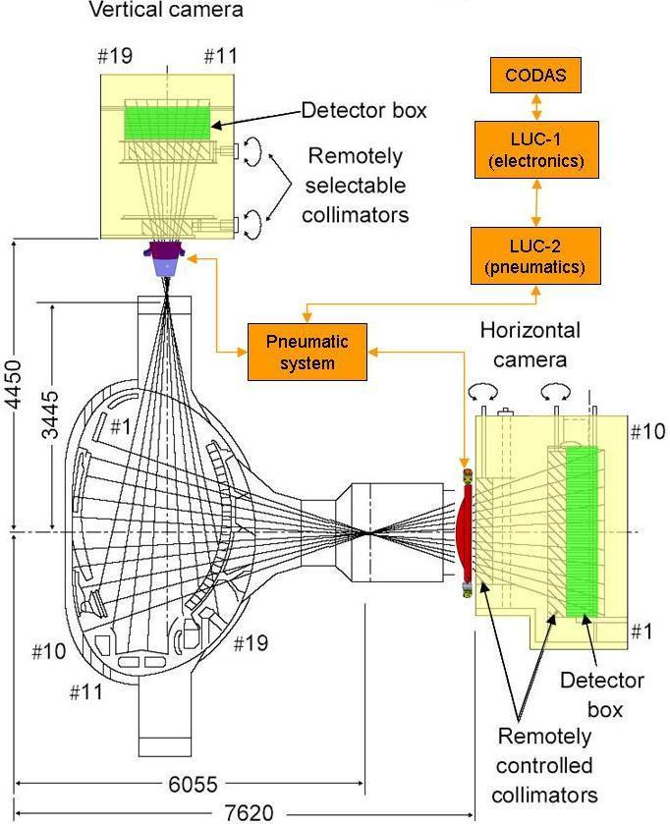
HC-NA
VC-NA
Figure 1. JET KN3 neutron/gamma diagnostics with neutron attenuators and their steering and control system (LUC: Local Unit Cubicle); HC-NA: Horizontal Camera Neutron Attenuator; VC-NA: Vertical Camera Neutron Attenuator
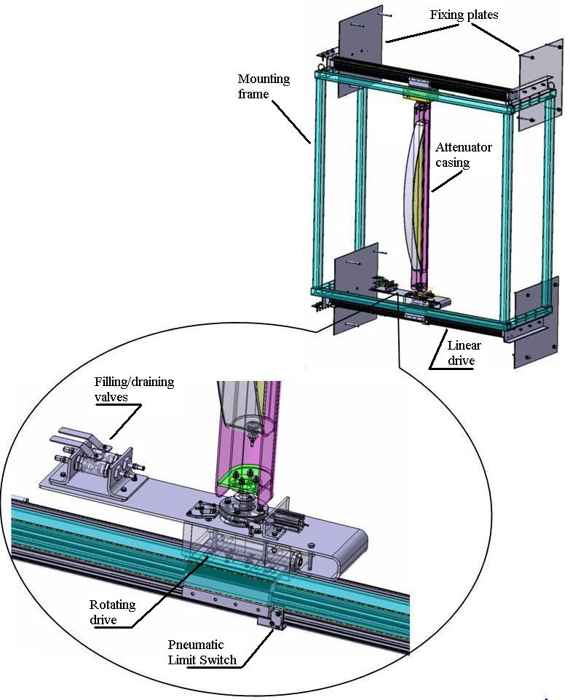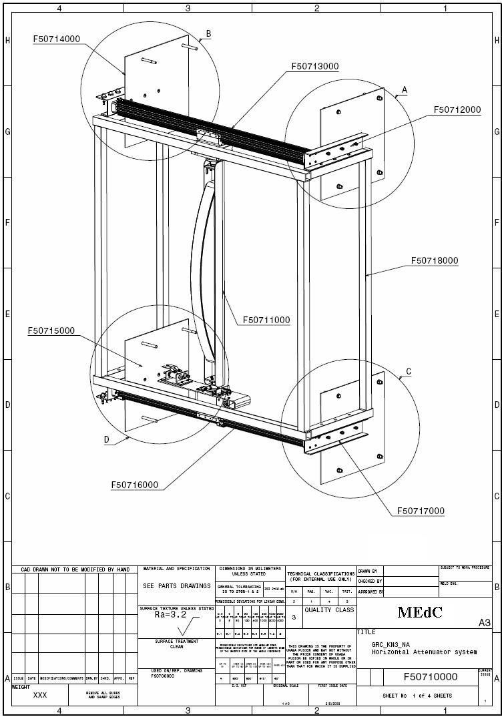
a) 3D CATIA full model and lower zoom b)

Figure 2. KN3 HC-NA 3D CATIA model and assembly drawings

The HC-NA sub-assembly (Figure 2) is composed of a quasi-crescent shape casing (INCONEL 600 welded structure - 3mm sheet), a mounting frame (Figure 2b), and pneumatic actuators and connections. The HC-NA metal casing will be filled with pure light water (as attenuating material), the attenuator being connected to the JET cooling water circuit. The case is supported by a U-shaped profile that provides the structure with mechanical strength and connects it with the steering and control system.
1.2.2. Vertical Camera Neutron Attenuator
The vertical camera neutron attenuator (VC-NA) casing was developed into two versions, long and short, the difference being in the attenuation length: 240 mm for the short option and 600 mm for the long one.
To move in and out of the working/parking location the attenuator is translated 100mm by the steering and control electro-pneumatic system. Both vertical camera attenuator casings (short and long version) have a quasi-trapezoidal shape with internal reinforcements parallel to and between the vertical camera channels, Figure 3a.
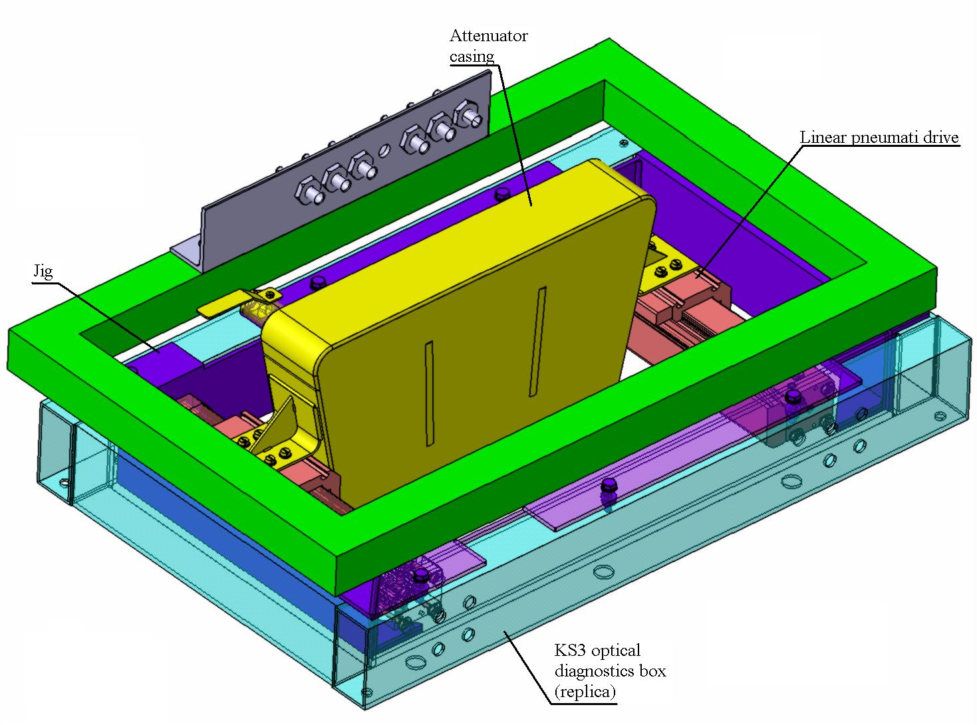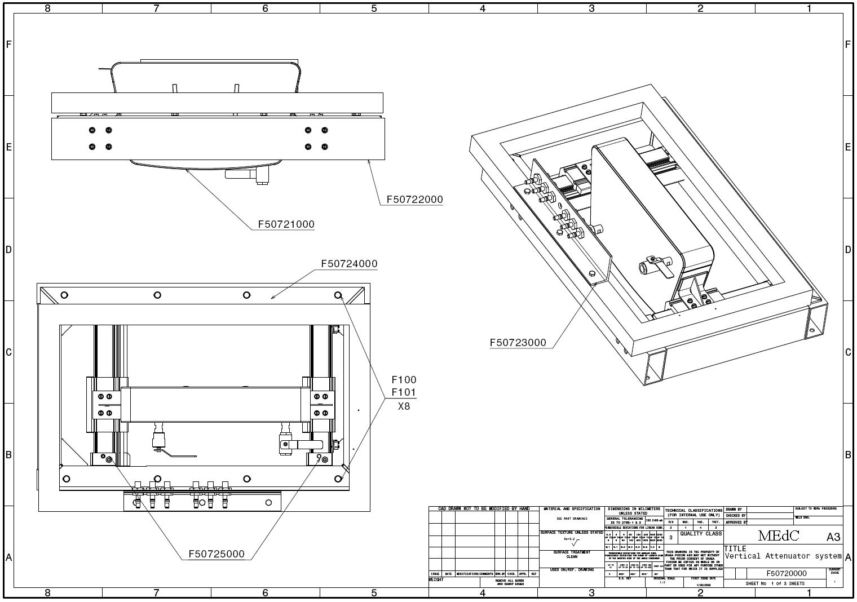
a) 3D CATIA model b)
Figure 3. KN3 VC-NA 3D CATIA model and assembly drawings
The attenuating material (pure light water) is contained in a casing made of welded INCONEL 600 sheet 3mm thick. The attenuator casing is bolted onto the pneumatic actuators which are fixed onto the JET KS3 optical diagnostics box frame, Figure 3b. The VC-NA sub-assembly is connected to the JET cooling water circuit and to the compressed air supplies required to power and control the actuators by means of the pneumatic limit switches.
1.2.3. Steering and control system for KN3 gamma ray camera neutron attenuators
The KN3 gamma-ray camera neutron attenuators will operate in a very harsh electromagnetic environment. Therefore the use of electrical and electronic should be avoided. A design solution based on pneumatic components was developed for attenuator steering. The KN3 neutron attenuator steering and control system consists of three sub-systems:
- LUC-1 (Local Unit Cubicle 1), contains a programmable logic controller, permanently connected to CODAS and to LUC 2.
- LUC-2 (Local Unit Cubicle 2), is the link between LUC – 1 and the Pneumatic System (PS). It converts the air pressure variations into electrical signals to be sent to the LUC-1 and sends instruction to PS.
- PS (Pneumatic System), is linked to LUC – 2, and it performs the actions necessary to move the attenuators and signals the end-stroke of neutron attenuators.

1.3. Manufacture and testing of the Vertical Camera Neutron Attenuator prototype
A fully functional prototype based on the vertical camera neutron attenuator was designed, manufactured and mechanically tested. The assembled prototype is shown in Figure 4. It is identical in size, shape and used materials to the KN3 vertical camera neutron attenuator. Additional to the actual vertical camera attenuator, the prototype is provided with a support frame which was manufactured to mimic part of the JET KS3 optical diagnostic box. The steering and command system is similar to that of the KN3-NA system in terms of components. The differences lay with the software that commands and controls the translations and end-stroke positions.
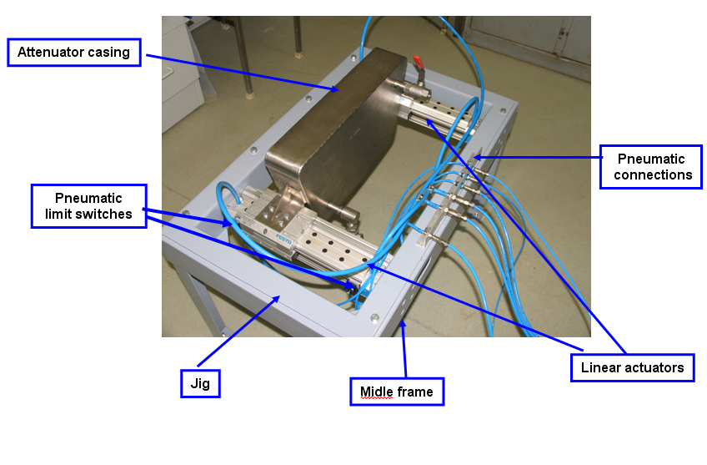

Figure 4. Vertical Camera Neutron Attenuator prototype.

LUC 1 prototype. The Programmable Logic Controller (PLC) together with the power supply, the main switch, the emergency stop switch, the main fuse, the push-buttons are placed into a RITTAL industrial case with dimensions of 380x600x210 mm. The electrical connection between PLC Cubicle and Electro-Pneumatic Cubicle was done using two 32 ways socket cable connectors and 50m/32 wires (7*0.2) automation cable.
LUC 2 prototype. All the pneumatic components are placed into a 500x500x210 RITTAL industrial case. The LUC 2 cubicle is connected with the PLC Cubicle by means of 50 m/32 wires (7*0.2) automation cable and 32 ways cable socket connectors. A compressor provides air at a pressure of 6-8 bar. The Electro-Pneumatic Cubicle (LUC 2) was built using an industrial case that can be wall mounted.
The attenuator casing (Figure 4) was designed and manufactured according to the legal requirements currently in-force in Romania (ISCIR and CNCAN, Romanian authorities for Pressurised Vessels and Lifting Equipment and Control of Nuclear Activities). Subsequently the casing was subject to several integrity tests: helium leak test, pressure test, and penetrating liquid. The casing passed successfully all the tests it was subject to. The tests and the results are presented in detail in [7]. The attenuator prototype report [7] has been evaluated in a technical meeting held at JET on April 2nd, 2008, and approved by the JET and JOC representatives.
All the activities related to the use of the attenuator prototype on the JET machine had to be cancelled in June 2008 due to the severe reduction (50%) of the planned funding for the project in the MEdC Association.

1.4. MCNP calculations for the performance of the KN3 neutron attenuators
The following task on the physical (neutronics) performance of the KN3 neutron attenuators was addressed during the second half of 2008: “Neutron beam energy and angular distributions at attenuator back end. Improved estimation of the neutron-induced gamma-rays. Application to the (long) vertical camera neutron attenuator (VC-NA-L), and to the horizontal camera neutron attenuator (HC-NA)".
Emphasis was given to the calculation of the attenuation characteristics of the long neutron attenuator for the vertical camera (VC-NA-L), to be used during DT discharges and for the neutron attenuator for the horizontal camera. Similar calculations for the short neutron attenuator, used for the vertical camera during DD plasma discharges have been previously performed and reported [8].

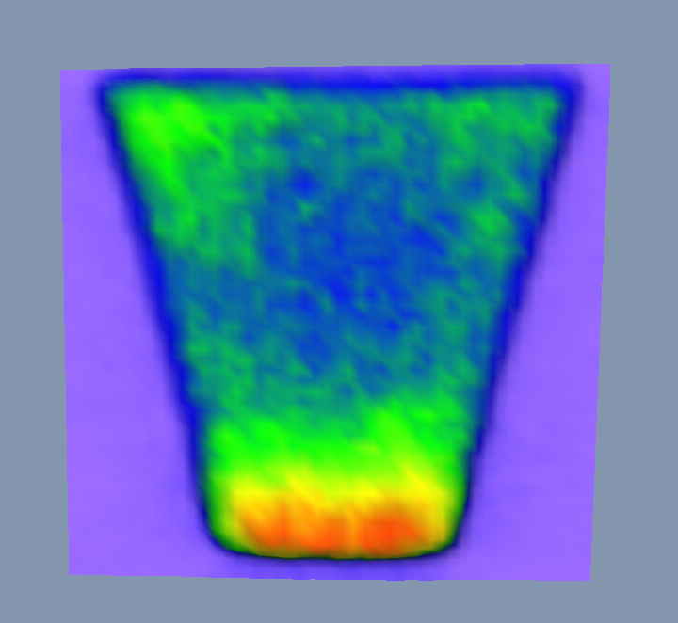
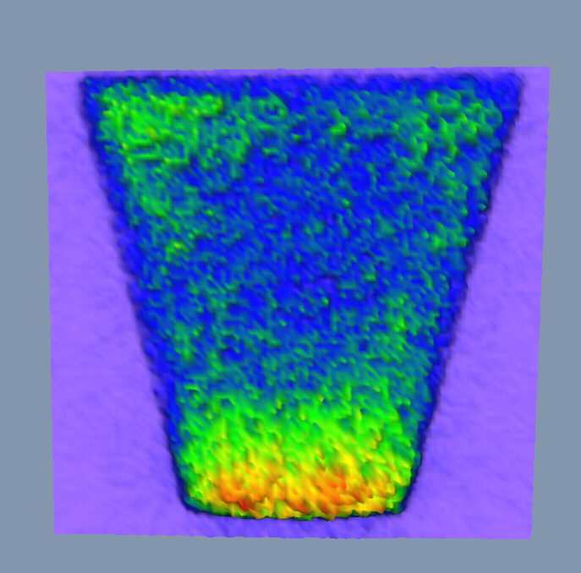

a)
b)
Figure 5. The distributions of a) the thermal flux (E<0.5eV) and b) neutron capture induced gamma emissions in the long vertical attenuator, exposed to DT plasma neutrons [8].

The number or the neutron induced gammas and the attenuation factors for neutrons in the neutron attenuators for the KN3 vertical (long attenuator, only DT case) and horizontal camera (DD case) were estimated. The estimations were performed on the basis of Monte Carlo calculations using the MCNP5 code. Due to the extreme degradation of the flux from the plasma to the KN3 detector position a variance reduction techniques were use, developed for the specific case of the KN3 profile monitor. An illustrative example of the results of the MCNP calculations is shown in Figure 5.
The results of the numerical simulations were estimated on the basis of the larger angle approximation method and can be summarised as:
- The 14.1 MeV neutron attenuation factor for the long vertical camera neutron attenuator is about 10².
- The attenuation factor of horizontal camera neutron attenuator for 2.45 MeV neutrons is about 10².
- The ratio of the neutrons scattered into the detectors with respect to transmitted neutrons is larger for the edge channels but less than 5% for all cases. The value is so low because the scattered neutrons have an isotropic angular distribution.
- The number of induced gammas reaching the detectors, per forward-moving transmitted neutron, is less than one for all cases.
- The induced gamma spectrum has only the 2.2MeV line in the DD case and several additional lines in the DT case.
The report on the MCNP calculations [9] was presented and favourably evaluated at a Progress Meeting held at JET on November 25th, 2008.

3. Conclusion
The detailed design of the neutron attenuator system for the JET KN3 Gamma-Ray Cameras (KN3-NA) has been finalised.
A fully functional prototype for the vertical camera neutron attenuator was manufactured and successfully tested.
Calculations of the attenuation characteristics of the long neutron attenuator for the vertical camera (VC-NA-L), to be used during DT discharges and for the neutron attenuator for the horizontal camera have been completed.
All these deliverables have been thoroughly evaluated in technical meetings held at JET during 2008. They have all been positively reviewed by the JET and UKAEA/JOC representatives.
Following the expected successful completion of the JET TCD-I procedure for the KN3-NA detailed design, the KN3-NA system manufacture can be launched during 2009.

Acknowledgements
The reported work includes contributions from the following people outside the EUATOM-MEdC Association:
T. Edlington, V. Kiptily, P. Prior, S. Sanders, B. Syme (Association EURATOM-UKAEA/JOC, Culham Science Centre, Abingdon, UK), K. Kneupner (Association EURATOM-FZJ, Julich, Germany), I. Lengar (Association EURATOM-MHST, Jozef Stefan Institute, Ljubljana, Slovenia), A. Murari (Association EURATOM-ENEA, RFX, Padova, Italy).
The authors would like to gratefully acknowledge the continuous support received from their institutes and laboratories. Under the very severe funding restrictions of 2008, the work reported here would not have been possible without this support.

References:
[1] V. Zoiţa, M. Anghel, T. Craciunescu, M. Curuia, T. Edlington, M. Gherendi, V. Kiptily, K. Kneupner, I. Lengar, A. Murari, A. Pantea, P. Prior, S. Soare, S. Sanders, B. Syme, I. Tiseanu, “Design of the JET Upgraded Gamma-Ray Cameras”, 25th Symposium on Fusion Technology SOFT2008, 15-19 September 2008, Rostock, Germany.
[2] S. Soare, V. Zoita, T. Craciunescu, M. Curuia, V. Kiptily, I. Lengar, A. Murari, P. Prior, M. Anghel, G. Bonheure, M. Constantin, E. David, T. Edlington, D. Falie, S. Griph, F. Le Guern, Y. Krivchenkov, M. Loughlin, A. Pantea, S. Popovichev, V. Riccardo, B. Syme, V. Thompson, I. Tiseanu and JET EFDA contributors, “Mechanical Design of the Upgraded JET Gamma-Ray Cameras”, J. Optoelectronics Advanced Mat., 10 (2008) 2088 – 2091.
[3] S. Soare, V. Zoita, T. Craciunescu, M. Curuia, V. Kiptily, I. Lengar, A. Murari, P. Prior, M. Anghel, G. Bonheure, M. Constantin, E. David, T. Edlington, D. Falie, S. Griph, F. Le Guern, Y. Krivchenkov, M. Loughlin, A. Pantea, S. Popovichev, V. Riccardo, B. Syme, V. Thompson, I. Tiseanu and JET EFDA contributors, “Upgrade of the JET Gamma-Ray Cameras”, AIP 988 (2008) 299.
[4] S. Soare, V. Zoita, T. Craciunescu, M. Curuia, M. Anghel, M. Constantin, E. David, A. Pantea, I. Tiseanu, et all, ”Upgrade of the Jet Gamma-Ray Cameras”, A 13-a Conferinta „Progrese in criogenie si separarea izotopilor”, Calimanesti-Caciulata 7-9 noiembrie 2007, Romania.
[5] T. Craciunescu, G. Bonheure, V. Kiptily, A. Murari, S. Soare, I. Tiseanu, V. Zoita, “The Maximum Likelihood Reconstruction Method for JET Neutron Tomography”. Nuclear Inst. and Methods in Physics Research, A, 595, p. 623–630, 2008.
[6] V. Zoita, M. Anghel, M. Curuia, T. Edlington, V. Kiptily, K. Kneupner, P. Prior, S. Sanders, S. Soare, B. Syme, “Detailed Design of the KN3 Neutron Attenuators (KN3-NA)”, (JET EP2 GRC) Upgrade of Gamma-Ray Cameras – Neutron Attenuators, Report April 2008.
[7] V. Zoita, M. Anghel, M. Curuia, T. Edlington, V. Kiptily, K. Kneupner, P. Prior, S. Sanders, S. Soare, “Manufacture and testing of the vertical camera neutron attenuator prototype”, (JET EP2 GRC) Upgrade of Gamma-Ray Cameras – Neutron Attenuators, Report April 2008.
[8] I. Lengar, “Modelling of the neutron beam distribution for the KN3 attenuators; neutron-induced gamma-rays in the attenuator”, (JET EP2 GRC) Upgrade of Gamma-Ray Cameras – Neutron Attenuators, Report April 2008.
[9] I. Lengar and V. Zoita, “Neutron beam distribution in the KN3 attenuators; Application for the horizontal and the long vertical attenuator”, (JET EP2 GRC) Upgrade of Gamma-Ray Cameras – Neutron Attenuators, Report November 2008.

