5. Tokamak Neutron Diagnostics Based on the Super-heated Fluid Detector (SHFD)

V. Zoita, T. Craciunescu, M. Gherendi, A. Pantea
National Institute for Laser, Plasma and Radiation Physics, Magurele

5.1. Introduction
Super-heated fluid detectors, SHFFD’s (also known as "bubble detectors") are suspensions of metastable droplets which readily vaporise into bubbles when they are nucleated by radiation interactions. The active detecting medium is in the form of microscopic (20-50 μm) droplets suspended within an elastic polymer. The phenomenon of neutron detection by a SHFD is a mixture of nuclear interactions (neutron collisions with nuclei of the active medium), thermodynamic behaviour of the detecting medium (the super-heated fluid), and the mechanical response of the elastic polymer. If sufficient energy is transferred from the colliding neutron to the nucleus of one of the elements in the composition of the active medium, the recoil nucleus will initiate the generation of a vapour embryo of sub-micron dimensions. Under proper conditions (that depend on the thermodynamics of the active medium) the vapour embryo will lead to the vaporisation of the super-heated droplet with the subsequent expansion into a macroscopic (0.2 – 0.5 mm) bubble.
The SHFD’s have a threshold-type energy response with the threshold energy depending on droplet composition, detector operating temperature, detector operating pressure. For a standard bubble detector like the BD-PND∗ type, the energy response is approximately flat within the range 0.3-10 MeV. Using detectors with different energy thresholds, a bubble detector spectrometer (BDS∗) is obtained. The BDS covers a broad energy range (0.01 – 20 MeV) and provides six energy thresholds in that range.
The particular features of the SHFD’s recommended the technique for an application on the JET tokamak machine with the aim of determining the neutron field characteristics in high performance (i.e., high neutron yield) discharges [1, 2]. As the main (host) experiment it was chosen that on “Steady-state scenarios at high beta-N” which employs high neutral beam powers (~20MW) and produces neutron yields in the range (3-5)x1016 neutrons, the experiments have been scheduled to be carried out as parasitic experiments during the JET campaigns C20-C25 [3, 4]. Additional SHFD measurements were carried out as parasitic experiments on other main experiments involving high yield discharges (e.g., “Exploration of the q profile in the hybrid scenario”).
Only the measurements carried out during the campaign C20 and C21 are reported here. The planned measurements for Campaign C25 (five sessions) could be done only at much reduced level compared with the initial schedule due to various reasons, which included both the availability of the SHFD diagnostics hardware and the change of the JET experimental plan.
The C25 sessions have been rescheduled for the C26 Campaign of the JET 2009 workprogramme.

5.2. SHFD neutron measurements at JET during campaigns C20b and C21
The measurements have been done at the end of the KM11 neutron diagnostics line-of-sight, above the TOFOR neutron time-of-flight spectrometer (Figure 1). The distance from SHFD location to the TOFOR first scintillator detector (S1) is approximately 3.5m and the distance to the torus mid-plane is approximately 20m.
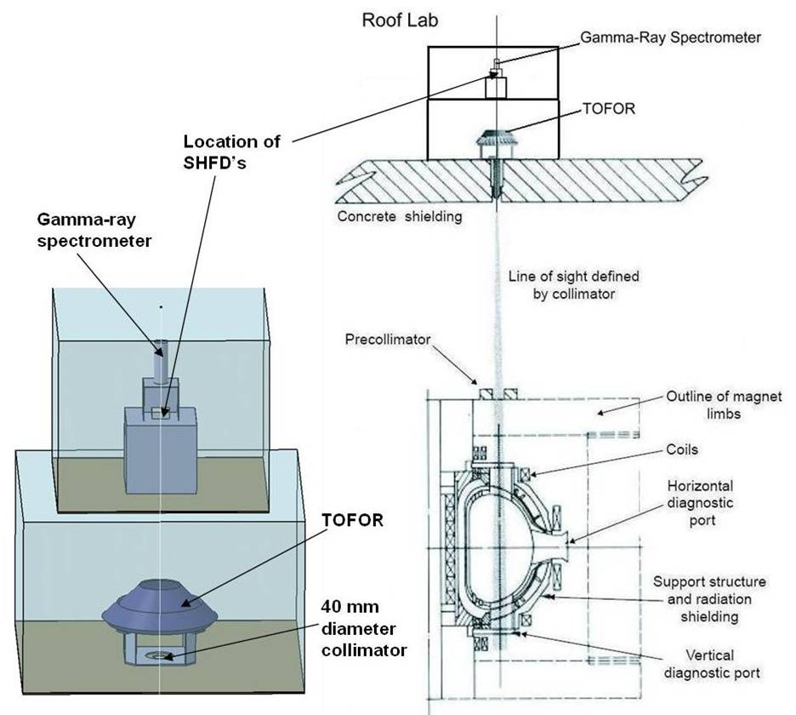
Figure 1. Experimental setup for SHFD neutron measurements along the JET KM11
Line-of-Sight.

By using high sensitivity DEFENDER detectors the profile of the neutron beam propagating along the collimated vertical line-of-sight of the KM11 diagnostics was obtained.
Two types of SHFD’s (BD-PND (absolutely calibrated) and DEFENDER (high sensitivity) have been used on the JET tokamak for neutron measurements during the 2008 experimental campaigns C20b and C21 (five experimental sessions) (Table 1). Sets of eight BD-PND type detectors have been used during ten JET pulses for absolute neutron fluence measurements and sets of seven high sensitivity DEFENDER type detectors during eight JET pulses for neutron beam imaging (determination of the “neutron spot”).
Table 1. Experimental program during campaigns C20b and C21

Session | Main (host) experiment | BD measurements
15.05.2008 E&L | S1-2.4.2  Design and Document viable ITER ramp up scenario for inductive scenario and hybrid  T-2.3.1  Effect of poloidal rotation on ITB triggering | 3 pulses  (0 with BD-PND)  (3 with DEFENDER)
20.05.2008 E&L | S2-2.3.3  Development of SS scenario at high beta-N and H98 | 7 pulses  (4 with BD-PND)  (3 with DEFENDER)
11.07.2008 L | S2-2.2.2  Exploration of the q profile in the hybrid scenario | 8 pulses  (6 with BD-PND)  (2 with DEFENDER)

A set of six DEFENDER type detectors have been used during the pulse JPN 72737 in the late session on 15.05.2008. A spatial distribution of the neutron fluence was obtained with radial and toroidal resolution (Figure 2).
A
B
C

Figure 2. Spatial distribution of the neutron fluence. A: 2D distribution; B: radial view (machine centre is on the left hand side); C: toroidal distribution.

The radial distribution of the neutron fluence obtained by a bubble detector array (BD-PNDs) for four pulses in session 20.05.08, for discharges with different beta-N (normalised plasma beta), is represented in Figure 3.
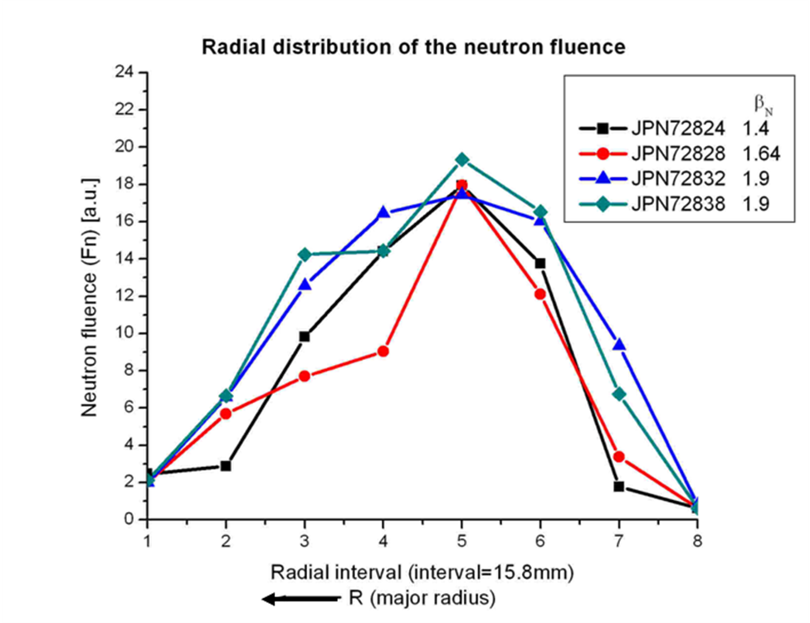
3. Dependence of the neutron fluence radial profile on the beta-N parameter.
It can be seen from Figure 3 and from the data in Table 2 that the radial neutron profile as determined by the bubble detector array is sensitive to the plasma pressure as expected.

Table 2. Session 20.05.2008E&L

JPN | Bt | Ip | P_{NBI}  (MW) | β_{N} | Yn (n/shot) | Bubble detectors
72817 | 2.7 | 1.8 | 1.4 | 0.3 | 6.10E+13 | 7 DEFs Set
72818 | 2.7 | 1.8 | 1.4 | 0.4 | 4.70E+14 | 7 DEFs Set
72824 | 2.7 | 1.8 | 14.1 | 1.4 | 1.70E+16 | 8 BD-PND Set
72828 | 2.7 | 1.7 | 18.3 | 1.64 | 2.10E+16 | 8 BD-PND Set
72832 | 2.7 | 1.7 | 18.2 | 1.9 (max) | 2.70E+16 | 8 BD-PND Set
72835 | 2.7 | 1.7 | 18.3 | 2 | 3.00E+16 | 7 DEFs Set
72838 | 2.7 | 1.8 | 18.3 | 1.9 | 2.80E+16 | 8 BD-PND Set

Another set of measurements was done in one session (11.07.2008L) during campaign C21, in collaboration with the VR (Swedish) and the IPPLM (Polish) EURATOM Associations. The neutron field characteristics measurements were planned to be done simultaneously by three different techniques: super-heated fluid detectors, time-of flight spectrometer (TOFOR), and indium neutron activation. All measurements were to be done on high performance discharges, for high neutron yields (above 10¹⁶ neutrons/ pulse). Due to the low neutron sensitivity of the initial experimental setup, no result could be obtained by indium activation during thise session.
The neutron measurements by means of bubble detectors were (Table 3):
-Spatial distribution of the neutron fluence on two discharges with the TOFOR pre-collimator position “fully closed”, using DEFENDER type detectors;
-Neutron fluence distributions on six discharges, with the TOFOR pre-collimator position as follows: “fully open”(pre-collimator opening ~ 100%), “outer jaw at 23 mm” (~ 40%) and “outer jaw at 83 mm” (~ 60%), with two measurements for each position, using BD-PND type detectors.

Table 3. Session 11.07.2008L

JPN | Bt | Ip | P_{NBI}/ P_{LH}  MW | β_{Nm} | KM11 pre-coll. | Bubble detectors | Yn (n/shot)
73742 | 1.7 | 1.4/  1.7 | 15.4 | 3.1 | Fully closed | DEFENDER (5+2) | 2.898E+16
73743 | 1.7 | 1.41/ 1.6 | 15.3 | 3.2 | Fully open | PND Set 1 (8) | 3.084E+16
73746 | 1.7 | 1.4/ 1.74 | 13.4 | 2.9 | Fully open | PND Set 2 (8) | 2.966E+16
73750 | 1.7 | 1.4 | 18.0/  1.5 | 3.3 | Outer jaw at 23 mm | PND Set 1 (8) | 1.710E+16
73751 | 1.7 | 1.4/ 1.74 | 15.4 | 3.2 | Outer jaw at 23 mm | PND Set 2 (8) | 2.935E+16
73754 | 1.7 | 1.4/  1.6 | 14.8 | 3.2 | Outer jaw at 83 mm | PND Set 1 (8) | 1.152E+16
73755 | 1.7 | 1.4/  1.6 | 15.2 | 2.8 | Outer jaw at 83 mm | PND Set 2 (8) | 1.485E+16
73756 | 1.7 | 1.4/  1.6 | 13.3 | 3 | Fully closed | DEFENDER (5+2) | 1.610E+16
Two measurements using high sensitivity DEFENDER-type detectors have been carried out on JET pulses with the pre-collimator fully closed. These measurements provided an estimation for the pre-collimator shutter factor which turned out to be approximately 10³. The distribution of the “leakage” neutron flux is shown in Figure 4.
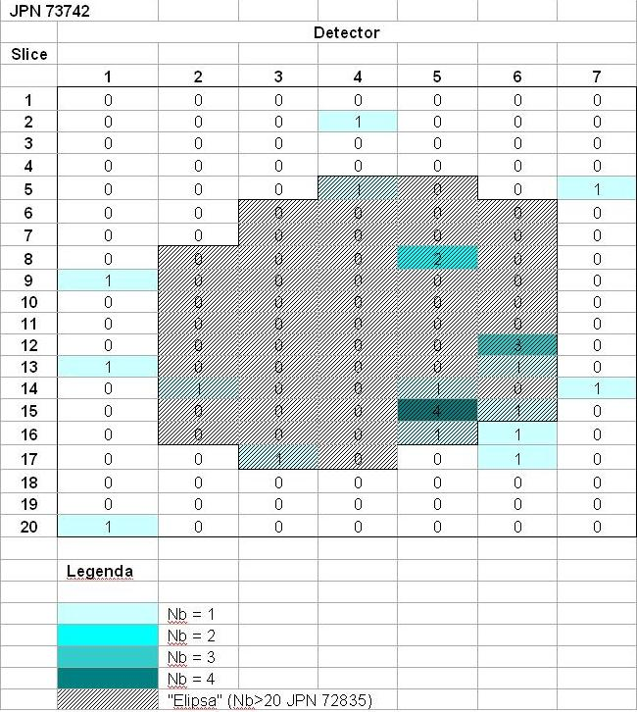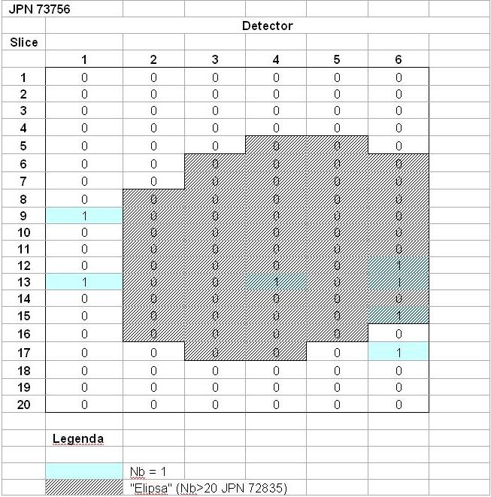
Figure 4. Distribution of the neutron flux (Nb= number of bubbles per area element; “Elipsa” = contour of the “neutron spot” determined for pulse JPN 72835).

The radial distribution of the neutron fluence using BD-PND-type detectors for three pulses in session 11.07.2008L, for different pre-collimator openings is shown in Figure 5.
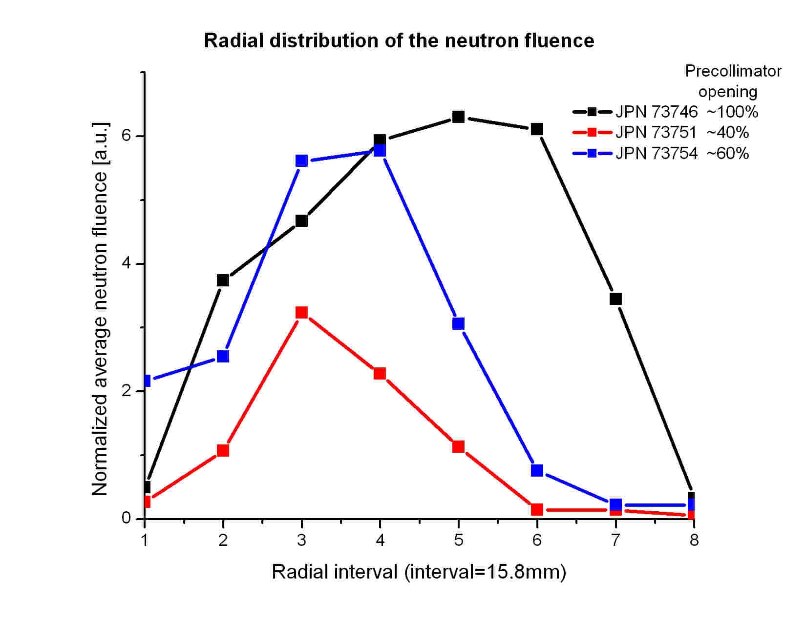
Figure 5. Radial distribution of the neutron fluence

The dependence of the radial profile on the pre-collimator opening (Figure 5) shows that the bubble detector array configuration operates as a neutron pinhole camera. From the geometry of the experimental setup it follows that this neutron “pinhole camera” has a magnification of about 3.5. It means that the bubble detector array can provide a spatial (radial) resolution of approximately 55 mm at the vacuum chamber mid-plane.

3. Comparison between simultaneous independent neutron measurements
A comparison between TOFOR and bubble detector neutron measurements of neutron flux per pulse was done for six pulses in session 11.07.2008L.
The number of neutrons detected by the calibrated bubble detector array was calculated by integrating the fluence distribution over the determined “neutron spot” area (the so-called “Area integrated fluence”, AIF). The area integrated fluence was plotted against the TOFOR neutron flux (the number of neutrons estimated to have entered the TOFOR line-of-sight). The result is shown in Figure 6. A linear fit with a correlation factor of ~ 0.92 was obtained.

Figure 6. Area integrated fluence (AIF) versus the TOFOR flux (six pulses) for session 11.07.2008L

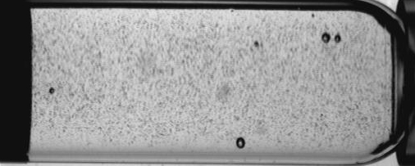
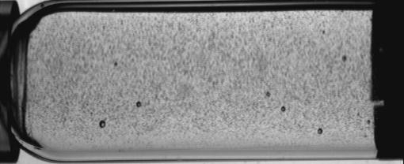
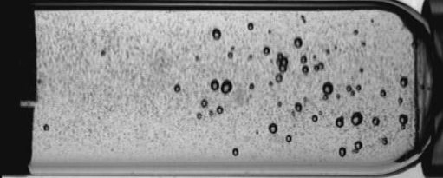
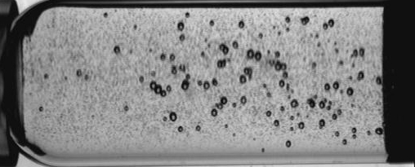
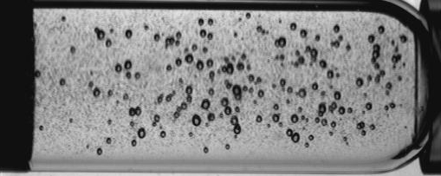
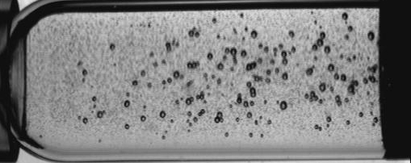
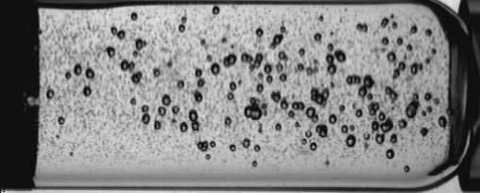
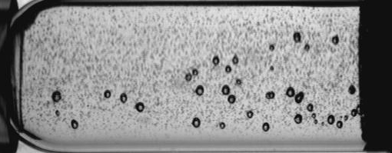
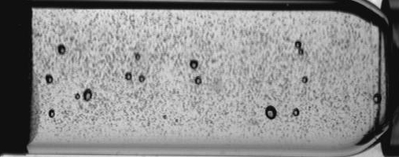
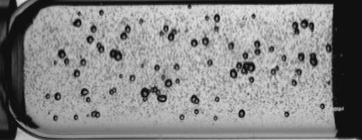
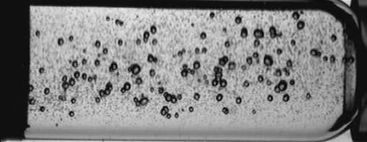
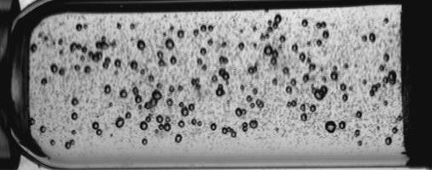
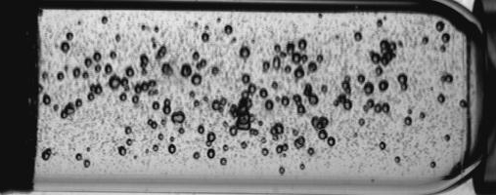
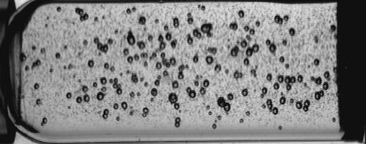
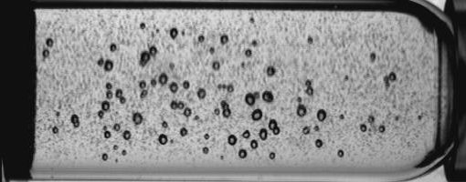
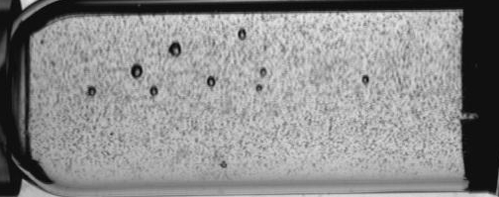
The rather low correlation factor is due to the point representing the neutron flux for JPN 73743 in which the detector scan shows that the bubble detectors array in that pulse was obviously misaligned (Figure 7).
JPN 73746
BD-PND No.
1
BD-PND No.
2
BD-PND No.
3
BD-PND No.
4
BD-PND No.
5
BD-PND No.
6
BD-PND No.
7
BD-PND No.
8
JPN 73743

Figure 7. Bubble detector scan comparison for JPN 73743 (misaligned) and 73746 (properly aligned)
After taking out the data for JPN 73743 a new plot was obtained (Figure 8) and it shows a linear fit with a better correlation factor of 0.987 (Figure 8).

Figure 8. Area integrated fluence (AIF) versus the TOFOR flux (five pulses) for session 11.07.2008L

5.3. Conclusion
Measurements on the neutron field characteristics for JET high performance discharges have been carried out by means of super-heated fluid detectors (“bubble detectors”) on a number of 18 JET pulses during campaigns C20b and C21 [5].
Spatial (radial and toroidal) distributions of the neutron fluence at the end of the KM11 neutron line-of-sight have been obtained by measurements performed during the two experimental sessions of 20.05.2008. The operation of the bubble detector array as a neutron pinhole camera having a radial resolution at the vacuum chamber mid-plane of about 55 mm was clearly demonstrated in measurements using various openings of the KM11 pre-collimator. The comparison of the area integrated fluence determined by means of the bubble detector array with the TOFOR neutron flux has shown a good correlation factor of about 0.99.

Acknowledgements
The work presented in this report was only partly funded by the contract no. 1EU/08.08.2008. Most of the expenditures necessary for the acquisition of the hardware and software, as well for the manpower were covered from funds made available at the level of the National Institute for Laser, Plasma, and Radiation Physics and of the Plasma Physics and Nuclear Fusion Department. The authors would like to gratefully acknowledge the support of Dr. R. Medianu, general director of NILPRP, and Dr. C. Ruset, department head. Under the conditions in which the first funds from contract 1EU/08.08.2008 became available at the beginning of November 2008, none of the work reported here would have been possible without this support.
The reported work includes contributions from the following people outside the MEdC Association: T. Edlington, V. Kiptily, S. Popovichev (Association EURATOM-UKAEA, Culham Science Centre, Abingdon, UK), S. Conroy, M. Gatu Johnson, C. Hellensen (Association EURATOM-VR, Uppsala University, Uppsala, Sweden), S. Jednorog, R. Prokopowicz, M. Scholz (Association EURATOM-IPPLM, Institute of Plasma Physics and Laser Microfusion, Warsaw, Poland) and A. Murari (Association EURATOM-ENEA, RFX, Padova, Italy).
References:
[1] A. Murari, T. Edlington, M. Angelone, L. Bertalot, I. Bolshakova, G. Bonheure, J. Brzozowski, V. Coccorese, R. Holyaka, V. Kiptily, I. Lengar, P. Morgan, M. Pillon, S. Popovichev, P. Prior, R. Prokopowicz, A. Quercia, M. Rubel, M. Santala, A. Shevelev, B. Syme, G.Vagliasindi, R.Villari, V.L. Zoita and JET-EFDA Contributors, “Recent Diagnostic Related Radiation Hardness Studies at JET”, International workshop on ITER-LMJ-NIF components in harsh environments, Aix-en-Provence France, 2007.
[2] M. Gherendi, V. Kiptily, V. Zoita, S. Conroy, T. Edlington, D. Falie, A. Murari, A. Pantea, S. Popovichev, M. Santala, S. Soare and JET-EFDA contributors, “Super-heated fluid detectors for neutron measurements at JET”, J. Optoelectronics Advanced Mat., 10 (2008) 2092-2094.
[3] V. Zoita, M. Gherendi, A. Pantea, V. Kiptily, S. Popovichev, M. Scholz, A. Szydlowski, I. Lengar, "Determination of neutron field characteristics for high yield discharges", Presentation to Task Force Diagnostics Meeting, JET, Culham, November 15th, 2007.
[4] V. Zoita, D. Falie, M.Gherendi, A. Pantea, S. Soare, V. Kiptily, S. Popovichev, A. Murari, S. Conroy, "Super-heated fluid detectors (“bubble detectors”) for neutron measurements at JET", Presentation to Task Force Diagnostics/Task Force Heating Joint Meeting, JET, Culham, January 29th, 2008.
[5] V.L. Zoita, T. Craciunescu, M. Gherendi, A. Pantea, A. Patran, T. Edlington, V. Kiptily, S. Popovichev, S. Conroy, M. Gatu Johnson, C. Hellensen, S. Jednorog, R. Prokopowicz, M. Scholz, A. Murari, G. Gros, "Determination of neutron field characteristics for high performance discharges (Experiment D-1.5.2)", Presentation to Task Force Diagnostics Meeting, JET, Culham, November 27th, 2008.

 All detectors used in this work were manufactured and calibrated by Bubble Technology Industries, Chalk River, Canada


