6. TUNGSTEN EROSION IN THE JET DIVERTOR

Cristian Ruset, Eduard Grigore, Ion Munteanu, Nicolae Budica
National Institute for Lasers, Plasma and Radiation Physics, Magurele

6.1. OBJECTIVE
The objective of the project is to measure the net erosion of tungsten on the divertor tiles. Tiles 6, 7, 8 and the lamellas of the load-bearing septum replacement plate (LBSRP) have been chosen for this investigation. The method which will be used is that of W markers. The marker layers consist of a tungsten layer at the surface with a thickness of about 5 µm and a molybdenum interlayer with a thickness of about 7 µm. The layers will be deposited at MEdC and then they will be analyzed with ion beam analysis methods at IPP Garching before and after exposure at JET. Six tiles and six W lamellas will be coated with W markers and then they will be installed in JET at different positions.

6.2. RESULTS AND DISCUSSIONS
In order to optimize the processing parameters for both production and analysis of the W markers the first experiments were carried out with small samples (~ 10 x 20 x 1.2 mm) of different materials: CFC, CFC coated with 12 μm Re/W multilayer, fine grain graphite (polished and unpolished) and W.
Two sets of such samples were coated with W markers using the Combined Magnetron Sputtering and Ion Implantation (CMSII) technology. They are shown in Fig.1.

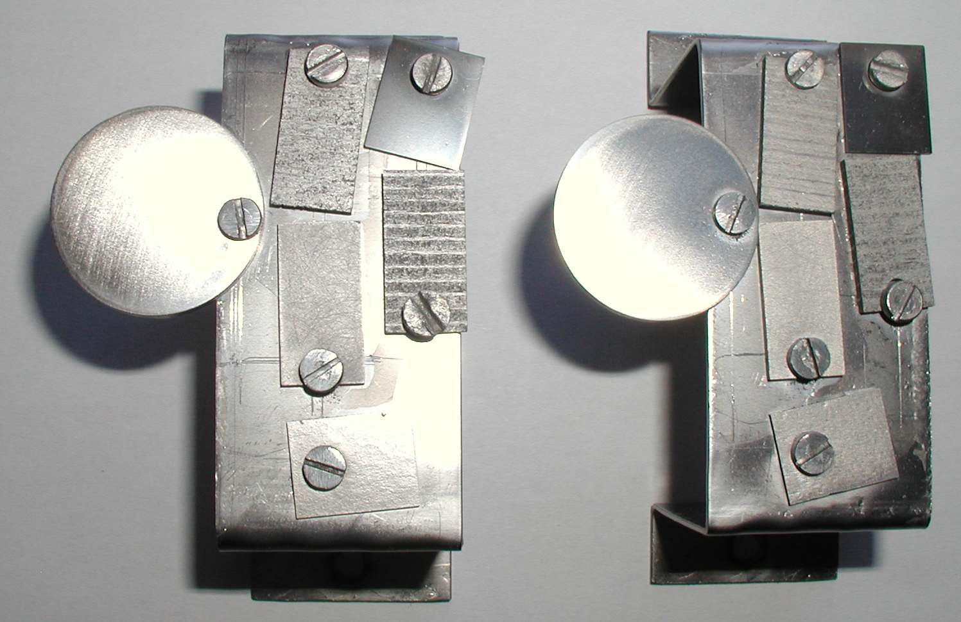
Fig.1 Tungsten markers deposited on various substrates by CMSII technology

The small samples were accompanied by two Ti samples (Φ30 x 4 mm) which are used for Glow Discharge Optical Spectrometry (GDOS) analysis. This method provides useful information on the distribution of the chemical constituents within the coatings. The GDOS depth profiles for W, Mo, Ti, C and O concentrations are shown in Fig. 2. It can be seen the Mo interlayer with a thickness of ~ 8 μm and the W coating of approx. 5.5 μm. The carbon concentration do not exceed 10 at.% at the surface and drops to zero into the coating. A little bit of carbon was also detected at the Ti-Mo interface. This comes from the usual contamination of the surface. Very little oxygen was detected. This is in agreement with the results obtained with a Residual Gas Analyzer (HAL 200 provided by Hiden Analytical) when the composition of the deposition atmosphere was investigated. Under normal conditions this atmosphere contains 99.97% argon and 0.03% oxygen.
The coated samples were sent to IPP Garching for investigation.

A close contact has been kept between MEdC Association and IPP Garching. Dr. Cristian Ruset, Romanian responsible officer for this project, remotely participated to the Kick-Off and progress meetings of the project.

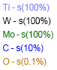 | 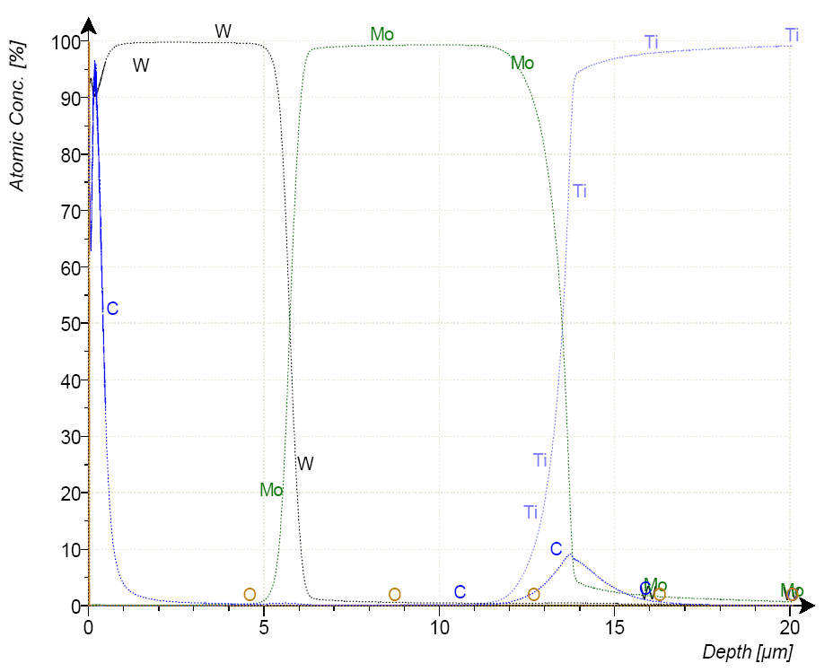
Fig. 2. The GDOS depth profiles of the constituents of the W markers

6.4. CONCLUSIONS
The current status of the project can be summarized as follows:
- MEdC fulfilled its task concerning optimization of the coating parameters and producing of W markers on samples of various materials.
- Since the strategy for W coating of divertor tiles was changed, the Mo/W markers could not be applied on the real divertor tiles yet. The application of the markers on real G6, G7 and G8 tiles will be re-define in agreement with the new W coating strategy for these tiles.
- According to the last version of the Task Agreement the due date for markers coating of the divertor tiles and their analysis is 30 September 2009.

