IV. TEHNOLOGICAL TASKS

1. Manufacturing and testing of W-coated CFC tiles for installation in JET for the ITER-like Wall project [EFDA Task Agreement Code: JW6-TA-EP2-ILC-01]

Cristian Ruset, Eduard Grigore, Ion Munteanu, Nicolae Budica, Daniela Nendrean
National Institute for Lasers, Plasma and Radiation Physics, Magurele

1.1. INTRODUCTION
Currently, the primary ITER materials choice is a full beryllium main wall with CFC (carbon fibre composite) at the strike points and tungsten at divertor baffles and dome. Since this combination has never been tested in a tokamak, ITER-like Wall project has been launched at JET (Joint European Torus) with the aim to replace the actual CFC first wall with a new one, comprising the same materials choice as it planned for ITER. In the R&D phase of this project (EFDA Task Agreement Code: JW6-TA-EP2-ILC-01) it was demonstrated that W coatings deposited on CFC by Combined Magnetron Sputtering and Ion Implantation (CMSII) technology exhibited superior thermo-mechanical properties in comparison with other W coatings deposited by conventional PVD and CVD techniques. Consequently, this technology was selected for 10 μm W coating of about 1,000 tiles, of different size and dimensions, under industrial conditions.

1.2. OBJECTIVES
The main objective of the present project is coating with 10 µm W approx ~ 1,000 CFC tiles for installation in JET. In order to achieve this objective new coating equipment was designed and built in 2007. Commissioning of this equipment was started in 2007 and was finished in 2008.

1.3. RESULTS AND DISCUSSIONS
1.3.1. Commissioning of the new coating CMSII equipment.
Schematic representation and the general view of the coating equipment are shown in Fig.1. The deposition chamber, made of stainless steel with double wall for water cooling, has an inner diameter of 800 mm and a height of 750 mm. Twenty-four magnetrons are positioned inside the chamber in 8 columns of 3 magnetrons each. By this way a usable volume Φ 420 x 370 mm is provided.
The magnetrons are energized by an 18 channel DC power supply with a total power of 25 kW. The current intensity for each channel is stabilized (±1%) and can be adjusted independently in the range of 0.3 – 2.5 A. Arc suppression devices are installed to each channel.
Due to the high innovative character of this equipment and to relative high power, commissioning was carried out very carefully, step by step. Initially, only 2 columns (one with Mo and the other one with W) were alternatively energized. An image of the discharge with three magnetrons running is shown in Fig.2. Then other two columns were energized. Six magnetrons running simultaneously are shown in Fig.3. At this stage, the research was focused on two objectives: plasma stability and the quality of the W coating. The configuration of the magnetic field of the magnetrons was optimized and stable plasma was produced in the deposition area. In first experiments small delaminations appeared in particular zones of the deposition area. This phenomenon was associated with the high internal stress induced into the coating deposited in those zones. The problem was solved by improving the geometry of the magnetrons. As a result of this improvement no blisters or delaminations were detected on the W coating. The remaining magnetrons were also energized.

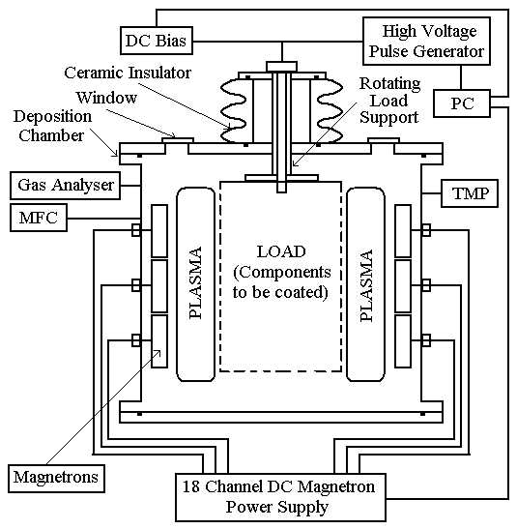(a) | 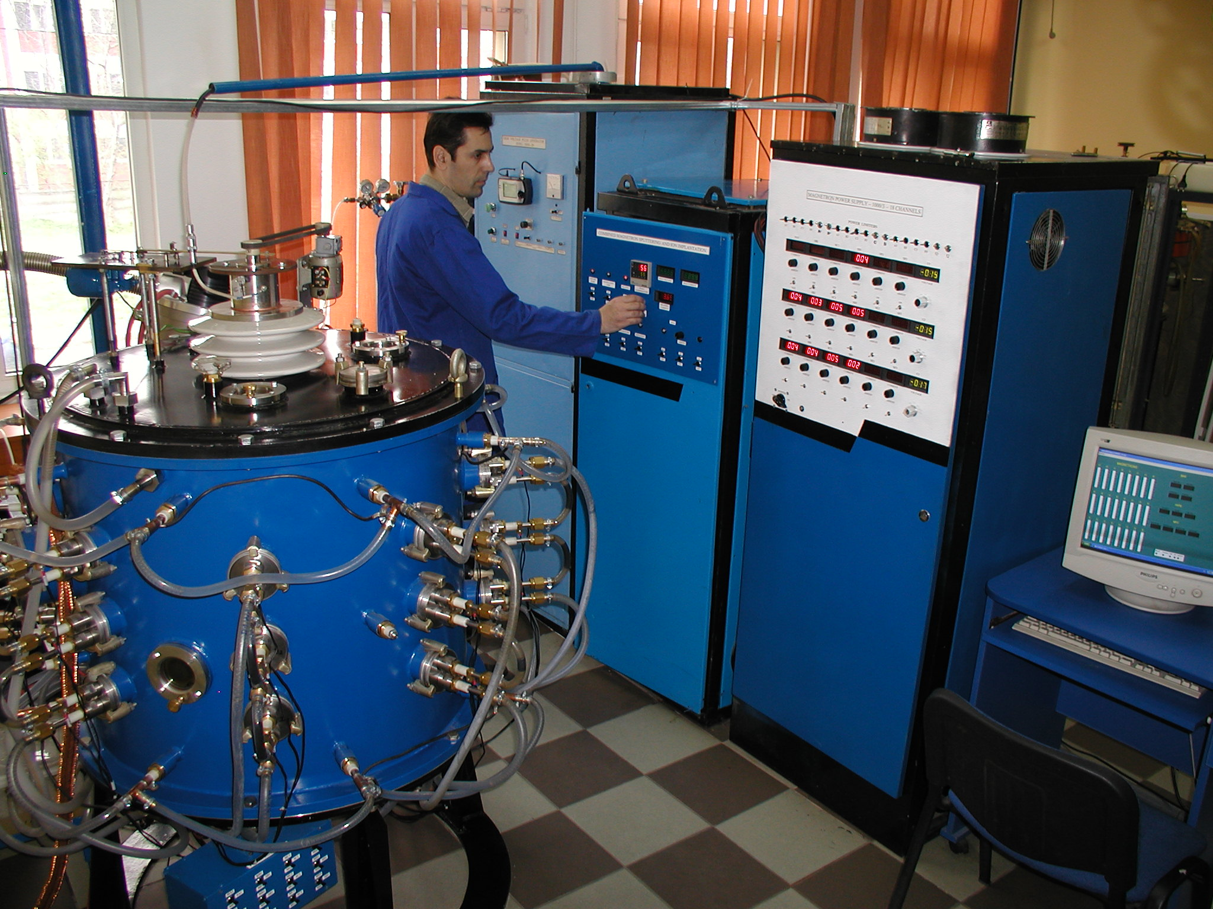  (b)
Fig. 1 CMSII coating equipment: schematic representation (a) and general view (b)

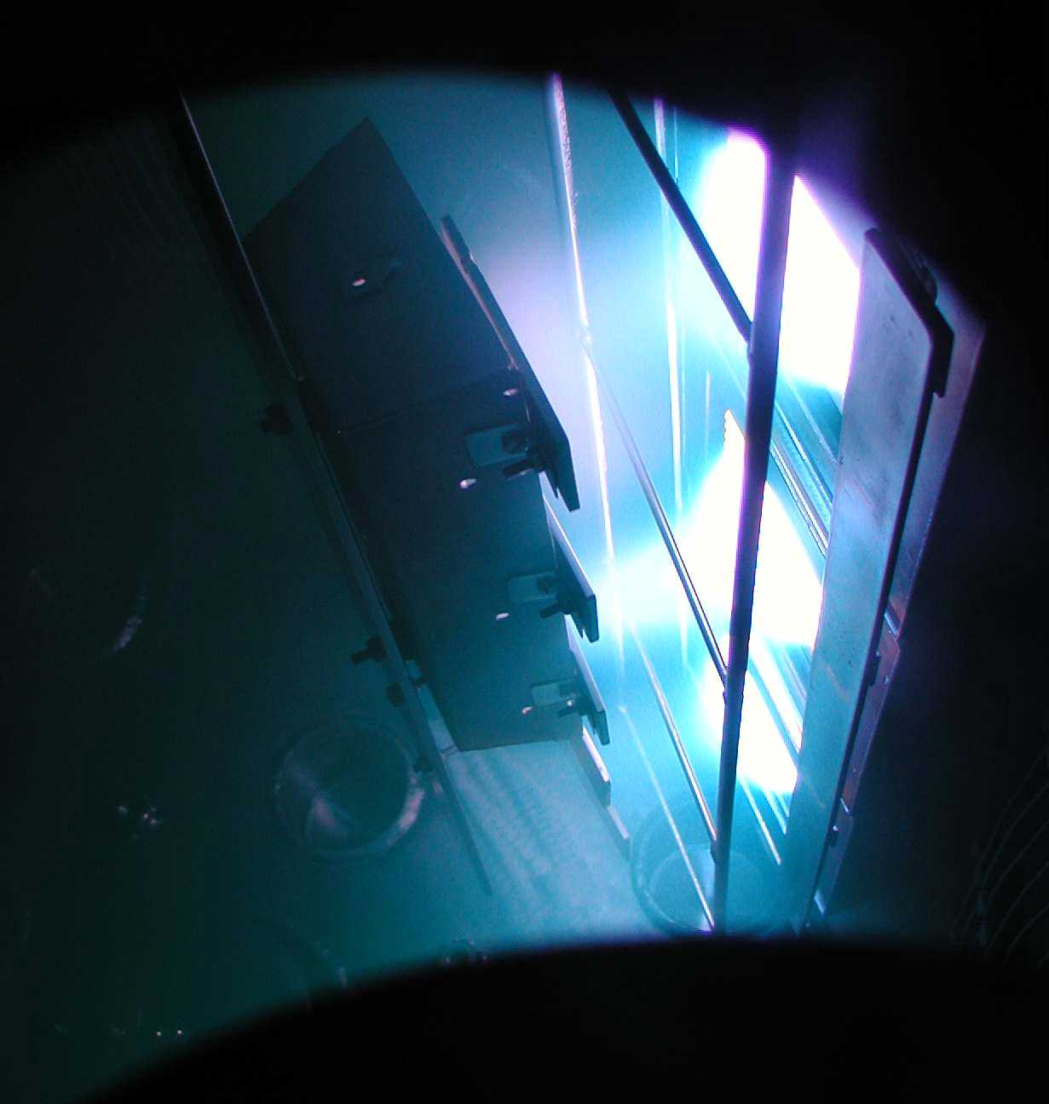 | 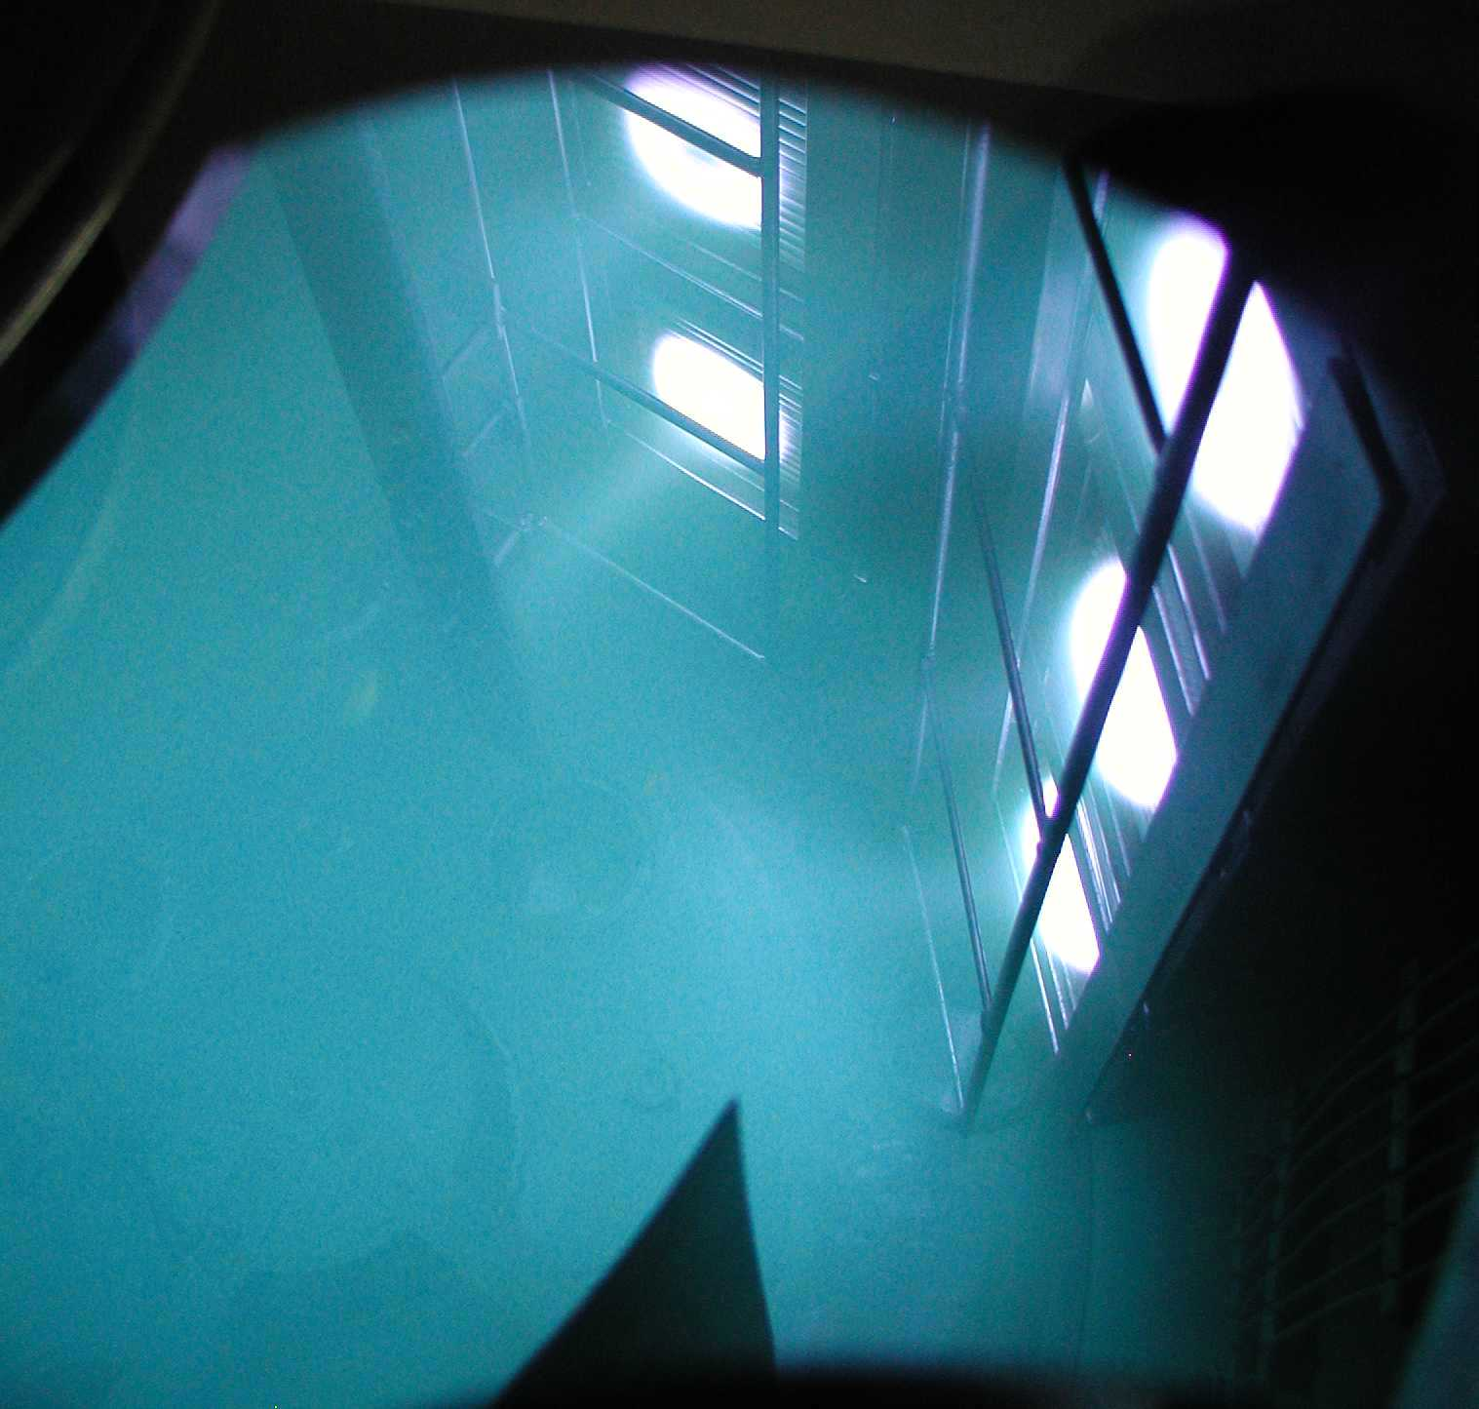
Fig.2 CMSII discharge with 3 magnetrons running | Fig.3 CMSII discharge with 6 magnetrons running

1.3.2. Jigging devices
In order to produce uniform coatings on the CFC tiles, they have to be moved in front of the magnetrons. Three jigging devices were developed for this purpose. Depending on the tiles geometry and on the requirements concerning the W coating uniformity, one of these devices is used. In Fig.4 the device with two axes is shown. It provides a good coating uniformity both on the front and on the side of the tiles. The maximum acceptable width of tiles for this device is 120 mm. The tiles to be coated are positioned on “L” shape stainless steel holders and they are rotated initially in front of the 12 magnetrons loaded with Mo and then in front of the other 12 magnetrons loaded with W. The magnetrons with Mo and W are energized alternatively. By this way the full W coating including the Mo interlayer is produced in one cycle. For large tiles with a width up to 220 mm a jigging device with central rotation is used (Fig.5). It provides a good productivity (up to 0.3 m2/cycle), but the coating thickness on the side of the tiles is ~ 70 % of that produced on the front of the tiles. This is generally accepted since for most tiles the coating thickness may reduce to zero on sides. When a small number of tiles have to be coated it is possible to do this by using two or four magnetron columns and to oscillate the tiles in front of the magnetrons loaded with Mo or W. The oscillating jigging device allows performing the coating with minimum consumption of W and Mo. The maximum height of the coating area is 370 mm for all devices. In this case the coating thickness can vary in the range of ± 10%.

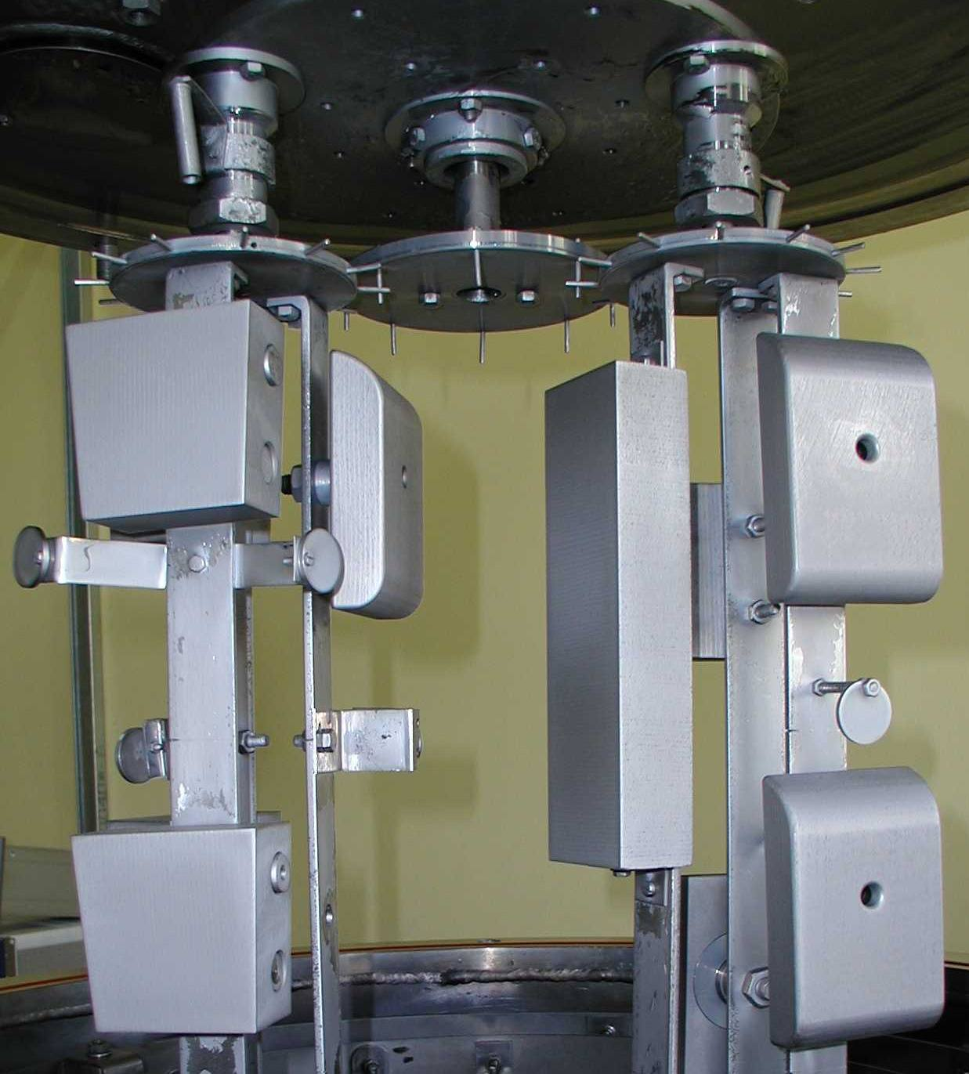 | 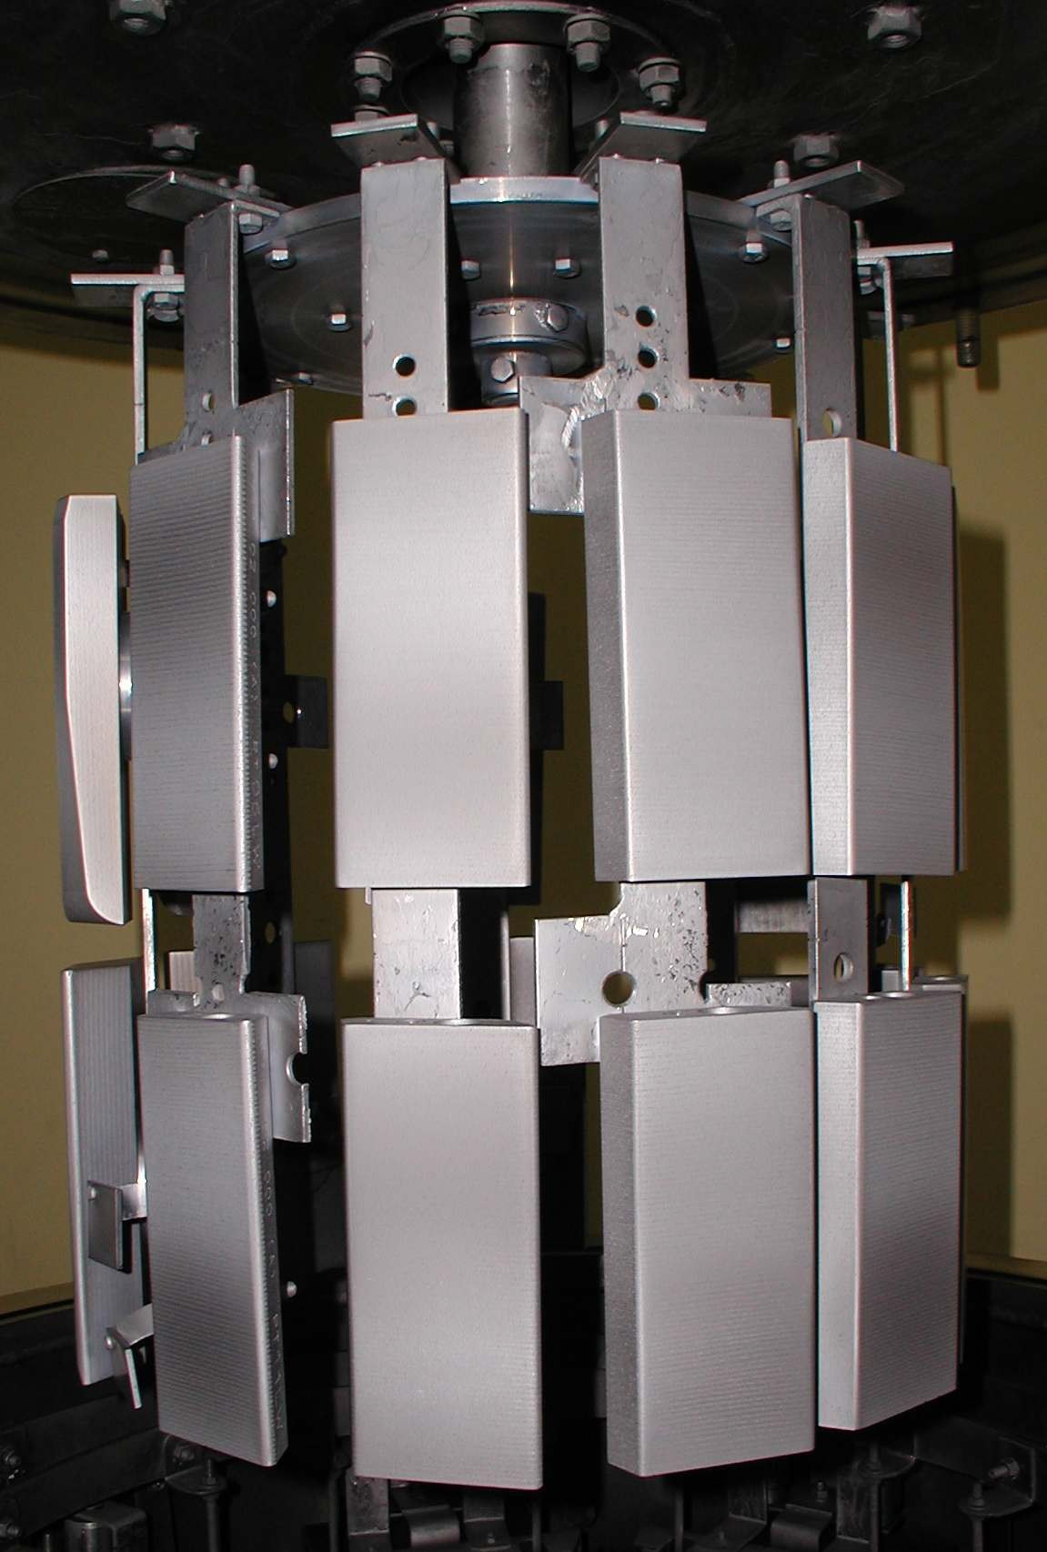
Fig.4 Jigging device with two axes | Fig.5 Jigging device with central rotation

1.3.3. Qualification of the CMSII – 10 μm W coating technology
In accordance with the Task Agreement, before starting the production of the W coating on CFC tiles the coating technology must be qualified. The qualification process involves two stages: experimental coating and prototype coating. Besides the standard QA measurements performed by the Glow Discharge Optical Spectrometry (GDOS) analyses (coating thickness and impurities concentrations), the qualification requires high heat flux (HHF) tests in hydrogen ion beam GLADIS facility at the IPP Garching.
Two lots of experimental coatings (6 + 12 Off), both perpendicular and parallel to fibre planes, have been tested in GLADIS during the January and June campaigns. The W-coated samples are shown in Fig.6. The thermal loading conditions were: 100 pulses at 16.5 MW/m2-1.5 s for coatings perpendicular to fibre planes and 100 pulses at 4.0 MW/m2-2.5 s for coatings parallel to fibre planes. The surface temperature was around 1.600 °C. The tests were successfully; no blisters or delaminations of the coatings were detected after thermal loading. Two pictures of the CFC tiles during the HHF tests are shown in Fig.6.
There are 11 types of CFC tiles which have to be W-coated and installed in the main chamber of JET. Only 8 types of these tiles require prototype coating. By 31.12.2008 a first lot of 70 Off Inner Wall Cladding tiles have been received from JET. Six of these tiles have been coated as prototype lot. They are shown in Fig.7. A number of 6 Ti samples (30 x 25 x 3 mm) were introduced into the load, in particular locations, with the aim to monitor the coating thickness in those locations. As the GDOS results show, the coating thickness non-uniformity, including the side round edges, is in the range of ± 10%. This value is in agreement with the Specification for 10 μm W coating of CFC tiles for JET. The prototype coated tiles were successfully tested in GLADIS at IPP Garching. Consequently, the qualification of the coating technology for Inner Wall Cladding tiles was accomplished and the coating production could start.

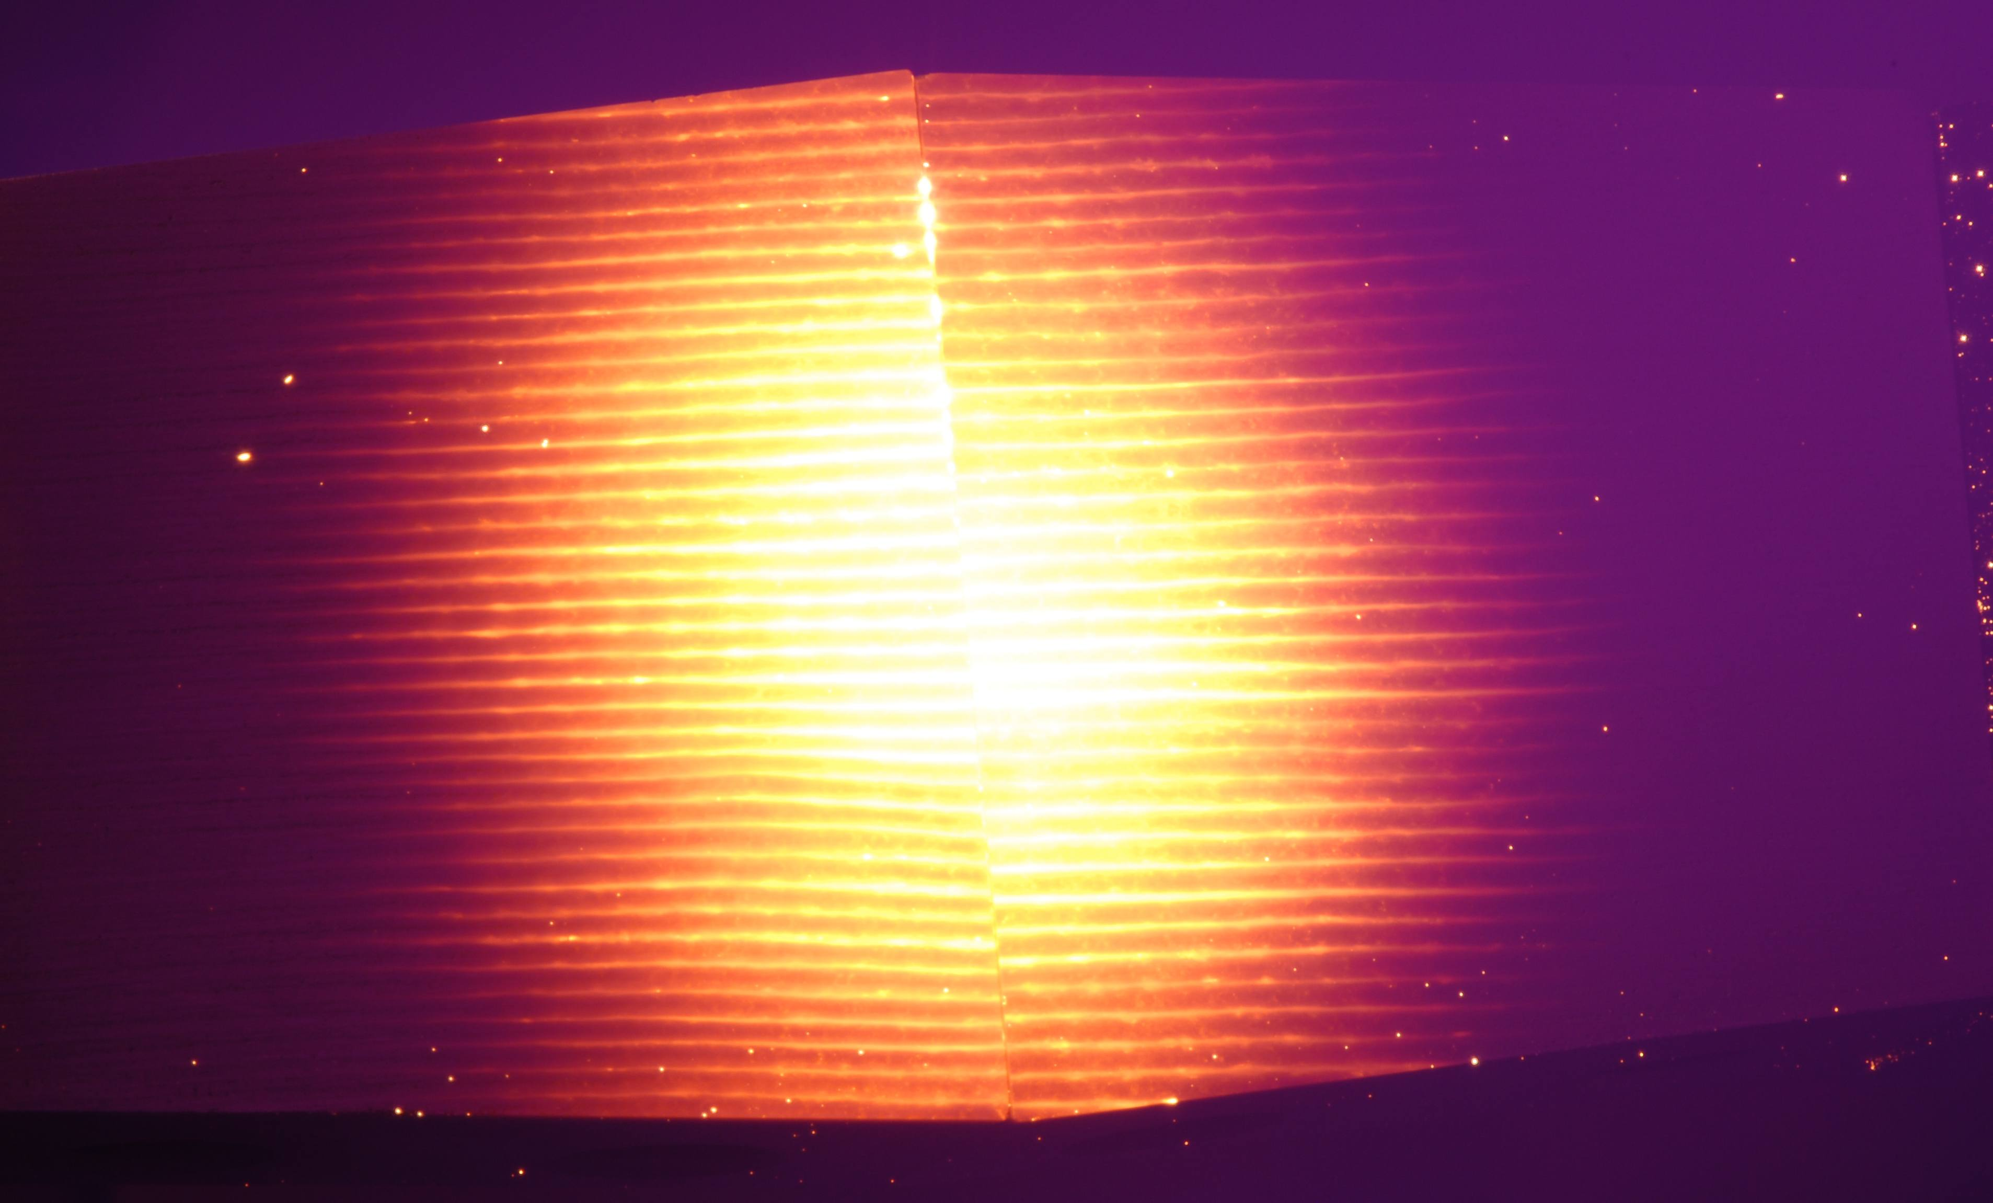  (a) | 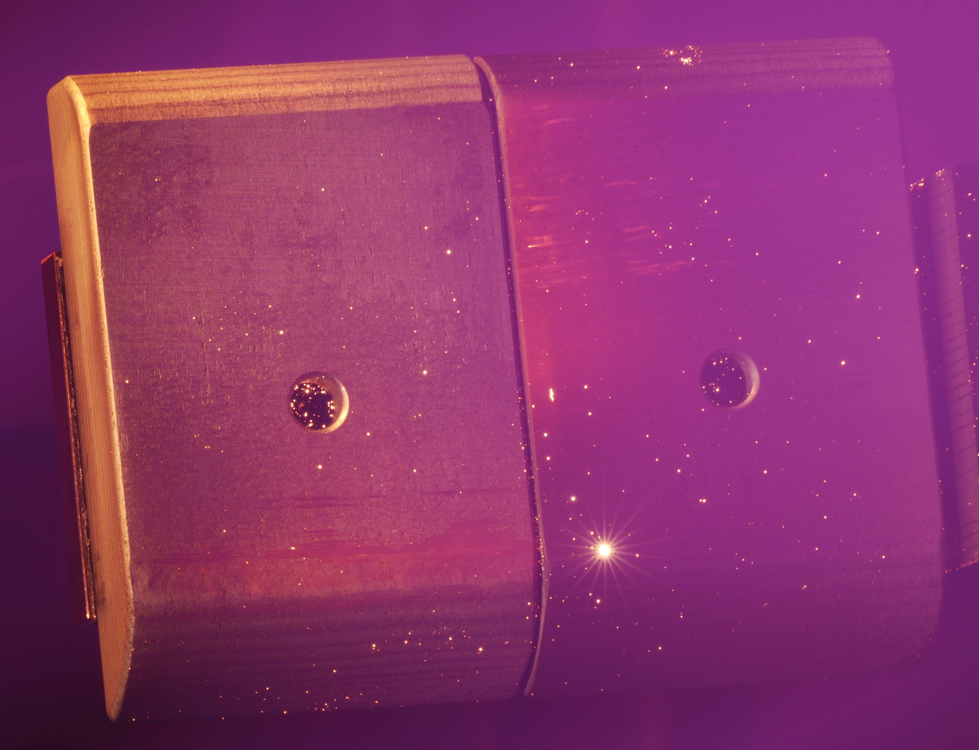  (b)
Fig.6 W coated CFC tiles perpendicular to fiber planes (a) and parallel to fiber planes (b) under HHF tests (GLADIS ion beam equipment)

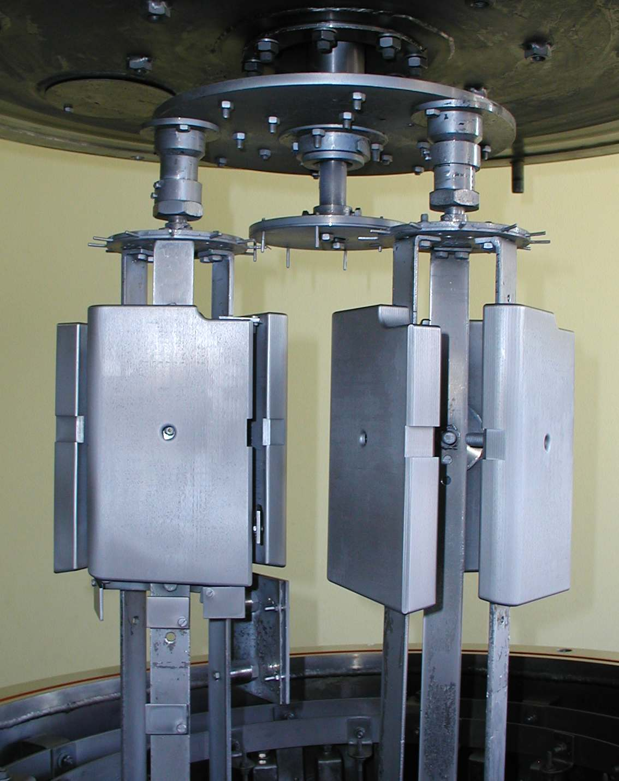
Fig.7 Inner Wall Cladding prototypes after W coating

1.3.4. Serial production of 10 μm W coating for Inner Wall Cladding tiles
The serial production of 10 μm W coating for Inner Wall Cladding tiles started, but it was it was stopped after 2 runs because of low efficiency. The deposition chamber was loaded at about 65% while the W and Mo consumption was 100%. It was established together with the project leader to suspend the coating production until Shinethrough protection tiles will be delivered from JET. Some of these tiles were small enough to be associated with Inner Wall Cladding tiles in the same batch increasing by this way the efficiency of the coating process close to 100%.

1.4. Conclusions
Due to significant delay in manufacturing of the CFC tiles for JET wall, the project was extended till 31.12.2009 by a new Task Agreement.
All the tasks of the MEdC Association for 2008, in the framework of the Task Agreement were fulfilled. Industrial coating equipment based on CMSII deposition method was designed, manufactured and commissioned. The coating technology was qualified for Inner Wall Cladding tiles, the only tiles received from JET.

1.5. Collaborative actions
A close cooperation with IPP Garching and JET occurred. Technical aspects concerning the HHF test parameters and their correlation with the W coating characteristics have been discussed. C.Ruset attended the two Project Board and the associated technical meetings at JET.

6. Publications
[1] C. Ruset, E. Grigore, I. Munteanu, H. Maier, H. Greuner, C. Hopf, V. Phylipps, G. Matthews, JET-EFDA Contributors, Industrial scale 10μm W coating of CFC tiles for ITER-like Wall Project at JET, 25th Symposium on Fusion Technology, 15-19 September, 2008, Rostock, Germany, Fusion Engineering and Design (in press).

