3. Update OF ITER ISS-WDS Process Design - 2

A. Lazar*, S. Brad*, N. Sofalca*, M. Vijulie*
I.Cristescu**,L. Dör**, W. Wurster**
*National Institute for Cryogenics and Isotopes Technologies (ICIT), Rm. Valcea, Romania
**Forshungszentrum Karlsruhe – Tritium Laboratory, Germany

3.1. Introduction
The isotope separation system utilizes cryogenic distillation and catalytic reaction for isotope exchange to separate elemental hydrogen isotope gas mixtures.
The ISS shall separate hydrogen isotope mixtures from two sources to produce up to five different products. These are: protium effluent for discharge to the atmosphere, deuterium for fuelling, deuterium for NB injector (NBI) source gas, 50 % and 90% T fuelling streams [1].
The concept of equipment 3D layout for the ISS main components were developed using the Part Design, Assembly Design, Piping Design, Equipment Arrangement and Plant Layout application from CATIA V5 and the rules from the “PRM and Standard Parts Catalogues in CATIA V5 for Tritium containing Systems and Components” report [2].
The 3D conceptual layouts for ISS system were created having as reference the DDD _32_B report [1], the drawings 0028.0001.2D. 0100. R “Process Flow Diagram” [1]; 0029.0001.2D. 0200.R “Process Instrumentation Diagram -1” (in the cold box) [1]; 0030.0001.2D. 0100. R “Process Instrumentation Diagram -2” [1] (in the hard shell confinement) and imputes from TLK team.

3.2. Hydrogen Isotope Separation System (ISS) Arrangement
The main components designed for ISS are: ISS cold box system (CB) with cryogenic distillation columns (CD) and recovery heat exchangers (HX), ISS hard shell containment (HSC) system with metals bellow pumps (MB) and chemical equilibrators (RC), valve box system, instrumentation box system, vacuum system and hydrogen expansion vessels [3]. The 3D layouts were created having as reference the DDD _32_B report [1] and the inputs from TLK team.
The ISS system will be located at level four (L4) in the Tritium Building [3].
Figure 1 shows the main components of the system with transparent wall for CB and HSC. The space allocated for the system is:
L x l x H =13m x 8m x 9m.
The refrigerating system, helium compressor and helium purification unit are not represented in this layout. The refrigerating system is located at level three (L3) and the helium compressor and purification unit at second level (L2) in the TP building [3].
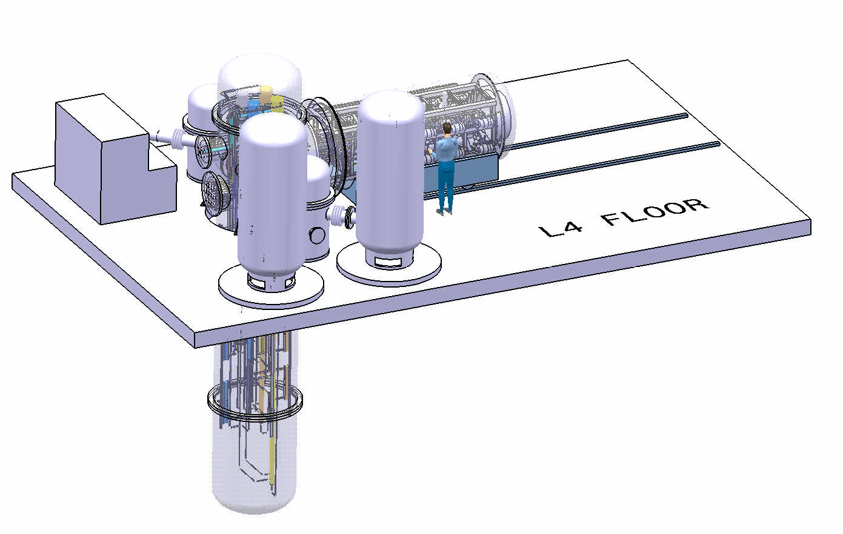
Valve BOX
CB Head
HSC
Instrumentation Box
Fixed CB
Lower CB
Vacuum Pumps Skid
Hydrogen expansion vessels

Figure 1. Hydrogen Isotopes System (ISS) Arrangement

3.3. Cold Box System Arrangement
The cold box is a vertical vacuum vessel, having the function to reduce heat ingress to the distillation columns and serves as secondary confinement. It has two sections: fixed cold box and lower cold box. The cold box weight will be supported on the level four (L4) floor.
The upper cold box is fixed and connected with the HSC through the bolted but seal-welded flanges. A shared wall separates the two confinement spaces one from each other. It has also a removable head connected with flanges for access to the maintenance for the CD columns condenser. The upper cod box is mounted on a support and fixed on the floor. It carries both the HSC content support structure and the cold box content-carrying internal structure. All cold box contents are mounted though appropriate structural supports which itself will be fastened on this upper cold box. There is a special devices installed to assure verticality of the columns. All flanges and tube penetrations are seal welded to eliminate atmospheric leaks into the cold box. Also all penetrations for process piping, sensing lines and wiring are lead through the sidewall nozzles. The nozzles made the connection between the cold box and the HSC system, the refrigerating system, vacuum pump system, valve box, instrumentation box, electrical connection and technological lines.
The four refrigerant supply line connections and one return line can be seen on the nozzle for connecting with refrigerating system. These are supplies from the top left in clock turn order from CD1, CD4, CD3 and CD2 and return line in centre of the nozzle.
On the valve box connection nozzle the following relief line can be identified: relief line for CD1, relief line for CD2, relief line for CD3, relief line for CD4.
On the nozzle for technological line the following line can be identified: tritium-carrying hydrogen product from the WDS line, ISS top product stream of H2 gas line, D2 (NB Injection) line, Plasma Exhaust feed line, DT (50%) product to SDS line, T2 (90 %) product to SDS line, D2(T) product to SDS line and the four H₂ supply line for the CD1, CD2, CD3, CD4 condensers.
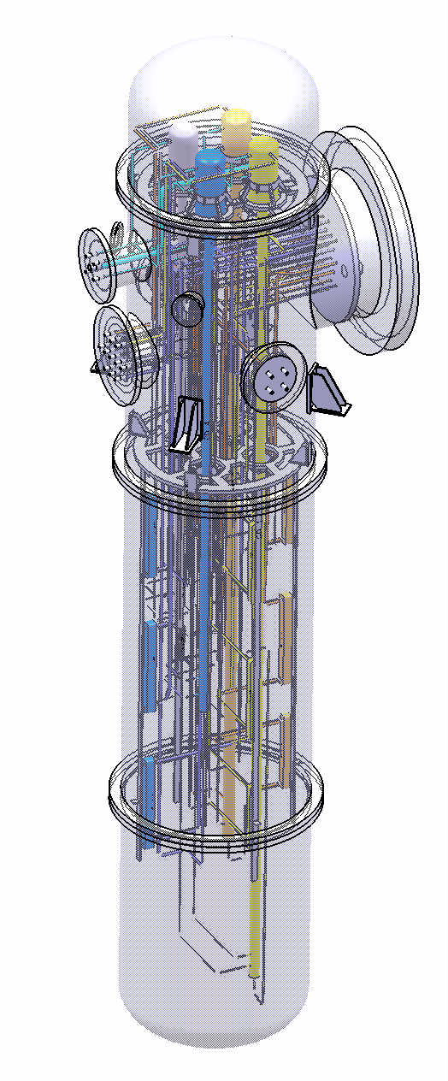
CD 3
CD 1
CD 2
CD 4
Nozzles for connection with HSC
Partition wall
Nozzles for connection with refrigerating system
Nozzles for connection with vacuum system
Nozzles for electrical connection
Nozzles for technological line
Nozzles for connection with valve box
Nozzles for connection with instrumentation box
HX-1-1002
HX-2-2001
HX-1-1004
HX-4-4003
HX-2-2003
HX-3-3001
HX-3-3003
HX-2-2002
HX-1-1001
HX-4-4003
HX-4-4001
HX-2-2004

Figure 2. Cold Box System Arrangement

The lower cold box is a plain bell-shaped vessel that can be removed without the need for disconnecting any of the process lines. The intent is to connect also the cold box evacuation system through the upper fixed cold box wall. If this is not possible this is the only connection to be connected to the lower shell, as it is not connected to the tritium process. The lower cold box shell is connected to the upper part to a bolted but seal-welded flange. It is made from two sections connected with bolted but seal-welded flange.
The four CD columns with the condensers and twelve heat recovery exchangers are located inside the cold box. The entire cascade operates with overhead recycles. The CD2 overhead is into CD1, CD3 and the CD4 overhead returns lead to CD2. This is highly advantageous as compared to a cascade with no recycles. Also, it is not possible to produce the NB injector quality product without the overhead return from CD3 to CD2. Inter-column flows are obtained though metal bellows doubly-contained pumps. All columns are fabricated from stainless steel tube and contain stainless steel packing and supports.
The compact plate-fin heat exchangers are constructed of brazed aluminum. These are connected with the distillation columns through thermal expansion compensated tubing. Since the connecting columns and tubing material is stainless steel, special transition pieces will be used. The joints will be located at a convenient straight part of the tubing runs. The piping between the exchanger and the joint will be aluminum and the piping outside of the heat exchanger part of the joint - stainless steel.
All cold piping in the cold box will have two fixed anchor points, one at the column and the second on the cold side of the heat exchanger. Piping on the warm side of the heat exchangers has larger diameter. It will be flexible as flexibility will be determined by its shape and it will be anchored at the HSC to cold box penetrations and at the hot end of the respective heat exchanger.
The cold box internals, mainly the CD columns and heat recovery exchangers, are leveled in relationship to the cold box. All cold box internals operating at cryogenic temperature are wrapped in approximately 60 layers of aluminized Mylar thermal radiation shield. The purpose if this is to minimize radiated heat gain from the ambient walls into the cold equipment and columns. The arrangements of the cold box internal parts were designed in terms of minimizing the length of interconnections, and taken into account to provide the adequate space for operation and maintenance. The material for the construction of the cold box vessel is 304L stainless steel. The cold box vessel is to be fabricated in accordance with the requirements of the ASME code, section VIII, division 1[4].

3.4. Hard Shell Containment System (HSC) Arrangement
The HSC system provides secondary confinement for the tritium handling components operating at ambient temperature. It will be constructed as a bell-shaped shell mounted in lateral part of the upper cold box section with flanges, in horizontal position. The internal structure for equipments is fixed on the upper part of cold box. The HSC shell is to be fabricated of type 304 stainless steel in accordance with the requirements of the ASME code, section VIII, division 1 [4]. For maintenance, the entire system will have to be exposed by removing the shell that will slide on a rail road system.
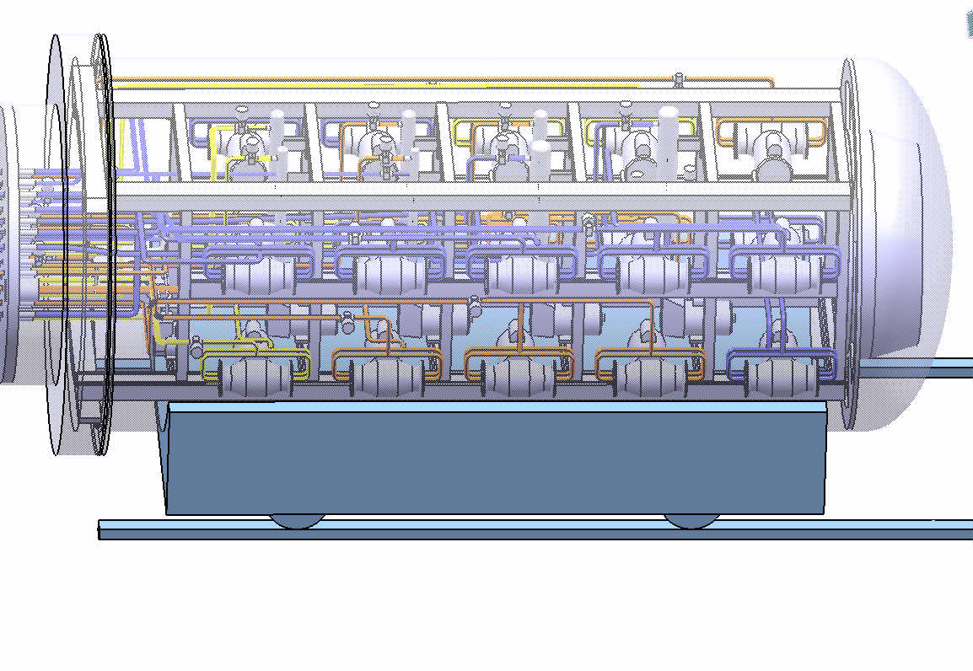
MB-118
RC-1-1001
RC-1-1002
RC-4-4001
RC-2-2001
RC-2-2003
RC-4-4002
RC-2-2002
Partition wall

MB-601
MB-302
Support Frame
Automatic Valve

Figure 3. Hard Shell Containment System (HSC) Arrangement

The internal system of HSC is composed by twenty six circulation metal bellows pump models MB-601, MB-118, MB-302 and seven catalytic equilibrators [3]. The cryogenic distillation columns are directly connected through the metal bellow pumps with the catalytic equilibrators (Eq), which are employed to split the mixed hydrogen isotopes into H2, D2 and T2, respectively. The ITER CD cascade has a total of seven equilibrators, one for the inter-column forward transfer lines to CD2, CD3 and CD4; one mid-column equilibrator in CD1 and CD2 and two in the CD4. The equilibrators use a small amount of Pt-on-alumina catalyst and must operate at room temperature for adequate reaction efficiency. The equilibrators are provided with heaters but these will be used only during commissioning or start after extended maintenance for humidity bake-out and will not be used during normal operation.
The contents of the HSC are mounted on a structure that is supported by the centre section. All pumps located in the HSC are rigidly mounted to this support frame. Tubing is rigidly mounted at the bottom at the point of penetrating the wall separating the cold box from the HSC. The rest of the individual loops are designed as flexible as possible. The purpose of this flexible joint is here to primarily isolate the tubing from the vibrations of the positive displacement pumps.

3.5. Valve Box
The valve box contains relief valves, automatic valves, manual valves and rupture disks. It is designed in vertical position with a removal head to gain access for maintenance work. To gain access to the relief valves the valve box head must be removed. In general the detailed design philosophy should be to locate penetrations in the fixed parts in order to avoid the need to disconnect any penetrating part in order to gain access to the maintained devices.

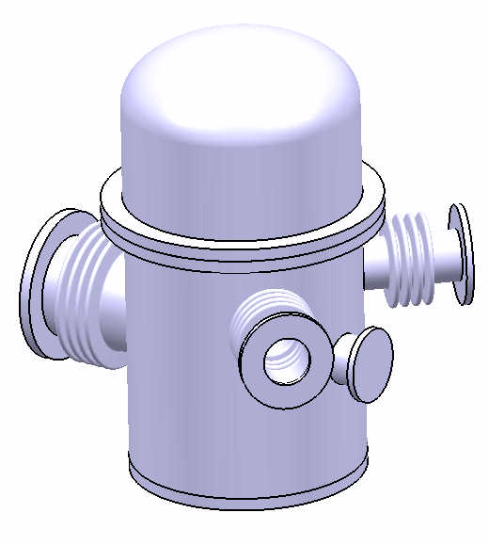
Nozzles for electrical connection
Valve Box Head
Flexible double-walled connection with CB
Valve Box
Flexible double-walled connection with hydrogen expansion vessels

Figure 4. Valve Box

It is connected to the fixed part of the cold box and to the hydrogen expansion vessels. A shared wall separates the valve box and the cold box one from each other.
The valve box is presented in Figure 4 and has the following dimensions: 1500 mm tall and 1000 mm in diameter.
The valve box shell is to be fabricated of type 304 stainless steel in accordance with the requirements of the ASME code, section VIII, division 1 [4].

3.6. Instrumentation Box
The instrumentation box contains the level and differential pressure transmitters and other instrumentation. It is designed in vertical position with a removal head to gain access for maintenance work. To gain access to the level and differential pressure transmitters and other instrumentation, the valve box head cover has to be removed. There will be considerable number of wiring and sampling connections penetrating this cover. It is connected to the fixes part of the cold box and separate with a shared wall.
The instrumentation box is presented in Figure 5 and has the following dimensions: 1500 mm tall and 1000 mm in diameter.
The instrumentation box shell is to be fabricated of type 304 stainless steel in accordance with the requirements of the ASME code, section VIII, division 1 [4].

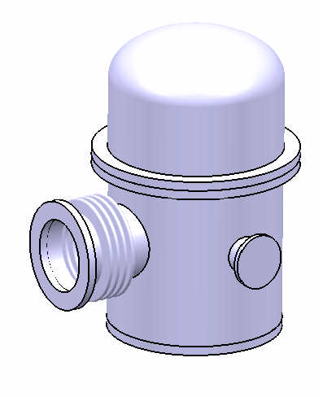
Nozzles for electrical connection
Flexible double-walled
connection with CB
Instrumentation Box Head
Instrumentation Box

Figure 5. Instrumentation Box

3.7. Hydrogen expansion vessels
The hydrogen expansions vessels are employed to contain all ISS contents including a safety margin at pressure below 280 kPa if all the column contents are evaporated and heated to ambient temperature. Under normal operation the tank is kept under vacuum. The expansion vessels will be connected with de valve box and separate with a shared wall. For removing gas from the expansion tank, the hydrogen contents would be processed though the TEP and the inert gas returned into the expansion tank.
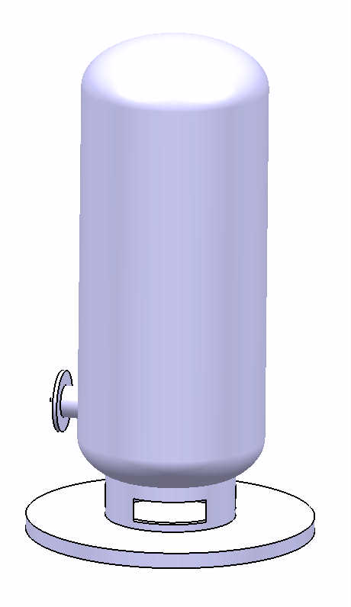
Hydrogen Expansion Vessels
Nozzles for connection with valve box

Figure 6. Hydrogen Expansion Vessels

The vessel is presented in Figure 6 and has the following dimensions: capacity 4 m³, 3000 mm tall and 1300 mm in diameter.
The vessels are to be fabricated of type 304 stainless steel in accordance with the requirements of the ASME code, section VIII, division 1 [4].

3.8. Vacuum system
The cold box has vacuum pumps for initial evacuation. When vacuum is established, the pump can be shut down and isolated. This will prevent releasing tritium during failure of the primary envelope within the cold box.
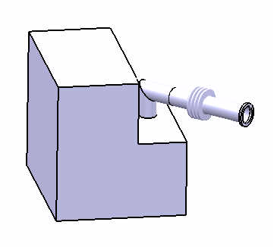
Vacuum Pumps Skid
Flexible connection with CB

Figure 7. Skid of the Vacuum System

The cold box vacuum pumps will be installed on a small skid. This will be mounted near the fixed-section and the vacuum lines will be attached to the fixed-section in order to minimize the need to remove any connection if the cold box shell is to be removed. For a seismically isolated ISS the vacuum pumps should be installed on the supporting frame that will have to be enlarged.
The vacuum pumps skid is presented in Figure 7 and has the following dimensions: 2000 mm tall, 1600 mm width and in 1600 mm length.

3.9. Collaborative work
Work related to these topics belongs to the task TW6-TTFD-TPI- 55-2 (Art.5.1b) from the EFDA Technology Work program 2006 and was done in collaboration with FZK Association team during the period January 2008 - October 2008.
Part of this work has been performed during the two-month Mobility Secondment of A. Lazar at Forshungszentrum Karlsruhe – Tritium Laboratory, Germany.

3.10. Conclusions:
The objective of this task is to update the designs of the ITER ISS as documented in the 2001 FDR (Final Design Report) taken into account the result and the recommendation of the FMEA report and experimental results from ongoing R&D tasks. Already during the preparation of the Design Description Document package for the final report of ITER 2001 a number of trades off between the Tritium Plant subsystems have been identified.
The CATIA V5 software was chosen to create layouts of plant sites by defining the buildings, the major areas, all the way down in the plant area, the path to the equipment and so on... Sub areas for facilities, and lines can then be created within the plant. The system allows a hierarchical approach including true partition of space with shared boundaries, areas with multi patches, and so on. Enable designers to reserve spaces, analyze area/volume allocations and optimize the general 3D layout of plants and equipment or piping lines placed in them. This can even be done for resources not yet designed [2].
The 3D conceptual layouts for ISS system has been developed based on the FDR 2001 report and the recommendation from the reports presented at Tritium Plant Project Team (TPPT) Meeting Cadarache, 8-10 October 2007 [5], [6], [7]. The arrangement of the constituent process systems, has been optimized in terms of minimizing the length of interconnections, and has taken into account provision of adequate space for operation and maintenance.

References
[1] Kveton O. K.,
“Tritium Plant and Detritiation Systems - Hydrogen Isotope Separation System (WBS 3.2B)”.
[2] Belogazov S., Caldwell C., Glugla M., Lazar A., Lux M., Wagner R., Weber V.,
“PRM and Standard Parts Catalogues in CATIA V5 for Tritium containing Systems and Components”
[3] Cristescu I.,
“WDS-ISS space allocation”, presented at Tritium Plant Project Team (TPPT) Meeting Cadarache, 8-10 October 2007.
[4] Standards,
“ASME section VIII, div.1 – Rules for construction of pressure vessels”.
[5] Beloglazov S.,
“TP_Layout_ITER_D_28YUVW_v1.0[1]”, presented at Tritium Plant Project Team (TPPT) Meeting Cadarache, 8-10 October 2007.
[6] Gugla M., Yoshida H.,
“ITER-FEAT Tritium Plant Numbering System (Doc. No. 32 OD 0010)”
[7] Belogazov S., Chiocchio S.,
“ITER_Plant_Identifica_ITER_D_27KSGF_v1_0”

List of publications in 2008
[P1] A. LAZAR, S. BRAD, N. SOFALCA, M. VIJULIE and I.CRISTESCU, “Update of ITER ISS-WDS Process Design”, Nuclear 2008, submitted 2008.
[P2] A. LAZAR, S. BRAD, N. SOFALCA, M. VIJULIE, I.Cristescu, L. Dör and W. Wurster , “Proposed Configuration For ITER Hydrogen Isotope Separation System (ISS)”, Progress In Cryogenics And Isotopes Separtion, submitted 2008.

Conferences:
[C1] Nuclear 2008 - Annual International Conference on Sustainable Development through Nuclear Research and Education, May 28-30, 2008 Piteşti, Romania
[C2] 14th INTERNATIONAL CONFERENCE “PROGRESS IN CRYOGENICS AND ISOTOPES SEPARATION”, October 29-31, Calimanesti-Caciulata, Romania

Mobility Secondment:
- Alin Lazar at FZK for 60 days (25 / 03 / 08 - 23/ 05/ 08).

