4. ENDURANCE TESTS FOR WDS COPONENTS

M. Vladu*, S. Brad*, F. Vasut*, M. Vijulie*, M.Constantin*
C.Postolache**,L. Matei**
*National Institute for Cryogenics and Isotopes Technologies (ICIT), Rm. Valcea, Romania
**Horia Hulubei National Institute of Physics and Nuclear Engineering(IFIN - HH), Bucharest, Romania

4.1. Introduction
The water detritiation system (WDS) for JET is based on the combined electrolysis catalytic exchange (CECE) process employing a liquid phase catalytic exchange (LPCE) column.
Endurance tests at tritium low concentrations on Pt/PTFE catalyst have been performed by different research institutes. In this task, ICIT Rm.Valcea extend the endurance tests with tritiated water with 100 Ci/kg for an LPCE column. With the experimental rig manufactured, ICIT Rm.Valcea investigated the time behavior of catalyst. For more ITER relevant operation condition, this experimental rig had a small LPCE column filled with the same type of catalyst as in the TLK LPCE column and was operated for one year with tritiated water of 100 Cikg-1.
The quality of tritiated water was measured on a regularly basis at 1,3,6,9 and 12 months and the time evolution of fluoride content in tritiated water, was determinated.

4.2. Experimental rig setup.
The main parts of the endurance test experimental rig, shown in figure 1 and figure 2, are as following:
- 1 - LPCE column;
- 2 - Process pump for tritiated water- Bran+Luebbe PS 100 (P1);
- 3 - Tritiated water vessel (V1)
- 4 - Electric heat exchanger for normal water (H101);
- 5 - Heat exchanger for tritiated water (V2);
- 6 - Normal water pump (P2);

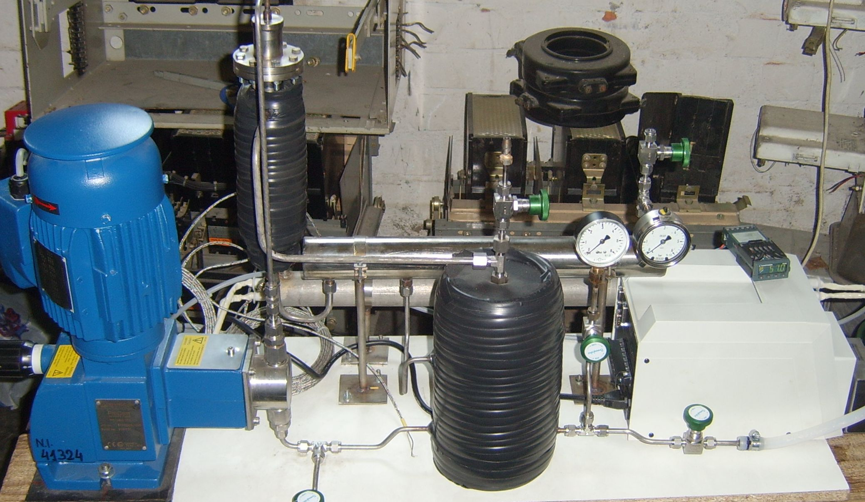
1
2
3
4
5
6
Figure 1. Experimental rig
All components of the rig, in contact with tritiated water, were made from polish pickling 316L stainless steel (the same material proposed to be use for the LPCE columns of WDS from ITER). All the technological pipes were acid pickling, in order to remove the oxides and impurities result from the machining and welding process. After that, the rig was subjected to pneumatic and hydraulic leakage tests, at 3 bars. The LPCE column has a heating jacket, with normal water, uses to maintain a constant temperature for the tritiated water, at 800C. Inside of the column we create an overpressure (1 bar of pure hydrogen). In order to assure an equal distribution on the catalyst, the inlet of the tritiated water is made by a spreading system. The operating duty tests, made with distillated water, were done to calibrate the temperature feedback control loop of the tritiated water from the LPCE column. In the H101, are installed inside of three concentric 316L pipes, electric resistances with 700W power each one. One of these electric resistances works permanently, one is use for regulating the water temperature and one is for back-up. Inside of the vessel V2 there is a heating coil through which the process pump P1 circulate the tritiated water. In this way we introduce the tritiated water pre-heated and we decrease the necessary difference of temperature need it to regulate.
The required flow rate of the tritiated water 5 l/h was regulated from the pump (P1) and flow rate of the heating water (P2) was calculated in order to obtain the necessary heat power for the electric resistances. All the experimental parameters are acquired with a Field-Point acquisition system using Lab-View software.
For this experiment, ICIT Rm.Valcea manufactured the necessary hydrophobic catalyst, same type of catalyst as in the TLK LPCE column. The tritiated water of 100 Ci/l was obtained by burning to water an HT mixture into a reactor with Al/Pd catalyst.
In order to respect the radioactive protection rules, the experimental rig was installed and all the experiments were carry out in a tritium monitored glove box, at IFIN HH Bucuresti.

Process description.
The tritiated water (100Ci/L) is filled up in the vessel V1. The normal water is filled in the vessel V2. In the experiment, we used approximately two liters of distillated water for heating the column.
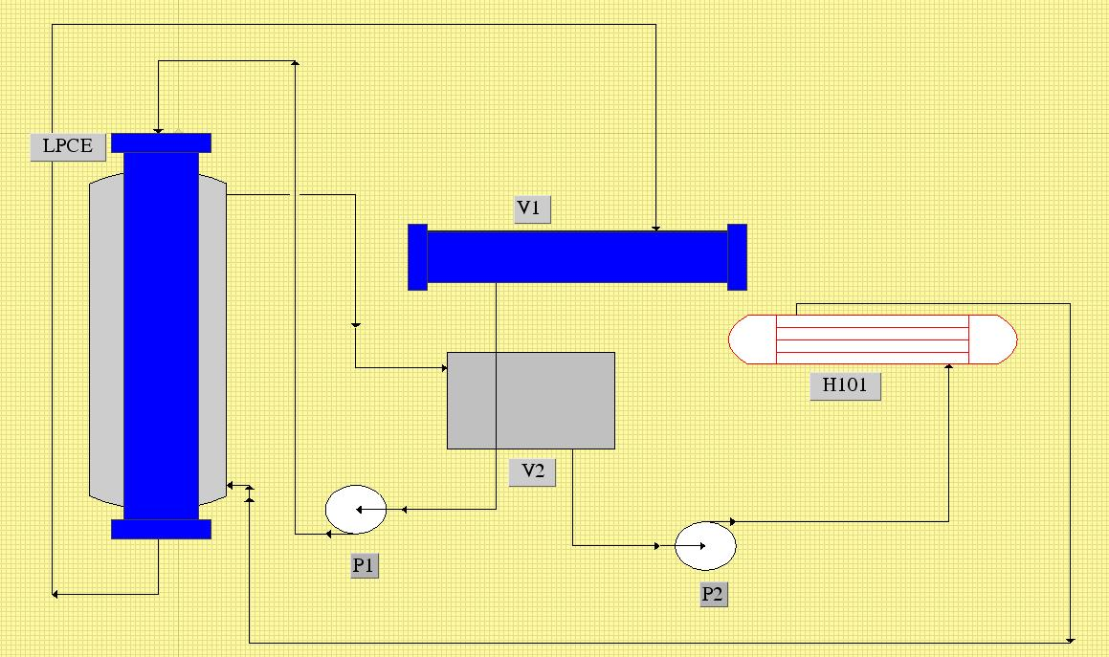
Figure 2. Process diagram for the experimental rig for catalyst endurance test in 100Ci/l
The normal water enters through the bottom of the column jacket and get out from the upper part and filled the V2 vessel. Pump P2 circulates the normal water from vessel V2 through the H101 heater to the column jacket, and the cycle is repeating. From vessel V1, the tritiated water is circulating by the P1 pump, through the heating coil from vessel V2 into the LPCE column. The tritiated water temperature is measured in three points, at the inlet, middle and outlet of the column. If the medium temperature, obtained from these three measurements, is different than 80 Celsius degree, the temperature feedback control loop decrease/increase the power supply to the regulating resistance from H101.
4.3. Analysis by X-ray diffraction techniques
The experimental stand was filled up with the Pt/C/PTFE catalyst manufactured by ICIT. This type of catalysts is one of the most studied groups due to the Pt high efficiency and due to the possibility of hydrophobisation.
During experiments carried out within this project, the Pt/C/PTFE catalyst used was manufactured from a mixture of Pt/C and Teflon, died into cylindrical shape Φ = 2,5 mm, L = 15 mm and subsequently sintered to improve the mechanical stability. The sintering process was done into a glass equipment at 355-360ºC for maximum 10 min
From the Scanning Electron Microscopies we can notice that the platinum particles dimensions are in the range of tens or hundred of microns, the pores are in the same size range. In comparison with the results obtained through the X-ray diffraction technique, we can conclude that the platinum particles contain numerous crystallites (fields of coherent scattering).
Platinum, carbon and platinum/carbon superficial tension have very similar values, which also signifies a similar behavior when they came into contact with different liquids. On the other hand, PTFE’s superficial tension and Pt/C/PTFE is approximately twice lower than the other materials taken for study.
The superficial tension of a solid is proportional with the solid-liquid interfacial tension, so it obviously results that the latter is also far lower at PTFE- liquid interface than on the interface of the other solids analyzed with a liquid. This fact leads to the conclusion that PTFE is a material having very high waterproof qualities.
Experimental results regarding the determination of the contact angle between the different liquids and the solid components of the catalyst sample PT/C/PTFE are presented in Table 1.

Table 1- Contact angle at the solid- liquid interface
 |  |  | surface
 | Pt | C | Pt/C | PTFE | Pt/C/PTFE
liquid |  |  | cosθ
water | 0,6293 | 0,5446 | 0,5877 | 0,1045 | 0,1953
glycerol | 0,3907 | 0,4539 | 0,4694 | 0,0000 | 0,1020
ethylene-glycol | 0,6293 | 0,8480 | 0,5150 | 0,1908 | 0,2708
diiodomethane | 0,7771 | 0,8386 | 0,6946 | -0,4539 | -0,3557
α-bromonaphthalene | 0,8829 | 0,9063 | 0,8660 | -0,5735 | -0,4645

4.4. Results

Radiolytic secondary effects evaluation
Through HTO radiolysis, a great number of active chemical species appear (free radicals, ions, solvated electrons, etc); from these primary species, from the induced effects point of view, the most important is HO⁹ radical.
In the study, we analyzed the attack mechanisms of the hydroxyl radical on the polymeric bound. Primary (reactants), final (reaction products) and transitional states were analyzed.
In the study we did not analyze the hydroxyl radical attack on the bound ending. They are in a small percentage and are not significant in the final balance. Because the PTFE structure is symmetrical, radical attack chances are limited. Actually we have two types of radical attack onto the polymeric substrate: the attack of HO⋅ by extracting one F atom and FOH formation as intermediate product; (b) HO radical attack by making up a HF molecule and inducing an alloy radical on the main bound.
The first mechanism was thermodynamically infirmed, the determined activation energy value being very high (+52.19 kcal/mol).
In case of (b) mechanism, many more possible transition states were obtained. The selection was done based on energetic criteria, respectively ΔH (+ 9.61 kcal/mol) and Ea (+0.59 kcal/mol) low values.
Reaction products do not present chemical stability. These were undergoing successive reactions up to the stabilization. Transition states analysis suggests a break up process of the main bound by forming an acid fluoride in the first stage and a free radial on C atom of the main bound (Ea = 6.15 kcal/mol, and ΔH + 17.57 kcal/mol). These products are also instable in presence of water, acid fluoride is converted into carboxylic acid by releasing HF, and the free radical is neutralized by proton hydroxyl transfer from a water molecule. Degradation mechanism of the PTFE in presence of HTO is:

According to this mechanism, each radical attack corresponds to the emission of three HF molecules.
The results obtained from the spectral analysis are also confirmed by the HF emission analysis using pH-analysis and fluoride ion concentration in watery solutions (table 2.)

Table 2. F radio-induced emission into the isotopic exchange catalyst.

Sample | Dose [kGy] | pH | F⁻ conc [mol/l] | Nr. F mol/g | G(F⁻)
PTFE : H₂O | 50 | 3.3 | 1.90E-03 | 4.37E-05 | 3.28
PTFE : H₂O | 100 | 3.5 | 1.66E-03 | 8.30E-07 | 3.12
PTFE : H₂O | 150 | 3.4 | 5.32E-03 | 2.32E-06 | 3.06
PTFE : H₂O | 200 | 3.1 | 6.35E-03 | 1.59E-06 | 2.99
PTFE : H₂O | 440 | 2.8 | 5.56E-03 | 1.86E-06 | 2.37
PTFE : H₂O | 2000 | 1.8 | 1.52E-02 | 5.06E-06 | 1.42

Tritiated water was analyzed by determining pH and fluoride ion total concentration.
The catalyst was decontaminated by multiple washings using deionised water, methylic alcohol and finally dried for 24 hours, stocked in a vacuum exicator.
The radio-induced modifications were analyzed by IR spectrometry
From the testing installation regarding the resilience of the catalyst which was exposed to tritiated water in a dynamic system, tritiated water samples having volumes of 2 mL were drawn out.
The results which were obtained are presented in Figure 3 and in Table 3
y = -1.0172x
2
+ 28.288x
R
2
= 0.9846
0
50
100
150
200
250
0
2
4
6
8
10
12
14
Exposure period [months]
F ion concentration [mg/900 ml]
Figure 3. Variation of fluoride ions concentration on HTO in terms of exposure period

In order to determine pH and the F⁻ content from the tritiated water samples we used a pH-meter/Inolab potentiometer pH 720 which was produced by WTW GmbH Company-Germany, to which we added a selective ion electrode, having the solid membrane for F⁻ DC219-F, which was produced by Mettler Toledo Company.

Table 3. Determination of the radio-induced effects in PTFE by HTO exposure with a 3,28 TBq (88.5 Ci)/l concentration
Exp.period  [mounth | pH | F ion concentration in HTO  [ppm] | F total emission  [mg] | Relative loss referred to PTFE | Procent relativ de pierdere F  [% F emitted/F total PTFE]
0 | 5.6 | 0 | 0 | 0 | 0.00
1 | 5.26 | 29.44 | 26.5 | 0.0002 | 0.017
3 | 5.7 | 90.67 | 81.6 | 0.0007 | 0.052
6 | 5.9 | 126.80 | 118.2 | 0.0010 | 0.075
9 | 5.7 | 207.22 | 186.5 | 0.0016 | 0.118
12 | 5.6 | 209.22 | 188.3 | 0.0016 | 0.119

4.5. Collaborative work
Work related to these topics belongs to the task TW6-TTFD-TPI- 55-2 (Art.5.1a) from the EFDA Technology Work program 2006 and was done in collaboration with Horia Hulubei National Institute of Physics and Nuclear Engineering (IFIN – HH) May 2007 - May 2008.
Part of this work has been performed during the two-month Mobility Secondment of M. Vladu at Forshungszentrum Karlsruhe – Tritium Laboratory, Germany.

4.6. Conclusions
The simulation of radiolytical processes by exposure to gamma radiation fields, emitted by 60-Co source, confirms the degradative mechanisms deduced by quanto-chemical simulations. Effects’ magnitude is low (ppm) in case of an absorbed dose of (0,2 MGy).
The study of the isotopic exchange catalyst’s behaviour in presence of tritiated water was made by analyzing the tritiated water and the exposed catalyst.
Tritiated water was analyzed from the content of HF (pH determinations) and F⁻ ion (F total) point of view.
The determined pH values are in the field 5,5-6,0. It was not identify the presence of HF which resulted from the primary or secondary radiolytic process. HF presence in HTO samples is contradictory to the results obtained by quanto-chemical simulations and by gamma radiation fields exposure.
HF absence in the samples is justified by its reaction with the material from which the testing installation was being made (stainless steel).
HF is a highly corrosive agent (it even damages the glass); it reacted with the metallic alloy by forming metallic fluorides. The presumption is sustained by the determined F⁻ ions concentrations values.
F⁻ ion concentration increases during the exposure period. The dependence on the exposure time is not linear, there is a flattening tendency of the curve to long exposure periods (absorbed doses).

References
[1] I. Cristescu , Ioana-R. Cristescu
“Design of a cryogenic distillation system within the JET water detritiation System”
[2] Ghe. Ionita, A. Bornea, J. Braet, I. Popescu, I. Stefanescu, N. Bidica, C. Varlam, Cr. Postolache, L. Matei.
“Endurance test for SCK-CEN catalytic mixed packing, proposed for water detritiation system at JET” -International Conference on Tritium Science and Technology No7, Baden-Baden , ALLEMAGNE (12/09/2004)
2005, vol. 48, no 1 (821 p.) [Document : 4 p.] (6 ref.), pp. 112-115 [4 page(s) (article)]
[3] I. Cristescu, U. Tamm, I.-R. Cristescu, R.-D. Penzhorn, C,J. Caldwell-Nichols
“Investigation of separation performances of various isotope exchange catalysts for the deuterium–hydrogen system”- International Conference on Tritium Science and Technology No6, Tsukuba , JAPON (12/11/2001)
2002, vol. 41 (2), no 3 (880 p.) [Document : 5 p.] (6 ref.), [Notes: Selected papers], pp. 1087-1091 [5 page(s) (article)]
[4] Kveton O. K.,
“Tritium Plant and Detritiation Systems - Hydrogen Isotope Separation System (WBS 3.2B)”.
[5] Rizzello C., Pinna T.,
“Failure Mode and Effect Analysis for Water Detritiation System of ITER”.
[6] I. Cristescu , Ioana-R. Cristescu, L. Dörr, M. Gluga, M. Murdoch, S. Welte
“ Long term performances assessment of a water detritiation system components”- International Symposium on Fusion Nuclear Technology No7, Tokyo , JAPON (22/05/2005)
2006, vol. 81, no 1-7 (874 p.) [Document : 6 p.] (4 ref.), pp. 839-844 [6 page(s) (article)]

