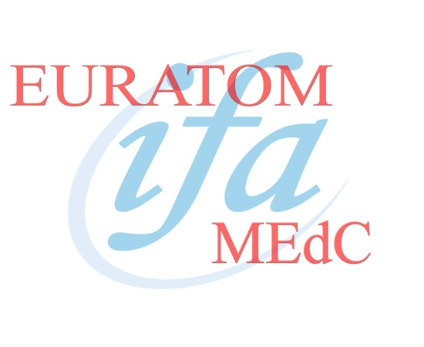

EURATOM – M.Ed.C ASSOCIATION

ANNUAL REPORT 2008

