STATISTICAL PHYSICS FOR ANOMALOUS TRANSPORT IN PLASMAS

Florin Spineanu, Madalina Vlad

Plasma Theory Group,

National Institute of Laser, Plasma and Radiation Physics, Magurele

1. Introduction
The theoretical investigation of the general topic of stable organized motion and coherent structures in turbulent plasmas have been continued. The main objective for this year was the study of impurity pinch in turbulent plasmas and the determination of the stability of the zonal flows in the frame of the model we have proposed [1]. Our research program was focused in 2006 on four subjects with strong theoretical and experimental relevance. We present below the main objectives and the main results obtained for each of these four subjects. The detailed description of the results is presented in Section 2.
1.1. Calculation of the spectrum of the problem of perturbed zonal flows (similar to the Orr-Sommerfeld); numerical description.
We have found an exact solution for the zonal flows [1] and this has very favorable comparison with the experimental data and with the numerical simulation. We have shown that sheared flow appears as quasi-coherent structure (exact solution) of the drift modes at larger space and time scales described by the Flierl Petviashvili equation. The milestone for 2006 was to investigate the stability of this flow. We have determined the spectrum of the linear perturbations applied on this flow. The decay of this periodic pattern was studied numerically. The main theoretical objective was to understand to what extent the zonal flow is a structured flow, closer to a coherent structure than to a turbulence effect under the action of the Reynolds stress. The first point of view arises from our model. The conclusion of this work is that the zonal flow has the characteristics of a coherent structure and not of a driven-dissipative system. This suggests a significant change of physical model, with less emphasis on turbulence and more focus on the self-organization properties of the vorticity field.
1.2. Continuous model for the stationary states of the Hasegawa-Mima equation (small scale decay of the ITG turbulence).
We have developed a continuous-field model of the point-like vortices interacting via a Kelvin-function potential in plane, the alternative formulation of the Hasegawa-Mima equation [2]. These results were developed in 2006 by studying an important application of the equation for asymptotic stationary states. We have identified a basic mechanism leading to structure generation in two-dimensional plasma, and we have proved that it has a contribution to the density pinch in tokamak, a major problem for ITER. It is related to the intrinsic tendency of the vorticity to self-organize, separating into positive and negative clusters. We have examined the contribution of this process to the density pinch in tokamak and to the existence of preferred stationary states playing a role in the transitions to higher confinement regimes.

1.3. Assessment of the effect of the magnetic field inhomogeneity on test particle transport and calculation of the impurity pinch and diffusion coefficients in turbulent plasmas using the decorrelation trajectory method
We have developed an alternative model for particle pinch in tokamak plasma based on test particle approach. We have shown that an average velocity is produced in turbulent plasmas through a ratchet-type process due to the space variation of the confining magnetic field. The preliminary results obtained last year were developed and extended to include the effects of particle collisions, of poloidal rotation of the plasma and of finite Larmor radius.
The prediction of this model were compared with the JET data base and we have shown that this ratchet mechanism can explain the dependence of the density peaking factor on collision frequency observed in H-mode.
The results are published in Physical Review Letters [P1].
1.4. Determination of alpha particle transport in realistic conditions obtained from simulations of collective modes.
The results obtained in the last years on the diffusion induced by ExB drift or by Lorentz force in electrostatic turbulence were extended to the study of electromagnetic turbulence. A test particle model for the study of transport in electromagnetic turbulence was developed. This model includes the non-isotropy of the potential correlation, the existence of a dominant mode in the spectrum and elements of the toroidal geometry. It will be further developed by analyzing the numerical results obtained at ENEA-Frascati for the Alfven modes.
The results obtained in the above four subjects are presented in 12 publications that appeared in 2006: one article in Physical Review Letters, 3 chapters in books, 2 electronic papers and 6 conferences (including 2 papers presented at IAEA Fusion Energy Conference).

2. Results obtained in 2006
2.1. Calculation of the spectrum in the problem of perturbed zonal flows (similar with the Orr-Sommerfeld); numerical description
This research has grown from the study that has led us to determine the exact solution of the stationary, large scale, drift wave instability, the Flierl-Petviashvili flow [1]. Its evolution has been strongly influenced by the parallel development of our involvement in the activities of the Task Force T, at JET. Basically, we have constructed the analytical and numerical instruments necessary to investigate the effects of perturbations and possible transitions from zonal flow to streamers, with the effect of intermittency, as shown by a very large number of experiments. Due to the exigencies of understanding recent JET experiments on the dependence of the radial density pinch on the collisionality, we have divided the work on this subject in distinct steps.
We have derived the dispersion relation for the waves developing from a perturbed zonal flow described by the exact solution we have obtained in [1]. We have obtained the following equation for the dispersion relation
$$\frac{1}{k_{y}}=\frac{ω±\sqrt{Q}}{P+1}\left\{1∓{\left[1+\frac{2\left(P+1\right)}{{\left(−ω+\sqrt{Q}\right)}^{2}}\right]}^{1/2}\right\}$$
where y is the poloidal direction, and
$$P=−\left(1−\frac{v_{d}}{u}\right)+φ_{0}, φ_{0}≈\frac{δn}{n_{0}}, Q=\frac{1}{2}{\left(δx\right)}^{2}s^{2}s_{1^{2}}, s_{1}=℘{\left(x\right)}_{\text{max}}−℘{\left(x\right)}_{\text{min}}$$
The parameter s is the amplitude of the Weierstrass function $℘\left(x\right)$ in the solution, $δx, v_{d}, u, δn$ are respectively: the width of the layer of periodicity of the solution, the diamagnetic velocity, the velocity of plasma rotation and the perturbation of the density profile.
From the presence of sheared flow the main emerging theoretical objective was to understand to what extent the high confinement regime, obtained in the condition of the generation of a transport barrier via a sheared poloidal velocity layer (zonal flow) was a structured flow, closer to a coherent structure than to a turbulence effect under the action of the Reynolds stress. This point of view has been put forward by us based on a large series of numerical solutions of the stationary equation for the Hasegawa-Mima two-dimensional plasma. We now have solid ground to argue that the high confinement has the characteristics of a coherent structure and not a driven-dissipative system.
We have considered the origin of the vortex merging and creation of ordered states as a fundamental trend to self-organization in two-dimensional plasma. The process is related to the geometrical significance that can be attached to the extremization of a functional defined on the ensemble of states of a linear vortex in the fluid. We consider a surface constructed from an ensemble of linear vortices parallel to the confining magnetic field and follow it in its time evolution. Since the linear vortices remain in time always perpendicular on the meridional plane, the problem can be reduced to the evolution of a line representing the intersection of the surface with the meridional plane. Now taking this line as an object evolving in time we consider the world-surface that it describes. The world surface is simply the set of successive positions of the line in the meridional plane, but lifted along the time direction. This world surface is in general not a flat one and its geometry can be described by the metric tensor. Using the metric tensor we can calculate the infinitesimal area of an element of the world-surface. In perfect analogy with the motion in space of a particle, we write the action functional for the line as the integral of the infinitesimal area. The equations of motion is obtained exactly as in the case of a particle by imposing the condition that the action (integral of the element of length on its world-line) is extremum. A set of equations representing the motion of the line in the meridional plane is obtained as the Euler-Lagrange equations at the extremum of the action functional. It has been shown that these equations are similar with those for an ideal fluid: equation of continuity for the density and equation of momentum conservation with a specific pressure. It is very interesting that this pressure is negative and it has a particular dependence on the density:
$$p=−{\text{λρ}}^{−1}\text{.}$$
This also arises for polytropic gases or Chaplygin gases. The fact that the equations of a perfect fluid with negative pressure results from the simple requirement of the extremum of the element of surface (a geometric property) is fundamental: this must be put in relation with the negative temperature which has been investigated in the past (Taylor, Montgomery, Edwards, etc.) and was connected with the tendency of organization of the fluids and plasmas.
We have applied this general analysis to the evolution of a line in the poloidal plane toward the center of the plasma (magnetic axis). We have solved the differential equations for the Chaplygin polytropic gas and we have found a constant velocity directed towards the magnetic axis. This may explain (or, at least, be one of the contribution to) the density pinch in tokamak. The constant velocity directed toward the magnetic axis is simply arising from a process of self-organization in which plasma is building up large vorticity structures.
We have also studied the statistical process by which a system can overcome a potential barrier leading to a reconfiguration of the system [P2].
2.2 Continuous model for the stationary states of the Hasegawa-Mima equation (small scale decay of the ITG turbulence)
The instabilities of magnetically confined plasmas (like tokamak) evolve in a geometry that is strongly anisotropic. The motion of the electrons along the magnetic field lines is in many cases sufficiently fast to produce a density perturbation that has the Boltzmann distribution in the electric potential. In these cases a two dimensional approximation (the dynamical equations are written in the plane that is transversal to the magnetic field) may be satisfactory. The linearized Boltzmann electron distribution suppresses the convective nonlinearity, leaving the ion polarization drift as the essential nonlinearity. This is of high differential degree (therefore it is enhanced at small spatial scales) and basically describes the advection of the fluctuating vorticity by the velocity fluctuations. The differential equation for the electrostatic potential has been derived by Hasegawa and Mima. A similar situation appears in the physics of the atmosphere and the differential equation for the stream function of the velocity field has been derived by Charney.
The stationary asymptotic states of the plasma/atmosphere fluid cannot be described in the same way as the model for Euler fluid. The main difference consists of the existence of an intrinsic length in the Charney Hasegawa Mima (CHM) model, while the Euler model is scale invariant (more generally: conformal invariant). The intrinsic length is the sonic Larmor radius for plasma and the Rossby radius for the atmosphere.
In a previous work [3] we have developed a field-theoretical formulation of a model that is considered to be a parallel version to the Euler equation: a system of point-like vortices in plane, interacting via the potential expressed as the logarithm of the relative distance. The latter model has been proposed long time ago in fluid physics by Onsager and is discussed by Kraichnan and Montgomery. The discrete version of the Euler equation has been used along the years in various analytical and numerical works. This was also the base for the derivation of the equation governing the asymptotic state of the Euler fluid, the sinh-Poisson equation. Our work was essentially directed to a reformulation of the continuum version of the point-like vortices as a field theory. The Lagrangian density that expresses the properties of the system was then: kinetic term with covariant derivatives, Chern-Simons for the gauge field, square nonlinearity for the scalar field, whose density represents the local magnitude of the vorticity. The action functional can be written in a form that reveals the possibility of self-dual states, and the equations simplify considerably. The final form is a general form of the sinh-Poisson equation.
This treatment is radically different from the traditional one and has clearly shown the effectiveness. Therefore we have continued the same line of theory for the Charney-Hasegawa-Mima equation. We have developed a field-theoretical formulation for the continuous version of a system of point-like vortices interacting in plane by a short range potential, in terms of Kelvin function. The basic physical model has been proposed by Kirchhoff and Onsager and has been used in meteorology by Stewart and Morikawa.
The model developed by us consists of a Lagrangian density with the structure: kinetic term with covariant derivatives, Chern-Simons term for the gauge field, sixth order polynomial self-interaction for the scalar field, the stream function $ψ\left(x,y\right)$. All fields belong to the adjoint representation of the SU(2) algebra. The model leads to self-dual states and we have been able to derive in [2] the form of the equation that governs the asymptotic states of the two-dimensional magnetized plasma and of the atmosphere (tropical cyclone):
$$Δψ+\frac{1}{2p^{2}}\text{sinh}ψ\left(\text{cosh}ψ−p\right)=0$$
These results were developed by analyzing the solutions of this equation for several physical systems: ITG turbulence, large vortices in fluids, crystals of vortices in non-neutral plasmas and current sheets in plasmas. We have done a large number of numerical calculations and we have compared the results with the experiment and with the observation, obtaining good agreement. Some results are presented in [P5] and [P11].
An important application of the equation for asymptotic stationary states is the identification of a new source of density peaking in tokamak plasma and of the transition to high confinement states. The density peaking of tokamak plasmas was studied from a completely different point of view. It is confirmed by experiments and numerical simulation that elements of vorticity manifest an intrinsic tendency to self-organize, separating into positive and negative clusters. This process is of the same nature as the Widom Rawlinson phase transition and has been studied in the past in connection with the concept of negative temperature. We have examined the contribution of this process to the density pinch in tokamak and to the existence of preferred stationary states playing a role in the transitions to higher confinement regimes. In tokamak plasma the intrinsic organization of vorticity is embedded in the Wakatani-Hasegawa model. However this model is derived from conservation laws and not from equations of motion (Euler-Lagrange equations) therefore the self-organization dynamics is just one of the possible evolutions. To become distinct, the vorticity must be seen as a fluid whose dynamics is represented by a discrete set of mutually interacting point-vortices (the Kirchhoff-Onsager model). The elements of vorticity drag the density, which can acquire a nonuniform profile due to the compressibility of the polarization drift (in contrast to the Euler fluid). The resulting gradient of density generates a diamagnetic velocity, which prevents the clusterization-singularity. This is quantified by the effective Larmor radius. When the diamagnetic velocity approaches the velocity of the vorticity cluster the effective Larmor radius tends to infinity. In consequence the interaction between the point-like vortices, which is on short range becomes actually of long range and, at the limit, logarithmic. At this limit the fluid becomes an Euler fluid (where the interaction between the point-like vortices is long range, logarithmic) and the third dimension decouples: the density slows down the vorticity and there is less compressibility due to weaker polarization drift.

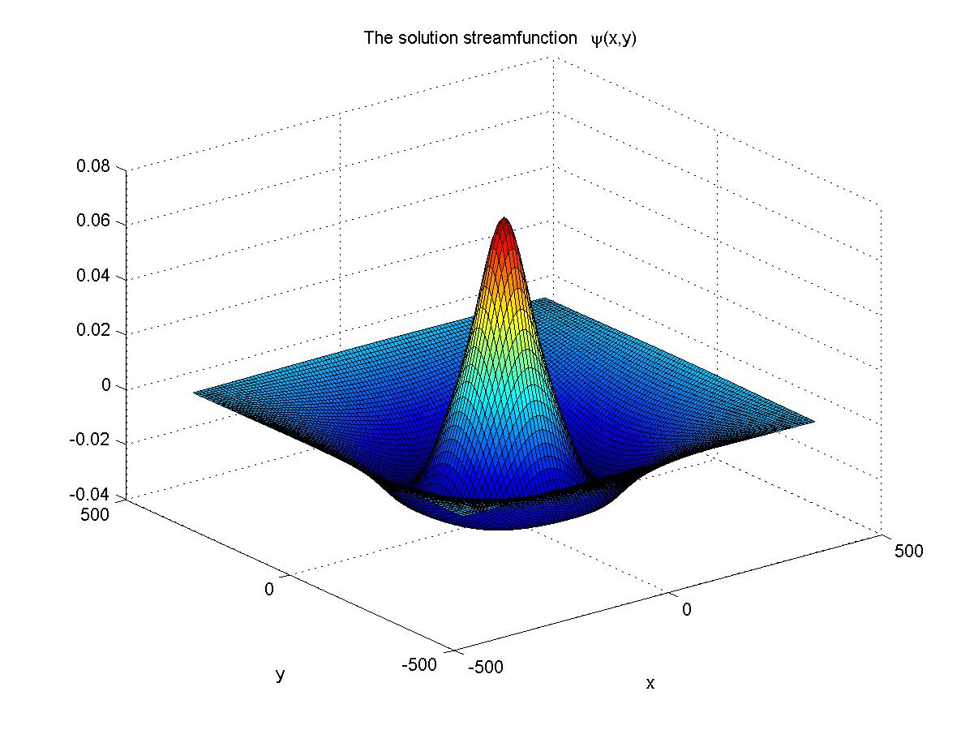 (a)
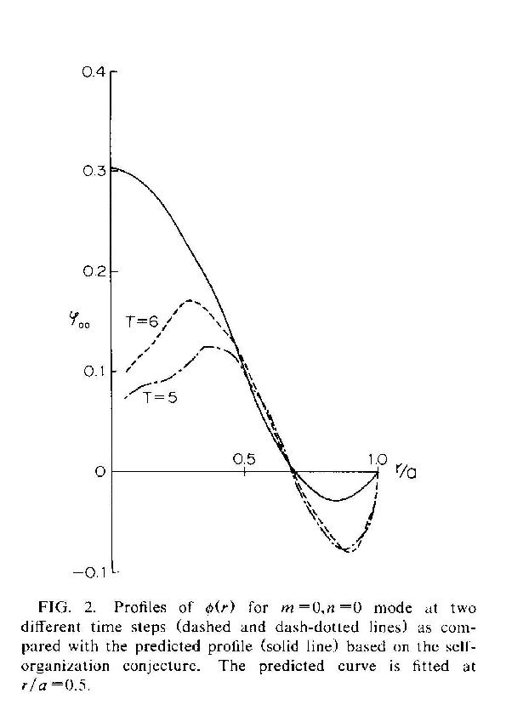(b)

Figure 1. Numerical result (a) and the profile obtained in [4] from simulation of Hasegawa-Wakatani equation (b).

We have found that the profiles of the vorticity-based velocity are similar to the profiles of the radial electric field measured in tokamak or determined from analytical theory of statistical equilibrium (the Wakatani-Hasegawa potential profile). Moreover we have found solutions that correspond to the L and respectively to the H states of confinement. The abrupt drop of electric field close to the separatrix after the L to H transition is reproduced, together with a fast increase of the poloidal velocity followed by a plateau toward the centre, which are similar with what is expected for internal transport barrier. On the basis of stationary solutions we predict a class of density profiles that can be strongly peaked close to the axis.
The numerical studies of our differential equation for the stationary states of the Hasegawa-Mima equation were continued, by developing codes for circular symmetry. This is necessary since the condition of zero stream function on a square domain (as we use in present) lead sometimes to values of poloidal velocity that are significantly altered by square cropping and the final total energy is not correctly calculated. Or, we intend to base our future physical interpretations on scaling relating the final energy and vorticity to the normalized dimension. The main purpose of such scaling laws is to assess the role of the effective Larmor radius in the coupling between the density and the vorticity
$$\frac{1}{ρ_{{\text{eff}}^{2}}}=\frac{1}{ρ_{s^{2}}}\left(1−\frac{v_{d}}{u}\right)$$
where $ρ_{s}, v_{d}, u$ are respectively: the sonic Larmor radius, the diamagnetic velocity and the velocity of rotation of plasma, associated with the vorticity content. Our explanation of the density pinch resulting from the self-organization of the vorticity implies the back-reaction of the density, which is dragged by the elements of vorticity. The density develops gradients and the diamagnetic velocity combines with the plasma rotation velocity leading to a modification of the Larmor radius as it is seen by the vorticity. The sonic Larmor radius is replaced by the much larger effective Larmor radius and the fluid is subject to a transition from the Charney-Hasegawa-Mima regime to the Euler regime. This has the consequence that the ability of the vorticity to drag the density is decreased, since in an Euler fluid the density is decoupled from vorticity.
In order to support this picture we have investigated:
- the action functional in the neighborhood of the self-dual states;
- the role of compressibility of the ion polarization drift in the coupling of density and vorticity;
- the gradual transition from short range (Hasegawa-Mima) to long range (Euler) models, induced by the effective Larmor radius.
The objective is to develop a quantitative determination of the flux of density pinch resulting from the self-organization of the vorticity fluid.
The main idea has been communicated at the meeting EU-US Transport Task Force [P6] and a paper is in preparation.
Other aspects on the poloidal rotation of the plasmas are presented in [P3] where we show that the poloidal asymmetry of the turbulence can have an important contribution to the plasma rotation through Stringer mechanism.
2.3. Effect of the magnetic field inhomogeneity on test particle transport
The so-called ratchet process is a generic name for a large class of average stochastic velocities that are generated by unbiased noise. This name suggests the motion of a circular saw with asymmetric saw-teeth. The main ingredients of a minimal model that produces such directed transport consists of a periodic potential (or velocity) with broken reflection symmetry, and a noise (usually a Gaussian white noise). It was shown that, in spite of the asymmetry, the stochastic motion has no systematic preferential direction such that the average velocity is zero at large times. But, if this kind of equilibrium is broken, a ratchet process appears. Thus, a third element has to be included in the minimal model, which can be for instance a driving force, a periodic or stochastic time variation of the amplitude of the periodic potential or of the noise, another noise with different temperature. As shown in a recent review paper [5], several important results were obtained that permitted a better understanding of these processes with many applications in physics, biology and industry.
We consider an electrostatic turbulence represented by an electrostatic potential φ(x₁,x₂), where x= (x₁,x₂) are the Cartesian coordinates in the plane perpendicular to the confining magnetic field directed along z axis (slab geometry). The magnetic field depends on the distance from the main symmetry axis as B=B₀R/(R+x₁), where R is the major radius and B₀ is the value of the magnetic field in the origin of the coordinates that is at the distance R from the symmetry axis. The electrostatic potential is considered to be a stationary and homogeneous Gaussian stochastic field, with zero average. Such a stochastic field is completely determined by the two-point Eulerian correlation function (EC), that is the Fourier transform of the spectrum (determined from experiments). The test particle motion in the stochastic ExB drift in this potential is described by:
$$\frac{d\vec{x}}{\text{dt}}≡v(x,t)=−∇φ×e_{z}\left(1+\frac{x_{1}}{R}\right)\text{.} (1)$$
We have shown in [P1] that the inhomogeneity of the confining magnetic field determines a directed transport (an average velocity), although the average drift is zero. The two-dimensional ExB drift is not similar to a typical model for a ratchet process. However we have shown that it contains the three specific elements mentioned above and discussed in detail in a recent review paper [5]. They are all included in the stochastic drift velocity. The periodic velocity does not appear explicitly in (1) but the solutions for static potentials are periodic functions of time that lie on the contour lines of φ(x). Thus, the Lagrangian velocity v[x(t)] is periodic. The space dependence of the magnetic field produces the symmetry braking of the Lagrangian velocity. The random dynamics is determined by the stochastic potential itself, which plays the role of the Gaussian noise found in the standard model for ratchets. The third element, which drives the system out of equilibrium, is the time variation of the potential. We have show that for static potentials the asymptotic average velocity is zero and that a ratchet process appears when the stochastic potential is time dependent. We have also shown that the ratchet process modeled by equation (1) has the property of current inversion: the sign of the average velocity depends on the parameters of the turbulence.
The average displacement generated by the stochastic equation (1) is determined using the decorrelation trajectory method, a semi-analytical approach we have developed in previous work [6]-[7]. An average velocity directed along the gradient of the confining magnetic field (along x₁ axis), V^{R}, is obtained [P1]. This velocity V^{R} is in the direction of the gradient of the confining magnetic field $∇B$ and its sign depends on the characteristic parameters of the turbulence represented by the Kubo number K: against $∇B$(positive) at small K and along $∇B$ (negative) for K>1. For typical tokamak plasma conditions this velocity is of the order of 1m/s and in principle it is large enough to produce impurity accumulation or density peaking. These processes appear when the turbulence is not poloidally symmetric. Since the amplitude of the turbulence is usually larger in the weak field side these effects appear only when the velocity is negative (at K>1).
We have analyzed the effects of the ratchet velocity on JET plasmas [P4]. More specifically we have focused on the recent results, which show that the peaking factor in H-mode plasmas mainly depends on the collision frequency and that data from a large number of shots determine a scaling that decreases when collision frequency increases. This is an important experimental result that has to be better understood in connection with ITER.
Introducing particle collisions represented by a time dependent velocity that is modeled by a white noise developed the test particle model. The poloidal rotation of plasma with a velocity V_{p} was also considered. We have derived the system of equation on the basis of the decorrelation trajectory method and we have written, tested and optimized a code for this rather complex system. We have determined the average velocity V^{R}, the radial diffusion coefficient D_{x} and their ratio p=aV^{R}/D_{x}, which is the measure of density peaking (a is the minor radius).
In the absence of collisions and rotation, the ratio p is small due to the rather large values of D_{x}, although the values of V^{R} are compatible with the experiments Thus, the ratchet velocity does not produce density peaking in these conditions.
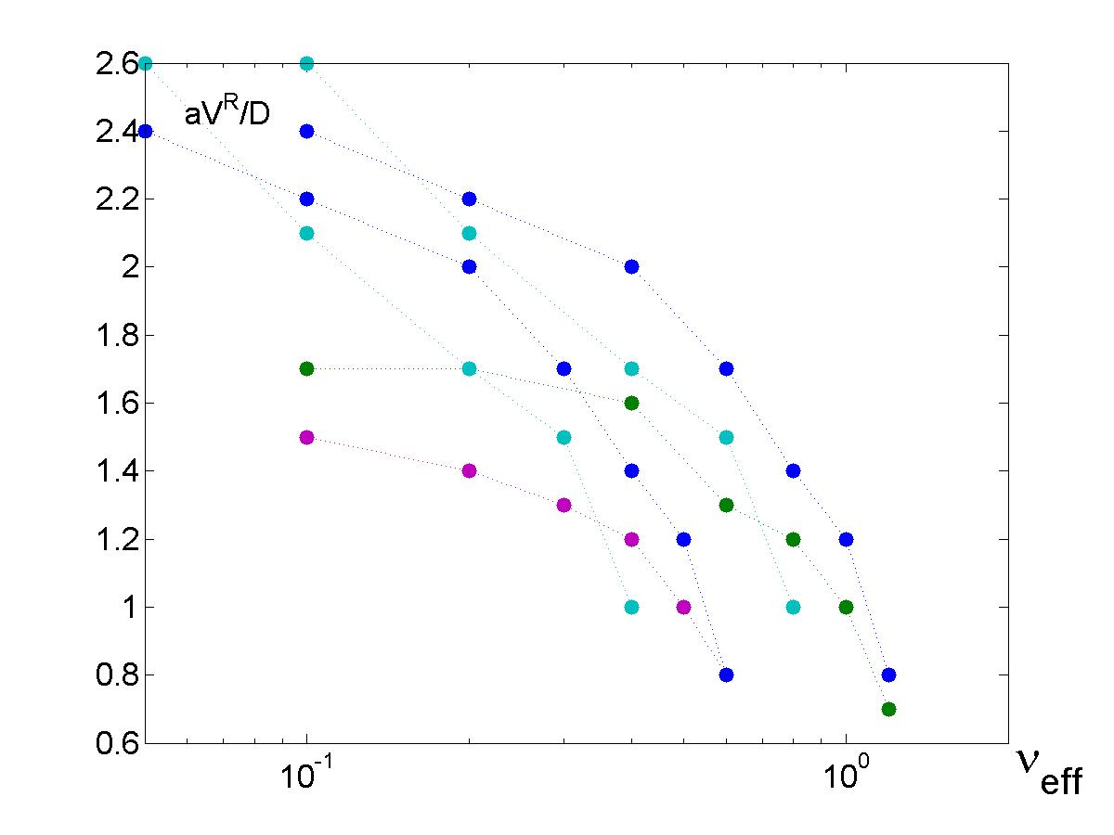
Figure 2. The peaking factor as function of the collision frequency obtained with the ratchet pinch for JET plasma parameters. The points correspond to diffusion coefficients of the order 0.2-0.5m²/sec, values of the Kubo number in the range 5-20 and poloidal rotation velocities V_{p} of the order 300-1000m/sec.

In the presence of a poloidal rotation, the diffusion process becomes strongly non-isotropic with diffusion coefficient that is smaller in the radial direction and larger in the poloidal direction. For poloidal rotation with velocity of the order of 0.2-0.4 of the ExB drift, the average velocity is only weakly decreased and the ratio p becomes larger than unity for Kubo numbers of the order 10. This shows that the ExB transport can determine the density peaking in these conditions. The collisions produce the decrease of the ratchet velocity. The decrease of p with the collision frequency at fixed rotation velocity is faster than in the global scaling obtained for JET data and it depends on V_{p} and K. However, if values of p for different V_{p} and K are plotted versus collision frequency, a qualitative agreement with the experimental database is obtained.
Thus, the ratchet velocity in presence of a poloidal rotation appears to represent correctly the density peaking in H-mode JET plasmas.
We have also taken into account the effect of the finite Larmor radii of the particles on the ratchet velocity. This is expected to determine the dependence of the pinch velocity on particle mass and charge. This work is the main subject of collaboration with the theory group from Universite de Provence, Marseille, France. We have introduced finite Larmor radius effects in the model of test particle transport due to ExB stochastic drift. We have derived the system of equation using the decorrelation trajectory method and we have developed a numerical code that determines the average velocity and the diffusion coefficient for test particles. At this stage the code is based on a simplified model for the Eulerian correlation of the potential but in the next step the Eulerian correlation obtained in the numerical simulations performed at Universite de Provence will be introduced. The code was tested and the parameters were optimized. This is a complicated process that leads to reduced calculation time. Preliminary results were obtained, which show that the effect of mass-charge is strongly connected with the characteristics of the turbulence represented by the Kubo number. The draft of a paper was discussed and established.
The results are presented in [P1] (concept of ratchet pinch), [P4] (application of ratchet pinch to JET plasma in collaboration with JET Task Force Transport) and [P10] (review of test particle transport nonlinear effects).
2.4. Determination of alpha particle transport in realistic conditions obtained from simulations of collective modes
The results obtained last year [10]-[11] on the diffusion induced by Lorentz force in electrostatic turbulence were extended to the study of electromagnetic turbulence. A realistic model was developed for the study of alpha particle transport in Alfven turbulence. This model includes the non-isotropy of the potential correlation and the existence of a dominant mode in the spectrum of the potential. It will be developed in the next year by analyzing the numerical results obtained at ENEA-Frascati for the Alfven modes. Some of the results are published in [P7], [P8].

3. Collaborative actions
3.1 Collaboration with EFDA JET
Subjects:
- Particle and impurity transport at low effective collisionality in H modes;
- Comparative perturbative heat and particle transport studies in H mode and hybrid plasmas
We have started this year collaboration with EFDA JET included in the Transport Task Force at Culham. We have examined several possible contributions that we could develop. Finally we have concentrated on the problem of density peaking. The experimental results concerning density peaking in H-mode, reported as one of the main achievements at JET last year, are not understood and much effort is devoted to this problem.
We have studied the density peaking from two completely different perspectives: the basic particle transport in turbulent plasmas and the intrinsic tendency of vorticity organization that entrains the density in a radial pinch. The results were presented at 11th EU-US Transport Task Force Workshop [P4], [P6].
In the first perspective, our aim was to examine the effect of the ratchet pinch (a new mechanism for pinch velocity we have found in the ExB motion of test particle) in the conditions of JET plasmas. More specifically we have focused on the recent results, which show that the peaking factor in H-mode plasmas mainly depends on the collision frequency and that data from a large number of shots determine a scaling that decreases when collision frequency increases. The test particle model was developed by introducing particle collisions and the poloidal rotation of plasma. We have derived the system of equation on the basis of the decorrelation trajectory method and we have written, tested and optimized a code for this rather complex system. A qualitative agreement with the experimental database is obtained for turbulent plasmas with values of the Kubo number in the range 5-20 and poloidal rotation velocities V_{p} of the order 300-1000m/sec. The results are presented in [P4] and a paper is in preparation.
In the second perspective we have presented an original model to explain the density pinch in two-dimensional plasma, based on the self-organization of the elements of vorticity. We started by presenting evidences obtained from numerical simulations and experimental observations on neutral fluids showing self-organization to universal profiles for the vorticity. These facts can be explained on the basis of the evolution to stationary states that correspond to the extremum of the action functional in a continuous model for point-like vortices. We have accumulated numerous numerical results in support of this explanation and have advanced the idea that the density pinch and the transition from low to high confinement regimes have the same nature.
During the visit at JET, we have presented three seminaries and we had many discussions with the permanent staff of the Transport Task Force at JET and other participants to experiments and modelisation work.
Secondments:
Dr. F. Spineanu at JET for 42 days (7/05/2006 – 17/06 /2006).
Dr. M. Vlad at JET for 42 days (7/05/2006 – 17/06 /2006).
3.2 Collaboration with CEA Cadarache and Universite de Provence
Subject: Particle transport in fusion plasmas using methods of statistical physics
Milestone: Assessment of the effect of the magnetic field inhomogeneity on test particle transport.
We have continued the collaboration on this topic, which started last year. We have studied the problem of particle pinch in tokamak plasmas and we have found a new mechanism that produces average velocities in turbulent plasma: the ratchet pinch [P1]. We have studied this year the effect of finite Larmor radius on ion pinch velocity in order to determine the mass-charge effect on the pinch velocity. As reported in § 2.3, we have derived the system of equation using the decorrelation trajectory method and we have developed a numerical code that determines the average velocity and the diffusion coefficient for test particles. At this stage the code is based on a simplified model for the Eulerian correlation of the potential but in the next step the Eulerian correlation obtained in the numerical simulations performed at Universite de Provence will be introduced. The code was tested and the parameters were optimized. Preliminary results were obtained, which show that the effect of mass-charge is strongly connected with the characteristics of the turbulence represented by the Kubo number. The draft of a paper was discussed and established.
Mobility Secondments:
Dr. F. Spineanu at Universite de Provence – CEA Cadarache for 35 days (27/02-2/04/2006)
Dr. S. Benkadda at Association EURATOM – MEdC Romania for 8 days (1-8/10/2006)
3.3. Collaboration with ENEA Frascati
Subjects:
- Generation and stability of coherent flows in tokamak plasma
- Simulation of alpha particle transport by collective modes
We have continued the study of the magnetic field fluctuations in the region of a quasi-stationary magnetic island in tokamak. Our new model [P9], [P12] on the fluctuation of link number and of helicity will be discussed as a possible direction of investigation. Most of this work will be done in 2007, according to common agreement.
We are developing a realistic model for the study of alpha particle transport in Alfven turbulence. This model includes the non-isotropy of the potential correlation and the existence of a dominant mode in the spectrum of the potential. At this stage we consider simplified models for the correlation of the fluctuations. It will be developed by analyzing the numerical results obtained at ENEA-Frascati for the Alfven modes.

References
[1] Spineanu F., Vlad M., Itoh K., Sanuki H., Itoh S. -I., “Pole dynamics for the Flierl-Petviashvili equation and zonal flows”, Phys. Rev. Letters 93 (2004) 025001.
[2] Spineanu F., Vlad M., “Stationary vortical flows in 2-dimensional plasma and planetary atmosphere”, Phys. Rev. Letters 94 (2005) 235003.
[3] Spineanu F., Vlad M., “Self-duality of the relaxation states in fluids and plasmas”, Phys. Rev. E 67 (2003), 046309.
[4] Hasegawa A., Wakatani M., Phys. Rev Letters 59 (1987) 1581
[5] Reimann P., Phys. Reports 361, 57 (2002).
[6] M. Vlad, F. Spineanu, Misguich J.H., Balescu R., “Diffusion with intrinsic trapping in 2-d incompressible velocity fields”, Phys. Rev. E 58 (1998) 7359.
[7] Vlad M., Spineanu F., “Trajectory structures and transport”, Phys. Rev. E 70 (2004) 056304.
[8] Weisen H. et al., Nuclear Fusion 45 (2005) L1-L4.
[9] Vlad M., Spineanu F., Misguich J.H., Balescu R., “Diffusion in biased turbulence”, Phys. Rev. E 63 (2001) 066304.
[10] Vlad M., Spineanu F., Plasma Phys. Controlled Fusion 47 (2005) 281.
[11] Vlad M., Spineanu F., Itoh S.-I., Yagi M., Itoh K., Plasma Phys. Controlled Fusion 47 (2005) 1015.

List of publications in 2006
[P1] Vlad M., Spineanu F., Benkadda S., “Impurity pinch from a ratchet process”, Phys. Rev. Letters 96 (2006) 085001.
[P2] Spineanu F., Vlad M., Itoh K., Itoh S.-I., ‘Review of analytical treatments of barrier-type problems in plasma theory’, Progress in Chemical Research, Editor A. N. Linke, Nova Publishers (2006), ISBN: 1-59454-483-2.
[P3] Spineanu F., Vlad M., ‘Soliton self-modulation of the turbulence amplitude and plasma rotation’, Progress in Soliton Research, Editor L. V. Chen, Nova Publisher (2006), ISBN 1-59454-769-6.
[P4] Vlad M., Spineanu F., Mantica P. and EFDA JET contributors, „Ratchet pinch and density peaking in H-mode JET plasmas”, 11th EU-US Transport Task Force Workshop, Marseille 2006.
[P5] Spineanu F., Vlad M., „Field theoretical methods in theory of turbulence relaxation”, BG-URSI School and Workshop on Waves and Turbulence Phenomena in Space Plasmas, 2006, Kiten, Bulgaria, invited paper.
[P6] Spineanu F., Vlad M., „The common ground of the density pinch and the transition to high confinement regimes in tokamak”, 11th EU-US Transport Task Force Workshop, Marseille 2006.
[P7] Vlad M., Spineanu F., “From Brownian diffusion to the non-linear transport by continuous movements”, in ‘Albert Einstein Century’, edited by J. Alimi (in print).
[P8] Vlad M., Spineanu F., „Nonlinear effects in charged particle transport in turbulent magnetic fields”, BG-URSI School and Workshop on Waves and Turbulence Phenomena in Space Plasmas, 2006, Kiten, Bulgaria, invited paper.
[P9] Spineanu F., Vlad M., „Helicity fluctuation, generation of link number and effect on resistivity”, TH/P3-12, 21st IAEA Fusion Energy Conference, Chengdu, China, October 2006.
[P10] Vlad M., Spineanu F., „Test particle statistics and turbulence in magnetically confined plasmas” , TH/P2-18, 21st IAEA Fusion Energy Conference, Chengdu, China, October 2006.
[P11] Spineanu F., Vlad M., “Scaling laws for the tropical cyclone derived from the stationary atmospheric vortex equation”, electronic preprint arXiv.org/Physics/0604059 (2006).
[P12] Spineanu F., Vlad M., “Helicity fluctuations, generation of linking number and effect on resistivity”, electronic preprint arXiv.org/Physics/0612248 (2006).

