Gy. Steinbrecher*, N. Pometescu*, M. Negrea*, Dana Constantinescu**, Iulian Petrisor*
*Department of Physics, University of Craiova, Craiova
**Department of Mathematics, University of Craiova, Craiova

1. Introduction
The anomalous transport issue was analyzed for different regions and regimes of the plasma in tokamak with special attention for ITER. Important results were obtained in the study of intermittency in tokamak plasma turbulence using models based on self-similarity concepts. Edge localized mode was analyzed to describe the influence of the stochastic noise.
Turbulent transport of ions (majority and minority species) in the presence of radio-frequency heating was described using kinetic models. For the transport in the scrape off layer region of tokamak plasma was obtained results useful for the qualitative cross-check of the numerical models of the first principle simulations, including ITER. Zonal flow generation in turbulent plasma and diffusion of stochastic magnetic field lines was investigated using the decorrelation trajectory method. These results are important for “Validation of physics-based transport models” and “Plasma edge characterization and modeling”, objectives for ITER.
The motion of the particles (in guiding center approximation) in Tore Supra and ASDEX-Upgrade tokamaks was described using Hamiltonian description and mapping technique. The results are relevant for the estimation of the particle loss and heat load on the ergodic divertor plates.

2. Results obtained in 2006
2.1. Elaboration of anomalous transport models based on self-similarity concepts.
Generalization of the shell model for intermittency study in tokamak plasma turbulence by using new techniques on stochastic differential equations.
Available data on the tokamak edge turbulence exhibits a series of regularities. Despite these regularities are the logical consequences of the first principle equations, their explanations require the study of the simplified, reduced models.
In this respect, the clear evidence of self-similarity observed in the statistical study of the edge plasma turbulence in DIII-D tokamak experiments, published in the works [1], [2] requires theoretical explanation. A partial answer to this problem was given in the work [3], as well as in the subsequent, more physical generalizations of the result of ref. [1], where the range of the applicability of the initial random linear amplification model was subsequently extended [4], [5]. The main limitation of our explanation remained the approximation of the complex nonlinear dynamics by linear stochastic differential equations.
Our efforts in this period are devoted to the generalization of the methods used in the study of our random linear amplification model to the study of the nonlinear models of the plasma turbulence.
In this stage of our study a reasonable balance between numerical accessibility and phenomenological reliability is achieved in the case of the shell model. We selected the version of the magneto-hydrodynamic shell model [6], [7], with spectrum adapted to the study of the Hasegawa-Mima equations. The forcing term was adapted according to the results from our work ref. [3].
a. Study of the heavy tail, large fluctuation effects.
In these previous studies the effects of the stochastic forcing term was explored. The stochastic terms used in the previous studies were stochastic processes with short-range memory, usually white noise or coloured noise.
In order to have an explanation based on more reliable, nonlinear models, of the DIII-D experiments, we performed a detailed study of the Hasegawa-Mima version of the magneto-hydrodynamic shell model, with forcing term having the structure derived from our previous model. The stochastic forcing term is from the category of the long-range memory models. From reasons related to the expected self-similarity and universality we considered the forcing term modelled by fractional Brownian motion.
In order to speed up the numerical studies, we elaborated a specialized algorithm and C++ code, devised to generate persistent (or super-diffusive) fractional Brownian motion for this study of the MHD shell model. It is derived from a result obtained in ref. [3].
The result of these numerical studies, performed according to the methods developed in the framework of our random linear amplification model, is the emergence of the large fluctuations of the turbulence amplitude. This large amplitude, asymptotic part of fluctuations was found to have an algebraic decay. More exactly, the probability $P[E: E>E_{0} ]$ to have fluctuations of the electrostatic energy $E$ larger than a fixed value $E_{0}$ was found numerically to have the asymptotic form $P[E: E>E_{0} ]∝ E_{0^{−β}}$. The values of the heavy tail exponent $β$ were found to have robustly very low values, independent on the amplitude and Hurst exponent of the superdiffusive fractional Brownian motion. According to the available numerical precision, we found $0\text{.}\text{06}≤β≤0\text{.}\text{14}$. These values are consistent with DIII-D experimental values as well as to the random linear amplification model, which predicts$β=0$. Numerical results were obtained by using the ANIC4 cluster from ULB.
In conclusion, the proposed objectives for this period were attained. We elaborated and studied numerically anomalous transport model based on self-similarity concept, by suitable extension of the magneto-hydrodynamic shell model.
b. Study of the intermittence effects in MHD turbulence.
The study of the intermittency in the framework of this version of the MHD shell model was performed according to the general methodology of studying the intermittence in dynamical systems driven by stochastic, developed in ref. [11], and by using the new methods elaborated in ref [3,4,5]. In the case when the noise was fractional Brownian motion, the statistics of the laminar times was studied. The probability distribution function of the laminar times $τ_{L}$, defined as $P(t)=\text{Pr}(τ_{L}>t)$ was measured. For large laminar times the following asymptotic form realized the best fit with the values obtained from the simulations: $P(t)∝t^{−γ}$. The dependence of the exponent from the value of the Hurst index, H, of the driving fractional Brownian motion was found numerically: $γ(H)=1−H$, for the values of H in the range $0\text{.}\text{55}≤H≤0\text{.}\text{95}$. The study of the intermittency exponent, defined in the work [8] was performed, for the case $1>H≥1/2$. The result is: The asymptotic behavior of the intermittency exponent $δ$ for large values of the stochastic forcing term amplitude $σ_{F}$ is given by $δ∝σ_{F^{−(1−H)/2}}$.
The study of the magneto-hydrodynamic shell model will be continued. These studies will be correlated to the study of the ELM modes: the output of the MHD shell model will be used as input stochastic noise for the stochastic equations associated to the ELM stochastic models. These studies are also useful to the benchmark of the large numerical codes, designated for the first principle optimization of the large tokamaks, like ITER, by comparing the statistical properties of the output with the output of our shell model.
c. Study of the extreme anomalous transport driven by instabilities
The dynamics of test particles moving in a constant magnetic field and stochastic electrostatic field was studied, in the framework of the model developed in ref. [3]. The multiplicative and additive noise was modeled by fractional Brownian motion with Hurst exponent H=0.75, according to the experimental results from ref. [2]. The study was performed by using the full equation of motion of the test particle, without zero gyro radius approximation. The following important physical effects were discovered ref. [15, 16].
c1. Solution of the isotope effect paradox.
Due to the wide spectrum of the driving fractional Brownian motion, there exist a cyclotron frequency domain where the particle transport exhibits the correct isotope effects. In this domain the tritium transport is slower compared to the deuterium, according to the experimental observations. This result explains at least partially the so-called isotope effect paradox. For large cyclotron frequencies the behavior from the drift approximation is recovered.
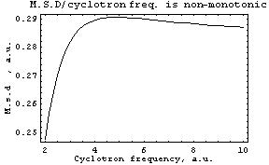
Figure 1. Test particle mean square displacement dependence of cyclotron frequency.

In Fig. 1 the mean square displacement/versus cyclotron frequency, at fixed time of a given ion species is plotted. In the first part of the graph the heaviest particles, having lower cyclotron frequency, will experience less transversal diffusion.
c2. The transversal to the magnetic field mean square displacement of the particles under the influence of the fluctuating electrostatic turbulence do not obey the usual rules of the classical transport theory, when algebraic time dependence is predicted. In our model the time dependence of the mean square displacement is exponential: $\left\langle {\left|r_{\text{transv}}(t)\right|}^{2}\right\rangle =\text{const} \text{exp}(D t^{2H})$. This result is important for elaboration of a strategy for the first principle optimization of tokamaks. Accordingly, to the previous formulae, the first step in reducing drastically the particle loss from tokamak could be achieved drastically by reducing the Hurst exponent H. On the other hand, according to the physical meaning of H, this reduction could be achieved by reducing the correlations of driving multiplicative noise.
2.2 Edge localised mode (ELM) modelling. Transport barrier relaxation in tokamak edge plasma.
a. Intermittence effects in the reduced models of the relaxation oscillations in tokamak
Efficient modeling of the stochastic aspects of the dynamics of the edge localized modes (ELM) is one of the high priority tasks in the route toward the elaboration of he virtual tokamak. While first principle calculations could explain, in principle, all of the details of the ELM dynamics, it is also of interest to capture the essential aspects of the complex dynamics by using reduced models. In this end the study of the reduced models was continued. The models under study were obtained by the projection of the first principle equations to the dominating eigen-modes. Details of the projection are explained in the refs. [5], [8], [9], [10]. We studied the intermittency effects in this category of models driven by stochastic noise of short-range memory.
Because there are many possible definition of the intermittency, in the case of the dynamical systems driven by stochastic noise we adopted the definition given in the article [11]. Accordingly we adopted as a measure of the intermittency the parameter that describe the asymptotic behavior of the so called “laminar times”, i.e. the waiting time between two burst. In the framework of our stochastic model, we found numerically that the laminar time, $τ_{L}$ distribution (the time between two strong ELM eruptions), asymptotically, can be described as follows. The probability that the laminar time $τ_{L}$ be greater than a prescribed value has the asymptotic form:$P[τ_{L}\text{: }τ_{L}>t] ≈t^{−γ}$ where the exponent $γ$ has the value $γ≈1\text{.}4÷1\text{.}6$.
Another characterization of the intermittency in noise-driven dynamical systems, according to the same authors S. Aumaitre, F. Petrelis, K. Mallick, is the exponent of the singularity of the probability density function (PDF), in our case near the line of zero value, of the turbulence amplitude $Y$. Accordingly, we have the definitions: $P(a)=\text{Pr}\text{ob}[Y:Y>a]=\int{ρ(y) \text{dy}}$, where $P(a)$ is the probability that the turbulence amplitude is larger than the prescribed value $\text{a}$ and $ρ(y)$ the marginal PDF of the turbulence amplitude. According to the definition, we have intermittency if the PDF $ρ(y)$ develops an integrable singularity: $ρ(y)∝y^{(δ−1)}$ for $y→0$, i.e. $0<δ<1$
In the case of the ELM driven by noises, that can be modeled by colored noise, with time constant (correlation time) $τ_{c}$, we measured the exponent $δ$ and we found the following scaling relation for large $τ_{c}$: $δ∝τ_{c^{−2}}$. By using the main result from the work [12], the stability of the numerical algorithm was proven. The numerical calculations were performed o the ANIC4 parallel cluster from ULB.
The study of the intermittence in the ELM dynamics is essential in the preventing the damage of the plasma facing components caused by the large, intermittent heat load.
b. Influence of the stochastic noise with long-range memory on the ELM dynamics
Reduced model for the pressure profile, obtained by previously elaborated class of ELM models ref. [5, 8-10], was studied by new methods from the theory of stochastic differential equations ref. [3-4], [10], and the filtering method from [12]. In the framework of the reduced models of ELM oscillations, the effect of stochastic noise with long-range memory was investigated. In the model under study, the quantity modelling the fuelling rate of the tokamak was supposed to have a stochastic component, modelled by fractional Brownian motion with Hurst exponent$H≥1/2$. By these studies, a new mechanism to model the type I ELM’s was discovered [13-14].
The important effects discovered are the following:
In the above mentioned class of models, the mean frequency of the ELM modes increase with the increasing fuelling rate. If the fuelling rate is decreased, then there is a threshold under which the ELM’s disappear.
Close to this threshold the time dependence of the burst of outgoing particle flux is highly intermittent.
The dependence of the ELM dynamics on the Hurst exponent H, of the fractional Brownian motion was studied. The increase of the intensity of ELM burst with the increase of the Hurst exponent was established.
The studies were performed for values of$0\text{.}5≤H≤0\text{.}\text{75}$, because these values of H are supported by experimental data on DIII-D and their theoretical interpretation from ref. [3].
For illustration, the above graphs in Figure 1-4 represents the ELM burst, derived in this category of models, for H=0.55. The increase of the frequency with increasing fuelling rate is manifest (rest of the parameters are fixed).

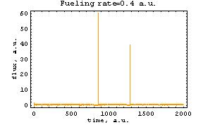

Figure 1. Intermittent time dependence of the outgoing energy flux, at fuelling rate 0.4

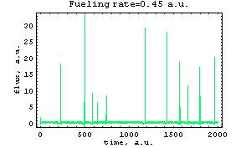

Figure 2 .The same as Fig.1, for fuelling rate 0.45.

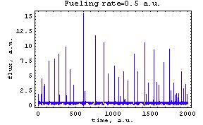
Figure 3. The same as Fig.1, for fuelling rate 0.5.

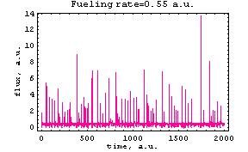
Figure 4. The same as Fig. 1, for fuelling rate 0.55.

Numerical and analytic method for the calculation of the intermittency exponent was elaborated. The dependence of the intermittency exponent versus fuelling rate was studied. Part of the results is given on Fig. 5. The unexpected fact is the non monotonous dependence of the intermittency exponent from the fuelling rate.

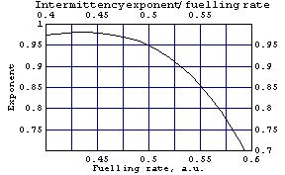
Figure 5. The non-monotonous dependence of the intermittency exponent from fuelling rate.

The study of the intermittence properties of the type 1 ELM is important for the reduction of heat loads on the plasma facing components of large tokamaks, like ITER. These studies were performed in collaboration with CEA –Cadarache.
2.3 Turbulent transport of ions in toroidal plasma with ICRF heating. Evaluation of the ion particle flux in trapped regime in turbulent plasma with ICRF heating.
One of the principal ICRF heating schemes foreseen for ITER is the second harmonic heating of tritium. For this reason is important to gain inside for the transport process of the ions in plasma with ICRF heating. The contribution from passing particle regime to the turbulent transport was evaluated [17]. To complete the picture we have studied the contribution given by particles in trapped regime. The fluctuating distribution function for trapped particles in turbulent plasma with radio-frequency heating was evaluated with a special attention for the absorption of the wave power. A specific case of ions and ICRF heating is studied. The linear solution is used to evaluate the nonlinear terms of the fluctuating distribution function [18]. The transport of the plasma driven by the instabilities is modified in the presence of radio-frequency heating. The turbulent transport due to untrapped ion particles in the presence of ICRF heating was analyzed in a previous study. The influence of the trapped particles on the turbulent transport in tokamak plasma with electromagnetic turbulence in the presence of ICRF heating is now studied. The variation of the radial particle flux of ions with the radio-frequency power density was described. This milestone was partially done during the mobility at ULB Belgium in collaboration with Dr. Boris Weyssow.
2.4. Impurities transport in the presence of rf heating. Evaluation of the particle flux for α particles.
The effect of micro-turbulence on alpha particle transport has received recently reconsideration. The energy transfer from the micro-turbulence to alpha-particles is of real interest for ITER.
In Deuterium-Tritium plasma we consider Deuterium as the heated species in an ICRH scheme. The equilibrium distribution function for D is of type given by Stix [19]. However, we evaluate the later in pitch angle variable and in a little more simplified form. The electromagnetic turbulence affects both electrons and D-T ions. Hence for these species we evaluate the perturbed distribution functions: for electrons perturbed distribution function is evaluated from a drift kinetic equation but for D and T ions we use a linear gyro-kinetic equation. The alpha species has a small density and the energetic particles collisional interact with the D-T plasma. An equivalent alpha-particle Maxwellian distribution function was considered [20]. The neutrality condition for the plasma is imposed to obtain a relation between distribution function of the plasma species. The radial particle flux for alpha particle was given in general analytical form. This milestone was partially done during the mobility at ULB Belgium in collaboration with Dr. Boris Weyssow and will continue in 2007.
2.5. The study of a stochastic collisional three waves system using the decorrelation trajectory method.
The model we continued to study is related to the guiding center motion of a charged particle in a strong magnetic field oriented along the z-axis supplemented by a stochastic weak magnetic field perpendicular to the strong one. The magnetic field is supposed to be obtained from a stochastic vector potential modeled by a superposition of three waves that are independent of the coordinate z. [28]. The stochastic components are assumed to be independent random numbers drawn from a uniform distribution. As a consequence the perpendicular magnetic field becomes stochastic and contains both a deterministic and a stochastic component. We assumed that the deterministic part depends on position and time that are uniform distributions such that the argument of the cosine is uniformly distributed. The density probability function is then of a Pareto-Levy form. We calculated the Lagrangian correlations and the diffusion coefficients in the framework of the decorrelation trajectory method [25]. Our main goal is to calculate the diffusion coefficients by direct numerical simulation using the above-mentioned distribution and to make a comparison with those obtained from de DCT method. This work is in progress and has been done in collaboration with Dr. B. Weyssow from ULB Belgium. The numerical simulations were performed mostly using the computing facilities of ULB-VUB Belgium (on the parallel computer ASTER).
2.6. The study of the diffusion of a stochastic anisotropic sheared magnetic field lines using the decorrelation trajectory method.
We have continued to develop the theoretical framework necessary to study the diffusion of the stochastic anisotropic sheared magnetic field lines for a field using the decorrelation trajectory method. This study is of interest for magnetic confinement devices; several transport regimes can be found for the magnetic field lines [23], depending on the parameters (three parameters: the magnetic Kubo number Km, shear parameter Ks and anisotropy parameter Λ). We have refined the code developed for this problem and implemented it on the ASTER cluster computer system (under UNIX/LINUX); the code is based on an optimized Runge-Kutta-Fehlberg (RKF45) solver. The numerical simulations were performed mostly using the computing facilities of ULB-VUB Belgium (on the parallel computer ASTER). Using this code we have also obtained numerically the ensemble averaged quantities of interest: the averaged radial and poloidal coordinates, the averaged trajectory and the averaged potential (see Figure 6). From Figure 6, the magnetic shear influences the shape of ψ(z)_{av} and a maximum appears related to an enhancement of the trapping effect. The stochastic anisotropy only influences the value of the maximum of ψ(z)_{av} and also the trapping phenomenon.
In Figure 7, the coefficients D_{xx}^{as}(z) and D_{yy}^{as}(z) are shown versus the magnetic Kubo number K_{m} (in a log-log representation) for different values of the shear and the anisotropy parameter. It is obvious that there exist a common feature: a linear portion of each curve exists from the start. For the asymptotic radial diffusion coefficient, the quasilinear regime is recovered (the slope is almost 2) in all cases except for the strong x-anisotropy Λ=5 and relatively large shear K_{s}=2 where the trapping phenomenon is important. In this case, the slope is 1.46, which represents an important deviation from the quasilinear value. The final slope, in the shearless cases, is almost 0.06 except for the case Λ=0.2 where the saturation regime is not yet reached for the same magnetic turbulence as for the other values.
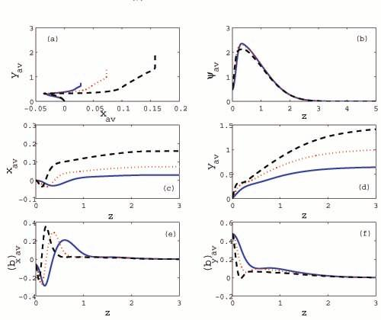
Figure 6: The DCT for three values of the magnetic Kubo number i.e., solid: K_{m}=0.5, dot: K_{m}=1, and dash: K_{m}=2. The other parameters are K_{S}=2 and Λ=5. The figures contain: (a): the mean DCT trajectory; (b): the average magnetic potential (ψ)_{av}; in (c) and (d): the average coordinates (x)_{av} and (y)_{av}, respectively; in (e) and (f): the averaged fluctuating magnetic field components (b_{x})_{av} and (b_{y})_{av}, respectively.
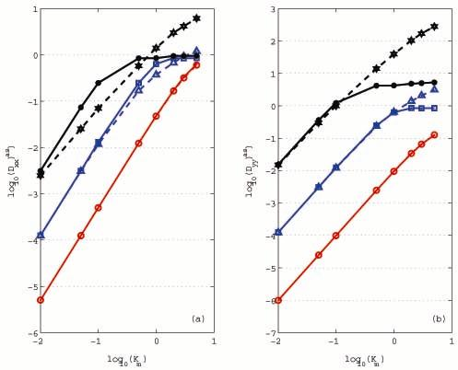
Figure 7: Log-Log representation of the radial (a) and the poloidal (b) asymptotic diagonal diffusion coefficients as functions of K_{m}. From top to bottom in both figures: solid-asterisk: x-anisotropy Λ=5 and shear K_{s}=0; dash-star: x-anisotropy Λ=5 and shear K_{s}=2; solid-square: isotropy Λ=1 and shear K_{s}=0; dash-triangle: isotropy Λ=1 and shear K_{s}=2; (5) solid-circle: y-isotropy Λ=0.2 and shear K_{s}=0.

The same behavior is observed for the case Λ=5, K_{s}=2. We conclude that the trapping is not enhanced by an increased shear parameter in the case of an anisotropy specific to the solar wind, i.e. Λ>1 like the one studied in [23].
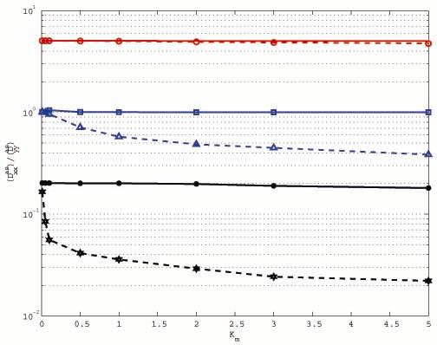
Figure 8: Ratio of the radial to the poloidal asymptotic diagonal diffusion coefficients as functions of K_{m}. From top to bottom: solid: y-anisotropy Λ=0.2 and shear K_{s}=0; dash-circle: y-anisotropy Λ=0.2 and shear K_{s}=2; solid-square: isotropy Λ=1 and shear K_{s}=0; dash-triangle: isotropy Λ=1 and shear K_{s}=2; solid-asterisk: x-anisotropy Λ=5 and shear K_{s}=0; dash-star: x-anisotropy Λ=5 and shear K_{s}=2.
In Figure 8 we displayed the ratio of the radial versus poloidal diffusion coefficients in terms of the level of magnetic turbulence for different values of the shear and anisotropy parameters; this ratio is practically constant except for two cases, namely the case of a strong stochastic anisotropy (like in the solar winds, with Λ=5) and a relatively high shear Kubo number K_{s}=2 and the isotropic stochastic case for the same shear parameter K_{s}=2. In the last case we have recovered the results already reported in [21]. In the shearless cases the ratio is practically constant for different anisotropic stochastic regimes; for Λ>1 the diffusion in the poloidal direction is greater than that in the radial one. The opposite behavior appears when Λ<1. The presence of the magnetic shear influences this ratio. We performed the analysis for different values of the anisotropy parameter in the range [0.01, 10]; the magnetic Kubo number was considered in the range [0.01, 10] and the shear parameter in the range [0, 10]. The competition between these parameters plays an important role and it is decisive in the determination of the trapping effects. We have used a quantity defined as: R= (Dxx/ Dyy) in order to compare our result with another one obtained by a different approach [23, 25]. We have identified some physically regimes that are favorable for the suppression of the diffusion in the radial direction. This work is in progress and is collaboration with Dr. B. Weyssow from ULB Belgium.
2.7. Transport phenomena in the scrape off layer (SOL) in tokamak plasma
We have developed a series of Smoothed Particle Hydrodynamics (SPH) adapted code for different flow problems [30] that are basically in the form of partial differential equations (PDE) of field variable such as density, velocity or energy. The SPH techniques have some important advantages like Lagrangian description of main PDE, also some disadvantages related to the initial distribution of particles, boundary particles implementation or the necessity to add into theory some “additional” terms in order to stabilize the numerical scheme. They can be also adapted for any hydrodynamic problems that are basically in the form of partial differential equations (PDE) of field variable such as density, velocity, energy, etc.
We intend to adapt this kind of numerical approaches to some actual and hot problems in fusion plasma field (such as: zonal flow or different phenomena in SOL).
We have developed a series of systematic tests in order to evaluate quantitatively and qualitatively the different flows in two dimensions. We have used SPH for the Navier-Stokes equation and then we have verified the accuracy of the developed codes.
For the simulation of a continuous, multiphase flow, the incorporation of surface properties for the phase boundaries constitutes an important problem, with many applications, such as the turbulent flows or different transport phenomena in SOL. In particular, many theoretical schemes have been put forward to treat surface tension for two-phase flows e.g. [31].
We have also studied in a systematic way the influences induced in the numerical scheme by the different choices of standard symmetrized SPH expression for the viscous forces, which involves usually the ﬁrst-order derivatives of the kernel through a direct evaluation of the viscous stress tensor or others approaches e.g. [32]. Also, the proper choice of dissipation terms taking into consideration some existed works [31-32] has been done. All these dissipations involve some singularities in appropriate quantities (momentum, energy and/or density). A good explanation of these singularities is provided in [32].
New boundary conditions were implemented using either ghost or fixed particles. For reflecting boundaries, ghost particles are created which mirror the SPH particles across the boundary. These particles are exact copies of the SPH particles in all respects except for the velocity, which is of opposite sign on the ghost particle, producing a repulsive force at the boundary. For periodic boundary conditions the ghosts are exact copies of the particles at the opposite boundary. In our simulations, involving non-zero velocities at the boundaries, boundary conditions are implemented by fixing the properties of some particles (e.g. 6 particles) closest to each boundary. The initial velocities of these particles are non-zero and their positions are evolved accordingly. A particle is removed from the domain once it has crossed the boundary. The distance between the closest particle and the boundary is greater than the initial particle spacing if a new particle is introduced into the domain. Hence for an inflow or outflow boundary conditions the resolution changes throughout the simulation.
In principle, we searched to develop a general model that is suitable for treating compressible fluids with arbitrary shear and bulk viscosities. The work is in progress and is collaboration with Dr. B. Weyssow from ULB Belgium.
2.8. The study of the influence of the diamagnetic Kubo number on zonal flow generation in turbulent plasma using the decorrelation trajectory method.
Drift wave zonal flow turbulence is a naturally self-regulating system of the predator-prey type. This follows from the fact that zonal flow generation extracts energy from drift waves, which may in turn be dissipated by zonal flow damping mechanisms. While return of energy from the zonal flow repository to the drift wave’s gas is possible, it does not readily occur, especially in plasmas with magnetic shear. Note that fixed points, limit cycles, and fixed points with long relaxation times (i.e. which are the time asymptotic states of slow modes) are possible. While there have been several experimental results which are suggestive of the existence and effects of zonal flows, a definitive experiment have only recently been performed. Poloidally and toroidally extended, but radially localized, electric field structures have been identified. Moreover the existence of radial structure and correlations has been demonstrated by exploiting the unique capabilities of the dual-beam system [33].
The influence of the generation of zonal flow on the anomalous transport in tokamak plasma was continued to study. The decorrelation trajectory method it was used also for the anisotropic case, as a starting point [22].
Zonal flows are radially moving structures whose radial propagation velocity is of order of the diamagnetic electron drift velocity V_{ds}. This velocity is opposite to the direction of the group velocity V_{g} and inversely proportional to it in amplitude. To the best of our knowledge, the influence of the gradient length of the density in x space on the diffusion coefficient on the zonal flow generation regime generated by an anisotropic electrostatic turbulence was not done until now. There is a large amount of literature concerning the zonal flow generation by different mechanisms. The important role of zonal flows in anomalous transport, including the creation of transport barriers, was discovered and discussed in detail in a long series of papers among which we cite a very exhaustive presentation of the state of art, with a very complete bibliography is the recent review paper of Diamond et al. [34]. In general a numerical simulation of the Hasegawa-Mima or other quasi-equivalent equations is the way to finalize an analysis of the zonal flow generation. Two interesting papers [35] and [36] analyze in a quite different context the influence of a diamagnetic parameter and of the ballooning parameter on the particle fluxes in a tokamak.

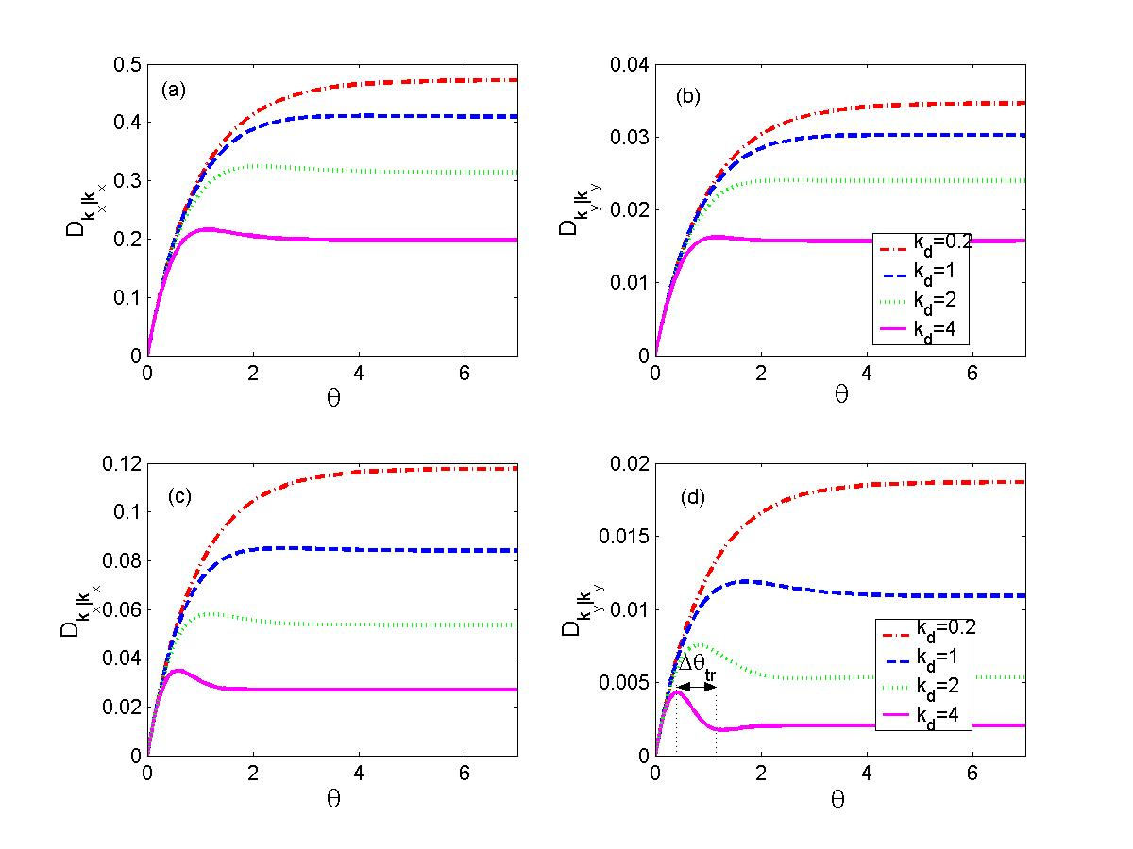
Figure 9. Running diagonal diffusion coefficients in k-space for two different initial vectors, a fixed value for anisotropy parameter Λ=0.4, a fixed value for magnetic Kubo number K_{m}=0.2 and 4 values for diamagnetic Kubo number

The main result obtained in our study consists in the analysis of the diamagnetic effect on the generation of zonal flow. The diamagnetic effect produces a clear damping of the zonal flow mode; this tendency is due to the spatial inhomogeneity of the density, i.e. to the variation of the spatial gradient length L_{n} (see Figure 9). Moreover, the spatial anisotropy of the stochastic electrostatic field plays an important role in the zonal flow evolution, i.e. in the values of the diffusion coefficients in k-space. To the best of our knowledge, an analysis of the zonal flow generation, considering both the influence of the stochastic anisotropy for a relatively weak turbulence and of the diamagnetic Kubo number, on the radial and poloidal diffusion in k-space, was done here for the first time.
Next, we developed the framework necessary to fit this problem in the Smoothed Particle Hydrodynamics (SPH) Techniques. This work is in progress and is collaboration with Dr. B. Weyssow from ULB Belgium.
2.9 The study of the motion of the guiding center in perturbed toroidal magnetic fields specific to Tore Supra and ASDEX-Upgrade tokamaks.
A general model describing the motion of the guiding center in toroidal magnetic devices, the GCD model, was obtained using the Hamiltonian description and the mapping technique. This model is appropriate for the study of the charged particles in tokamaks with large inverse aspect ratio (like Tore Supra ($ε_{T}=0\text{.}\text{31}$), ASDEX-Upgrade ($ε_{T}≈0\text{.}\text{33}$), ITER ($ε_{T}=0\text{.}\text{32}$) etc) because it is not a cylindrical approximation ($ε_{T}≈0$) as the usual models. For the study of the dynamics of the guiding center we use two pairs of canonical coordinates, namely $\left(θ,ζ,P_{θ},P_{ζ}\right)$, where $θ$ is the poloidal angle and $ζ$is the toroidal angle of the torus. The magnetic momentum and $P_{ζ}$ are constant of the motion.
The general (GCD) model was particularized for some magnetic configurations specific to Tore Supra, DIIID and ASDEX Upgrade tokamaks by using specific q-profiles (monotonous for Tore Supra and ASDEX-Upgrade, respectively with reversed shear for DIIID) and perturbations.
In the unperturbed (ideal) case the trajectories of the particles were classified and the values of the parameters of the system for which various types of trajectories appear in each magnetic configuration were determined. In the Figure 10 and Figure 11 can be found the values of the magnetic momentum (depending on $P_{θ}$) for which each type of particles is obtained.
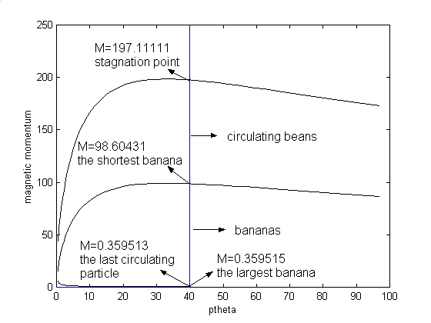
Figure 10. Classification of particles' trajectories in ASDEX-Upgrade

In the perturbed case, a systematic study of the influence of the magnetic islands and of the magnetic internal transport barriers on the dynamics of the guiding centre was realized by increasing the amplitude of the perturbation. Some intrinsic indicators (Lyapunov exponent, entropy) for the dynamical complexity of the trajectories were computed for various mass and energy of the charged particles.
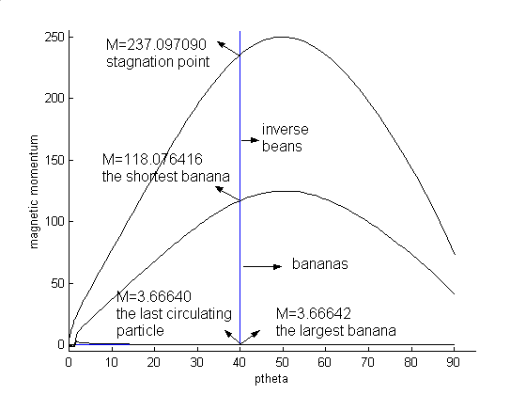

Figure 11. Classification of particles' trajectories in DIIID

It was observed that the toroidal trajectories (passing particles) are stochastized as soon as an additional magnetic perturbation is introduced. The resonance condition is satisfied when the toroidal trajectory crosses its resonant magnetic surface. The stochastic trajectory of the guiding center is localized near the rational surfaces provided the parallel velocity is large enough. The trapped particles are only locally stochastized and the parallel velocity for the stochastization of the trajectory must be larger for heavier particles.
The results are relevant for the estimation of the particle loss, heat load on the ergodic divertor plates, phenomena that are partially caused by the anomalous transport generated by chaotic particle dynamics.
2.10. The interpretation of some results obtained in experiments in tokamaks in the frame of the transport barriers’ presence using Hamiltonian models.
Some data from the ASDEX Upgrade discharge #11681, t=2.98s were interpreted using the Hamiltonian model presented in [37]. In this model the perturbations were obtained by means of electron cyclotron emission (ECE) measurements and the safety factor describes correctly the experimental position of the neoclassical tearing modes.
The aim of the study was to relate the mechanism of frequently interrupted regime of neoclassical tearing mode (the FIR-NTM regime) to the dynamical properties of the magnetic field, namely the existence of the internal transport barrier.
The interaction between the (3,2) and (4,3) modes, experimentally observed, was systematically studied by fixing the magnitude of the (3,2) perturbation amplitude from the experiment and by increasing the (4,3) perturbation amplitude. The mechanism of FIR-NTM regime was explained by the breaking up of the magnetic internal transport barrier separating the two modes. It was shown the experimental (4,3) perturbation does not play a special role in the dynamics of the system: for somewhat smaller or larger perturbation amplitudes the dynamics of the system would be the same.
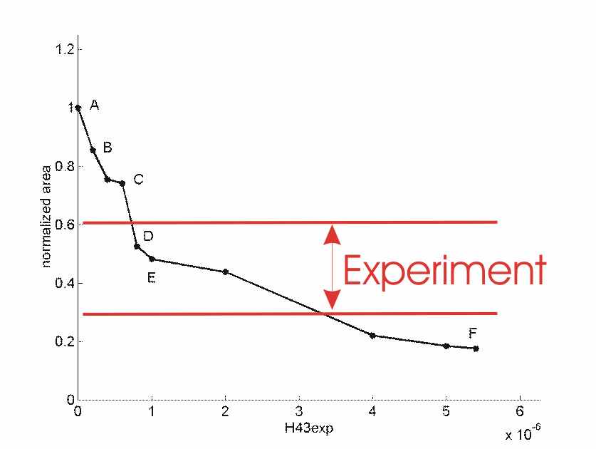

Figure 12. The area of the (3,2) island as a function of . Experiment means the relation between the island width before and after the (3,2) amplitude drop obtained by means of the ECE and magnetic measurements

The analytical results concerning the island area reduction were compared those obtained from ECE and magnetic measurements (see Figure 12). The experimental estimations are somewhat larger than the analytical one (but in qualitative agreement).
It was found that the FIR-NTM regime is not restricted to these modes, similar phenomena being observed between the resistive mode (4,3) and the ideal (5,4) modes.
The main results were published in [38].

3. Conclusions
The transport models elaborated on self –similarity concepts, developed in the framework of the random linear amplification model from ref. [3], successfully correlates experimental data from refs. [1], [2], explains at least partially the isotope effect paradox and provide a possible future step to a very efficient reduction of particle loss from edge plasma of tokamak.
In the study of edge localised modes (ELM), a new class of model of type I ELM’s was discovered. The study of this class of models is in progress. The study of the ELM is a High Priority Task for ITER modelling.
The pinch terms in turbulent transport of ions was evaluated for passing particle regime in the presence of ICRH [17].
Specific codes were developed [in collaboration with ULB, Belgium and CEA Cadarache, France] in order to evaluate the diffusion coefficients for different stochastic models related to the tokamak plasma. We have used in our various analyses the decorrelation trajectory method and the direct numerical simulations (the numerical simulations will be performed mostly using the computing facilities of ULB-VUB Belgium on the parallel computer ASTER). A comparison between the results obtained by these two different methods was done and a good qualitatively agreement was emphasized.
In the study of the motion of the guiding center in perturbed toroidal magnetic fields were obtained results relevant for estimation of the particle loss and heat load on the ergodic divertor plates. For the experiments in tokamaks concerning transport barriers’ was analyzed FIR-NTM regime.
These results were obtained in collaboration with Professor Radu Balescu and Dr. Boris Weyssow from Université Libre de Bruxelles, and in collaboration with Xavier Garbet from C.E.A. Cadarache. The tasks assumed in the Contract of Association were achieved.

4. Next steps
The ELM dynamics, in particular the parameters related to the intermittency, will continue to be studied in the framework of the new class of models. The statistics properties of the intermittency in the evolution of pressure gradient, turbulence intensity and outgoing flux will be investigated.
The dynamics of test particles in time independent magnetic field and stochastic electric field will be studied and appropriate numerical methods developed.
Kinetic models will be developed to study the particle turbulent transport in the presence of radio frequency heating.
Specific models and codes for particles and energy transport in scrape off layer will be developed. Diffusion coefficients will be calculated by decorrelation trajectory method and direct numerical simulation for the proposed models and different autocorrelations of the stochastic electrostatic (or magnetic) potential.
The dynamics of magnetic field lines and of charged particles in toroidal chambers will be studied using discrete Hamiltonian models. Also will be analysed the effects of the magnetic reconnection on the dynamics of the guiding centre.
These results provisioned for 2007 are in agreement with the tasks assumed in prolongation of the Contract of Association in 2007.

References
[1] Rhodes T. L. et all, “Experimental evidence for the self-organized criticality in tokamak plasma turbulence”, Phys. Lett. A 253, 181, (1999).
[2] Gilmore M., Yu C.X., Rhodes T. L., Peebles W. A., “ Investigation of the rescaled range analysis, Hurst exponent and long time correlations in plasma turbulence”, Physics of Plasmas, 9, 1312-1317 (2002).
[3] Steinbrecher G., Weyssow B., “Generalized Randomly Amplified Linear System Driven by Gaussian Noise. Extreme Heavy Tail and Algebraic Correlation Decay in Plasma Turbulence”, Physical Review Letters 92, 12500.
[4] Weyssow B., Steinbrecher G., “Stochastic Modeling of Edge Turbulence”, 11-th European Fusion Theory Conference, 26-28 September 2005, Aix-en-Provence, France.
[5] Steinbrecher G., “Fractional Brownian Motion in the Edge Plasma Turbulence”, 13th Conference on Plasma Physics and Applications, October 27-29, Iasi.
[6]. Ottinger J. -L., Carati D., “Scalar model for plasma turbulence” PRE 48, 2955, (1993)
[7]. Ottinger J. -L., Carati D., “Relation between information transfer and structure function in shell models”, PRE 53, 601, (1995).
[8]. Beyer P., Benkhada S., Fuhr-Chaudrier G., Garbet X., Ghendrih Ph., Sarazin Y., “Nonlinear Dynamics of Transport Barrier Relaxation in Tokamak Edge Plasmas”, Physical Review Letters, 94, 105001 (2005),
[9]. Lebedev V. B., Diamond P.H., Gruzinova I., “ A minimal dynamical model of edge localized mode phenomena”, Physics of Plasmas, 2, 3345, (1995).
[10]. Steinbrecher G. “Modeling Instabilities by Stochastic Differential Equations”, Seminar, DRFC, GTTM Group, Cadarache, 14-15 September 2005.
[11] Aumaitre S., Petrelis F., Mallick K., “ Low-Frequency Noise Controls On-Off Intermittency of Bifurcating Systems”, Physical Review Letters, 95, 064101 (2005).
[12] Steinbrecher Gy., Scorei R., Cimpoiasu V. M., Petrisor I.,” Stable Reconstruction of the T2 Distribution by Low-Resolution NMR Measurements and the Classical Markov and Hausdorff Moment Problem” Journal of Magnetic Resonance, 146, pp321-334 (2000).
[13] Garbet X., Steinbrecher G., “ Noise driven intermittent models of ELM’s”, Seminar DRFC/GTTM, 5 October 2006.
[14]. Garbet X., Steinbrecher G., “ Noise driven intermittent models of ELM’s”, 3rd The Days of the Association EURATOM-MEdC, Cluj-Napoca, 11-12 October 2006.
[15] Steinbrecher G., Weyssow B., “Extreme Anomalous Particle Transport at the Plasma Edge ”, presented at the Biennial Workshop on Stochasticity in Fusion Plasmas, (SFP 2007), Juelich, 05-07 Mars. Posted at http://www.fz-juelich.de/sfp/talks/2007/Poster/05_Weyssow.pdf
[16] Weyssow B., Steinbrecher G., “Instability Induced Anomalous Transport in Tokamak”, Physics AUC, vol 16, part I, pp. 79-87, (2006) and “Extreme Anomalous transport driven by fractional Brownian motion” to appear in Physics AUC, vol 17, (2007).
[17] Pometescu N. and Weyssow B., “Radial and poloidal particle and energy fluxes in a turbulent non-Ohmic plasma: An ion-cyclotron resonance heating case”, Physics of Plasmas, Vol.14, 022305 (2007)
[18] Pometescu N. “Fluctuating distribution function for trapped particles in turbulent plasma with radio frequency heating”, Annals of the University of Craiova, (Physics AUC), vol.16, (2006).
[19] Stix T.H., “Fast-Wave Heating of a Two-Component Plasma”, Nuclear Fusion 15, 737 (1975)
[20] Estrada-Mila C., Candy J. and Waltz R.E., “Turbulent Transport of alpha particles in reactor plasmas”, Phys. Plasmas 13, 112303 (2006)
[21] Negrea M., Petrisor I., Balescu R., “Intrinsic trapping of stochastic sheared magnetic field lines”, Phys. Rev. E, 70, 046409 (2004);
[22] Balescu R., Petrisor I. and Negrea M., “Anisotropic electrostatic turbulence and zonal flow generation”, Plasma Phys. Control. Fusion, 47, 2145 (2005).
[23] Pommois P., Veltri P., Zimbardo G., “Kubo number and magnetic field line diffusion coefficient for anisotropic magnetic turbulence”, Phys. Rev. E, 63, 066405 (2001).
[24] Horton W., Choi D.-I., Yushmanov P. N. and Parail V. V., “Electron diffusion in tokamaks due to electromagnetic fluctuations”, Plasma Phys. Control. Fusion 29, 901 (1987).
[25] Petrisor I., Negrea M., Balescu R., “The influence of the diamagnetic Kubo number on zonal flow generation in weak electrostatic turbulence, [submitted to Plasma Physics and Controlled Fusion (2006)].
[26] Negrea M., Petrisor I., “Electron diffusion in a sheared unperturbed magnetic field and a relatively high electrostatic turbulence”, Physics AUC, 15, 58-66 (2005).
[27] Petrisor I., Negrea M. and Weyssow B., “Electron diffusion in a sheared unperturbed magnetic field and an electrostatic stochastic field”, Physica Scripta 75, 1 (2007).
[28] Weyssow B., “Guiding center motion in three electrostatic waves: a pedagogical example for studying adiabatic motions”, Physics Letters A 232 (1997) 234-242; B. Weyssow, J. D. Reuss and J. H. Misguich, “Separatrix crossing and large scale diffusion in low-frequency three-wave systems”, Physical Review E, 58, 3, 3768, (1998)
[29] Naulin V., Nielsen A.H., Rasmussen J.Juul, “Dispersion of ideal particles in a two-dimensional model of electrostatic turbulence”, Phys. Plasmas 12, 4575 (1999)
[30] Graves J. P., Horacek J., Pitts R. A. and Hopcraft K. I., “Self-similar density turbulence in the TCV tokamak scrape-off layer”, Plasma Phys. Control. Fusion 47 (2005) L1–L9.
[31] Tartakovsky A. and P. Meakin, “Modeling of surface tension and contact angles with smoothed particle hydrodynamics”, Physical Review E 72, 026301 (2005)
[32] D.J. Price and J.J. Monaghan, “Smoothed Particle Hydrodynamics - II. Variational Principles and variable smoothing-length terms”, No.Not.R.Astron.Soc. 348, 139-152 (2004)
[33] Fujisawa A. et al., “Identification of Zonal Flows in a Toroidal Plasma”, Phys. Rev. Lett. 93, 165002 (2004)
[34] Diamond P.H., Itoh K., Itoh S.-I. and Hahm T.S., “Zonal flows in plasma—a review”, Plasma Phys. Control. Fusion 47 R35 (2005)
[35] Rogers B.N. and Drake J.F., “Enhancement of Turbulence in Tokamaks by Magnetic Fluctuations”, Phys. Rev. Lett., 79, 229, 1997
[36] Rogers B.N., Drake J.F. and Zeiler A., “Phase Space of Tokamak Edge Turbulence, the L-H Transition, and the Formation of the Edge Pedestal”, Phys. Rev. Lett., 81, 4396, 1998
[37] Dumbrajs O., Igochine V., Constantinescu D., Zohm H., and ASDEX Upgrade team Stochastization as a possible cause of fast reconnection in the frequently interrupted regime of neoclassical tearing modes Physics of Plasmas 12 (2005), pp 110704-110708
[38] Igochine V., Dumbrajs O., Constantinescu D., Zohm H., Zvejnieks G. and ASDEX Upgrade Team, Stochastization as a possible cause for fast reconnection during MHD mode activity in the ASDEX Upgrade tokamak, Nuclear Fusion 46 (2006) 741-751

5. Collaborative actions
5.1. ELM modelling
Non-linear stochastic dynamics of one-dimensional models of relaxation oscillations, analytical and numerical methods.
Collaboration C.E.A., DRFC, Cadarache, U.L.B. –Belgium, M.Ed.C, Univ. Craiova.
“Stochastic modelling for anomalous transport in plasmas” (X. Garbet, B. Weyssow, G. Steinbrecher)
5.1.1 Intermittence effects in the reduced models of the relaxation oscillations in tokamak
Reduced model for the pressure profile, obtained by previously précised projection method, was studied by new methods from the theory of stochastic differential equations.
The study of the reduced model, obtained by projecting the nonlinear partial differential equation for the pressure profile, on the dominating eigenmodes, was continued. The intermittency effects in this category of models driven by stochastic noise of short-range memory were studied. The study of the intermittency is important because it is related to large, bursty heat transport to the plasma facing components in the future large tokamaks, like ITER. The study of the intermittency was performed according to our previous result and recent progresses in the theory of stochastic differential equations. The statistical properties of the intermittent behavior in the framework of model driven by stochastic processes with short-range memory were clarified.
The study of the intermittence in the ELM dynamics is essential in the preventing the damage of the plasma facing components caused by the large, intermittent heat load.
Part of these results was obtained along mobility at DRFC/GTTM, CEA-Cadarache, and U.L.B-Belgium.
5.1.2 Influence of the stochastic noise with long-range memory on the ELM dynamics.
By the study of the reduced models of ELM oscillations, the effect of stochastic noise with long-range memory was investigated: the effect of the noise in the fuelling rate, modeled by superdiffusive, or persistent fractional Brownian motion. In the model under study, the quantity modeling the fuelling rate of the tokamak was supposed to have a stochastic component, modeled by fractional Brownian motion with Hurst exponent $H≥1/2$.
According to numerical evidence, it is possible to generate relaxation oscillations, in the framework of the models, which in the absence of the noise are overdamped. In this class of purely stochastic models, the mean frequency of the ELM modes increases with the increasing fuelling rate. If the fuelling rate is decreased, then there is a threshold under which the ELM’s disappear. Close to this threshold the time dependence of the burst of outgoing particle flux is highly intermittent. This class of models corresponds to type I ELM’s. The study is in progress. For illustration, in the Figure 2 the time evolution of the bursts of the outgoing flux is displayed, for increasing fueling rate. The remaining parameters of the model are fixed. The increase of the mean repetition frequency, as well as the intermittence is visible. These results were obtained in collaboration with Dr. X. Garbet, DRFC, Cadarache, in the mobility period. The numerical results were obtained by using the facilities from CEA-Cadarache. The study of ELM dynamics will continue.
5.2. Radial turbulent transport of ions in trapped regime.
Collaboration of M.Ed.C, Univ. Craiova with Association EURATOM-Etat Belge U.L.B. (N. Pometescu, B. Weyssow)
A study of radial transport of particle and energy in plasma with electromagnetic turbulence in the presence of a radio frequency heating was accomplished in drift approximation for passing particle regime. The results were published in [17]. The study of contribution from trapped particle regime was started. The fluctuating distribution function for trapped particles, as a solution of drift kinetic equation, containing both linear and nonlinear terms was evaluated [18].
5.3. Evaluation of the α - particles flux.
Collaboration of M.Ed.C, Univ. Craiova with Association EURATOM-Etat Belge U.L.B. (N. Pometescu, B. Weyssow)
The problem of energy transfer between microturbulence and impurities has received a new consideration in last time to explain the transport processes of energetic particles. The transport processus of alpha particles in a plasma with Deuterium, as a majority ion species and alpha particle as minority ion species was considered. The study will continue.
5.4. The study of a stochastic collisional three waves system using the decorrelation trajectory method
Collaboration Association EURATOM-Etat Belge U.L.B. and M.Ed.C, Univ. Craiova. (M. Negrea, B. Weyssow)
Our main goal is to calculate the diffusion coefficients by direct numerical simulation using the Pareto-Levy distribution and to make a comparison with those obtained from the DCT method. This milestone is in progress.
5.5. The study of the diffusion of a stochastic anisotropic sheared magnetic field lines using the decorrelation trajectory method.
Collaboration Association EURATOM-Etat Belge U.L.B. and M.Ed.C, Univ. Craiova. (M. Negrea, I. Petrisor and B. Weyssow)
A constant asymptotic average velocity is found and a final linear dependence of the poloidal diffusion coefficient on the poloidal average velocity is also obtained. We have focused our analysis in order to identify some physically regimes that are favorable for the suppression of the diffusion in the radial direction. This milestone is closed in 2006 and was done during the mobility at ULB Belgium.
5.6. The study of the influence of the diamagnetic Kubo number on zonal flow generation in turbulent plasma using the decorrelation trajectory method
Collaboration Association EURATOM-Etat Belge U.L.B. and M.Ed.C, Univ. Craiova. (R. Balescu , M. Negrea and I. Petrisor)
The main result obtained in our study consists in the exploring of the effect of the diamagnetic effect on the generation of zonal flow. The diamagnetic effect produces a clear damping of the zonal flow mode; this tendency of the suppression of the zonal flow is due to the spatial inhomogeneity of the density, i.e. to the variation of the spatial gradient length. This milestone is closed in 2006 and was performed during the mobility at ULB Belgium.
5.7. Transport phenomena in the scrape off layer (SOL) in tokamak plasma
Collaboration Association EURATOM-Etat Belge U.L.B. and M.Ed.C, Univ. Craiova. (M. Negrea, I. Petrisor and B. Weyssow)
We intend to adapt SPH (Smoothed Particle Hydrodynamics) numerical approach to some actual problems in fusion plasma field (such as: zonal flow or different phenomena in SOL). The numerical simulations will be performed mostly using the computing facilities of ULB-VUB Belgium (on the parallel computer ASTER). This milestone is in progress and is partially performed during the mobility at ULB Belgium.
5.8. The interpretation of some results obtained in experiments in tokamaks in the frame of the transport barriers’ presence using Hamiltonian models.
(Collaboration Technical University of Riga, Latvia, and the ASDEX-Upgrade team and M.Ed.C, Univ. Craiova, D. Constantinescu, Olgierd Dumbrajs).
In order to relate the mechanism of frequently interrupted regime of neoclassical tearing mode (the FIR-NTM regime) to the dynamical properties of the magnetic field a Hamiltonian model was used. In this model the perturbations were obtained by means of electron cyclotron emission (ECE) measurements in ASDEX Upgrade discharge #11681, t=2.98s and the safety factor describes correctly the experimental position of the neoclassical tearing modes.
The mechanism of FIR-NTM regime observed in the experiment was explained by the interaction between the (3, 2) and (4, 3) modes and general features of FIR-NTM regime were pointed out.
5.9. The study of the motion of the guiding center in perturbed toroidal magnetic fields specific to Tore Supra and ASDEX-Upgrade tokamaks.
Collaboration Association EURATOM-Etat Belge U.L.B. and M.Ed.C, Univ. Craiova. (D. Constantinescu B. Weyssow)
The Hamiltonian formalism and the mapping technique represent useful tools in the study of the magnetic field configuration and of the charged particles’ motion in tokamak. The effects of the discrete time approximation induced by the mapping technique were studied. The comparison of the numerical stochasticity (related to the discrete time approximation) and of the intrinsic stochasticity (due to some components of the continuous model) were compared in order to improve the models describing the motion of the charged particles in tokamak.
The entire obligations in collaborative actions anticipated for 2006 was respected and well finalized.

