the investigation of discrepancy in Z_{eff} measurements on the jet plasma. SIMULATION OF THE VUV PLASMA FROM THE RFP EXTRAP T2R

V. Stancalie, V. Pais, A. Mihailescu, A.R.D. Chelmus, M.Totolici
Department of Lasers, National Institute for Laser, Plasma and Radiation Physics, Magurele

- Introduction
The work undertaken in 2006 has been devoted to spectroscopy related to better understanding of plasma characteristics for improved concept, the specific ITER and JET objectives related to the establishment of databases needed for the interpretation of diagnostics or experiments (atomic data for spectroscopy). On the basis of selected experiments, results refer to the following specific milestones: a) comparative studies from CXS and VB on the JET plasma taking full account of the contribution from resonances to the rate coefficients for many transitions in complex ions having open 3d shell; b) atomic data calculation for complex Zn-like W ions ; c) development of web services for remote data access and distributed applications; e) the use of XUV spectral line intensity ratios in a proposed alpha particle diagnostic.

- Results
Under co-operation with Task Force D and Core-Spectroscopy Group, as part of the JET 2006 Workprogramme, the work has been oriented toward contributing on outstanding issue of discrepancies in Zeff measurements. With this aim the computational implementation incorporated TEC Web Umbrella Interface to access experimental measurements used into theoretical calculation of the line-integrated intensity from visible bremsstrahlung emission. These data were then been considered to probe possible reasons that may contribute to resolving the discrepancy between Zeff as measured by the charge exchange system and the visible continuum spectrum.
During 2006 the work can be summarized as follows:
  - Objective 1.: “ Comparative studies from CXS and VB on the JET plasma taking full account of the contribution from resonances to the rate coefficients for many transitions in complex ions having open 3d shells (macro task 2-2.6 ITER diagnostic system related R&D)
    - Achievements
- New algorithms to treat d –shells efficiently, and associated computer codes for implement them, have been used to output cross sections and collision strengths for electron-impact excitation of Co³⁺ and Ni⁴⁺ .(Milestone to be continued in 2007).
The plasma contains impurities that also will show characteristic radiation after interaction with beam atoms. Due to the high temperature in the core plasma of a tokamak, electrons of light ions can be stripped completely. These ions cannot emit any line radiation. Therefore neutral atoms have to be injected which do not charge exchange (CX) with the ions. The excited ions can radiate their characteristic line spectra when decay to the ground level. As a result of the reaction:
I ^{Z+} + A(n) → I ^{(Z-1)+*} (n,l) + A⁺
an electron of the beam atom A(n) is captured by impurity ion I^{Z+} into an excited state with the quantum number n, l. The excited state then decays under emission of line radiation that is characteristic for the respective impurity. Usually the temperature is deduced from the Doppler shift and the density of the impurities from the intensities of charge-exchange recombination lines. The ion temperature, T_{i}, can be calculated from the spectral line width assuming a Maxwell distribution:
$$T_{i}=\frac{m_{i}}{k_{B}}{\left(\frac{{cλ}_{w}}{λ_{0}\sqrt{8\text{ln}2}}\right)}^{2}$$
m_{i} is the impurity mass, k_{B} Boltzmann’s constant, c the speed of light, λ_{w} the full width at half maximum (FWHM) and λ₀ the wavelength of the transmission. If the wavelength center of the charge exchange recombination line is shifted in respect to an unperturbed line center, the rotation velocity can be determined:
$$ν_{\text{rot}}=c\frac{{Δλ}_{\text{rot}}}{λ_{0}}$$
The density of impurity in the respective charge state, n_{Iz+} can be calculated if the emission cross section σ_{em} , the local beam density n_{beam} and velocity v_{beam} are known.
The field of electron-ion collision studies has reached a level of maturity where both, in recombination and ionization, total cross sections are investigated with excellent precision. In this case is usually necessary to have an accurate representation of several target states and the energy gap between them. We have examined the importance of the contribution from resonances to the cross sections for many transitions in complex atoms as Co and Ni. Calculations of the collision strengths are computationally demanding because of the dense Rydberg resonance structure below the highest target threshold. The low-temperature effective collision strength will be sensitive to the resonance structure. Fe-peak elements (Co, Fe, Ni) are complicated by having open 3d shells, which give rise to large numbers of low-lying target energy levels, whose associated channels are strongly coupled. In electron-impact excitation of these complex atoms, large number of target states are required both to allow for coupling between levels, and to obtain accurate atomic structure via a large configuration-interaction basis. The importance of the contribution from resonance structure from resonances to the rate coefficients for many transitions make the R-matrix method the optimal close-coupling theory to use. New algorithms to treat d-shells efficiently, and associated computer codes for implement them, have been developed at Queen’s University of Belfast. These codes have been used to output target states for Co³⁺, 1s²2s²2p⁶3s²3p⁶3d⁶ configuration. Eight orthogonal one-electron orbitals 1s, 2s, 2p, 3s, 3p, 3d, 4s, 4p were used in our work. The configuration interaction structure code CIV3 was used. The calculated energy of the states relative to the ground agreed well with observed values. Our results are believed to be the first calculation for Co³⁺ system [1].
  - Objective 2.: “ Atomic data related to plasma diagnostics”
    - Achievements
- Atomic data and collision strengths for Li-like Al and C ions (Milestone completed)
We have examined electron-capture process followed by radiative decay in Li-like Al and C ions or by auto-ionization in Zn-like W ion. The process could be particularly important in high temperature plasmas since the whole Rydberg series of doubly excited states can contribute. A further effect is to give loss of flux in electron scattering channels.
The standard R-matrix program has been used to calculate the field-free atomic states in Li-like Al and C ions, including full description of the electron-electron correlation effects. Effective collision strengths have been obtained using SUPERSTRUCTURE code [2]. The effect of the electromagnetic field on the position and width of selected quantum states, has been considered in the Quantum Defect Theory and the R-matrix Floquet formalism. Results refer to Δn =2 transition in C³⁺[3].
- Atomic data for Zn-like W ion (Milestone completed)
High particle and energy fluxes in future fusion experiments demand the investigation of materials for plasma facing components. A promising alternative to the present frequently used low-Z materials carbon and beryllium is tungsten. Due to the high temperature in the plasma, the tungsten ions reach high ionization stages and the radiation of the element occurs mainly in the far ultraviolet (VUV), extreme ultraviolet (EUV) and X ray regions. There have been many measurements of particular lines and many theoretical predictions of transitions.
The atomic structure code of Cowan was used to output energy levels, radiative transition probabilities, cross sections and rates for electron-impact excitation and the plane-wave Born collision strengths in Zn-like W ion.
- Web services for remote data access and distributed application (Milestone to be continued in 2007)
A special attention has been devoted to the implementation of remote data access at JET[5]. Our specialists are providing part of the web service interfaces codes, and sometimes, general windows interfaces. We have also implemented video-conferences infrastructures with H323 protocol.
  - Objective 3. The use of XUV spectral line intensity ratios in a proposed alpha particle diagnostic (Milestone to be continued in 2007);
    - Achievements.
We have implemented the procedure suggested by Burgess and Tully(2005) to extract information on impact parameters , effective collision strengths, high-energy Bohr collision strength and cross sections for proton impact excitation of forbidden lines in Li-like ions[4]. An examination of cross section for excitation with electrons, protons and alpha particle in Li-like ions has been provided. In Figure 1 are given cross sections for proton-impact excitation of forbidden lines in Al¹⁰⁺.

Figure 1. Cross sections 9in atomic units) for proton-impact excitation of 2p_{1/2} – 2p_{3/2}, 3p_{1/2} – 3p_{3/2} forbidden transitions in Li-like Al, plotted versus initial kinetic energy of projectile, E (in Rydbergs units).

The collisional excitation of medium to high Z ions by fast heavy particles (D, α-particles) suggests the use of the XUV spectral line intensity ratios as a possible diagnostic for α-particles. A novel technique is being investigated, which involves the use of XUV spectral line intensity ratios to measure the product ’alpha particle density collisional excitation rate’. The n = 2 shell of, for example, the F-like ionization stage has 3 energy levels, heavy particle excitation being important between two levels, 1 and 2, of the ground configuration. Line intensity ratios between an allowed transition and the forbidden transition within the ground configuration, I_{31/} I₂₁ = n₃A₃₁/n₂A₂₁, where A is the transition probability and n the level population, is sensitive to heavy particles.
The sensitivity of the line ratio to alpha particles depends on the electron and heavy particle rates and experiments have been performed to test these rates for F-like Kr ion. New R-matrix calculations including the configuration interaction and all relativistic effects (Aggarwal and Keenan) are used to model spectral line intensity ratios for a number of scenarios. The change in ratio is less sensitive to T_{e} and plasma composition than the ratio itself and the dependence on n_{e} becomes negligible. The dependence on both parameters decreases with increasing Z. To allow a comparison with theory, the KT4 spectrometer calibration needs to be finalized.
Lines of interest in F-like Kr ions are listed below:
2s²2p⁵ ²P_{3/2}(ground) $\vec{E2}$2s²2p⁵ ²P_{1/2} λ = 22.400nm
2s²2p⁵ ²P_{3/2} (ground) $\vec{E1}$ 2s2p⁶ ²S_{1/2} λ = 5.259 nm
Our task has been focused on the reduction in the neutron noise in KT4 spectrum and subsequent analysis of the spectrum line intensities. The following sessions have been of interest:
I. 26th April 2006: #66138 – 66152# (C15); 5 pulses of a power scan at an NBI energy of 50kV(all PINIs) and 6 pulses of a power scan at an NBI energy of 80kV, one with low T_{e} because of an ICRH trip.
II. 25th October 2006:#68168-#68175(C17).Technical more difficult session with fewer pulses achieved, higher Kr levels used, allowing a more reliable analysis;4 pulses towards a power scan at an NBI energy of 65kV, 2 repeat pulses at 50kV NBI energy with highere Kr levels than in the April session. Two independent methods have been used:
- The spectral line integration, which is of particular concern when looking for small changes.
The distortion to the line profile has been treated essentially by averaging scans and the neutron spikes have been removed manually. A decrease of 1-7% and 3-14% for, respectively, pulses 68174 and 68175, has been obtained;
The neutron noise can seriously affect the spectral line integration, which is of particular concern when looking for small changes. The Figure 2 shows 3 line integrations for the 224,0 Å line in pulse 68174. It is noted that the distortion to the line profile is being treated essentially by averaging scans and the neutron spikes are removed manually in an update version of the ‘lispr’code. Plotting median values (Figure 3) shows a decrease of the ratio with power for these pulses, 68174 (*) and 68175(+) which is not due to neutron noise .
There is a ‘rogue’ point that comes from the time of the neutron spike in pulse 68174. Nevertheless, removing this spike only increases the ratio by ~3%. This point is not due to noise, but is not seen in the similar pulse 68175
Figure 4 shows the F-like allowed/forbidden ratio for pulse 68174 as function of time.
b) The use of de-noising methodology for dealing with asymmetrical noise. The method uses a regression model where the noise is supposed to be additive and distributed following a mixture of Gaussian densities. Simulated and real signal from #68174 reveals that the proposed approach performs better than previously reported results. This is to be confirmed during 2007 with similar simulation from different pulses signals.

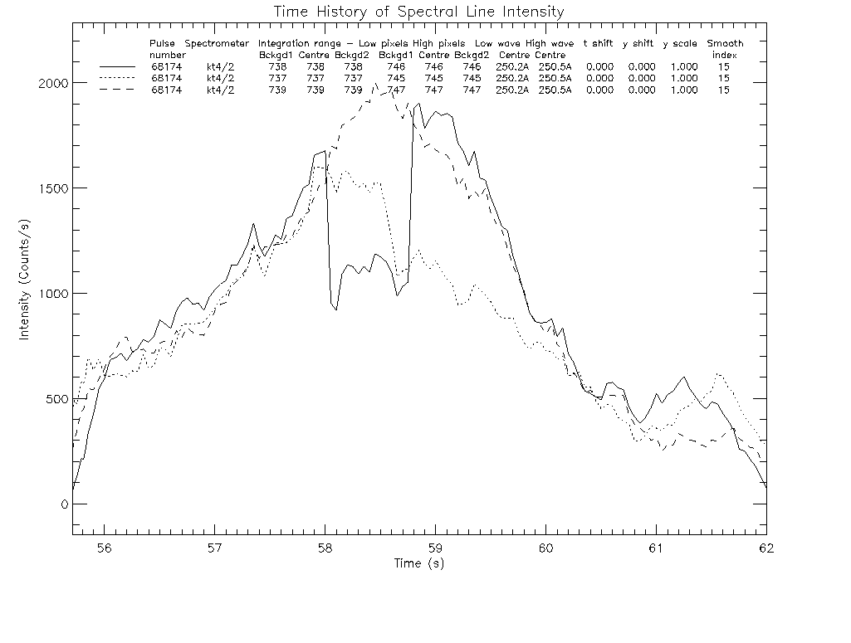

Figure 2. Line integrations for the 224.0Å line in pulse 68174
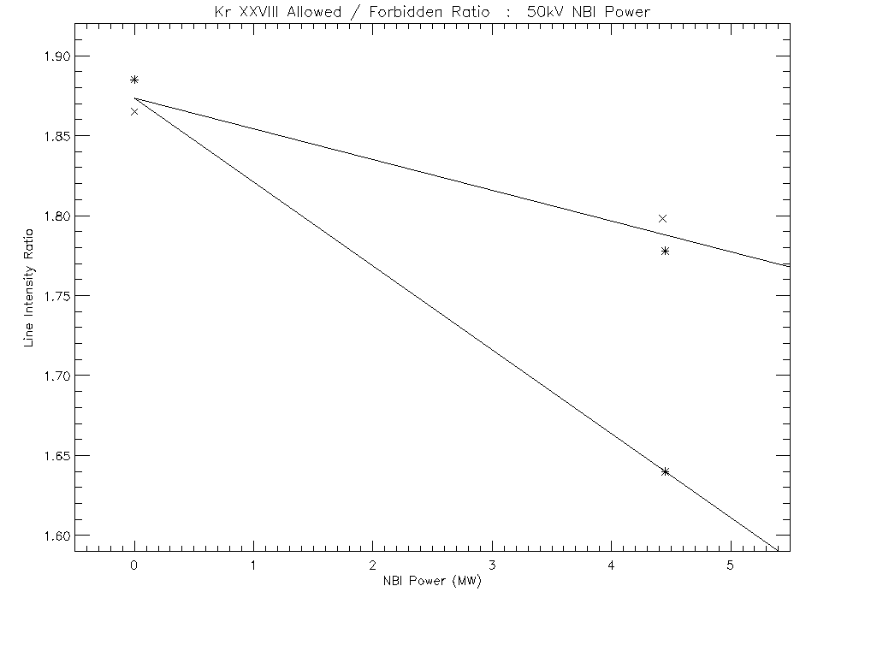

Figure 3. The median values of the line intensity ratios shows a decrease of the ratio with the NBI power for pulses 68174(*) and 68175(+) which is not due to neutron noise

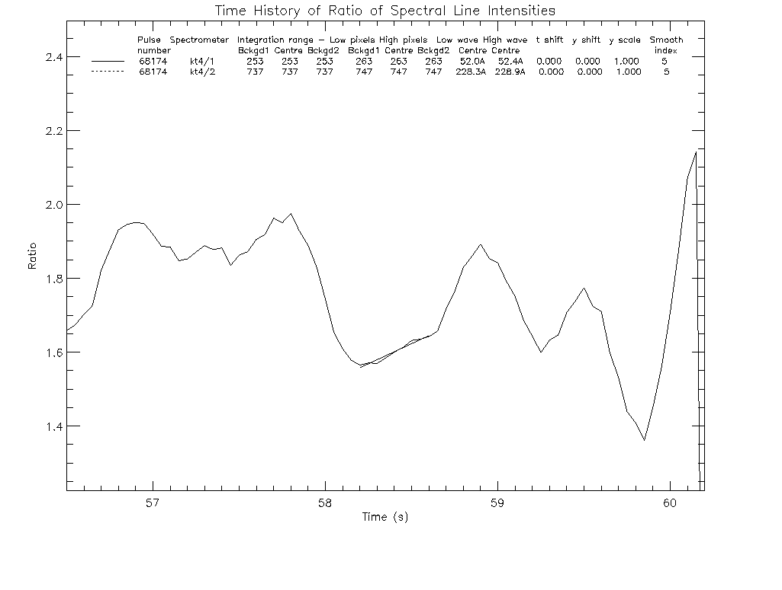

Figure 4. F-like intensity ratio for pulse 68174 as function of time.

- Conclusions
The work which has been undertaken in 200 was focused on the analysis of discrepancies between Zeff values as given from visible bremsstrahlung and charge exchange recombination spectroscopy. It has been improved by additional calculation on bound-free and free-free transitions in complex atomic system. A special attention has been paid to the accuracy of atomic data supplied by ADAS. Results on Δn=2 dielectronic recombination channel in Li-like into Be-like C was first time reported. The iso-electronic sequence of Li-like ions has been analyzed and the consequences on the rate coefficients were been discussed.
Atomic data for tungsten ions belonging different iso-electronic sequences have been provided and reported.
Web service for remote atomic data access has been proposed and distributed applications were been pointed out.
The experiments on alpha particle diagnostic performed during C15 and C17 have demonstrated the validity of the method. New refined results have to be obtained from the recently proposed ‘Least Square Deconvolution’ (LDS) method.

- Expected results for 2007
The following milestones will continue during 2007:
- Atomic data for complex atoms with 3d open shell will be provided on the basis of the close-coupling method. e.g. R-matrix calculation(RMATXII) including relativistic effects and configuration interaction.(Collaboration with The Queen’s University of Belfast)
- Web service for remote atomic data access will be implemented on atomic server, to make possible distributed applications and collaborative work between different groups belonging to different Associations interested to use our computer facility.
- Analysis, modeling and interpretation of the experimental results on alpha particle diagnostics. The necessary atomic data is available for the analysis of the experiments with Kr gas-puffing, although at present the data for heavy particle excitation of the allowed transitions is only available in preliminary form. Measurements of the change in the line intensity ratio due to the effect of heavy particles will provide confirmation of the atomic data. If the experiments prove successful, further R-matrix calculations for the electron collisional excitation and heavy particle collisional excitation data will be required for different elements and ionization stages in order to predict the best experimental arrangement for ITER. It could be used to diagnose α particles in ITER

References
[1] Stancalie, V., “MQDT/R-Matrix Floquet for Dielectronic Recombination”, American Institute of Physics Conference Proceedings, April 7, 2006, Vol. 827,448.
[2] Burke P.G., Burke V.M., Hibbert A., McLaughlin B.M., Noble C.J., Ramsbottom C.A., Scott M.P., Stancalie V., „Electron impact excitation of Fe-peak ions of astrophysical interest“ Paper presented at the International Conference on Atomic and Molecular Data, October 15-19, 2006, Meudon, France
[3] Stancalie V., Pais V.F., “Effective collision strength for electron-impact excitation of Al¹⁰⁺”, Laser and particle Beams 24(2006)235.
[4] Stancalie V., Pais V.F., Totolici M.C., Mihailescu A.F., “Forbidden transitions in excitation by proton impact in Li-like Al ions” Paper presented at the International Conference on the “Interaction of Atoms, Molecules and Plasmas with IntenseUltrashort Laser Pulses” IAMPI 2006, 1-5 October 2006, Szeged, Hungary
Laser and Particle Beams 25(2007)267.
[5] Pais V., Stancalie V., “Using Web Services for Remote Data Access and Distributed Applications”, Fusion Engineering and Design, 81(2006)15.

- Collaborative actions
Collaborative research on the plasma edge characterization and modeling , under the key area “Simulation of the VUV spectra from the reversed field pinch Extrap T2R plasma” between Association EURATOM/MEdC and Association EURATOM/VR has been concentrated towards hydrogen, the continuum and the series limit, the recombination spectrum (the volume recombination)-and the accurate measurements of fluxes which are derived from absolute intensities. The main processes, which concur to the emitted radiation spectrum from hydrogen atoms into the reversed field pinch plasma device Extrap T2R, were been examined in order to determine their contribution to the effective emissivity rate corresponding to different Balmer series lines. The model includes complete population structure of the emitting hydrogen atoms calculated in bundled picture on the basis of the Atomic Data Analysis Structure package programs. The main population output is very complete and in principle contains all information on possible emitted spectrum lines up to very high n-shell together with both ionization and recombination collisional-radiative coefficients. Separate account was taken of the bremsstrahlung emission with respect to plasma parameters and components
With respect to this task a specific milestone was included as collaborative action: Study of the emitted radiation from hydrogen atom as related to the modeling of the Extrap T2R plasma, plasma characterization and modelling; (macro task 3-3.6). Develop integrated models of edge plasma.
The main processes, which concur to the emitted radiation spectrum from hydrogen atoms into the reversed field pinch plasma device Extrap T2R, are examined in order to determine their contribution to the effective emissivity rate corresponding to different Balmer series lines. The model includes complete population structure of the emitting hydrogen atoms calculated in bundled picture on the basis of the Atomic Data Analysis Structure package programs. The main population output is very complete and in principle contains all information on possible emitted spectrum lines up to very high n-shell together with both ionization and recombination collisional-radiative coefficients. Separate account was taken of the bremsstrahlung emission with respect to plasma parameters and components

Achievements
We refer to the emission from hydrogen atoms special attention being paid to the contribution from the line radiation, the photo recombination and bremsstrahlung. The two groups of atomic coefficients relevant for plasma modeling: the photon emission coefficients and the energy emission coefficients entering the statistical balance equations (that is number of conservation) and the energy balance equation, respectively, have been averaged over the Maxwellian distribution for thermalised electron plasma region. A special attention was paid to charge exchange and ion-impact excitation transition with Δn =0 in hydrogen – hydrogen reactions. At low velocities, v ~ 1 atomic units (a.u.), electron capture is mainly into the ground state of atomic hydrogen: H+ + H(1s) →H(1s) + H+. This is a case of symmetrical resonance, in which the initial and final systems are identical. It is only in this case that the capture cross-section increases as v decreases to zero. Due to the fact that the heavy particle motion is essentially classical and for collision energy greater than a few electron volts, the incident nucleus is only scattered through a very small angle of order of milliradiants. It follows that hydrogen atoms appearing close to the direction of incidence must be product of charge – exchange. Charge exchange rate coefficient, in cm3s-1 units, involving donor H0, receiver H+, plotted versus receiver temperature, in eV units, is given in Figure 1.
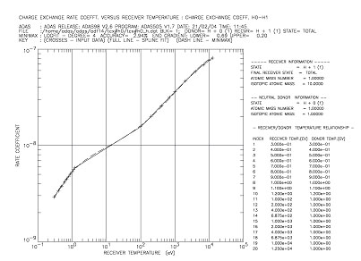
Figure 1. Charge-exchange rate coefficient in cm³s⁻¹ units, for H + H⁺ process, plotted versus ionic temperature in eV units. Results are provided from ADAS, Atomic Structure Package Programs, the VR-Association being part of the collaborative ADAS consortium.
The model is based on the collisional-radiative calculation of the atomic population density of hydrogen atoms emphases being placed on the low temperature range of a few eV. Present calculations gave numerous values of various excitation, recombination and ionization rate coefficients. Results on the emission rates from different processes have been obtained using ADAS computer package programs. Figure 2 shows results on charge exchange rate coefficient, in cm³⁺ s⁻¹, involving donor H⁰, receiver O⁺, versus receiver temperature, in eV units.
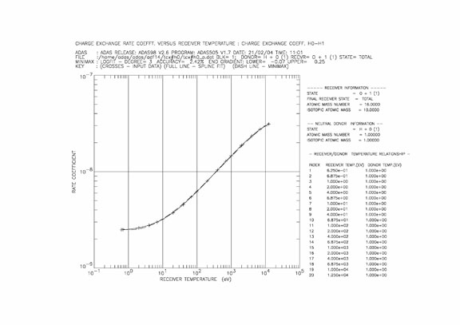
Figure 2. Charge-exchange rate coefficient in cm³s⁻¹ units, for O⁺ + H⁺ process, plotted versus proton temperature in eV units. Results are provided from ADAS, Atomic Structure Package Programs, the VR-Association being part of the collaborative ADAS consortium

In Fig. 3 is presented predicted total emissivity rate versus electron temperature from Balmer series lines, as output from calculation.

Figure 3. Predicted total emissivity rate versus electron temperature, from Balmer series lines

This work has been completed. A paper “Study of the emitted radiation from hydrogen atom as related to the modeling of the Extrap T2R plasma” by V. Stancalie and E. Rachlew, has been written being under consideration for publication in referred journal.

