G. Popa, C. Costin, S. Teodoru, V. Anita, C. Lupu, M. L. Solomon
“Al. I. Cuza” University, Faculty of Physics, Iasi

1. Introduction
This study focuses on the sheath formed between plasma and different solid electrodes (probes or targets) inserted in devices with magnetic confinement (e.g. Castor Tokamak at IPP-Czech Republic, Pilot-PSI at FOM-The Netherlands). The subject was investigated both experimentally and theoretically.
The report is structured in several parts, corresponding to the main objectives assumed by our group in the work-plan for 2006. A multi-channel analyzer was used to obtain the energy ion distribution, perpendicularly on the magnetic field, in Pilot-PSI. In the same device, current-voltage characteristics were drawn on the multi-channel analyzer plate and on the target in order to estimate the power transferred from the plasma to the solid surface. Secondary electron emission induced on a solid surface by electron bombardment was investigated in Iasi. Space charged sheath formation in front of a floating wall was numerically investigated via PIC simulations. Katsumata probe measurements were performed in Castor Tokamak regarding the ion temperature and plasma potential fluctuations.

2. Multi-Channel Analyzer
2.1 Ion Multi-Channel Analyzer. Theoretical aspects
A new type of ion analyzer was designed, which will permit to obtain the energy ion distribution, perpendicularly on the magnetic field. The constructive detail of the multi-channel analyzer (MCA) is shown in Fig.1. It consists of two multi-channel plates (MCP) made of graphite (1,3), separated by graphite spacer (2). The MCP (3) is used to fix the metallic collectors (5) through ceramic insulators (4), while the MCP (1) is exposed to the plasma.
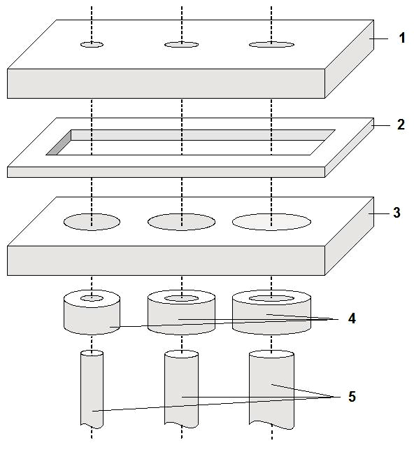 | Figure 1. Constructive detail of the  multi-channel analyzer (MCA):  1,3 – graphite multi-channel plates (MCP);  2 – graphite spacer;  4 – ceramic insulators;  5 – metallic collectors
The MCP (1) is pierced by a number of parallel holes or cylindrical channels of different diameters. One collector is associated to one channel. The collectors are metallic wires of the same diameter as the corresponding channels in MCP (1). Their collecting surfaces are situated in the same plane, parallel to the MCP. The MCA has to be orientated normally to the magnetic field lines so that the axis of the channels became parallel with direction of the magnetic field B.
An analytical treatment was performed to determine the ratio f between the ion current that passes through one channel and reaches the corresponding collector (I) and the total current entering in that channel (I₀). The analytical expression of this fraction is
, (1)
where R is the channel radius, B is the magnetic field strength, m_{i} – the ion mass, q_{i} – the ion electric charge and T_{i⊥} – the temperature of the ions in the normal plane to the magnetic field. The expression of f is obtained considering that the channel length is longer than the helical pitch of the ion trajectory. The integration variables vary in the range of 0 ≤ x ≤ 1 and 0 ≤ ϕ ≤ 2π. The distribution function of the ions was considered Maxwellian.
It can be observed that, for a given magnetic field strength B and for a specific type of ions, the ratio f depends on the ion temperature T_{i⊥} and on the channel radius. This result can be used to determine the ion temperature in the normal plane on the magnetic field. Combining the results from different channels a complete picture of the ion energy distribution in perpendicular direction might be obtained.
Theoretical results are presented in Fig.2 for hydrogen plasma, by numerically integrating the expression (1). The figure shows the variation of the ratio f with respect of the channel radius R, having the ion temperature T_{i⊥} as parameter.
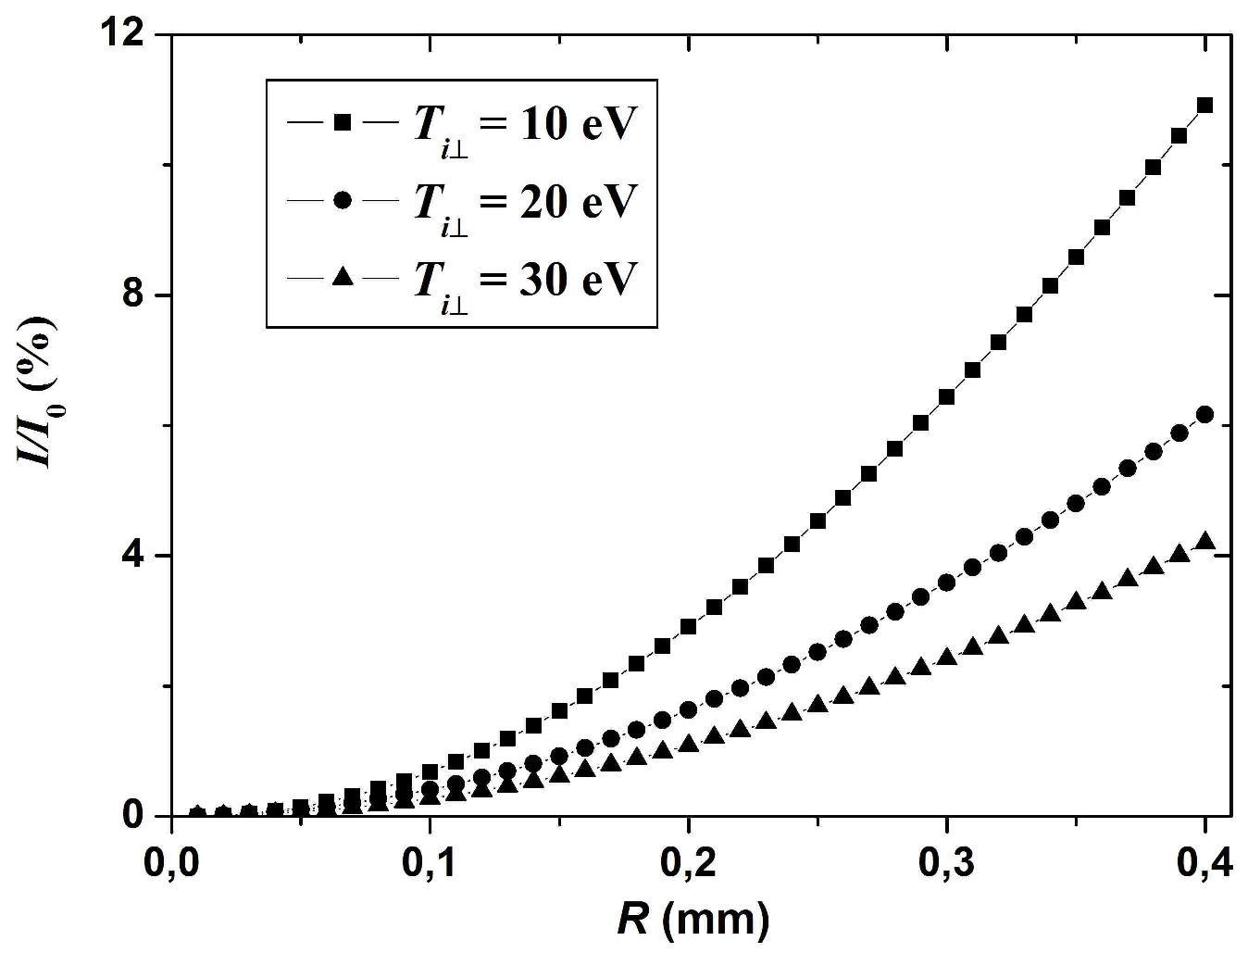

Figure 2. The variation of the ratio f = I/I₀ with respect of the channel radius R,
for different values of T_{i⊥}
From the experimental point of view, the dependence of the ratio f with R can be obtained using an analyzer with several channels of different diameters. If the experimental points fit perfectly with a theoretical curve that is similar with those plotted in Fig.2, it means that the distribution function of the ions in perpendicular direction on the magnetic field is Maxwellian. The theoretical curve gives also the perpendicular ion temperature T_{i⊥}.
Hence, to obtain these results it is necessary that only the ions coming from the plasma could enter into the channels, the electrons being rejected. This condition requires that the diameter of the channel to be smaller than the sheath thickness formed in front of the MCA. The latter one is of the order of a few Debye lengths. As an example, for hydrogen plasma with the density of 10¹² cm⁻³ and T_{e} = T_{i} = 10 eV, the Debye length is about 20 μm. With proper negative bias of the plate, the sheath thickness can be larger even as 0.2 mm. It means that diameters of the holes less as 0.2 mm have to be used. Moreover, in a magnetic field of 1 T, the corresponding Larmor radius for the above ion temperature is about 0.35 mm. Thus, for a good energetic resolution, the analyzer is suited for a lower plasma density or a higher magnetic field strength. Also, the resolution of the collected currents decreases when the ion temperature increases. This imposes another constriction to the range of use of the analyzer.

2.2 Ion Multi-Channel Analyzer. Experimental results
Results obtained in collaboration with FOM Institute for Plasma Physics “Rijnhuizen”, Association EURATOM/FOM, The Netherlands.
The Multi-Channel Analyzer (MCA) (Fig.3(a)) used for measurements of the ion energy perpendicularly on the magnetic field lines was manufactured in our laboratory in Iasi and it is composed of:
- One multi-channel plate of 1cm diameter made of graphite. Three channels are drilled in this plate, of 0.3, 0.6 and 0.9 mm in diameter.
- For each channel corresponds one collector that takes over the current passing through the channel.
- The mentioned components are fixed in a ceramic support.
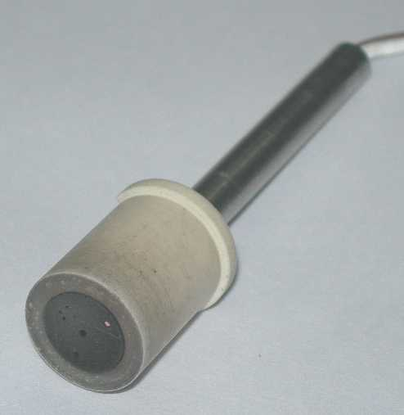 (a) 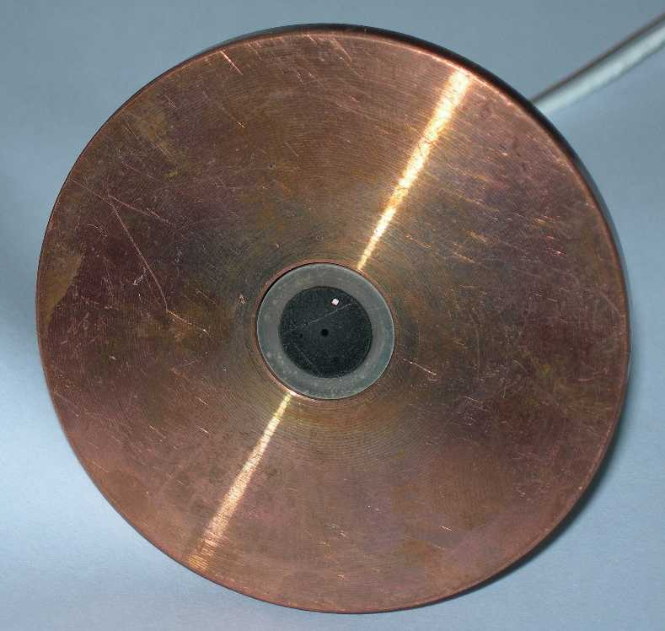 (b)

Figure 3. The Multi-Channel Analyzer (a) fixed in a copper target (b)
The MCA was designed and realised for an experimental device for which the direction of the magnetic field is well known. For this reason, the MCA was used for measurements in Pilot-PSI device at FOM Institute for Plasma Physics “Rijnhuizen”, Association EURATOM/FOM, The Netherlands. A schematic representation of Pilot-PSI is given in Fig.4. The vessel is a cylinder of 1 m length and 40 cm diameter. Plasma is produced by a cascaded arc source centred on the vessel’s axis. A water-cooled target is placed also on the axis, but opposite with respect of the arc source position. The distance between the target and the arc source can be adjusted. Using five coils, beam shaped plasma is obtained by magnetic confinement.
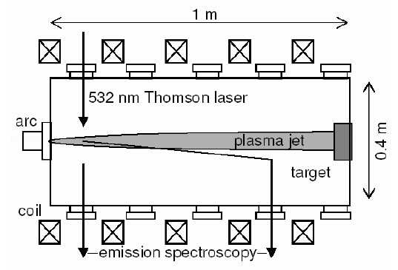

Figure 4. Schematic representation of the Pilot-Psi device
The analyzer was centred in a copper target of 6.5 cm in diameter (Fig.3(b)) and it was positioned at 67 cm from the cascaded arc source.
Three types of measurements were performed:
- The currents from the plate and the collectors were registered for different discharge conditions.
- Current-voltage characteristics of MCA plate (only the negative part of the characteristic).
- Current-voltage characteristics of a carbon target (MCA was replaced by a carbon target).
2.2.1 MCA measurements
The measurements were performed in Ar, H₂ + Ar and H₂, for a magnetic field strength B = 0.4 T, and for different current intensities of the cascaded arc source. The plate of MCA and the collectors were negatively biased with respect of the ground and more negatively than the measured floating potential of the plate in order to get only ions on the analyzer. The currents from the plate (of the order of mA) and the collectors (of the order of μA and below) were registered.
Using the collected currents, we have estimated for each channel the fraction
f = I_{c}/I_{0c} (2)
where I_{0c} is the current entering in one channel and I_{c} is the current reaching the corresponding collector. Supposing that the current density is the same all over the plate surface, the current I_{0c} can be calculated with the formula:
I_{0c} = I_{p}(S_{c}/S_{p}) = I_{p}(d_{c}/d_{p})² (3)
where S_{p} and S_{c} are the surfaces of the plate and, respectively, of the collector; d_{p} and d_{c} are the diameters of the plate and, respectively, of the collector.
The experimental values of the fraction f are plotted in Fig.5, in comparison with the analytical calculated ones, for the next discharge conditions: the current intensity of the cascaded arc source I_{s} = 60 A, the gas pressure p = 0.018 mbar and the total gas flow Q_{v} = 1 l/min. The analytical data, calculated using the expression (1), are plotted for Ar and for H₂, for two different temperatures of the ions (2 and 4 eV), while the experimental ones are plotted for Ar, H₂ + Ar and H₂.

Figure 5. The fraction f versus channel radius. Experimental and analytical values
Fig.5 shows a certain discrepancy between the experimental and the theoretical data. This disagreement may have several causes, such as:
- The plasma beam and the analyzer are not perfectly aligned, so that the current density is not the same all over the plate surface. Thus, different current densities correspond to different channels and the currents I_{0c} cannot be evaluated anymore with the formula (3).
- The radial non-homogeneity of the plasma beam. Plasma beam diameter is evaluated at ∼ 1 cm, which is the diameter of the analyzer plate. Plasma density decreases radially from the centre and also the current density. Thus, even if the alignment of the plasma beam and the analyzer is correct, the current density coming from the plasma has not the same value for all the three channels and the formula (3) is again not valid.
- The fluctuations of the plasma beam parameters. Such fluctuations were evidenced on the plate of the MCA. They are generated by the instabilities of the cascaded arc source. This is also the reason why some measurements performed in Ar and separately in H₂ seem not to be reproducible.
The main conclusion extracted from these measurements is that the proposed MCA might be useful for diagnosis of magnetised plasma radially homogeneous (homogeneous at least in a region comparable with dimension of the analyzer plate). Thus, the analyzer may be useful for the next Magnum-PSI device, where the estimated diameter of the plasma beam is about 10 cm. Moreover, attention has to be paid for aligning of the channels with magnetic field lines. The fact that the fraction f, estimated from the experimental data, is smaller than the analytical values leads to the question: were the channels of the analyzer perfectly aligned along the magnetic field lines? If not the number of ions passing the channels is decreased and that decreasing is more pronounced for smaller diameters.
After these measurements, another type of multi-channel analyzer was proposed in order to follow on-line the radial distribution of the particle flux bombarding the target of Pilot-PSI device. The new analyzer has basically the same configuration, except the number of the channels and their diameter. There are about 60 channels of the same diameter each, uniformly 2D distributed. This analyzer replaces the target, thus the plasma beam is directed perpendicularly on the analyzer surface. The electrical currents drawn by the collectors are registered simultaneously and the radial profile of the plasma beam can be reconstructed. This new analyser will be used for tests and measurements in 2007.
2.2.2 Current-voltage characteristics of MCA plate
The current-voltage characteristics of MCA plate were taken in order to determine the density of the ion current that can be obtained on the MCA plate and to verify if this value is comparable with the current densities drawn by the divertor in a tokamak. It was taken only the ion part region of the characteristic, where the plate bias was negative with respect of the ground and more negatively than the measured floating potential. The measurements were performed in Ar (Fig.6(a)) and in H₂ (Fig.6(b)), respectively, for a current intensity of the cascaded arc source of 80 A. In the case of H₂ the characteristic was taken with and without magnetic field. The range of the currents are mA for B = 0.4 T and μA for B = 0 T.
One can observe that the ion saturation current is about 0.6 A for Ar and 0.3 A for H₂ in the presence of the magnetic field. The obtained ion current intensities are small with respect of the cascaded arc source current intensity (80 A). Because the area of the analyzer plate is rather small (disk of 1 cm in diameter), the current-voltage characteristics were taken also for a carbon target of 3 cm in diameter.
(a) Ar, I_{s} = 80 A | (b) H₂, I_{s} = 80 A
Figure 6. Current-voltage characteristic of the analyzer front plate
2.2.3 Current-voltage characteristics of a carbon target
The characteristics were taken in Ar. The whole current-voltage characteristic, both electron and ion regions, is shown in Fig.7(a), for a current intensity of the cascaded arc source of 90 A. In Fig.7(b) the ion part of the characteristic is shown, for three different current intensities of the cascaded arc source, 90, 120 and 150 A, respectively. It can be observed that the ion current intensity drawn by the target is of the order of tens A, of about 4 times less than the corresponding current intensity of the cascaded arc source.
Knowing that the divertor in a tokamak is floating with respect to the plasma, the target in Pilot-Psi device should be floating in order to operate in a divertor-like mode. In this case the electron current and the ion current are equal at the target surface
I_{e} = I_{i} = I_{0i}
and the total current intensity drawn by the target is zero. The I_{0i} represents the ion saturation current intensity that can be obtained from the current-voltage characteristic of the target (Fig.7).
(a) | (b)
Figure 7. Current-voltage characteristic of the carbon target
The power density transferred by plasma to the target can be estimated as
P = P_{e} + P_{i} + βP_{R}
where P_{e} is the power density transferred by electrons, P_{i} is the power density transferred by ions, P_{R} is the power density due to electron-ion recombination at the target surface and β the fraction of P_{R} that is captured by the target.
The power density transferred by electrons or ions can be calculated as
, s = e, i
where
,
with the mean energy of s-type particle at the target surface and A the target area collecting the plasma current. The power density due to electron-ion recombination at the target surface is
,
with E_{iz} the ionisation energy for Ar (E_{iz} = 15.76 eV). Thus, the total power density becomes:
When the current of the cascaded arc source is I_{s} = 150 A, the ion saturation current is about 40 A (Fig.7(b)) in Ar and the target area is about A = 7 cm² (R = 1.5 cm). Estimating that the mean energy of the ions at the target surface is of the order of the electron temperature (Bohm’s criteria) (T_{e} ~ 1 eV as previously measured), the mean energy of the electrons is of the same order of magnitude and supposing a fraction β ≈ 0.5 (from geometrical considerations), we obtain
P ≈ 0.6 MW/m².
It has to be mentioned that this power is obtained by operating the device at low magnetic field, 0.4 T. Typical fluxes of about 1 MW/m² are considered for the chamber walls while much higher fluxes of about 10 MW/m² are estimated for the divertor in the future ITER machine. This means that Pilot-PSI can be successfully used for studying plasma-surface interaction at physical parameters that are interesting for fusion devices.
2.3 Electron Multi-Channel Analyzer
The working principle of the multi-channel analyzer is verified also in our laboratory, using electrons instead of ions, because it is easier to realise the experiment in this case. We want to confirm that the channels with various diameters are capable to collect and distinguish between the particles that have different energies perpendicularly on the magnetic field.
The experimental device consists from a cylindrical glass vessel of 16 cm in diameter and 24 cm in length. Both ends of the glass tube are closed with 2 stainless steel flanges. The vessel is connected to a vacuum system which provides an ultimate pressure of about 5×10⁻⁶ Torr. On the tube axis, at one end is mounted the multi-channel analyzer while at the other end is mounted an electron gun. The electron gun is used as source of electrons, the latter ones being accelerated up to 100 eV. For an analyzer having the channel diameters in the range of 0.3-0.9 mm, the required magnetic field strength is of the order of hundreds Gauss. The magnetic field is created with a Helmholtz coils system, which can provide a constant magnetic field up to 400 G. The device is placed inside the Helmholtz coils system such as the multi-channel analyzer is positioned in the constant magnetic field region of Helmholtz coils while the electron gun is positioned outside the coils.
The analyzer used in these experiments is different from the one described in section 2.1. The main difference is made by the insertion of a grid between the plate and the collectors. This grid permits a better separation of the charged particles. The plate is also a graphite disc, of 12 mm in diameter and 2.5 mm in depth. The grid has 100 stainless steel wires/inch, each wire having 0.1 mm in diameter. The analyzer has 8 channels, of 4 different diameters, 0.3, 0.4, 0.5 and 0.6 mm (2 channels of each diameter), disposed as in Fig.8. Each channel has a corresponding collector of about 1 mm in diameter. The channels having the same diameter are oppositely disposed with respect of the analyzer axis. This will allow verifying the axial symmetry of the electron beam and also the alignment of the electron gun and of the analyzer. This new experiment is in tests.
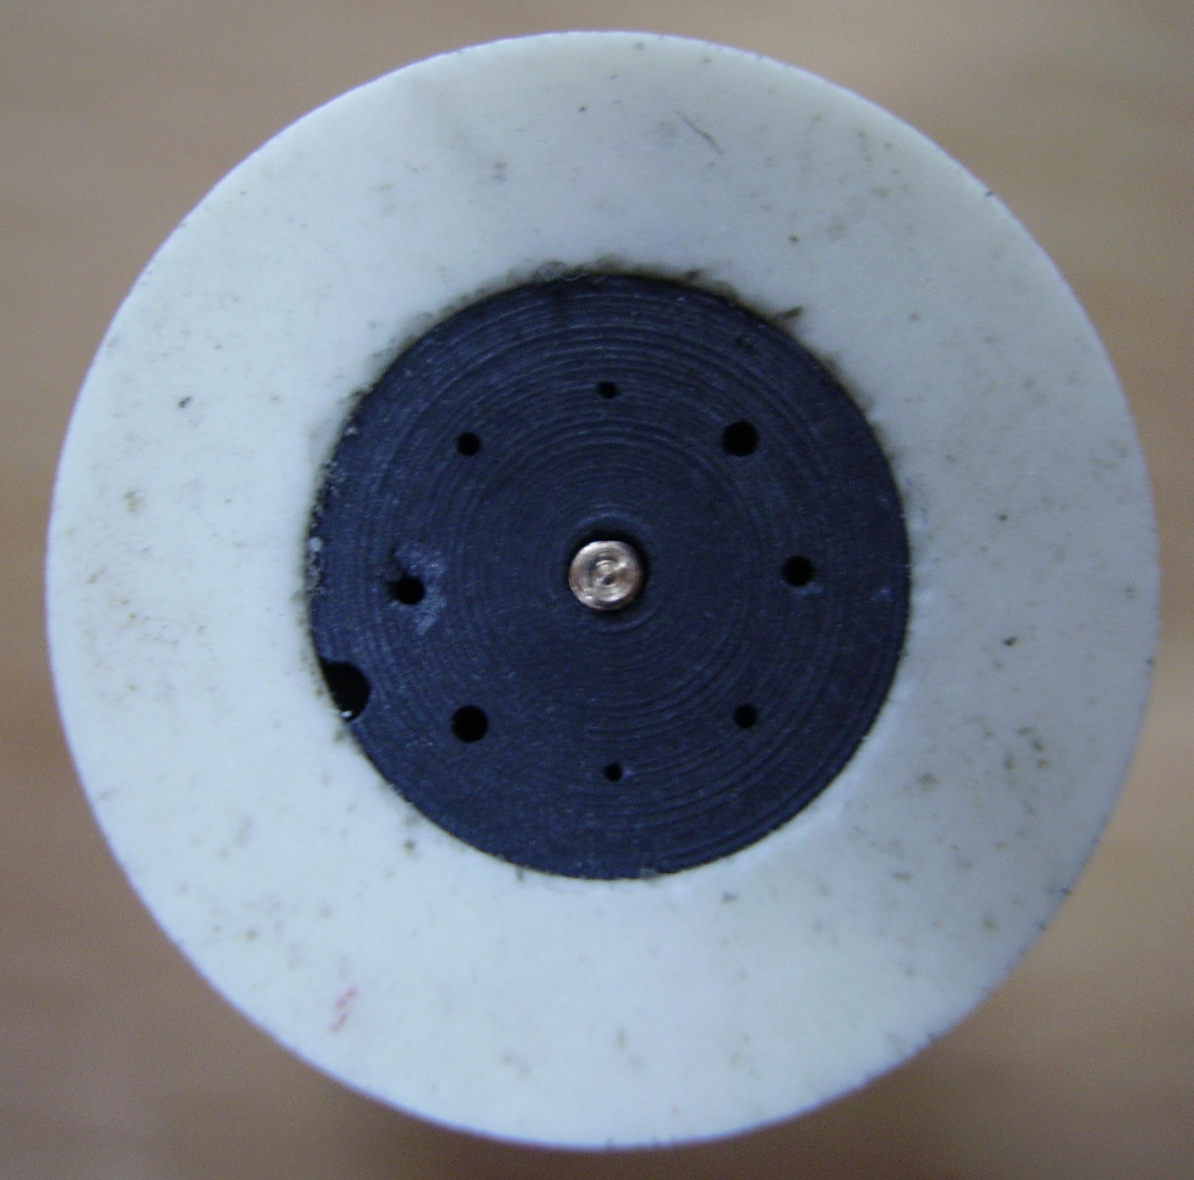
Figure 8. Frontal picture of the multi-channel analyzer
3. Fluid modelling for hydrogen magnetron
The fluid model developed for the description of an Ar/O₂ magnetron discharge was considered in order to be applied to hydrogen-magnetised plasma. Before adapting the numerical code for hydrogen, this period was dedicated to the bibliographical research concerning the input necessary data for hydrogen (atomic and molecular data). First of all there were identified the main collision processes that may occur. The corresponding elementary cross sections were processed. For electron-hydrogen interaction we have studied ionisation, rotational excitation, vibrational excitation, dissociative excitation, elastic momentum-transfer, etc. For hydrogen heavy particles we have studied the binary interactions for the following species: H, H₂, H⁺, H₂⁺, H₃⁺, H⁻. The reaction coefficients for heavy particles collision and the kinetic coefficients for heavy particles transport were investigated. Concerning the surface phenomena, we focused on the surface affinity and reactivity of different hydrogen species (atoms, molecules and ions) on carbon, tungsten and stainless steel targets. The next step is the implementation of the hydrogen data in the existing fluid model.

4. Study of the secondary electron emission induced by electron bombardment
The main objective of this research direction aims the determination of the secondary electron emission coefficient induced by bombardment of conductive surfaces (Langmuir plane-probes) with a mono-kinetic electron beam. The experiments are performed either in vacuum (~ 10⁻⁵ Torr) or in gas atmosphere, with or without plasma. The probe is immersed in low-temperature plasma burning in a multi-polar confinement system (similar with a DP machine, but with only one chamber). The electrical discharge is DC excited, working in hydrogen at 10⁻⁴ - 10⁻³ mbar pressures, in a non-magnetic stainless-steel chamber (a cylinder with 32 cm in diameter and 40 cm in length). The vessel plays the role of the grounded anode while tungsten or tantalum filament is the cathode. The chamber wall is covered with line-cusp type permanent magnets for plasma confinement.
The source of the mono-kinetic electron beam is an electron gun. The beam is directed perpendicularly to the probe surface. We have tested the functionality of the electron gun for different accelerating potentials of the electrons. The electron gun was placed at 10 mm in front of the Langmuir plane-probe, a disc made of stainless steel, of 5 mm in diameter. For electron accelerating potentials between 0 and 120 V we heave measured the current-voltage (I-V) characteristics of the Langmuir probe (plotted in Fig.9). For these characteristics the voltage of the probe was swept between -25 V and + 25 V with respect of the ground. The background pressure in the vessel was about 10⁻⁵ Torr and we did not use any buffer gas.
For accelerating potentials between 0 and 40 V the current-voltage characteristics are linear, showing that a mono-energetic electron beam bombards the probe. For accelerating potentials larger than 40 V an electrical discharge burns inside the gun. The plasma produced inside the electron gun expands out of the device and this phenomenon is evidenced on the I-V characteristic of the probe. One can see that for probe polarisation potential between -25 V and -10 V the probe collects only electrons from the mono-energetic electron beam and plasma electrons are repelled. For probe polarisation potential between -10 V and +25 V the probe collects both electrons from the mono-energetic beam and from the plasma. Thus, the total current increases. Processing the I-V curves, we can obtain the density of the two groups of electrons mentioned above.
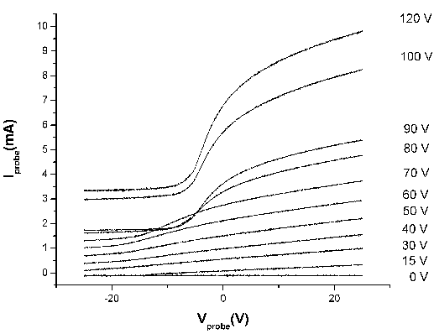
Figure 9. Current-voltage (I-V) characteristics of a plane Langmuir probe,
for different values of the accelerating potential of the electron gun

Introducing a Wehnelt cylinder between the filament and the extraction shell, the initial electron gun was modified in order to prevent the appearance of the electrical discharge inside the gun. The fact that the electrical discharge burns inside the electron gun in the absence of the Wehnelt cylinder is indicated also by the electrical current drawn by the extraction shell which could attain ~ 500 mA. The Wehnelt cylinder was polarised between 0 and +10 V with respect of the ground. Thus, even at high accelerating potentials all the characteristics are linear, indicating that only the mono-energetic electron beam bombards the probe surface.
The I-V characteristics plotted in Fig.9 show that for accelerating potentials lower than 120 V applied on the electron gun and for the sweeping voltage of the probe ranging between –25 and +25 V, the secondary electron emission is not evidenced. In order to obtain the secondary electron emission we need larger accelerating potentials and larger sweeping voltage of the probe. A new system for probe polarisation was realised, allowing the sweeping voltage to vary in the range of +/- 430 V. This system will be used in the next step of the experiment. We have also modified the data acquisition system in order to accord with the new polarisation system. The wide range of the voltage will allow studying the coefficient of the secondary electron emission induced at the probe surface by the mono-energetic electron beam.
The secondary electron emission on the probe surface may produce strong changes in the current-voltage characteristic of the probe, mainly in the ion side. For example, for a coefficient of the secondary electron emission γ > 1 the probe current may become zero for three different values of the applied voltage on the probe.

5. Collaborative actions
The following results were obtained in the framework of the collaborations that we had with other groups, involved in the EURATOM programme. The results reported in the paragraph 2.2 are also a part of the collaborative actions, but they were previously presented for a better coherence of the report.

5.1 Katsumata-type probes. Numerical simulations via XOOPIC code

Collaboration with Theoretical Plasma Physics Group, Innsbruck University, Association EURATOM-ÖAW, Austria
The purpose of the mission (April-June 2006) was to establish a correlation between the experimental results obtained with a Katsumata type probe at Castor Tokamak and an analytical estimate of the ion current of the collector electrode of the Katsumata probe.
The first part of the mobility was dedicated to complete a review of the Katsumata probe, collecting the existing material on this subject from the literature.
In the second part we tried to use XOOPIC code provided freely by the University of California, Berkley, USA, to simulate the Katsumata probe but the code was incompatible with the Linux/UNIX operating systems available at the Innsbruck University on the cluster machines. Consequently, our efforts were concentrated on developing a theoretical fluid model for the investigation of the Katsumata probe, taking into account the effects of the ionisation and of the charge exchange collisions, as well as the effects of the E×B and of the diamagnetic drifts. In our analysis we have assumed the gradients parallel with the magnetic field to be negligible small comparing with the gradients perpendicular to the magnetic field. Due to the complex geometry of the problem, we considered non-null components of the electric field along and perpendicular to the magnetic field. This analytical model of the Katsumata probe considers a three-dimensional geometry of the problem. With this analytical model we expect to estimate the ion behaviour near the collector surface of the Katsumata probe. This subject is in progress.

5.2 Evolution of the space charged sheath

Collaboration with Theoretical Plasma Physics Group, Innsbruck University, Association EURATOM-ÖAW, Austria
We have performed particle-in-cell (PIC) simulations of the sheath dynamics in front of a floating conductive planar absorbing plate collector in contact with collisional magnetised plasma. The magnetic field is uniform and is inclined at the angle θ with the normal to the collector surface. The chosen plasma parameters correspond to the conditions of the scrape-off layer (SOL) region of tokamak plasma. During the observation time, approximately sixty electron plasma oscillations, we analyse the spectrum of the longitudinal waves.
We have succeeded in showing that in the case θ = 0, the dynamics of floating-sheath formation is similar to the one for non-magnetised plasma. Due to the much higher thermal velocity of the electrons, negative electric charge starts to accumulate on the collector. Electrons with low energy are repelled and ions are attracted, gradually establishing a positive space charge. During the initial stage of the charging-up process, electron plasma waves are excited and propagate into the unperturbed plasma region.
For θ ≠ 0, the charged-particle dynamics during floating-sheath formation is more complicated, additional frequencies being observed in the plasma oscillation spectrum. Due to the presence of the magnetic field, longitudinal hybrid waves are observed.
Fig.10 shows the time evolution of the collector potential for different values of the angle θ. It is observed that for small values of θ the evolution is similar to the case of non-magnetised plasma. The dominant frequency of the oscillations is the electron plasma frequency. At higher values of θ, the motion of the charged particles along the magnetic field affects the charging-up process of the collector. In the spectrum we observe two frequencies, corresponding to lower- and upper-hybrid-mode oscillations.
Figure 10. Time evolution of the collector potential for different values of the angle θ between the magnetic field and the normal direction to the wall surface
In order to explain the behaviour of the collector potential at θ = 90° (Fig.10), the electron and ion-density evolution in time and space are investigated in the perturbed region (Fig.11). In contrast to the case θ = 10° where the electron density constantly decreases and oscillates (Fig.11(a)), we observe for θ = 90° (Fig.11(b)) that only at the very early stage the electron density decreases strongly, charging the collector negatively. After this stage the density remains almost constant, showing only small oscillations due the gyro-motion. Because of the small electron gyro-radius and the much larger ion gyro-radius, the number of positively charged particles reaching the collector is larger than the number of negatively charged ones, thus increasing the collector potential.
(a) | (b)
Figure 11. Electron density evolution in time and space for (a) θ = 10° and (b) θ = 90°.
Our previous model of the floating-sheath formation has been improved by adding the influence of the magnetic field and particles collisions. We have increased our time of observation by a factor of three and we are at the upper limit of the electron time scale.
The Particle-In-Cell (PIC) code Bit1, developed at Innsbruck University, Austria, has been ported on a new hardware with dual-processors and Scientific Linux at “Al. I. Cuza” University, Iasi, Romania, in order to continue the numerical simulations. Here the simulations will be performed for a time interval of approximately fifty ion plasma oscillations (instead of about sixty electron plasma oscillations). The time evolution of the collector potential for different values of the angle θ will be analysed having the magnetic field strength B as parameter.
5.3 Experimental measurements at Castor Tokamak in Prague

Collaboration with Castor Tokamak, Institute of Plasma Physics, Prague, Association EURATOM/IPP.CR, Czech Republic
The main goal of the campaign on May 2006 was to perform electrical measurements for plasma diagnostic, using a standard Katsumata probe, with shielded metal tube. Several plasma parameters were followed, as the fluctuations of the floating potential, electron and ion saturation currents, electron and ion temperature, especially for the comparison of these results with previous ones obtained with Langmuir probes, ball-pen probes or segmented-tunnel probes.
The fluctuations of the floating potential were measured for different biasing voltages applied on the external tube of the probe, at various positions of the collector inside or outside of the tube, in order to get information about the physical phenomena manifested inside of the probe. We were especially interested to clarify if there is a diffusion of the plasma inside the probe when the axis of the probe is perpendicular on the magnetic field lines. Biasing of the shield tube, strongly positive or negative with respect to plasma potential has strong influence on both amplitude of the collector signal and its power spectrum. It shows that diffusion model might be considered for floating regime and dielectric tube.
Another type of measurements consisted in the acquisition of current-voltage (I-V) characteristics taken simultaneously for both the external tube and the collector. Thus, from the tube I-V characteristics were obtained the plasma potential, electron temperature and electron saturation current. From the collector I-V characteristics were obtained the ion temperature and ion saturation current. Both the electron and ion temperature were in good agreement with those previously obtained by ball-pen probe and, respectively, segmented-tunnel probe measurements. The segmented-tunnel probe is a new kind of the robust Langmuir probe, designed for the parallel ion temperature measurements. It consists of a hollow conducting tunnel a few millimetres in diameter and typically 5 mm deep, closed at one end by an electrically isolated conducting back plate. The tunnel axis is parallel to the magnetic field. To remove the electron component of the incident plasma flux, both conductors are negatively biased with respect to the Tokamak vessel. The ions that flow into the orifice are diverted onto the tunnel surface by the intense radial electric field in the magnetic sheath. The tunnel is divided into two segments and the parallel ion temperature can be found from the ratio of ion current to the first and the second segment. The advantage is that the probe is operated in DC mode and thus provides fast measurements of ion temperature.

Publications and Conferences
[1] Schrittwieser R., Ionita C., Adamek J., Stockel J., Brotankova J., Martines E., Popa G., Costin C., van de Peppel L., van Oost G., “Direct measurements of the plasma potential by Katsumata-type probes”, Czechoslovak Journal of Physics 56 (2006) B145.
[2] Brotankova J., Adamek J., Stockel J., Martines E., Popa G., Costin C., Schrittwieser R., Ionita C., van Oost G., van de Peppel L., “A probe-based method for measuring the transport coefficient in the tokamak edge region”, Czechoslovak Journal of Physics 56 (2006) 1321.
[3] Costin C., Grigoras L., Popa G., “Multi-channel analyzer and perpendicular ion energy distribution in magnetised plasma”, 33rd European Physical Society (EPS) Conference on Controlled Fusion and Plasma Physics, Rome, Italy, June 2006.
[4] Brotankova J., Martines E., Adamek J., Stockel J., Popa G., Costin C., “A new-probe based method for measuring the diffusion coefficient in the tokamak edge region”, 33rd European Physical Society (EPS) Conference on Controlled Fusion and Plasma Physics, Rome, Italy, June 2006.
[5] Schrittwieser R., Adamek J., Ionita C., Stockel J., Martines E., Brotankova J., Costin C., Popa G., van Oost G., van de Peppel L., “Direct measurements of the plasma potential by Katsumata-type probes”, 33rd European Physical Society (EPS) Conference on Controlled Fusion and Plasma Physics, Rome, Italy, June 2006.
[6] Lupu C., Tskhakaya D. D. sr., Kuhn S., Tskhakaya D. jr., Popa G., “Floating sheath formation in a collisional magnetised plasma”, 33rd European Physical Society (EPS) Conference on Controlled Fusion and Plasma Physics, Rome, Italy, June 2006.
[7] Adamek J., Stockel J., Panek R., Kokan M., Martines E., Schrittwieser R., Ionita C., Popa G., Costin C., Brotankova J., van Oost G., van de Peppel L., “Simultaneous measurements of the parallel and perpendicular ion temperature by Katsumata and segmented tunnel probe”, 9th Workshop on the Electric Fields, Structures and Relaxation in Edge Plasma, Rome, Italy, June 2006.
[8] Brotankova J., Martines E., Adamek J., Stockel J., Popa G., Costin C., Schrittwieser R., Ionita C., van Oost G., “A probe-based method for measuring the transport coefficient in the tokamak edge region”, 9th Workshop on the Electric Fields, Structures and Relaxation in Edge Plasma, Rome, Italy, June 2006.

