V. Zoita*, T. Craciunescu*, M. Curuia**, S. Soare**, M. Anghel**, M. Constantin**, E. David**, A. Pantea*, I. Tiseanu*
*National Institute for Laser, Plasma and Radiation Physics, Magurele
** National Institute for Cryogenics and Isotopic Technologies, Rm. Valcea

1. Introduction
The JET KN3 gamma-ray camera diagnostics system has already provided valuable information on the fast ion evolution in JET plasmas [1]. The applicability of gamma-ray imaging diagnostics to high power deuterium pulses and to deuterium-tritium discharges is strongly dependent on the fulfilment of rather strict requirements for the control of the neutron and gamma-ray radiation fields. These requirements were augmented by the very hard design restrictions on JET (e.g., the requirement of minimum effects on the co-existing neutron camera diagnostics).
The main objective of the JET EP2 diagnostics upgrade project “Gamma-Ray Cameras – Neutron Attenuators” (GRC) is the design, construction and testing of neutrons attenuators for the two sub-systems of the KN3 gamma-ray imaging diagnostics:
- KN3 gamma-ray horizontal camera (KN3 HC)
- KN3 gamma-ray vertical camera (KN3 VC)
(The design, construction and testing of neutrons attenuators for the KX1 gamma-ray tangential spectrometer is not addressed in this report).
This diagnostics upgrade should make possible gamma-ray imaging measurements in high power deuterium JET pulses, and eventually in deuterium-tritium discharges.

Another objective of this project is to develop and test design solutions of relevance to ITER. Eventually, the JET KN3 gamma-ray cameras diagnostics upgrade should validate design solutions of interest for ITER.

2. KN3 Gamma-ray cameras neutron attenuators
Several design versions were developed and evaluated for the JET gamma-ray camera neutron attenuators at the conceptual design level. The main design parameter was the neutron attenuation factor. The following design solutions were finally chosen and developed at the level of scheme design:
- One quasi-crescent shaped neutron attenuator for the horizontal camera
- Two quasi-trapezoid shaped neutron attenuators for the vertical camera, with different attenuation lengths: a short version, to be used together with the horizontal attenuator for deuterium discharges and a long version to be used for high performance deuterium and DT discharges.
Two materials were considered for the attenuators casings: INCONEL 600 and aluminium alloy 6061. The final choice was for INCONEL 600 (3mm thick sheet) and it was determined by considerations related to the manufacturing process flow (effects of welding, bending, mechanical and electrical behaviour).

The locations of the neutron attenuators are shown schematically in Figure 1 together with the detector lines of sight of each of the two KN3 cameras. The attenuators are placed within the KN3 diagnostics system in Octant 1 between the vacuum port and the collimator body (also called “radiation shield”) both in the case of the horizontal camera (HC) and vertical camera (VC) (Figure 1).

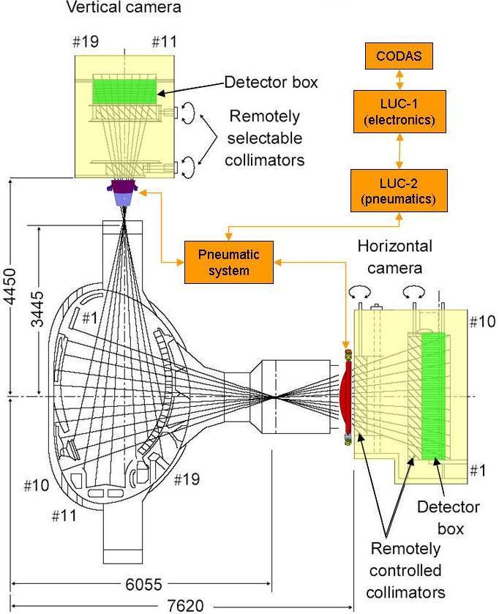

Figure 1. Horizontal and Vertical Camera Neutron Attenuator (HC-NA, VC-NA)

2.1 Horizontal Camera Neutron Attenuator
The horizontal camera neutron attenuator is designed to function as a neutron filter when in working position (in the plane determined by the gamma-ray detectors lines of sight). To remove the neutron attenuator from the working position two movements are required: first a 90º rotation (to the right when looking to plasma) and second a 630mm translation as shown in Figure 2.
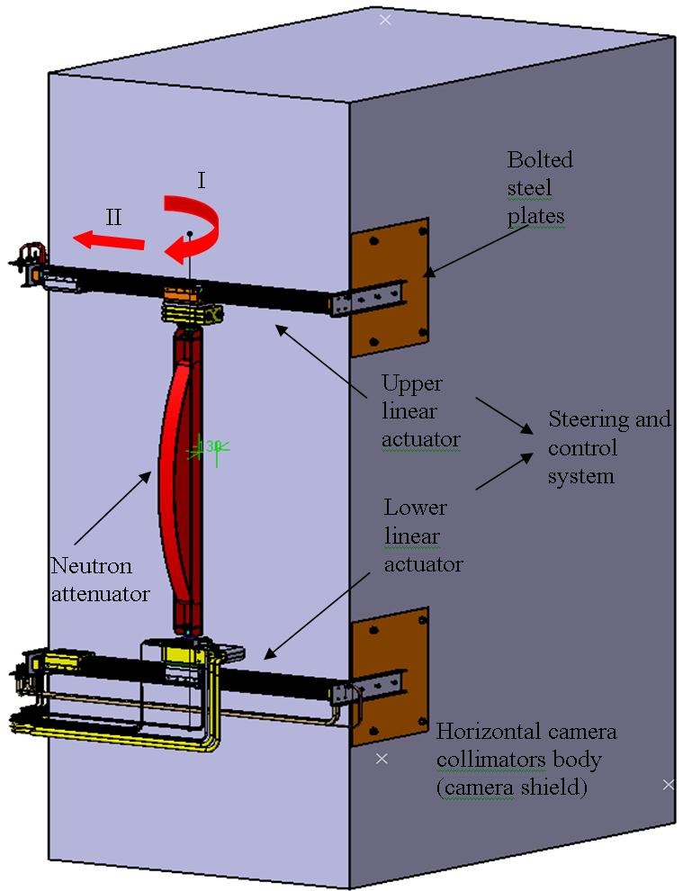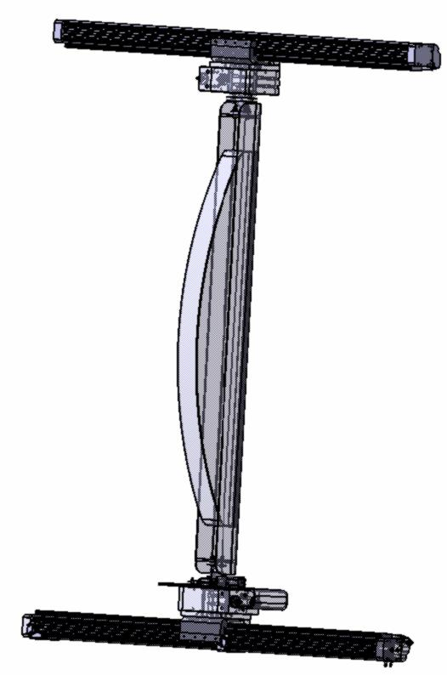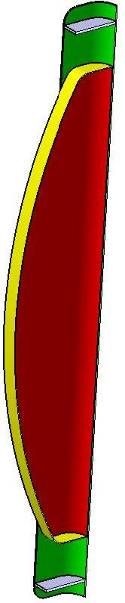

Figure 2. Horizontal Camera Neutron Attenuator in working position; HC-NA system; attenuator casing

To place the attenuator into the working position the same actions are to be taken in reverse order. The attenuator is steered and controlled by a commercially available electro-pneumatic system that includes additional several custom-tailored parts.
The neutron attenuator consists of the pure light water (used as attenuating material) casing and a U-shaped profile that provides the structure with mechanical strength and connects with the steering and control system, fig. 2.1.1.
2.2 Vertical Camera Neutron Attenuator
The vertical camera neutron attenuator is positioned on Octant 1, inside the KS3 diagnostics box, mounted on the diagnostics metal frame. To move in and out the working/parking location the attenuator is translated 100mm by a steering and control electro-pneumatic system (not as complex as that from the horizontal camera neutron attenuator), Figure 3.
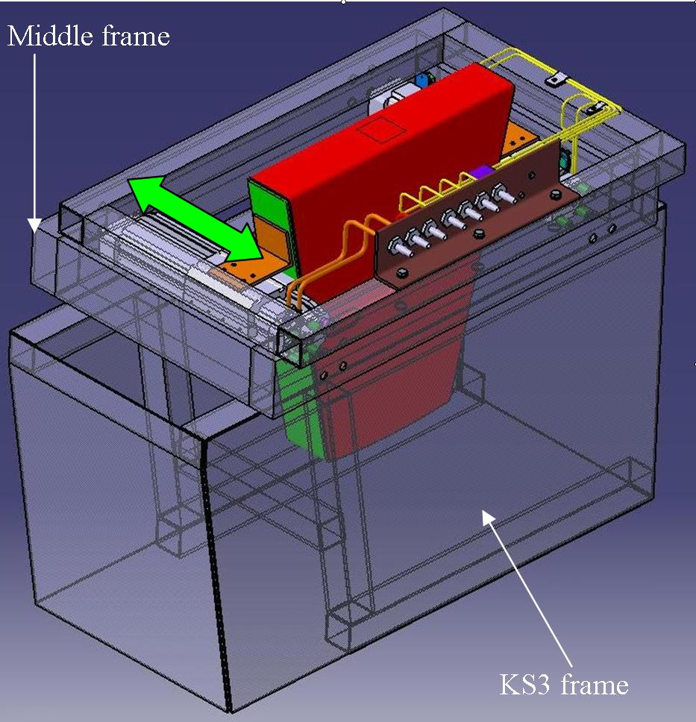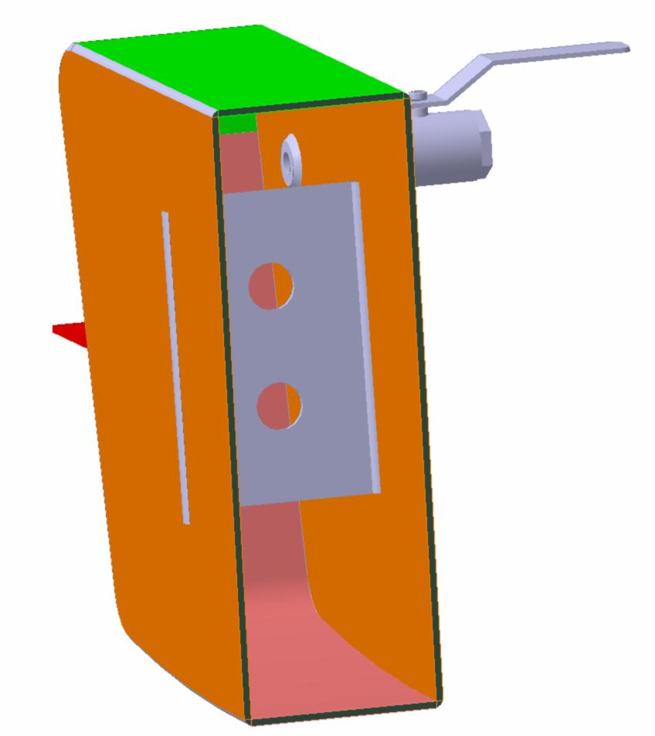

Figure 3. Vertical Camera Neutron Attenuator in working position; cross-section of the attenuator casing

Both vertical camera attenuator casings (short and long version) have a quasi-trapezoidal shape with internal reinforcements parallel and between the lines of sight.
2.3 Mechanical Stability and installation procedure
Both attenuators are situated in strong poloidal magnetic fields generated by the nearby poloidal and shaping coils. The vertical camera neutron attenuator is in a worse situation than that of the horizontal camera one due to larger torques from different directions. Finite Element Analysis was used to evaluate the casings deformation and stresses when subjected to torques larger than those thought to exist. Results suggest there is no cause of concern from this point of view.
For a reliable and repeatable installation or the neutron attenuator system (attenuator casing and pneumatics) markers existent on KN3 neutron cameras will be used. Data on the position of the markers were provided by a wide source such as site inspections, drawings, photogrametry reports and existent CATIA models. Installation of the neutron attenuators on the horizontal camera collimator body and KS3 diagnostics box will be carried out during JET shut down in the assembly hall.
Markers placed on the attenuator casings together with parts such as bolts, dowels will be used to align the casings relative to the lines of sight. At certain check points the position of the markers placed on the casings will be compared to that of the markers existent on the KN3 neutron cameras.

3. Steering and control system for KN3 gamma ray camera neutron attenuators
The KN3 gamma-ray camera neutron attenuators will operate in a very harsh electromagnetic environment. It was thus recommended to avoid as much as possible the use of electrical and electronic components for the attenuator steering and control. Therefore a design solution based on pneumatic components was developed for attenuator steering.
A block-diagram of the KN3 neutron attenuator steering and control system is presented in Figure 4. The components are grouped into three sub-systems:
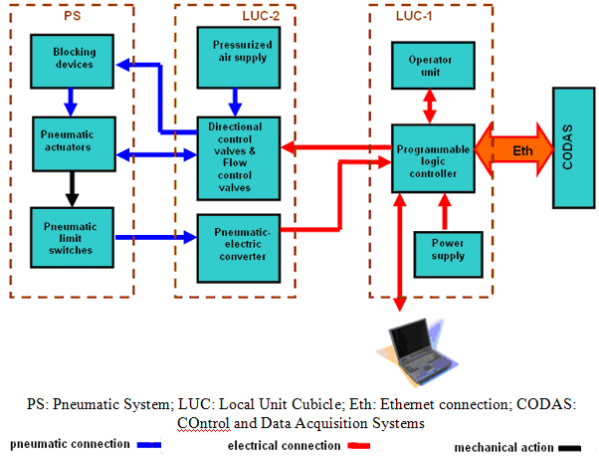
- LUC-1 (Local Unit Cubicle 1) contains a programmable logic controller, an operator unit and a power supply. The programmable logic controller that is permanently connected to CODAS receives electrical signals from the pneumatic-electric converter from Local Unit Cubicle-2, (LUC 2) and sends electrical signals to the directional control valves from LUC-2.

Figure 4. Block-diagram of the KN3 neutron attenuator steering and control system

- LUC-2 (Local Unit Cubicle 2) contains the directional control valves, the flow control valves, the pressurized air supply and the pneumatic-electrical converter.
There are two pressurized air circuits for each actuator. The pneumatic-electric converter (PEC) receives pneumatic signals (air pressure changes) from the pneumatic limit switches and converts them into electrical signals that will be sent to the Local Unit Cubicle 1 (LUC-1). The pressurized air supply will be connected to the JET pressurized system that will provide 5-7 bar air pressure.
-PS (Pneumatic System) consists of pneumatic actuators, pneumatic limit switches and blocking devices. The pneumatic actuators perform the translation and/or rotation movements necessary to place the attenuators either in the working or in the parking positions. The role of the pneumatic limit switches is to indicate whether the attenuators have reached their pre-set positions (either the working or the parking position, with no intermediate position indications). The blocking devices will hold firmly the attenuators into their pre-set positions.

4. Evaluation of detector response
The goal of this work was to analyse the influence of different CsI detector geometries for an optimum detector response in case of KN-3 gamma spectrometry. For this assessment, a working environment able to provide a realistic numerical simulation of a gamma-ray spectra measurement was established on the basis of the Integrated TIGER Series (ITS) [2], a powerful software package permitting state-of-the-art Monte Carlo solution of linear time-independent coupled electron/photon radiation transport problems.
Calculations were performed for the KN-3 channel 15 (vertical camera), for which a cylindrical geometry can be used. For source definition, a representative JET gamma spectrum, recorded with a NaI detector, was considered [3]. The existing response function for the NaI detector [3] was used, in dedicated software, as a pattern for peak fitting in order to eliminate the influence of single and double escape peaks. Realistic shapes of spectra were obtained (Figure 5). The integrated area of the spectra, for different widths of the CsI crystal, is presented in Figure 6. This global detector response can be used to choose the optimal detector thickness, as a compromise between a good detection efficiency and a reasonable price (directly related to the thickness of the crystal).
Figure 5. Experimental (left) and Monte Carlo calculated (right) pulse height spectrum in the energetic range (1.5 ÷ 5.0 MeV). The experimental spectrum is obtained in a NaI detector and the Monte Carlo calculated spectrum is performed for a CsI detector

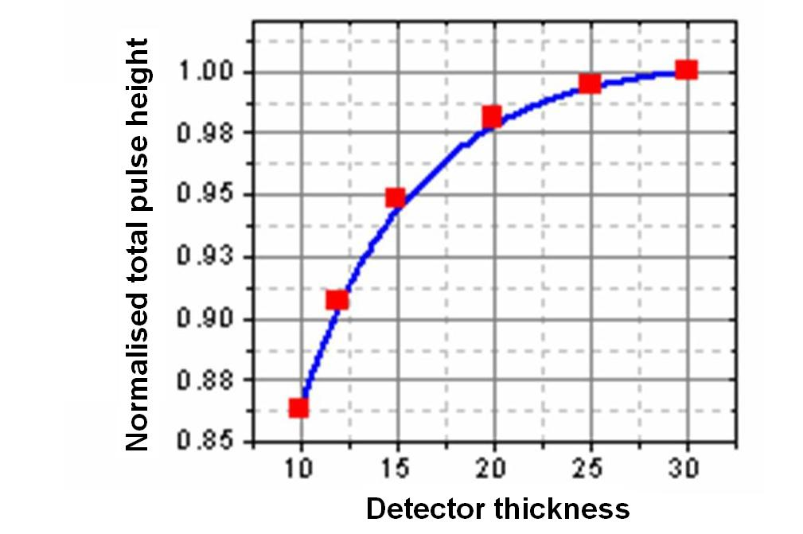 | 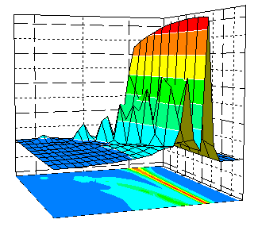
Figure 6. Global detector response vs crystal thickness | Figure 7. Energy dependent response function

The energy dependent response function of the CsI detector, necessary for spectra unfolding, was evaluated by ITS calculation of the energy deposition in the CsI detector for incident gamma rays up to 10 MeV. The response matrix for the unfolding codes must be completed by folding these calculated response functions with the Gaussian distribution using the energetic resolution function. This function can be, in principle, determined from a number of experimental spectra using gamma ray reference sources. As this experimental data is not yet available we used a FWHM value of 7% at 0.662 MeV [4] and an energetic dependence given by the equation FWHM(E) ~ E^{1/2} that is also in agreement with Ref. [5]. The response function was calculated using 256 energetic channels, and is presented in Figure 7.

5. Conclusions
The neutron attenuator system for the JET KN3 Gamma-Ray Cameras (KN3 GRC) diagnostics has the following main components (sub-systems):
- Horizontal camera neutron attenuator (HC-NA)
- Vertical camera neutron attenuator (VC-NA)
- Neutron attenuators steering and control
The activities carried out during the Scheme Design phase of the GRC diagnostics project included:
- Scheme design work for the main components mentioned above
- Numerical calculations for radiation (neutrons and gamma-rays) transport through certain components of the KN3 GRC diagnostics system
During the scheme design work for the KN3 GRC all interface problems identified at the Conceptual Design phase for the KN3 neutron attenuators have been addressed, adequate design solutions have been found and developed at the assembly design level. In some cases these solutions have been developed to the detailed design level.
The mechanical behaviour of the attenuator structure subject to the forces and torques produced by the JE disruptions was analysed by means of the finite element analysis (FEA) method and it was found that the deformations were insignificant with respect to any causes for concern.
A numerical (Monte Carlo) study of the gamma-ray detector (CsI(Tl)) provided preliminary results for the detector sensitivity and spectral response.
An updated work plan for the KN3 component of the GRC project has the following main milestones:
- Detailed design: Dec. 2007
- Manufacture: Dec. 2008
- Installation at JET: June 2009
- Commissioning: March 2010

References:
[1] Kiptily V. et al., Plasma Phys. Control. Fusion, 48 (2006) R59–R82

[2] Halbleib J.A., Kensek R.P., Mehlhorn T.A., Valdez G.D., Seitzer S.M., Berger M.J., “ITS version 3 – The integrated TIGER series of Coupled Electron/Photon Monte Carlo Transport Code”, Sandia National Laboratories.
[3] Kiptily V. – private communication
[4] SCIONIX HOLLAND BV – Specifications Detectors JET, 2005.
[5] Briesmeister J. F., Ed., “MCNP - A General Monte Carlo N-Particle Transport Code, Version 4C”, LA-13709-M (April 2000)

