underlying technology programme 2006

PHYSICS INTEGRATION

TASK: UT-tpdc-irrcer

COMPLEMENTARY INVESTIGATION ON IRRADIATED OPTICAL FIBRE

D. Sporea*, Adelina Sporea*, C. Oproiu*, Ion Vata**, Rodica Georgescu**, Ioan Petre**
*National Institute for Laser, Plasma and Radiation Physics, Magurele
** “Horia Hulubei” National Institute of R&D for Physics and Nuclear Engineering, Magurele

Optical fibre are expected to play an important role in plasma diagnostics, distributed sensing and communication within the ITER infrastructure, as different types of signals have to be transmitted in radiation environments, under high temperatures and high electromagnetic noise. Most of our previous work was dedicated to irradiation effects in the UV-visible optical range, in UV enhanced transmission and solarization resistant optical fibers. Both gamma-ray and neutron irradiation was performed. Some investigations were done on-line, at room temperature. Under gamma irradiation the phenomenon observed was related to the increase of the optical absorption with the total irradiation dose, as well as a broadening of the absorption spectrum, as more colour centres are created by the irradiation.

The objective of this investigation was to perform additional, complementary investigations (test of special optical fibers, temperature induced recovery, Electronic Paramagnetic Resonance – EPR, etc.) on large diameter optical fibers to assess their possible use in plasma diagnostics tools in ITER

- Introduction
Large diameter silica optical fibers were previously investigated in the frame of the EU’s Fusion Program in order to evaluate their qualification to be included as parts of light-guides to be used for plasma diagnostics in ITER like fusion installations.
The problems related to the use of silica optical fibers in radiation environments derive from:
- the existence on “native” colour centres in silica glasses, mostly in the UV part of the spectrum (< 400 nm);
- the build-up of additional colour centres in the UV-visible range of the optical spectrum as the fibers are subjected to various irradiations;
- the development of some colour centres induced by the manufacturing process (mechanical stress, Cl⁺ and HCl traces, different ingredients and dopants) in the optical fibre core and at the core-cladding interface.
Most of these colour centres are stable and affect permanently the optical transmission of the optical fibre in different spectral bands. In the case of some colour centres the temperature induced recovery of the optical attenuation was observed. In some situations even photobleaching (the exposure of the colour centres to optical radiation) can diminish the influence of the radiation-induced attenuation.
The interaction of radiation (either the ionising one or UV radiation) with silica optical fibers proved to be a very complex phenomenon and research in the field is carried out for almost 50 years. The complexity of the problem resides both in the multitude of effects present in these interactions, and in the great variety of optical fibers proposed as possible candidates to operate in radiation environments. As it concerns the optical fibers able to work in the UV spectral range several types were proposed:
- optical fibers with an enhanced UV transmission,
- solarization resistant optical fibers, etc.
More recently, H₂-loaded optical fibers entered the competition of radiation hardened components. Up to now, they were investigated in the visible – near IR spectral range. Besides the requirements for radiation resistance, such optical fibers have to exhibit a fairly good optical transmission below 400 nm and have to perform well under high temperature stress.
Our previous investigations concerning the radiation effects on silica optical fibers to be used in the UV range showed that the content of irradiation induced colour centres is dependent on the optical fibre type, and the irradiation conditions (energy spectrum, total dose/ fluence).
The attenuation spectrum not only increases its maximum as the total dose increases, but also presents a broadening of the absorption peak, as new colour centres appear.
Considering the complexity of the problem, we decided to perform additional investigations to complement data obtained for the optical attenuation measurements done over different spectral bands. The use of some complementary investigation methods is expected to offer more information on the radiation - optical fibre interaction and to assist us in the identification of, at least, some colour centres. By finding such answers, more links between the optical fibre type and its irradiation history can be established. Of course, the task it is not an easy one as far as we miss an inside view on the manufacturing process and a detailed knowledge of the optical fibre composition.
Based on a bibliographic research, we decide on a two-way approach in the investigation of irradiation induced colour centres:
- the development of a method to deconvolute the optical attenuation spectra of the irradiated optical fibers as they were measured after the irradiation in the UV spectral range;
- the run of several investigations, which are expected to offer a better inside on the dynamics of colour, centres in irradiated optical fibers.
Referring to the first approach, we started form the optical attenuation spectra we have obtained during automatic measurements run either in situ (during the irradiation process), or in the Laboratory after the irradiation. We have to recall here that we perform all the measurements under PC control using an optical fibre multi-channel spectrometer, adequate light sources and an optical fibre multiplexer. Data are collected and saved in Excel compatible format by original data acquisition programmes run under the LabVIEW graphical programming environment.
To deconvolute the acquired spectra in the 200 nm – 400 nm spectral band we devised a virtual instrument able to recall the saved spectra, to compensate for the optical biasing introduced by the optical fibre connectivity used during the measurements, and to fit the attenuation spectra associated to colour centres reported in the literature to the real attenuation spectra. The colour centre related spectra could be introduced by the programmer as the peak value of the attenuation curve and its FWHM (full-width half maximum).
Of course, at this stage the deconvoluted spectra constitute only a starting point, a hypothesis. Nevertheless, such an approach is useful for comparative investigation on the dynamics of colour centres, the way different colour centres contribute to the overall attenuation as function of the optical fibre type, irradiation/ recovery conditions.
The second step (the complementary investigations proposed) tries to identify some of the colour centres present in the sample in order to assist the first step in a more realistic evaluation of the post irradiation situation. Paramagnetic colour centres can be localized by Electron Paramagnetic Resonance (EPR) measurements. As far as some colour centres exhibit also a fluorescence emission, attempts to observe this optical emission can help to identify the respective colour centres. Additionally, some colour centres are related to radioluminscence emission. As some colour centres can be compensated by heat treatment of the optical fibre, the measurement of the optical attenuation during sample heating can assist further in identifying specific colour centres. From the beginning we have to underline that such an approach is a very difficult one as far as:
- the amount of material (i.e. optical fibre used in these investigations) can be quite small as compared to the sensitivity of the proposed methods of investigations, hence, a difficulty in extracting data for such experiments;
- not all colour centres respond to the stimuli used in these investigations (i.e. temperature recovery, fluorescence, radioluminescence, photobleaching);
- some measurements are either destructive (the optical fibre sample has to be cut in pieces in order to fill the space available for investigations), or the measurement itself alters the optical fibre characteristics (i.e. temperature induced recovery).

- Experimental set-up
For the investigations related to the temperature effect on the recovery of the optical attenuation we prepared a set-up in which a PC controls the temperature changes in an oven that accommodates the optical fiber sample during the test. As the temperature increases linearly for the room temperature to about 250 ^{O}C the optical fiber attenuation is automatically monitored. Any temperature-induced modification of the optical attenuation can be associated with a would-be transition temperature. A typical temperature profile we used during our investigation is presented in Figure 1.
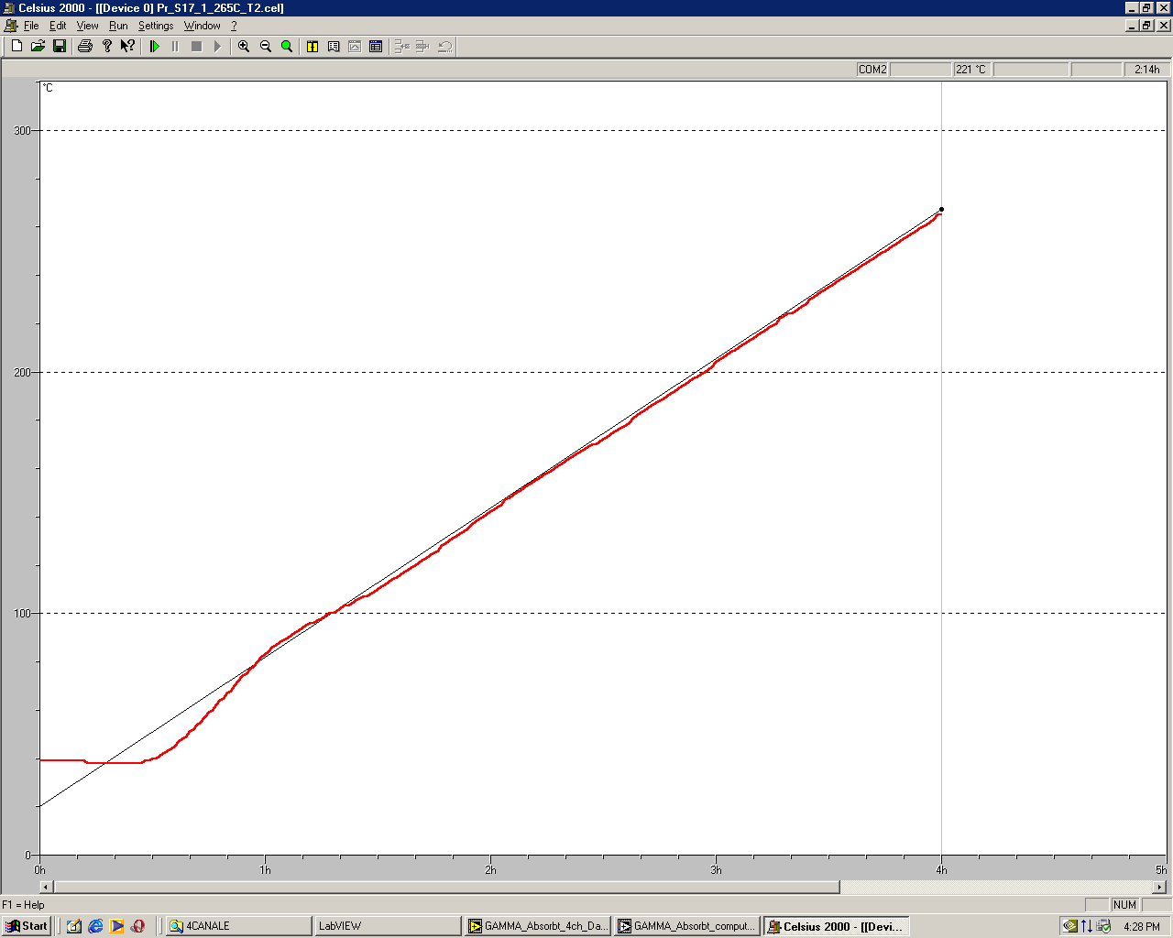
Figure 1. The typical temperature profile used to evaluate the heating induced recovery of the optical attenuation in irradiated optical fibers.

Up to now, during all the in-situ investigations we carried out we looked also for some form of radioluminescence. For the gamma-ray irradiation and the neutron irradiation used we noticed no irradiation induced optical emission in silica optical fibers.
At this stage we performed some in-situ investigation on light emission under electron beam irradiation at the Accelerator Laboratory of our Institute. The set-up used for the in-situ electron irradiation at room temperature is given in Figure 2.
We investigated one type of optical fiber having an UV enhanced transmission and covered with polyimide jacket (core diameter: 400 μm). The tests were carried out at two dose rates: 2 kGy/min and 0.7 kGy/min. In the first case, two segments of the optical fiber were irradiated of a length of about 10 mm. In the second case, the investigated optical fiber was coiled with a radius of 45 mm, and the coil was completely exposed to the electron beam. A second investigation was performed on an OF1 sample (see Table 1 below). In this situation the optical fiber was of 50 cm length, while the dose rate was 2 kGy/min and the exposure time was 3 hours. The irradiations were done both at room temperature and at 240 ^{O}C. At the mentioned dose rates, no radioluminescence signal was detected.
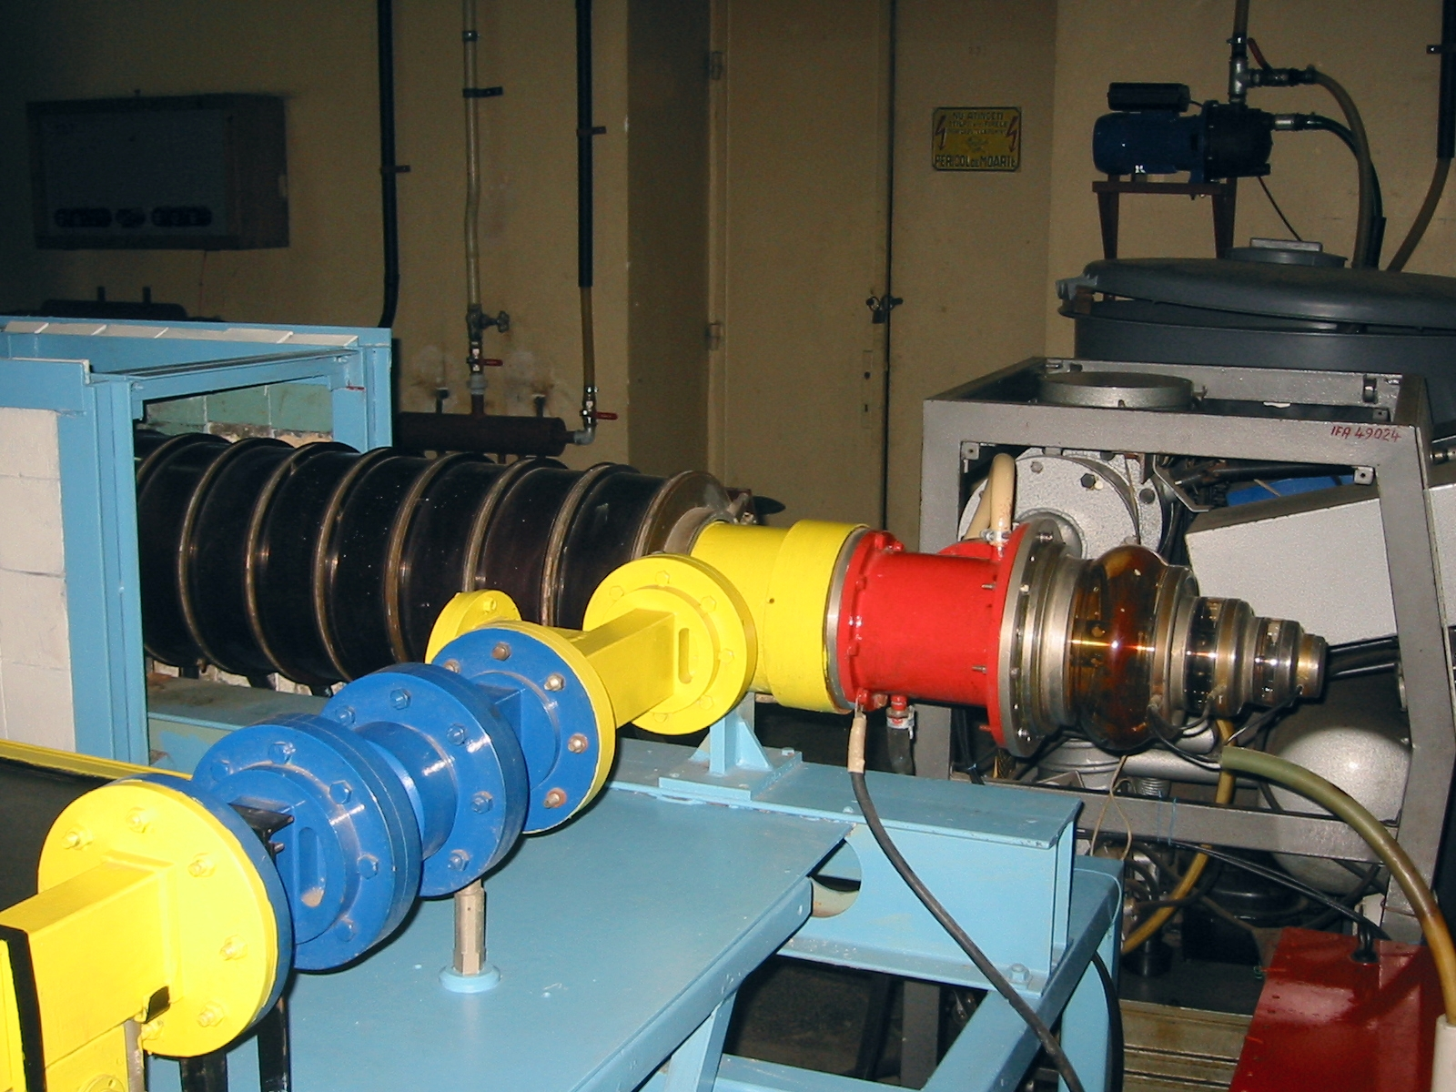
Figure 2. The set-up for the in-situ electron beam irradiation of optical fibers.

We continued our investigation on radiation induced optical absorption in optical fibers by evaluating the optical attenuation induced by electron beam irradiation followed by gamma ray irradiation, using the set-up illustrated in Figure 2. In this case gamma ray was obtained, as the electron beam was incident on a tungsten target. The electron beam dose rate was 2 kGy/min, while the gamma ray dose rate was 9 Gy/min. The total irradiation dose for the electron beam irradiation was 360 kGy, and the total gamma dose was 468 Gy.
Investigations on the detection of paramagnetic color centers in the optical fibers we irradiated were performed at the University of Palermo, within the frame of a bilateral cooperation and research exchange programme, and at the “Horia Hulubei” National Institute of R&D for Physics and Nuclear Engineering–IFIN-HH. Some attempts were also made by our Italian partners to observe luminescence emission in optical fibers we use for UV applications.

- Results
3.1. Gaussian deconvolution for the optical attenuation spectra
Some examples of the deconvolution of optical attenuation spectra for the UV enhanced transmission (OF1) and solarization resistant optical fibers (OF2 and OF3) under various irradiation conditions are given in Figures 3 – 16. For the description of the optical fibers used see Table 1.
Table 1. Characteristics of the investigated optical fibers.

 | Optical fibre | Type of the optical fibre | Core diameter [μm] | Cladding diameter  [μm] |  | Jacketing  (diameter, μm) | Sample length  [mm]
 | OF1 | Enhanced UV response | 600 | 660 |  | Polyimide (710 μm) | 25
 | OF2 | Solarization resistant/ H2 | 400 | 440 |  | Polyimide (480 μm) | 25
 | OF3 | Solarization resistant/ H2 | 400 | 440 |  | Polyimide (480 μm) | 25
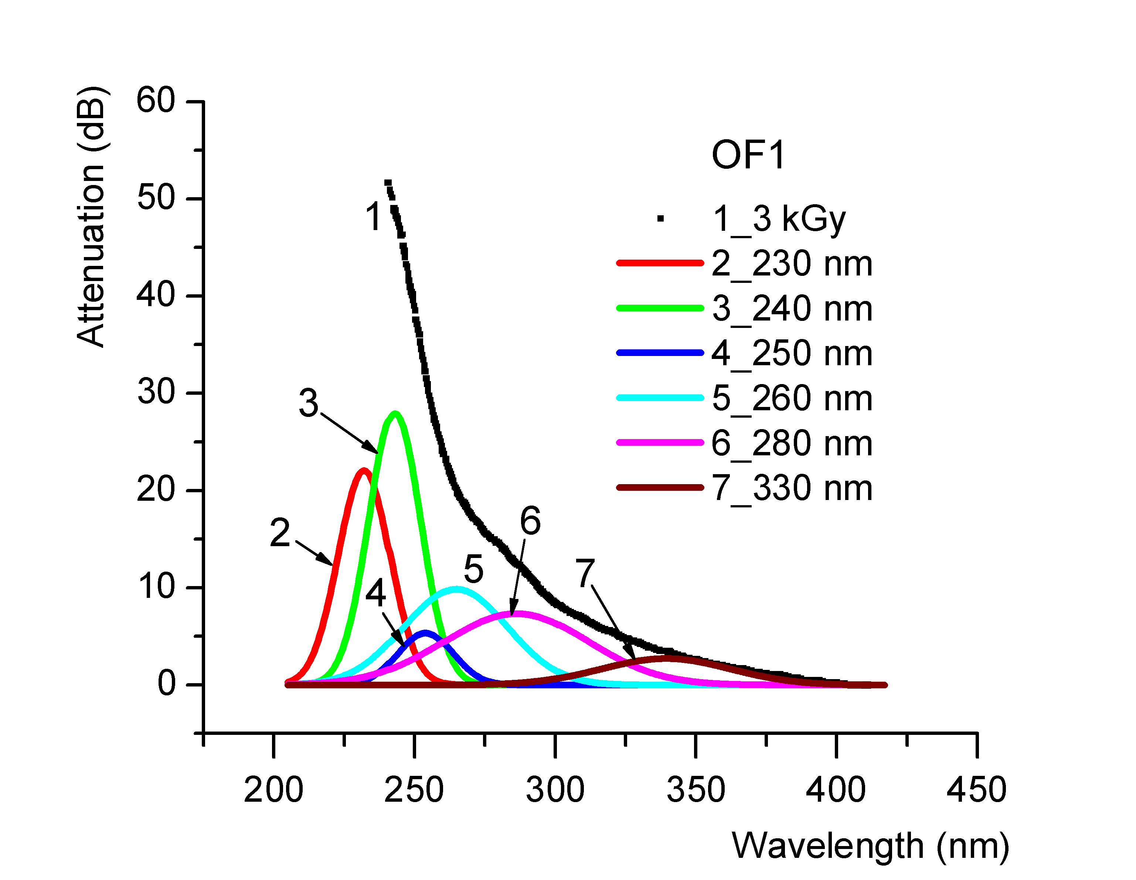 |  |  |  |  | 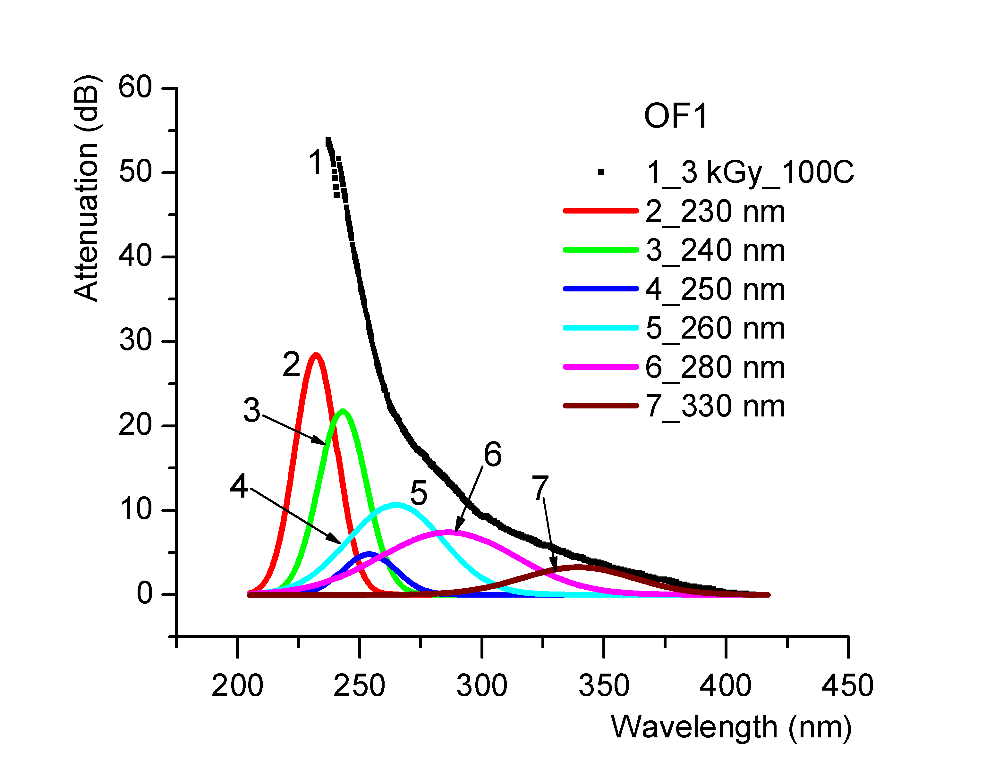
Figure 3. The Gaussian deconvolution for the optical fibre OF1, at the total irradiation dose of 3 kGy (off-line, gamma irradiation) |  |  |  |  | Figure 4. The Gaussian deconvolution for the optical fibre OF1, at the total irradiation dose of 3 kGy followed by heating at 100 ^{O}C, for four hours (off-line, gamma irradiation).
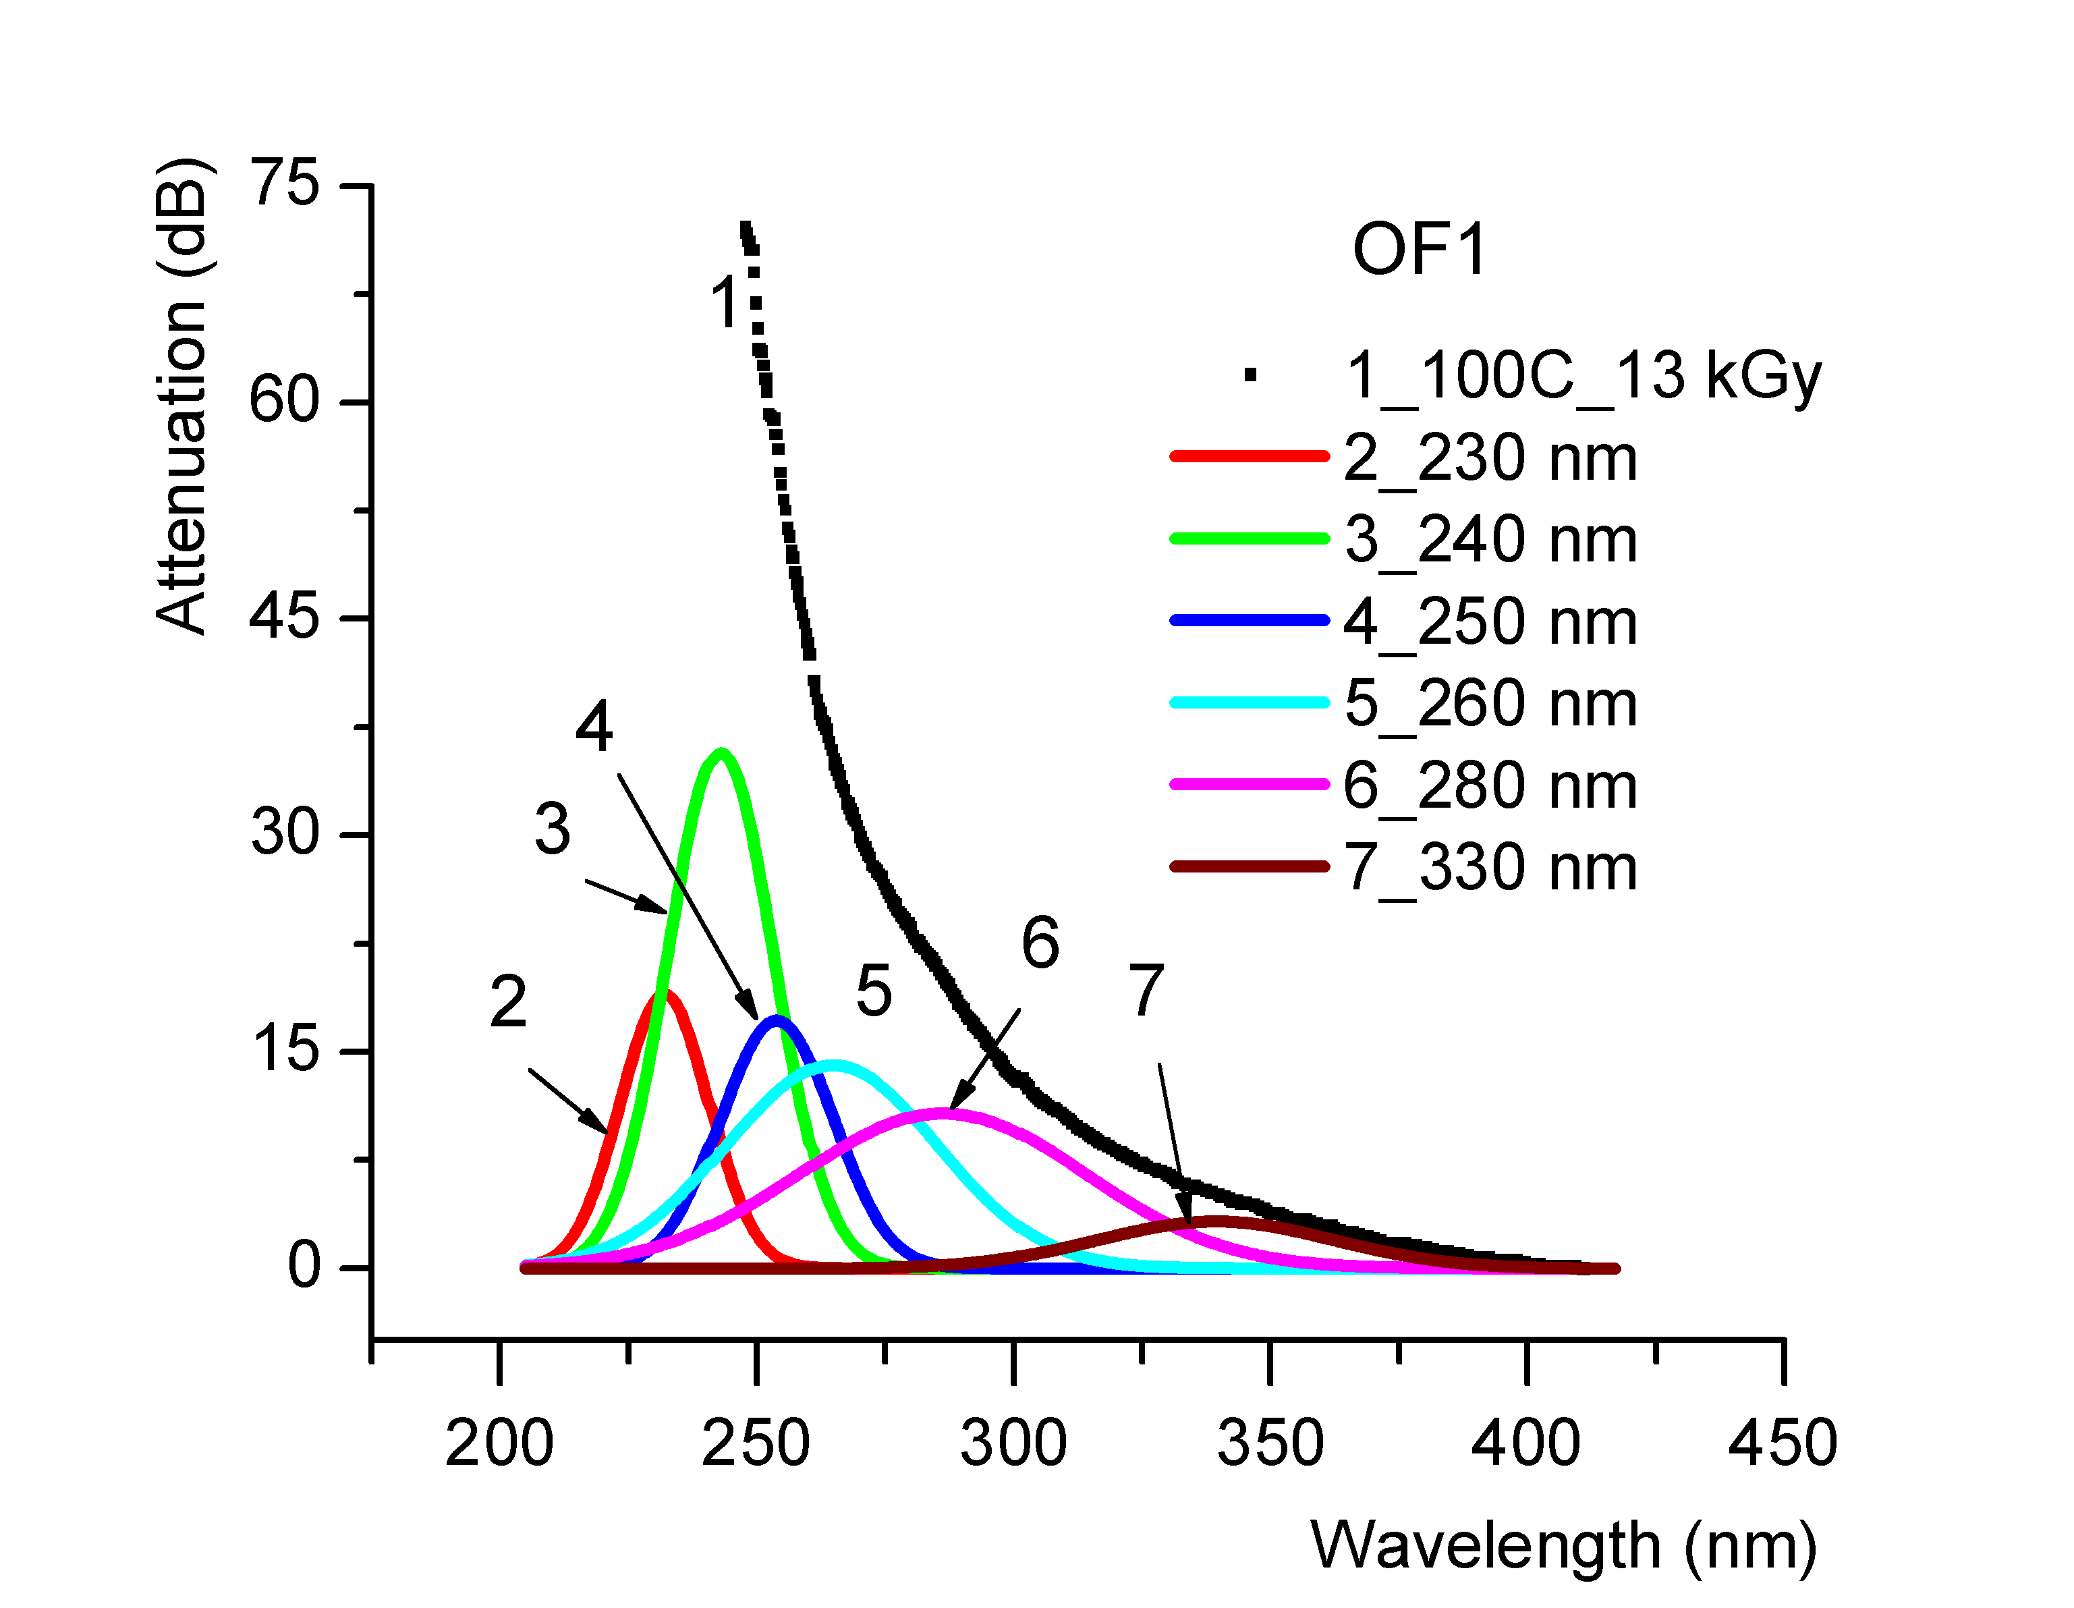 |  |  |  |  | 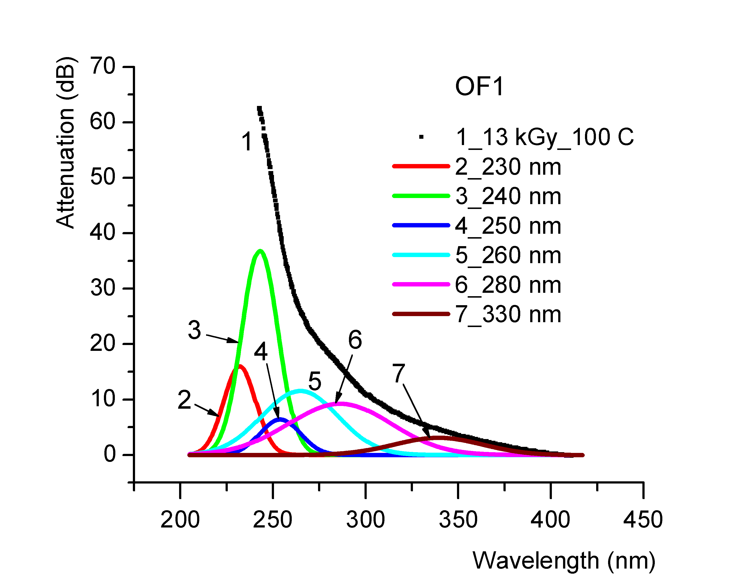
Figure 5. The Gaussian deconvolution for the optical fibre OF1, being heated at 100 ^{O}C (for four hours) and then irradiated at a total dose of 13 kGy (off-line, gamma irradiation). |  |  |  |  | Figure 6. The Gaussian deconvolution for the optical fibre OF1, at the total irradiation dose of 13 kGy followed by heating at 100 ^{O}C, for four hours (off-line, gamma irradiation).
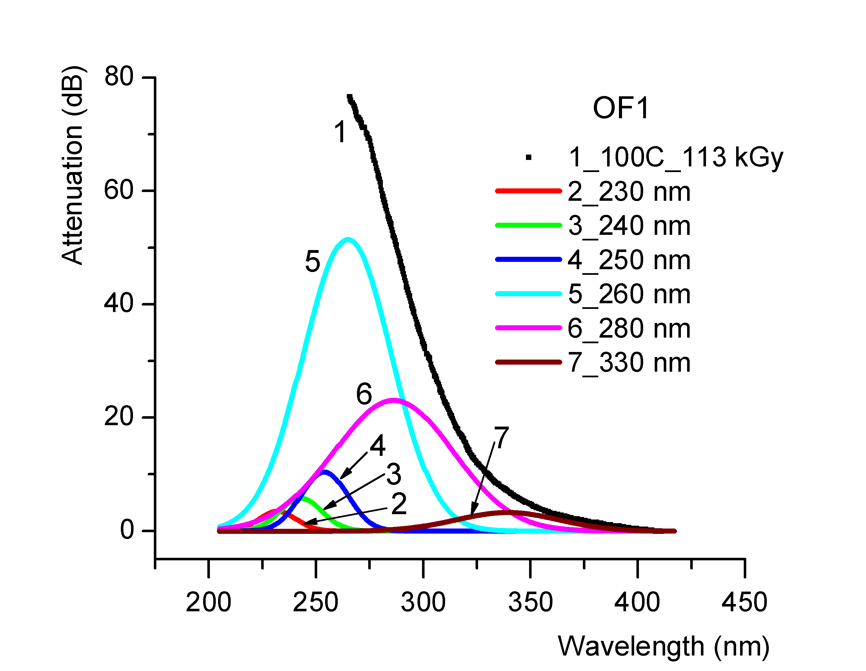 |  |  |  |  | 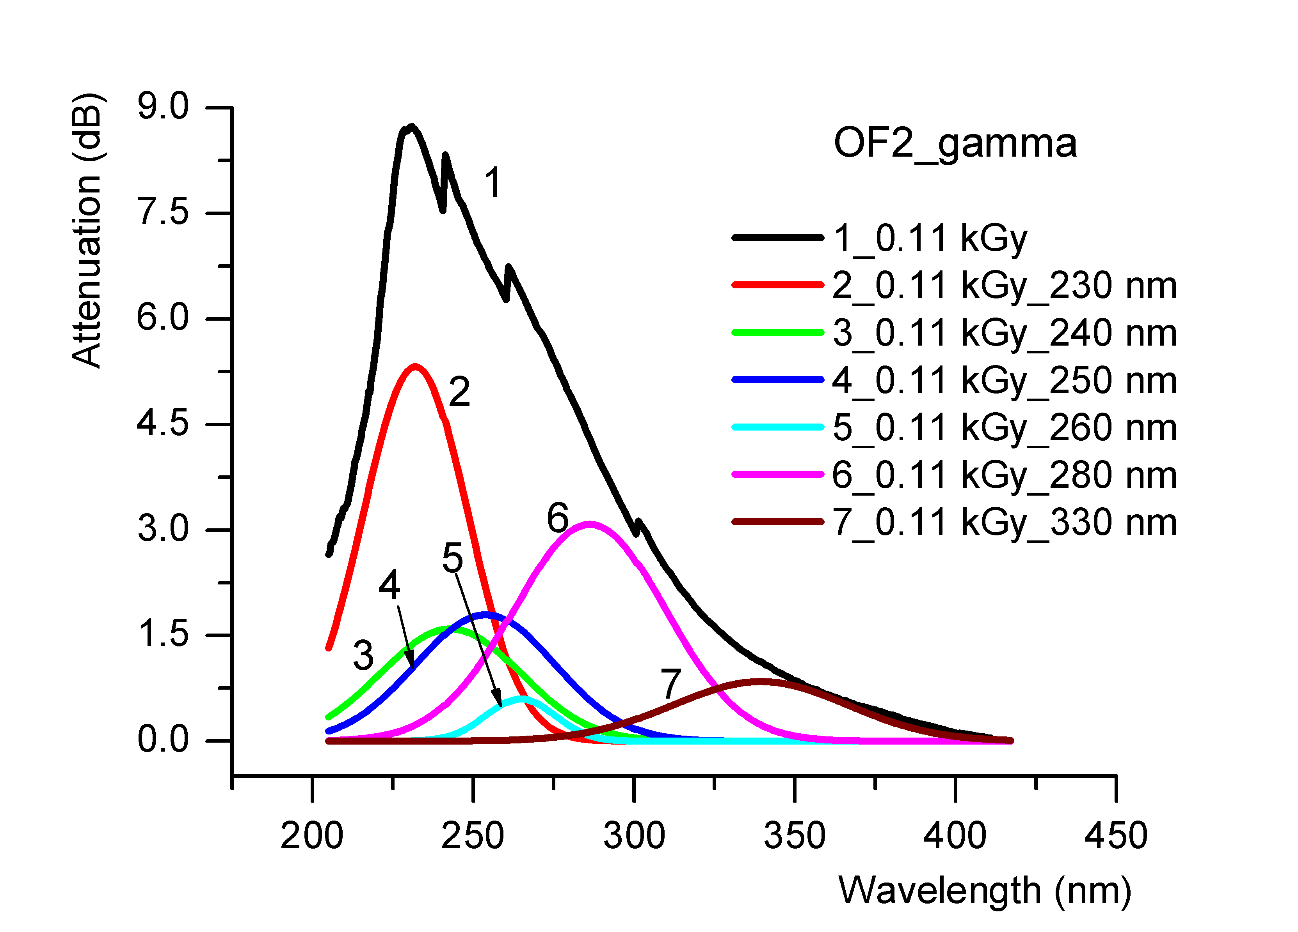
Figure 7. The Gaussian deconvolution for the optical fibre OF1, being heated at 100 ^{O}C (for four hours) and then irradiated at a total dose of 113 kGy (off-line, gamma irradiation). |  |  |  |  | Figure 8. The Gaussian deconvolution for the optical fibre OF2, at the total irradiation dose of 0.11 kGy (in situ gamma irradiation).
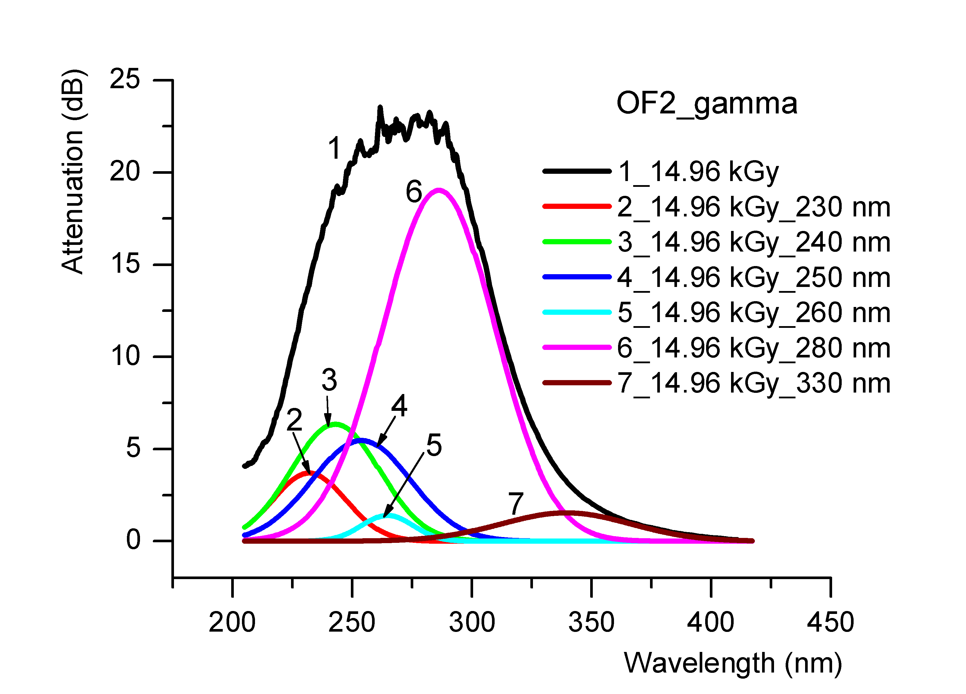 |  |  |  |  | 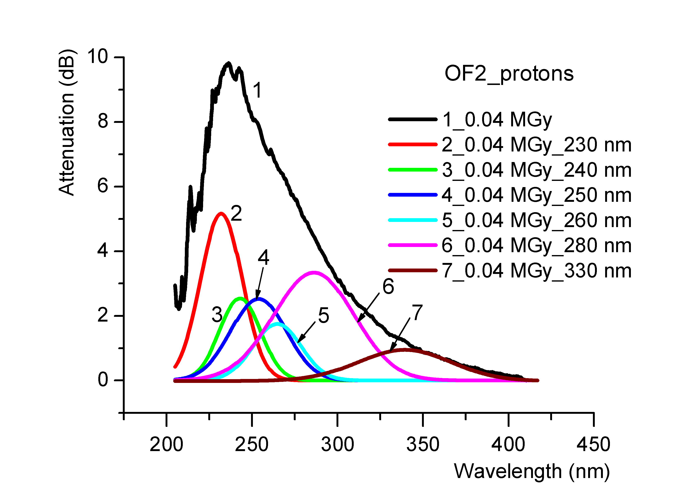
Figure 9. The Gaussian deconvolution for the optical fibre OF2, at the total irradiation dose of 14.96 kGy (in situ gamma irradiation). |  |  |  |  | Figure 10. The Gaussian deconvolution for the optical fibre OF2, at the total irradiation dose of 0.04 MGy (in situ proton irradiation).
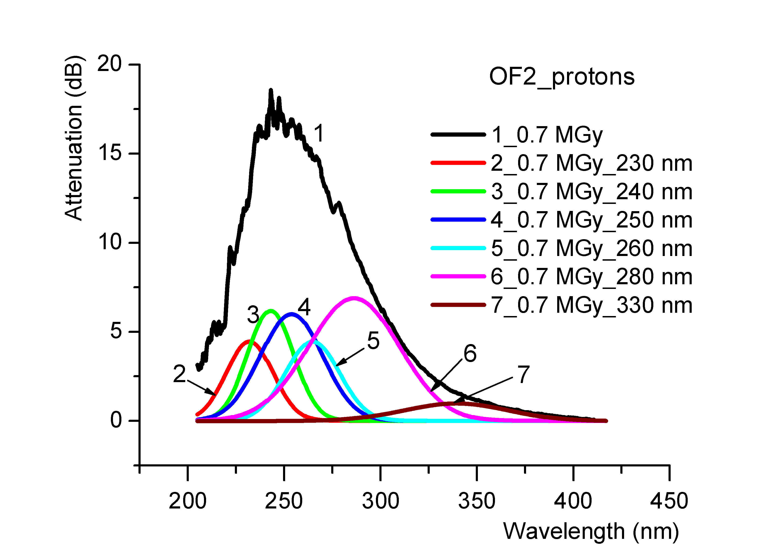 |  |  |  |  | 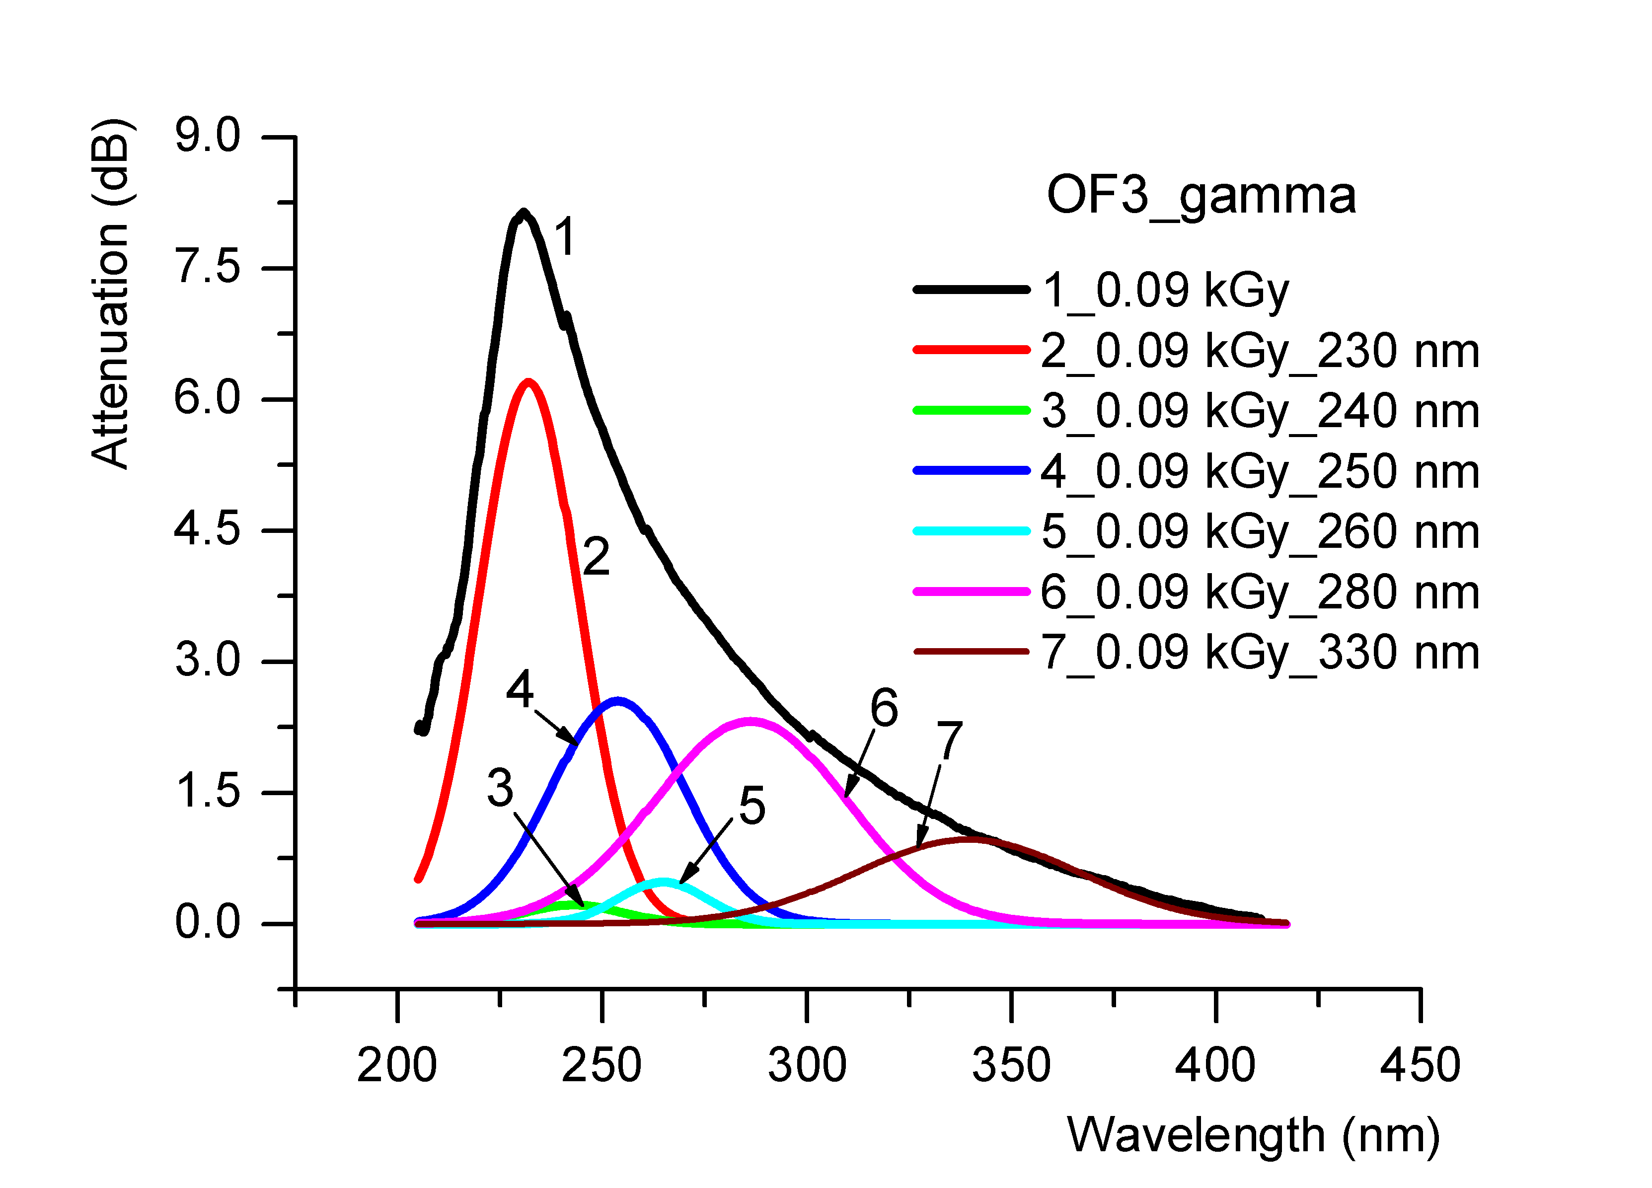
Figure 11. The Gaussian deconvolution for the optical fibre OF2, at the total irradiation dose of 0.7 MGy (in situ proton irradiation). |  |  |  |  | Figure 12. The Gaussian deconvolution for the optical fibre OF3, at the total irradiation dose of 0.09 kGy (in situ gamma irradiation).
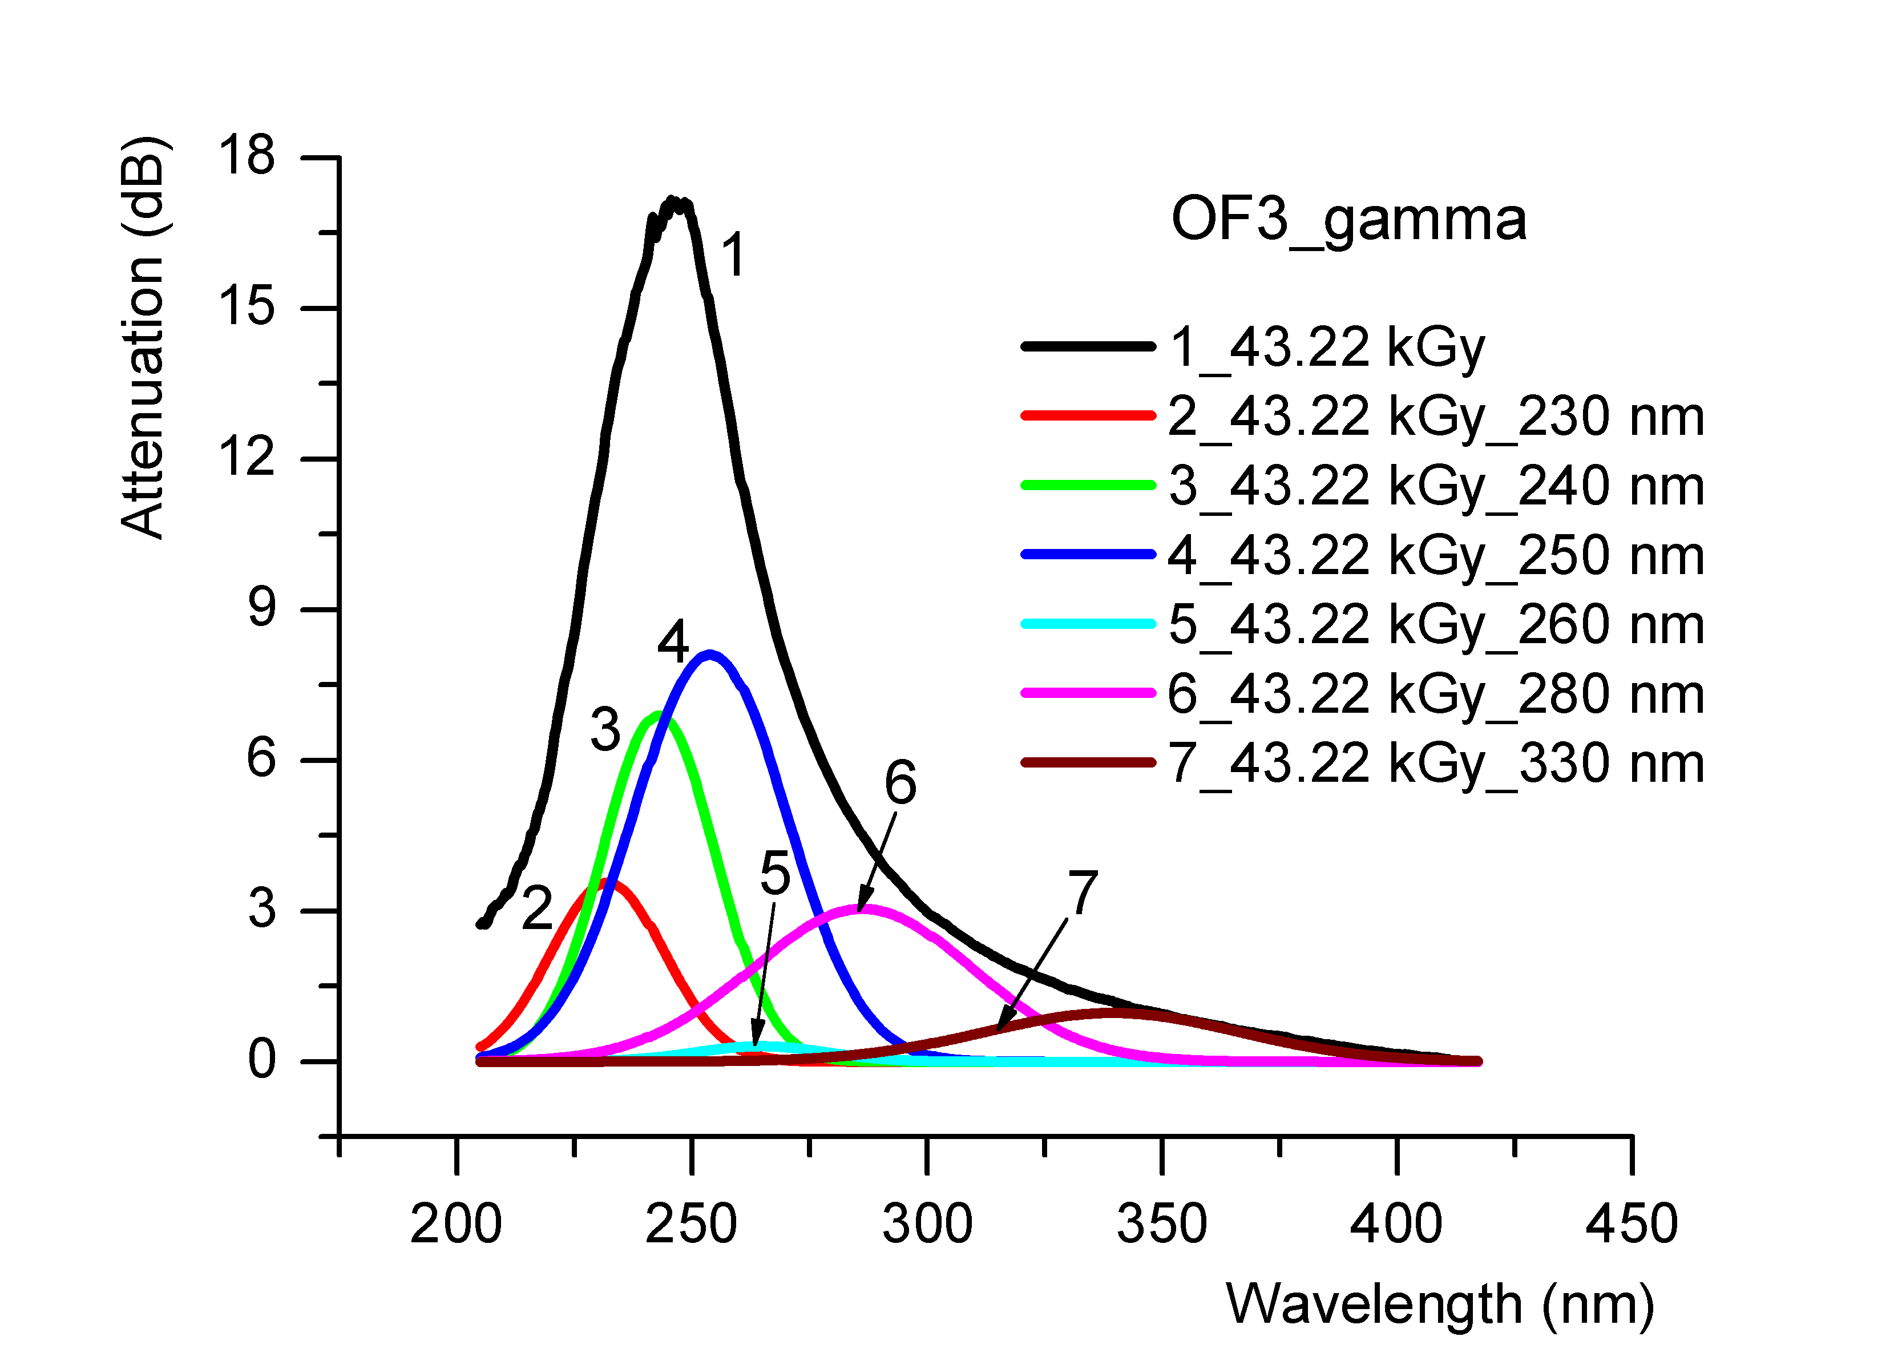 |  |  |  |  | 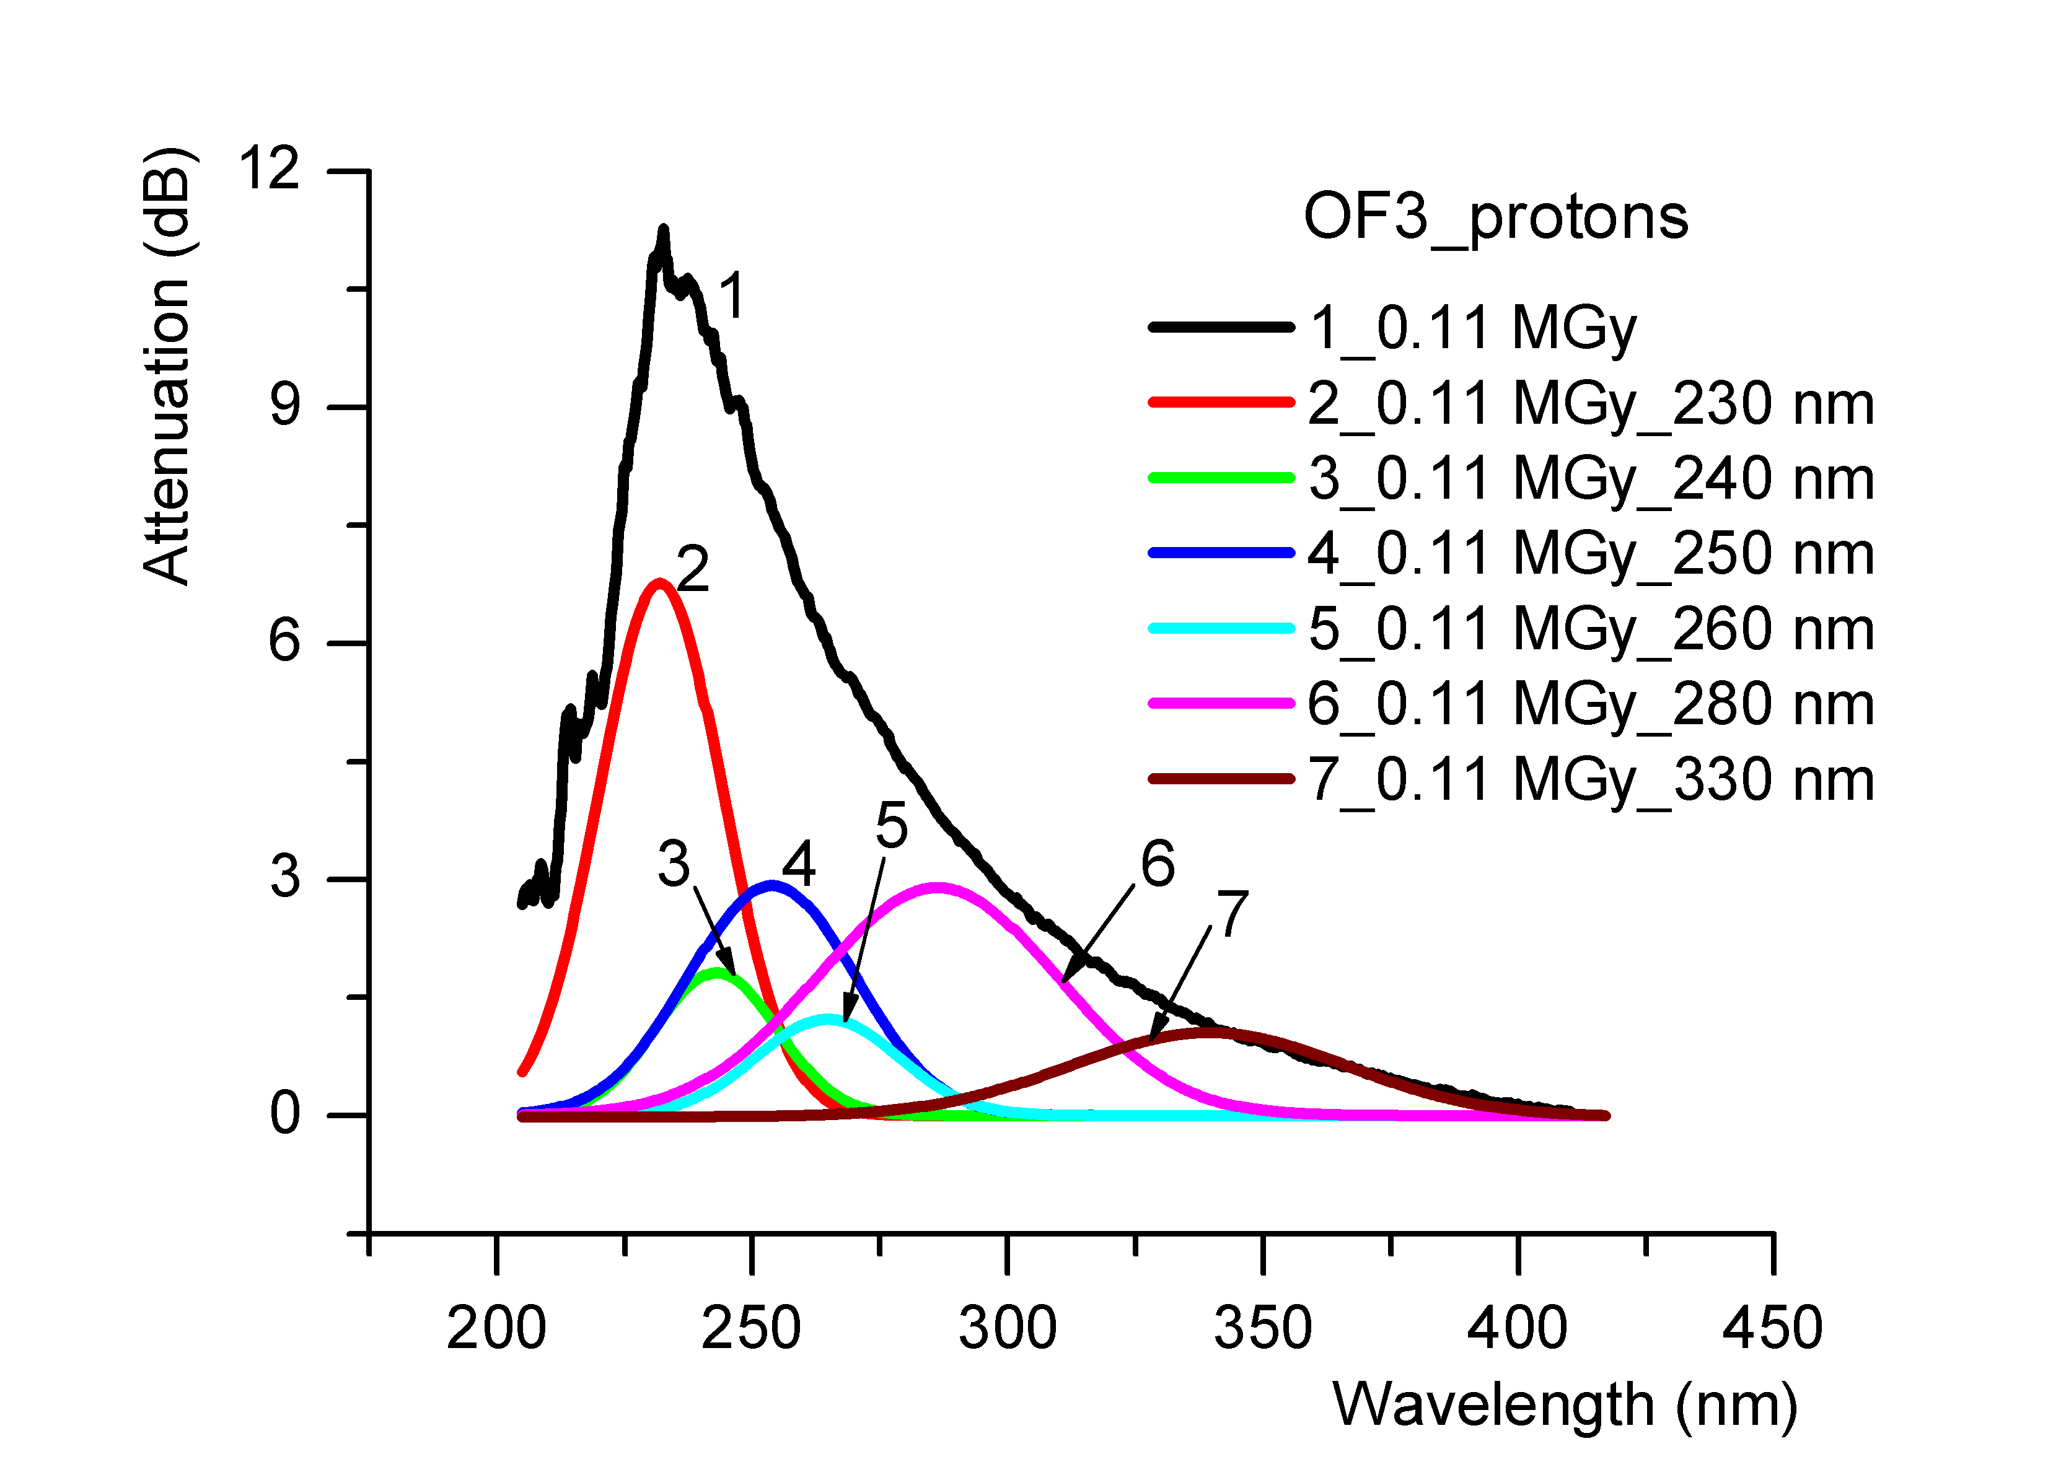
Figure 13. The Gaussian deconvolution for the optical fibre OF3, at the total irradiation dose of 43.22 kGy (in situ gamma irradiation). |  |  |  |  | Figure 14. The Gaussian deconvolution for the optical fibre OF3, at the total irradiation dose of 0.11 MGy (in situ proton irradiation).
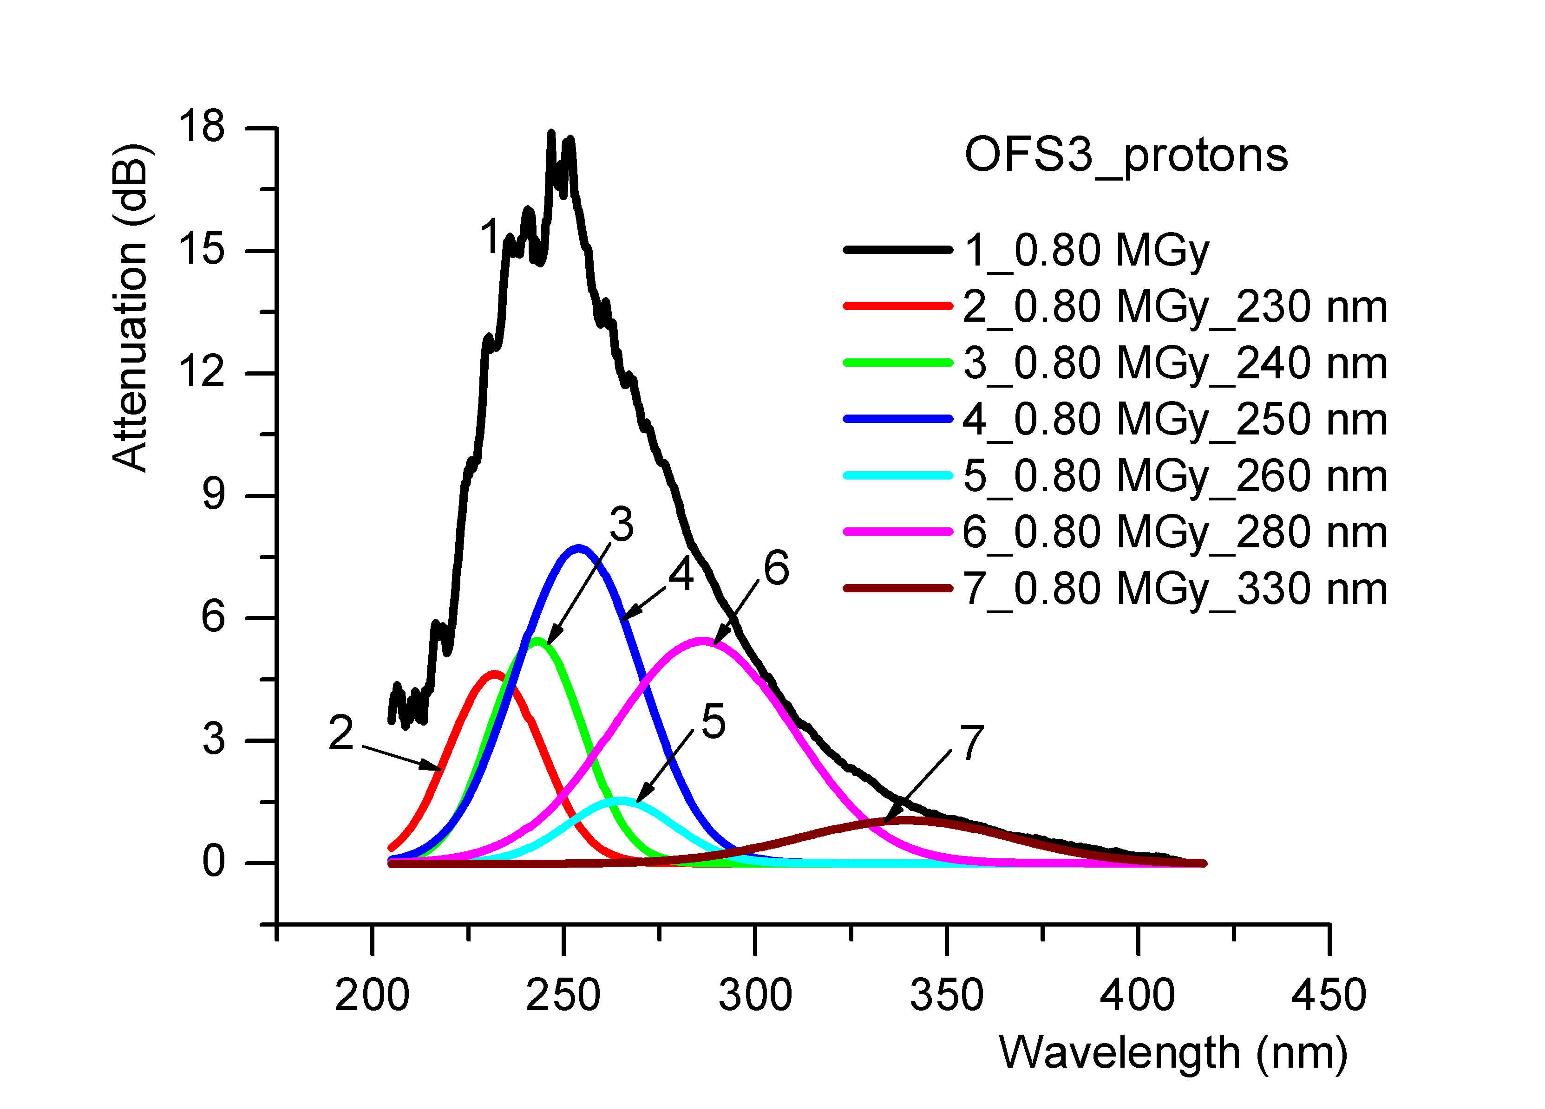 |  |  |  |  | 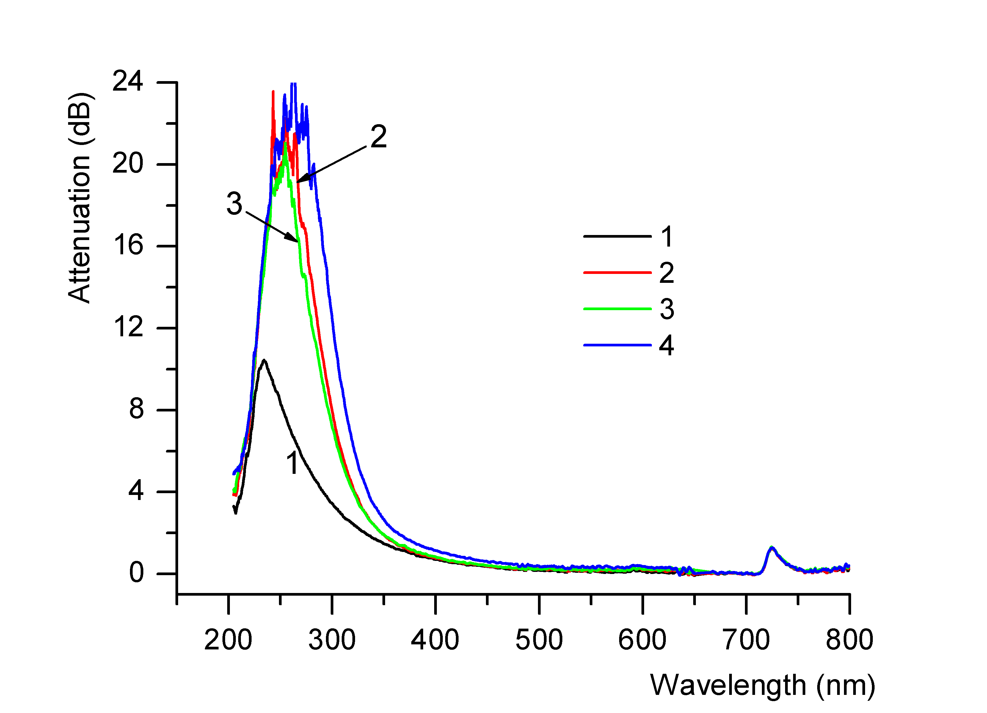
Figure 15. The Gaussian deconvolution for the optical fibre OF3, at the total irradiation dose of 0.80 MGy (in situ proton irradiation). |  |  |  |  | Figure 16. The attenuation for the OF4 measured during in situ electron beam and gamma irradiation: 1: non-irradiated; 2: 120 kGy – electron beam irradiation; 3: recovery after 18 hours; 4: 468 Gy – gamma irradiation.

3.2. Investigations on the post irradiation thermal treatment
Samples of different types of optical fibers were irradiated in various conditions, as indicated in Table 2. In order to observe the dynamics of the colour centres, on-line measurements on the optical attenuation were performed in the laboratory during the progressive heating of the optical fibers samples. The maximum temperatures for the measurements are given in column 6 of Table 2.
The results of the measurements are illustrated in the Figures 17-31 (the attenuation of the non-irradiated optical fiber is marked in black, the attenuation of the optical fiber irradiated at room temperature or heated during the irradiation is indicated in red, while the optical attenuation recovery during the post irradiation heating is designated by blue or green (according to the case). The temperature control was done automatically using a PC and the software provided by the manufacturer of the oven. The optical transmission measurements were performed simultaneously.

Table 2. Optical fibers subjected to post irradiation thermal treatment

Sample | Type of the optical fibre | Core diameter [μm] | Total gamma dose [kGy] | Temperature during the irradiation [ºC] | Maximum temperature in the oven  [ºC] | Duration of the post irradiation heating  [hours]
S17_1 | Solarization resistant | 400 | 4 | 20 | 265 | 4
S17_1a | Solarization resistant | 400 | 4 | 200 | 155 | 2
S17_2 | Solarization resistant | 400 | 4 | 20 | 265 | 4
S17_2a | Solarization resistant | 400 | 4 | 200 | 265 | 4
S17_3 | H₂ loaded | 200 | 4 | 20 | 265 | 4
S17_3a | H₂ loaded | 200 | 4 | 200 | 265 | 4
S17_4 | High OH content | 400 | 4 | 20 | 90 | 1
S17_4a | High OH content | 400 | 4 | 100 | 90 | 1
S17_5 | High OH content | 400 | 4 | 20 | 265 | 4
S17_5a | High OH content | 400 | 4 | 200 | 265 | 4
Sample | Type of the optical fibre | Core diameter [μm] | Total gamma dose [kGy] | Temperature during the irradiation [ºC] | Maximum temperature in the oven  [ºC] | Duration of the post irradiation heating  [hours]
S17_6 | High OH content | 400 | 4 | 20 | 130 | 1 ½
S17_6a | High OH content | 400 | 4 | 150 | 130 | 1 ½
S17_7 | Solarization resistant | 400 | 4 | 100 | 90 | 1

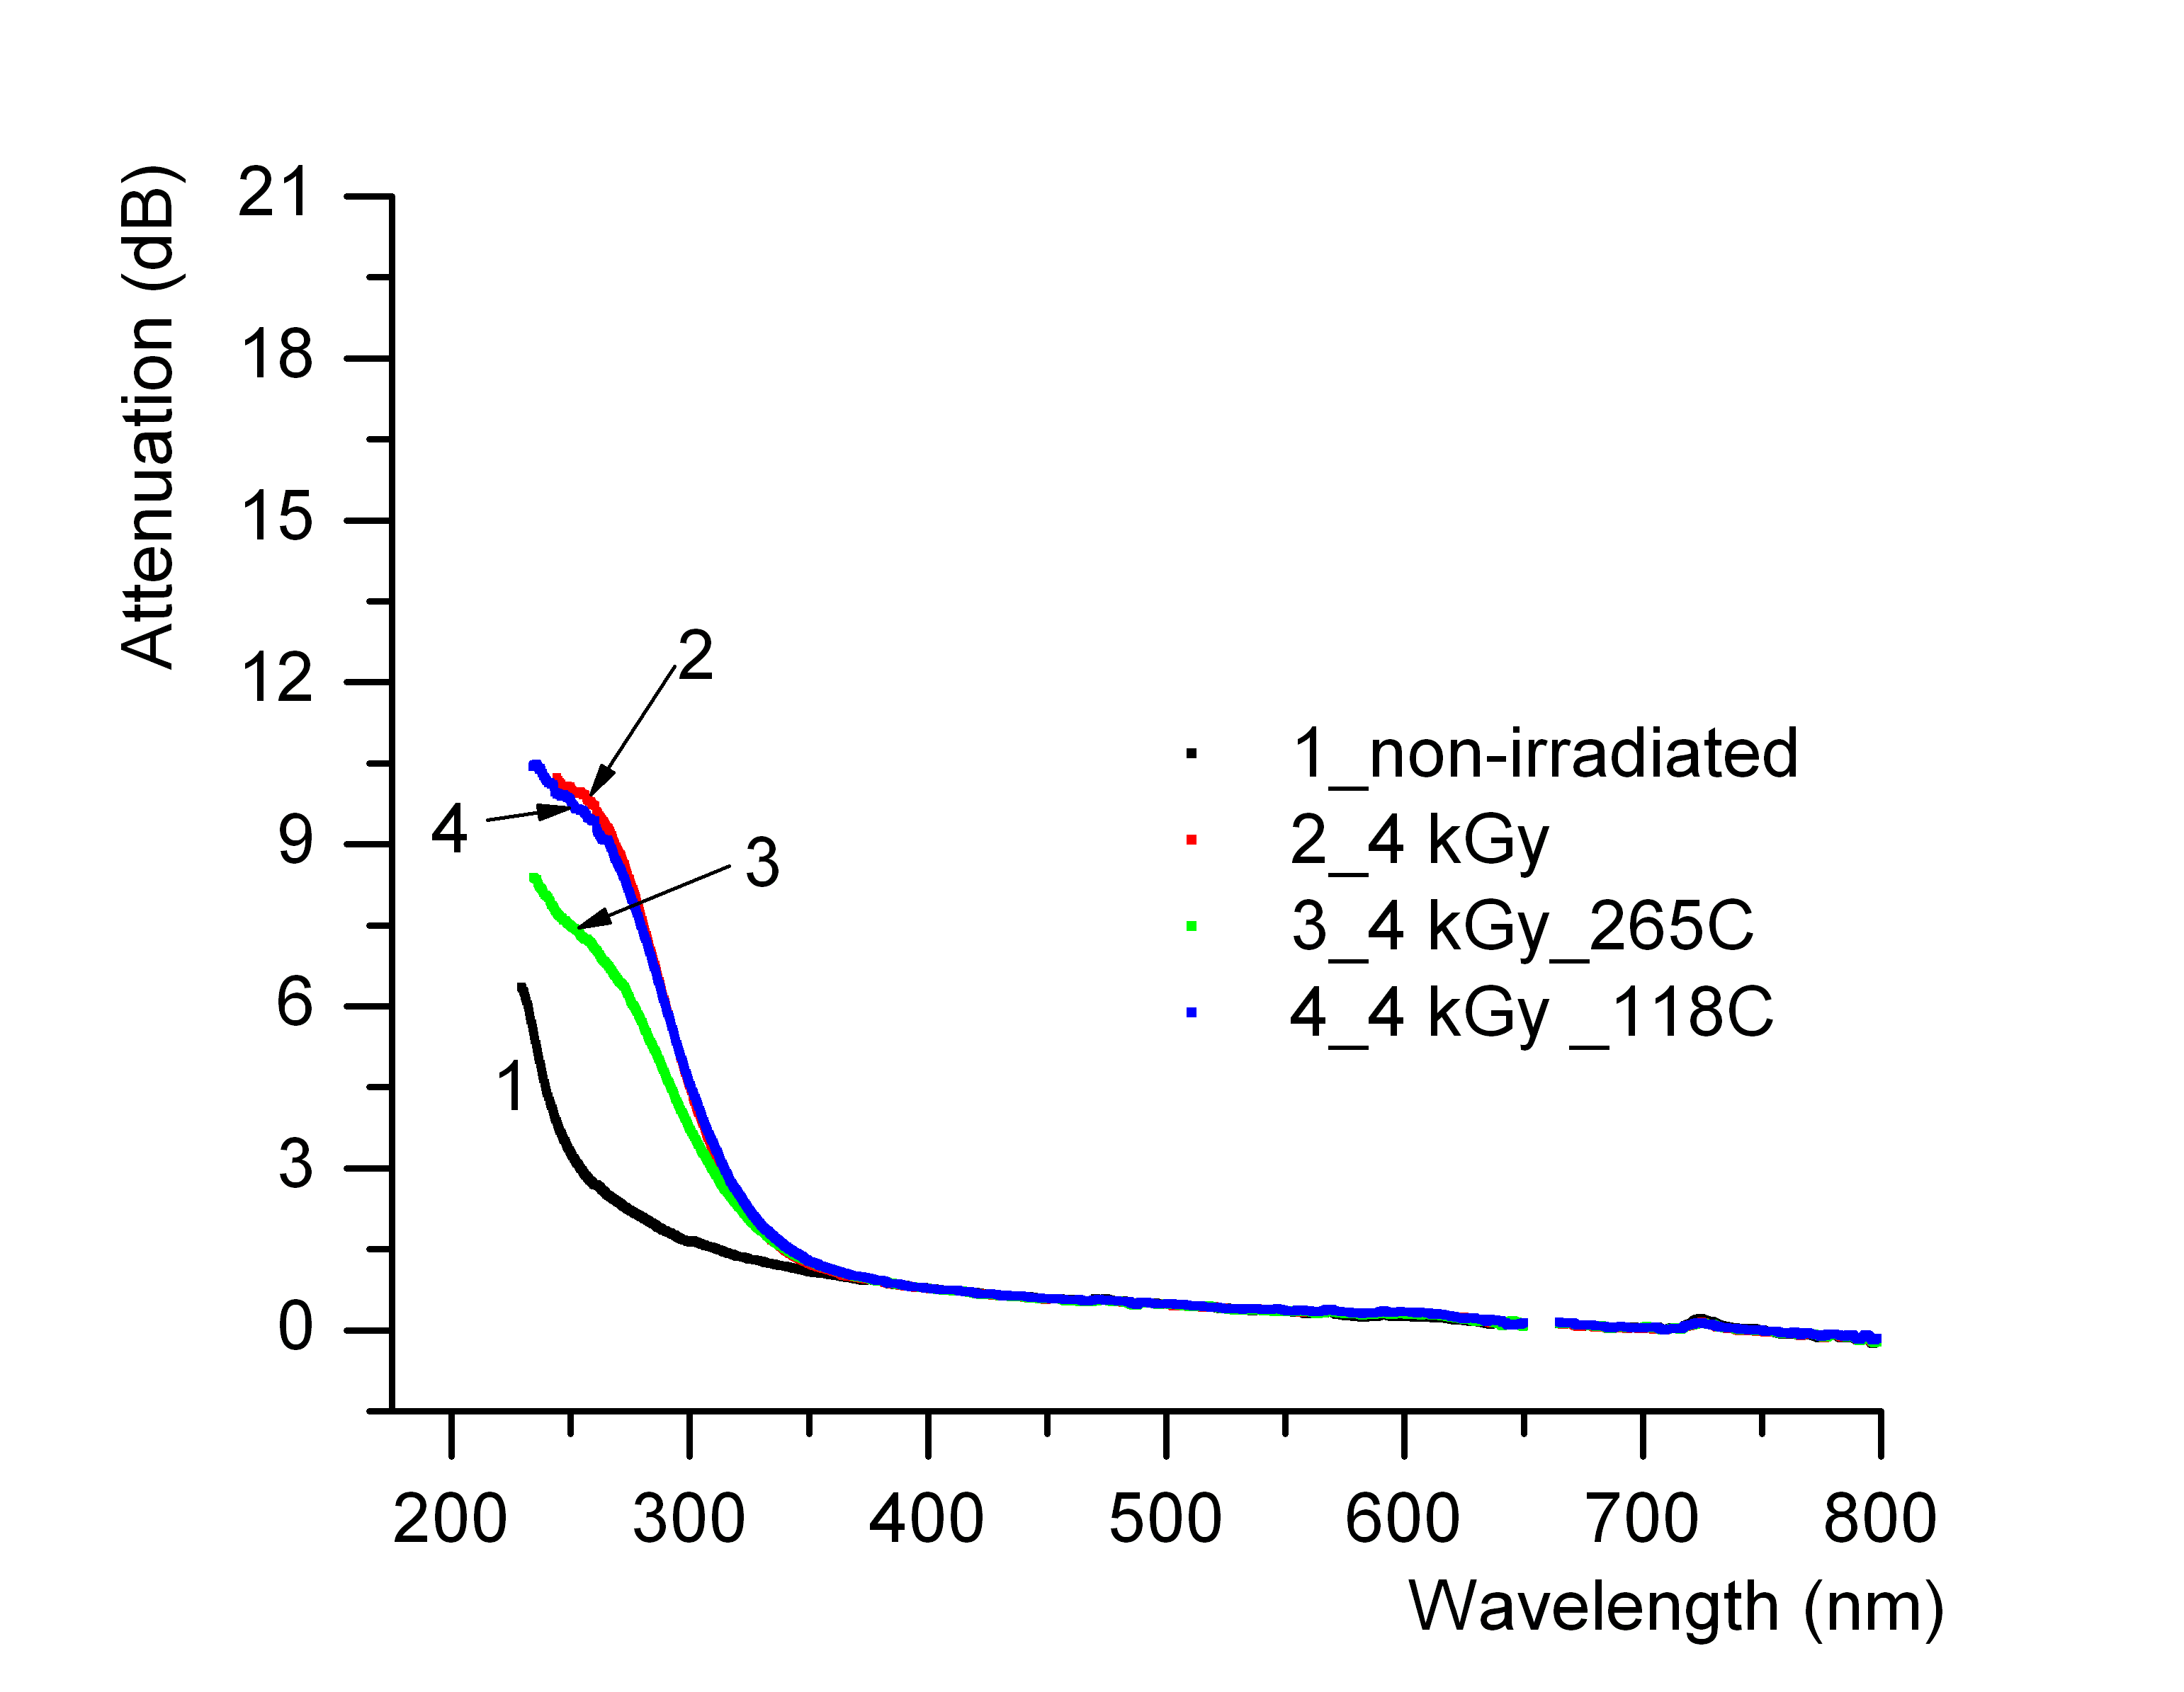 | 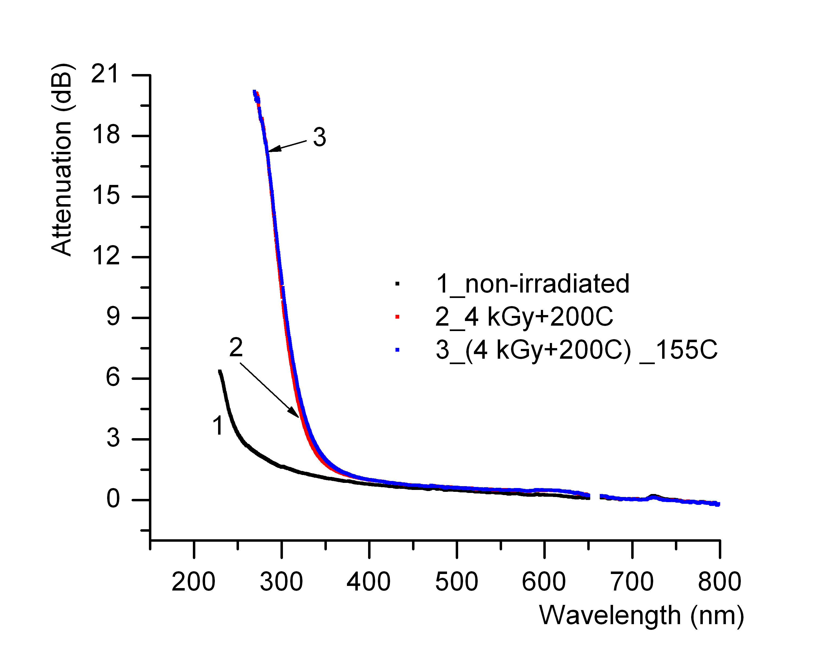
Figure 17. The optical attenuation for the sample S17_1. | Figure 18. The optical attenuation for the sample S17_1a.
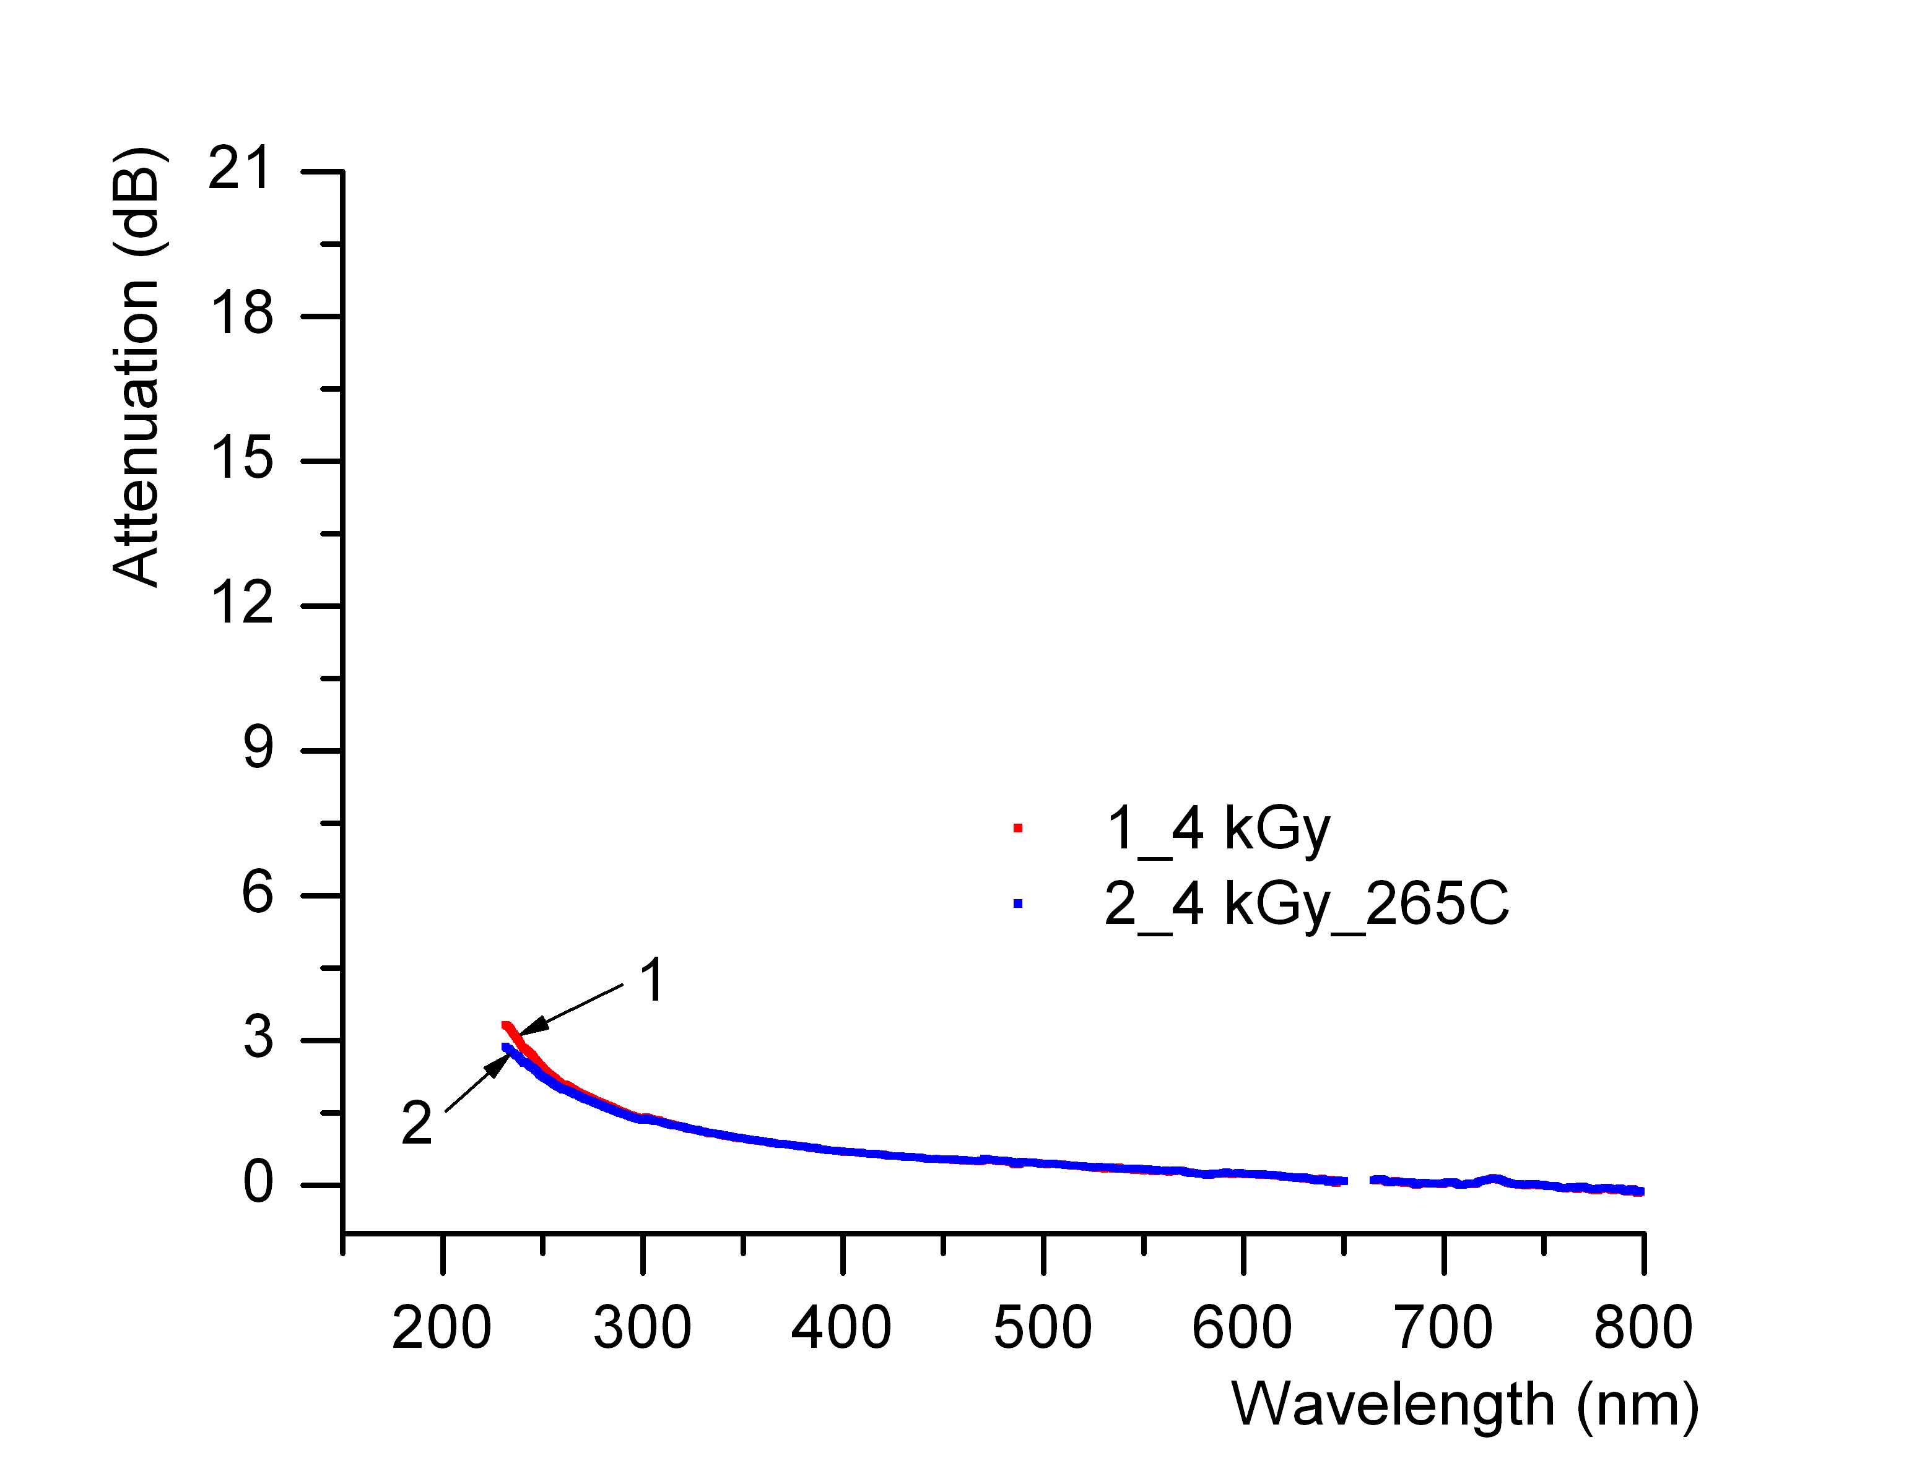 |  |  |  | 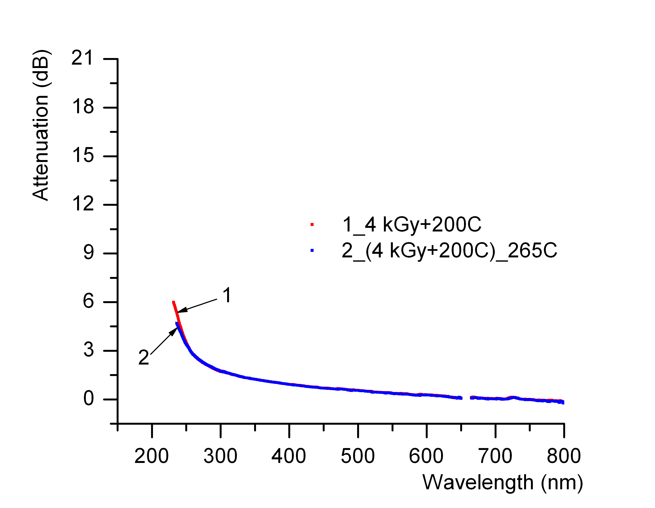
Figure 19. The optical attenuation for the sample S17_2. |  |  |  | Figure 20. The optical attenuation for the sample S17_2a.
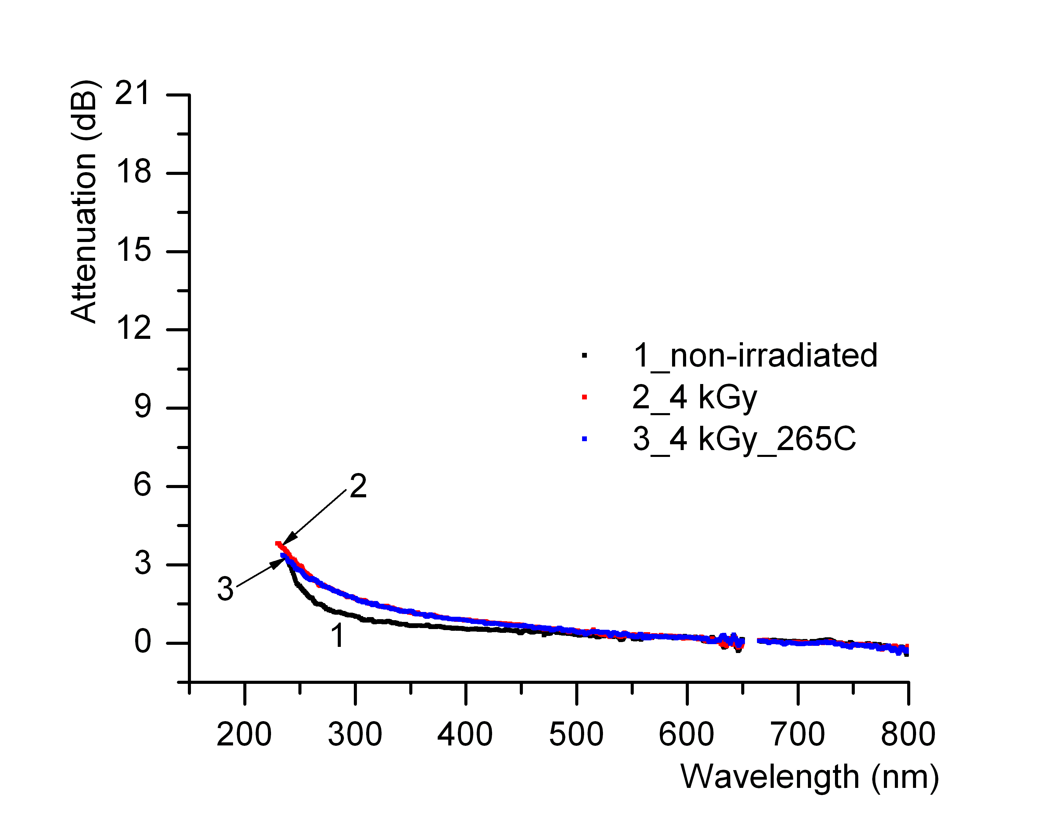 |  |  |  |  | 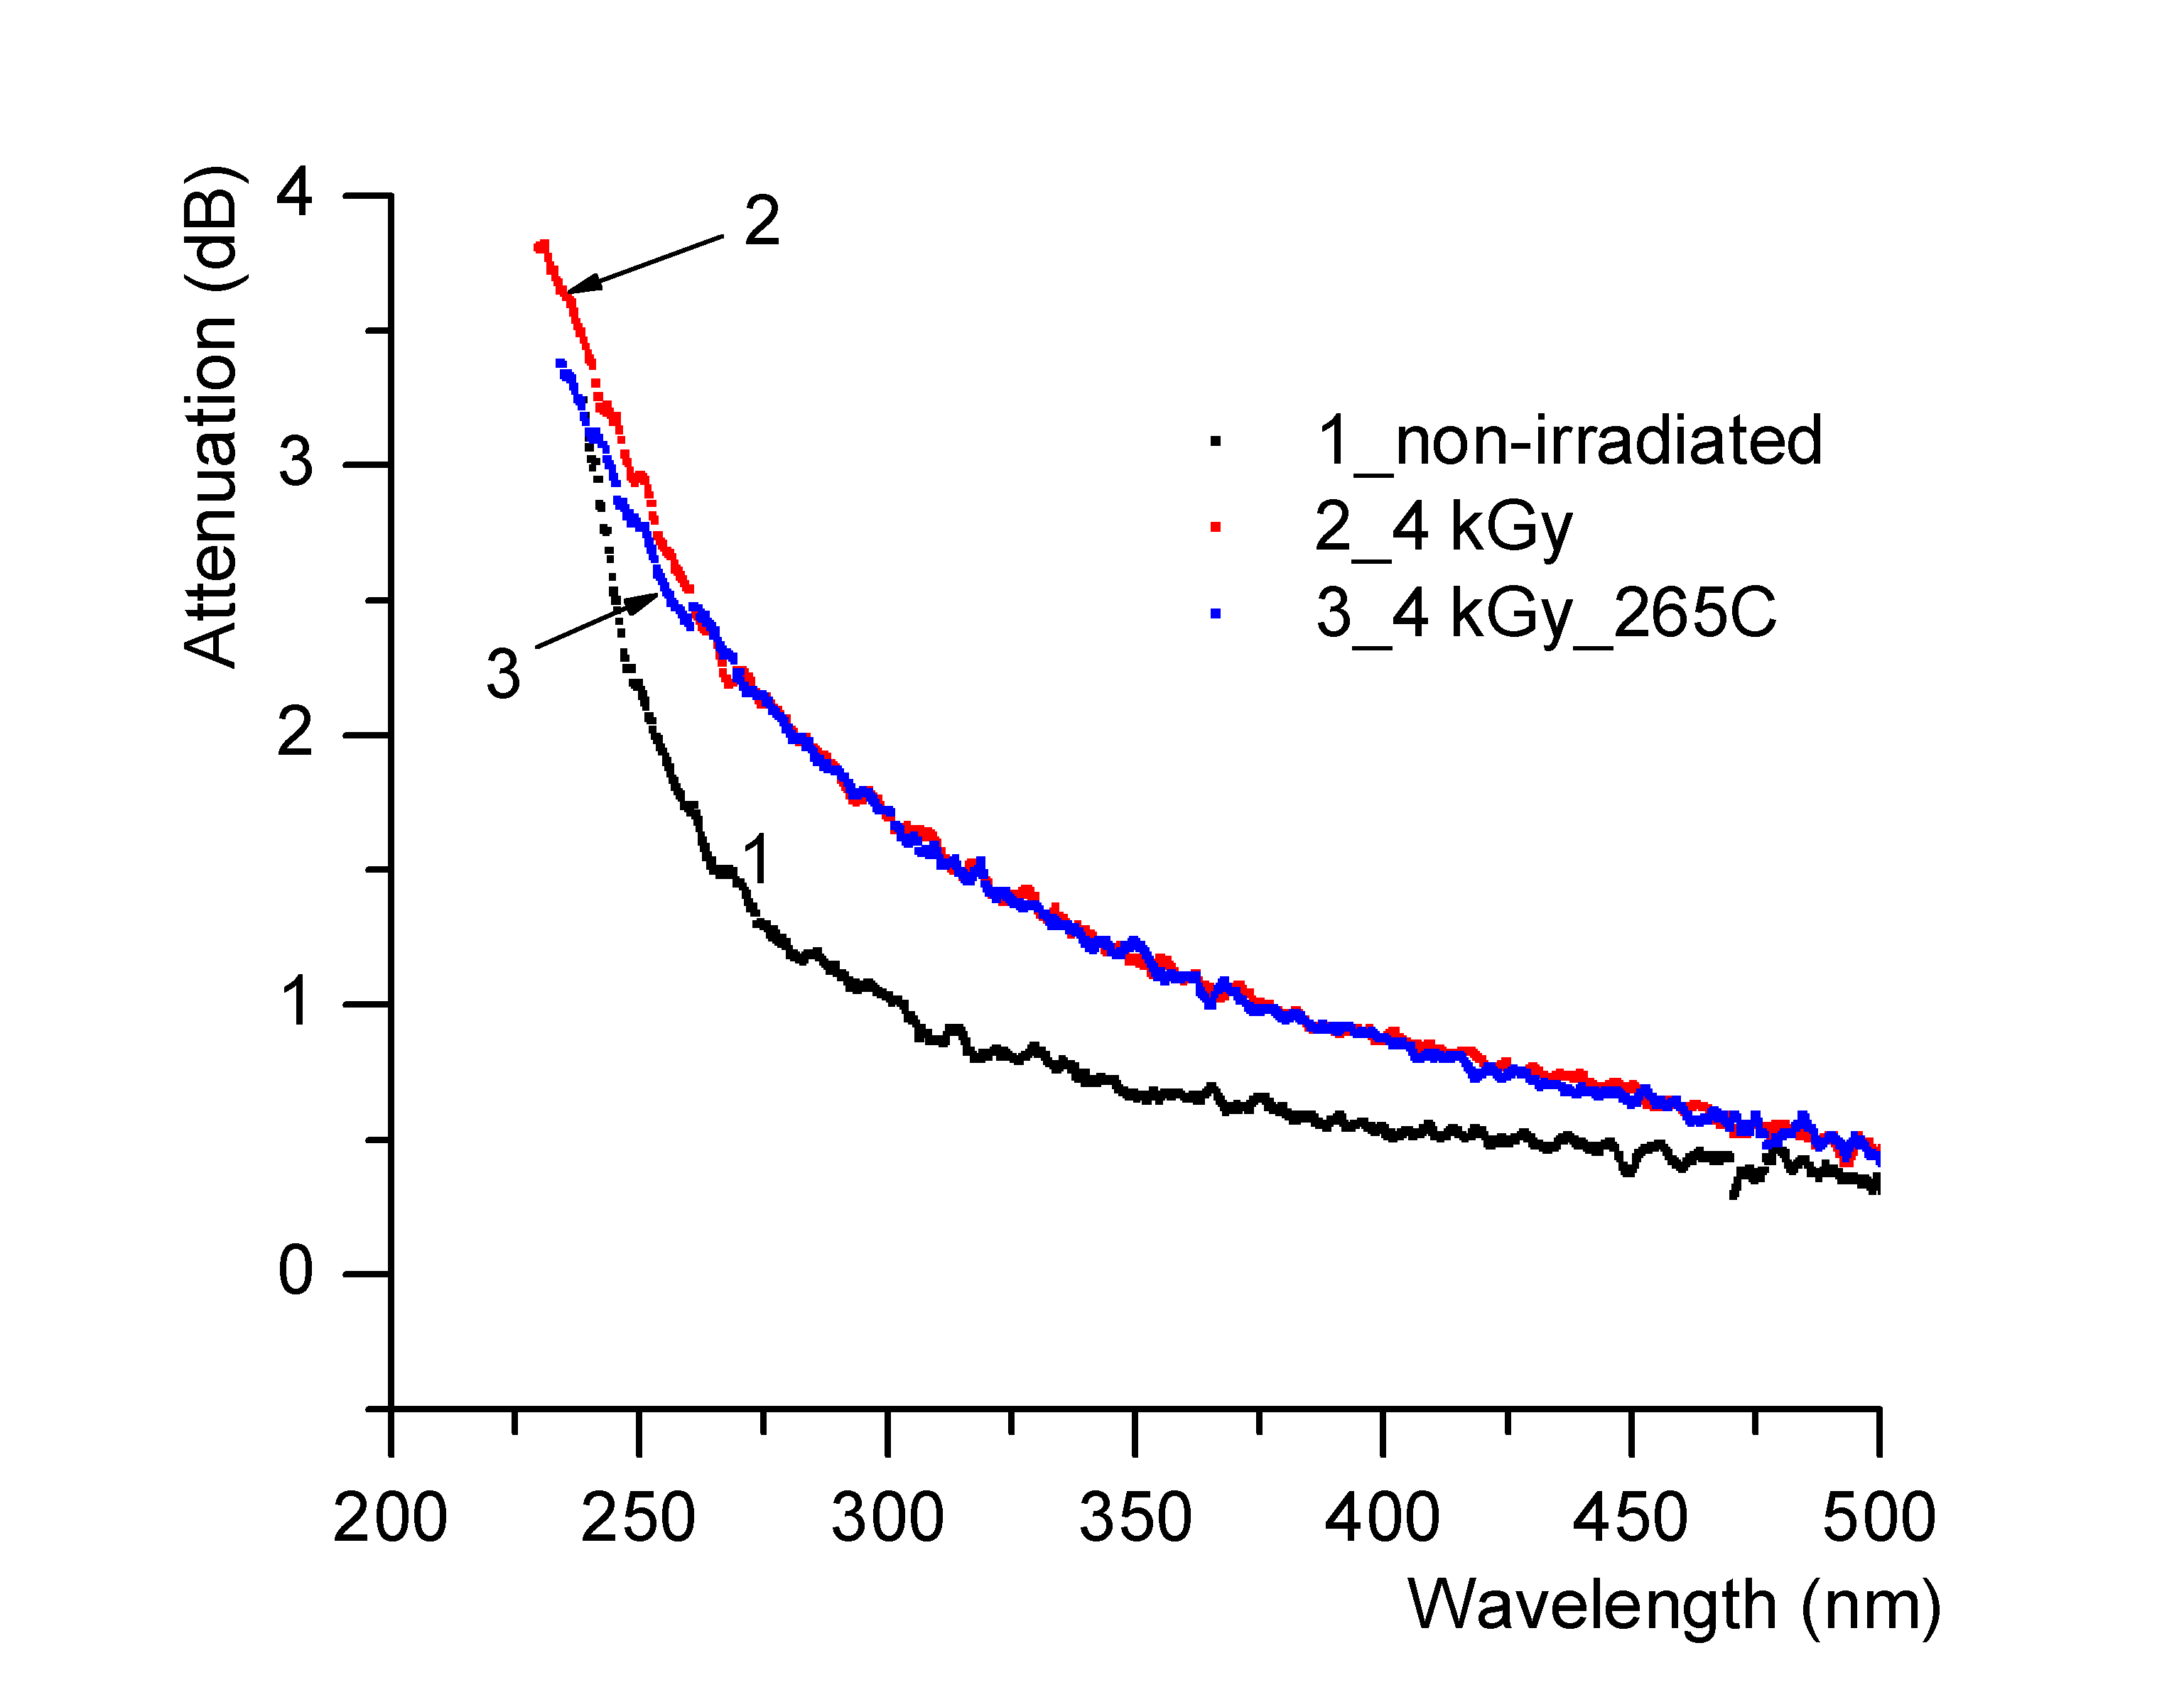
Figure 21. The optical attenuation for the sample S17_3. |  |  |  |  | Figure 22. Detail of Figure 21.
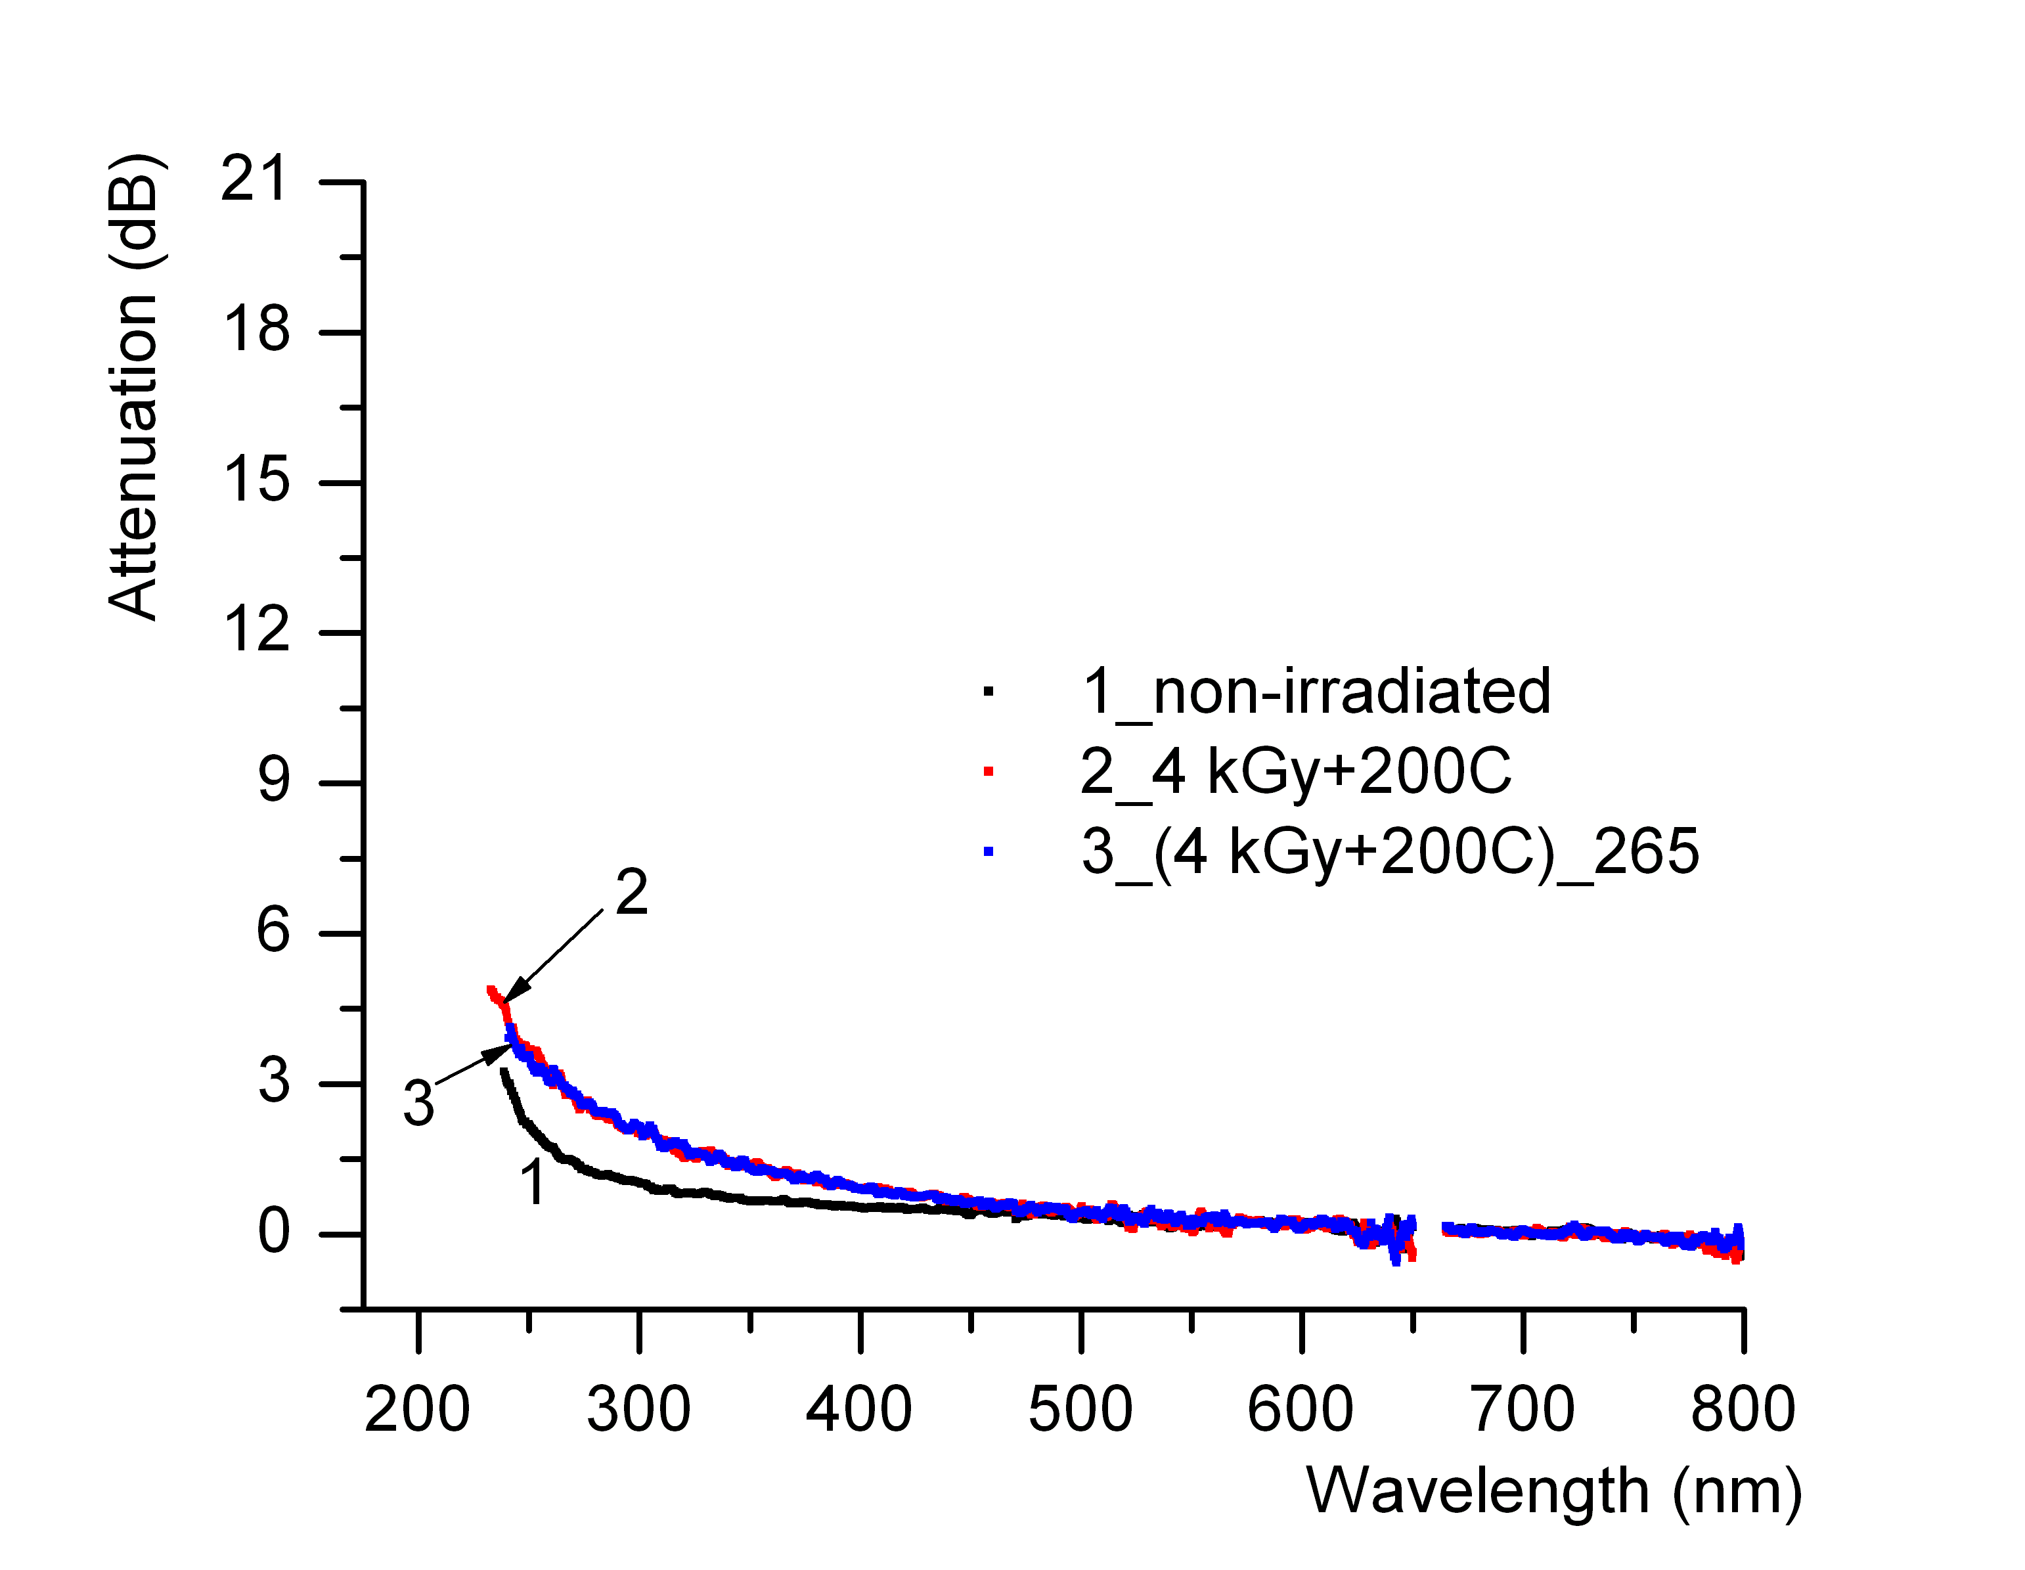 |  |  |  |  | 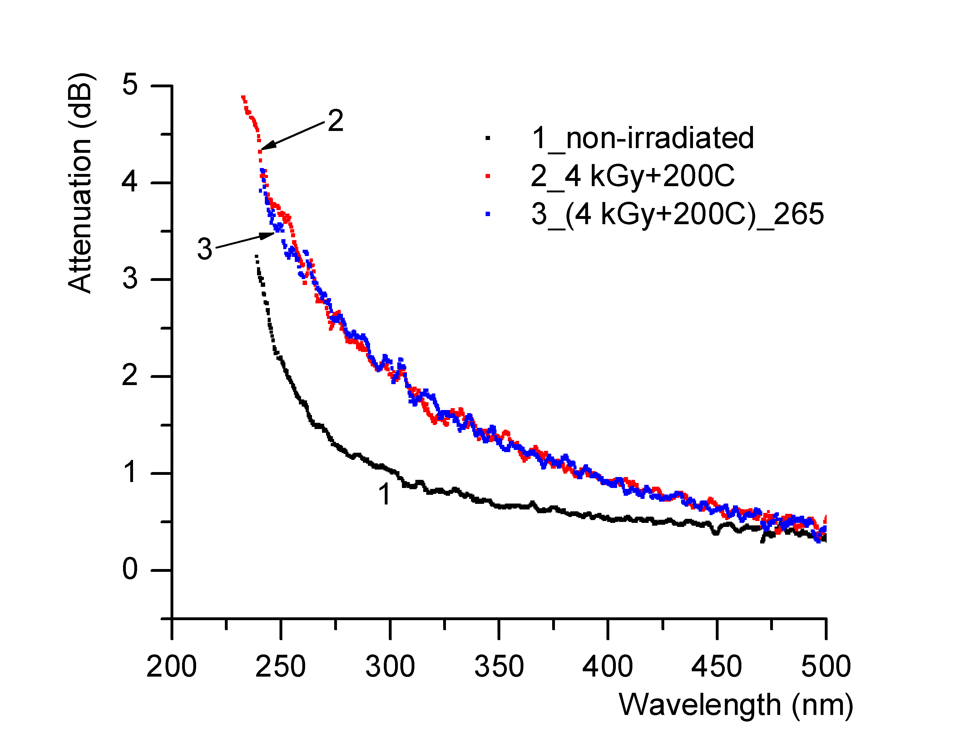
Figure 23. The optical attenuation for the sample S17_3a. |  |  |  |  | Figure 24. Detail of Figure 23.
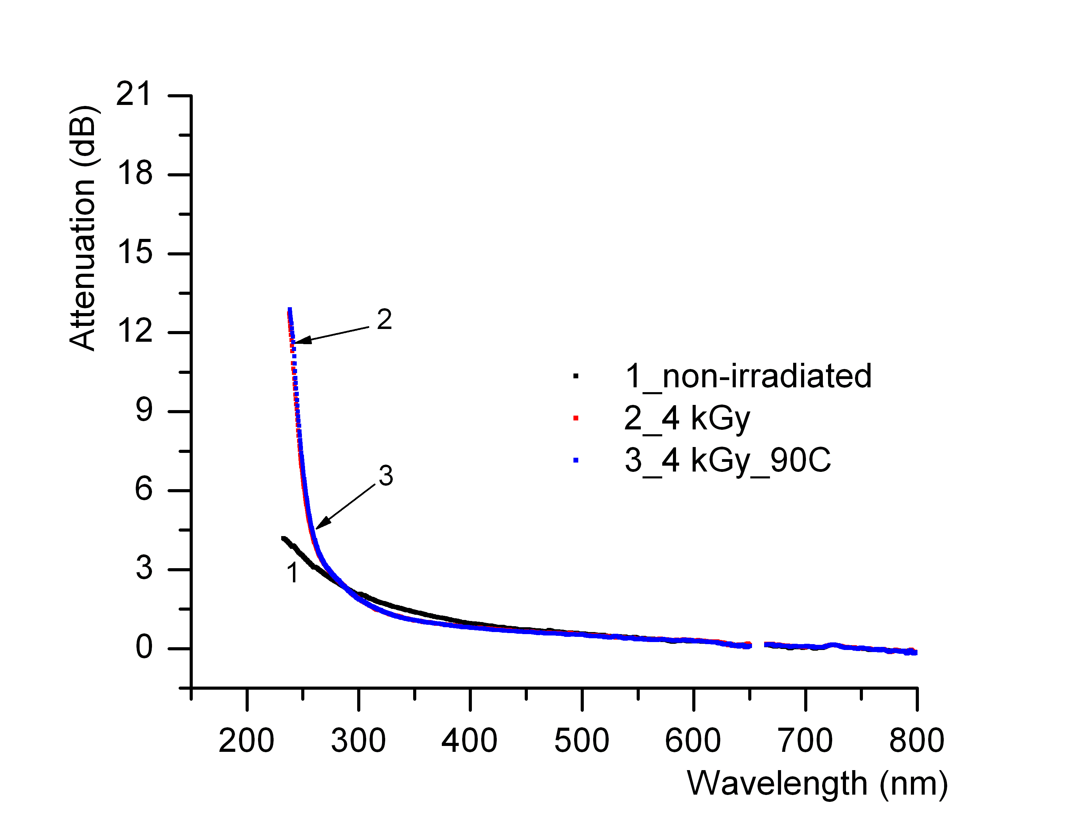 |  | 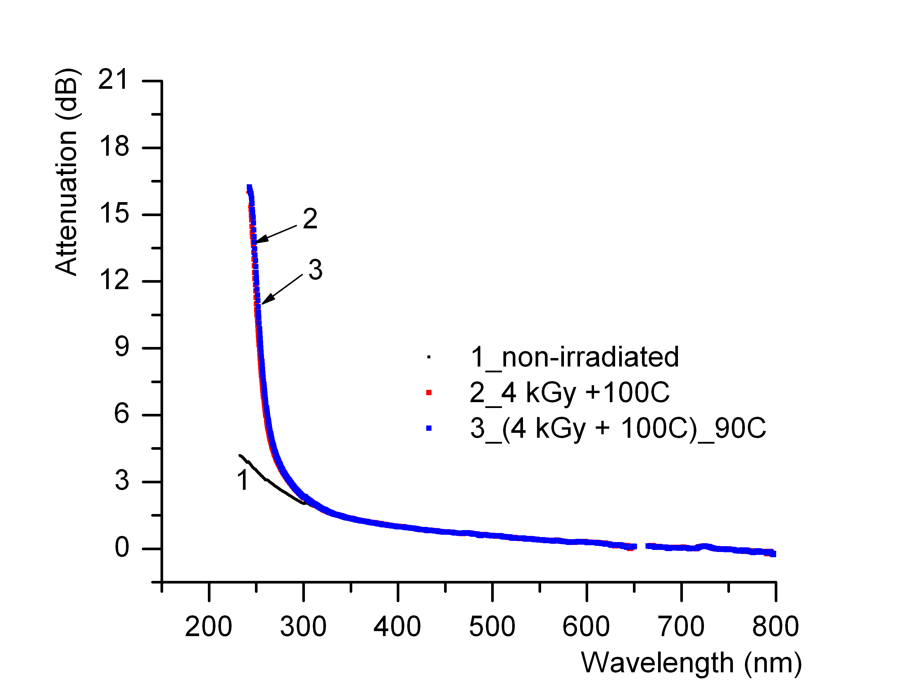
Figure 25. The optical attenuation for the sample S17_4. |  | Figure 26. The optical attenuation for the sample S17_4a.
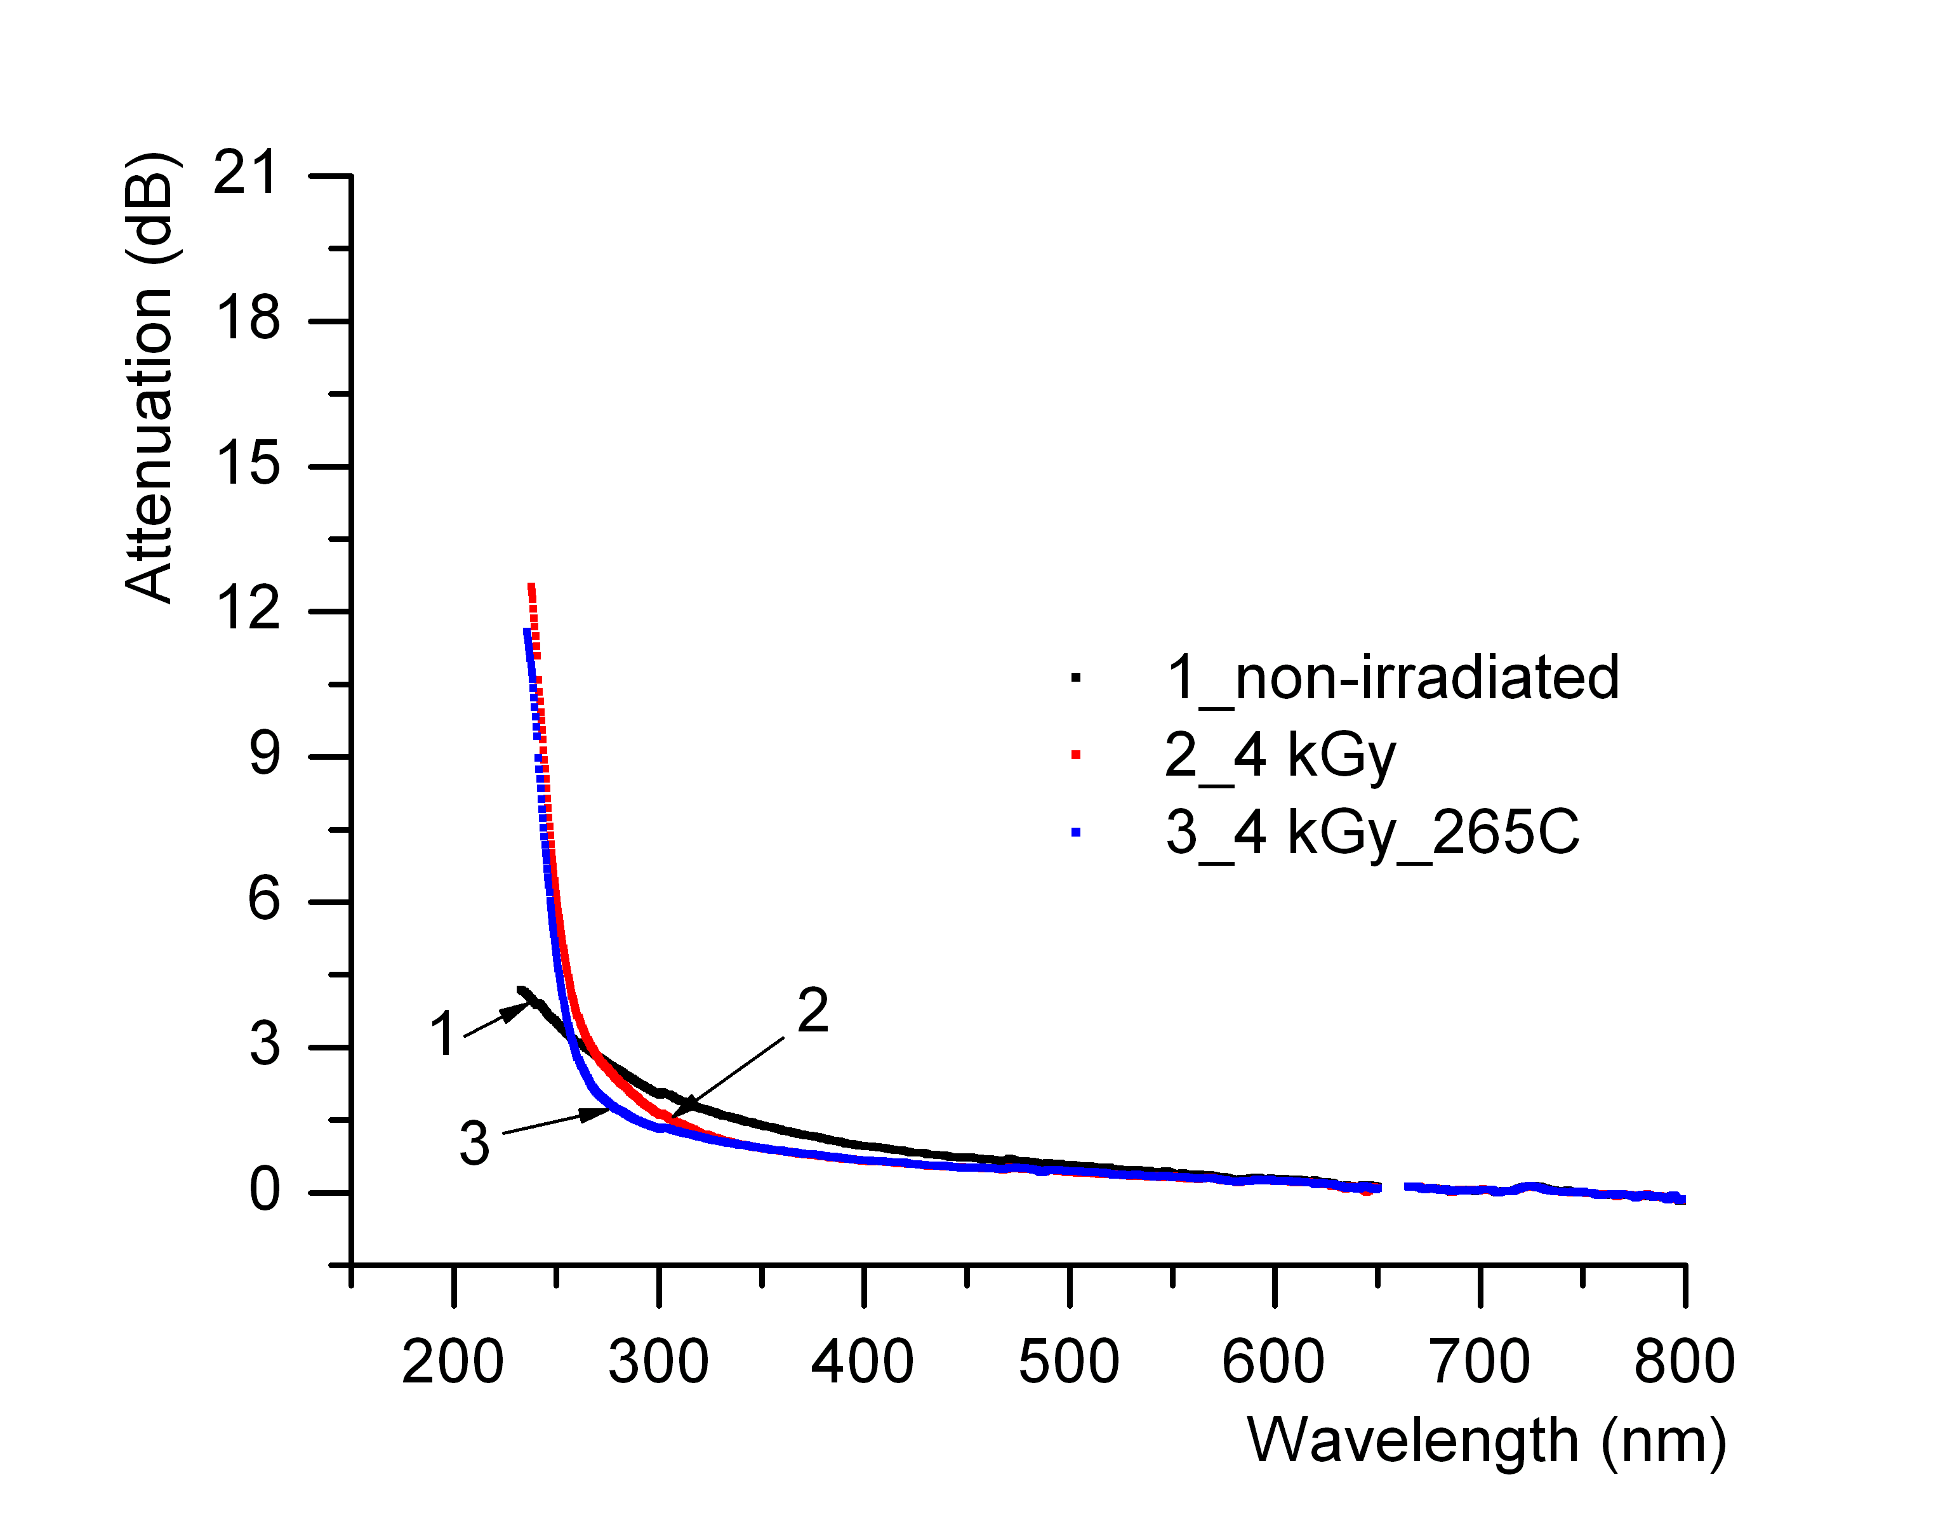 |  |  |  |  | 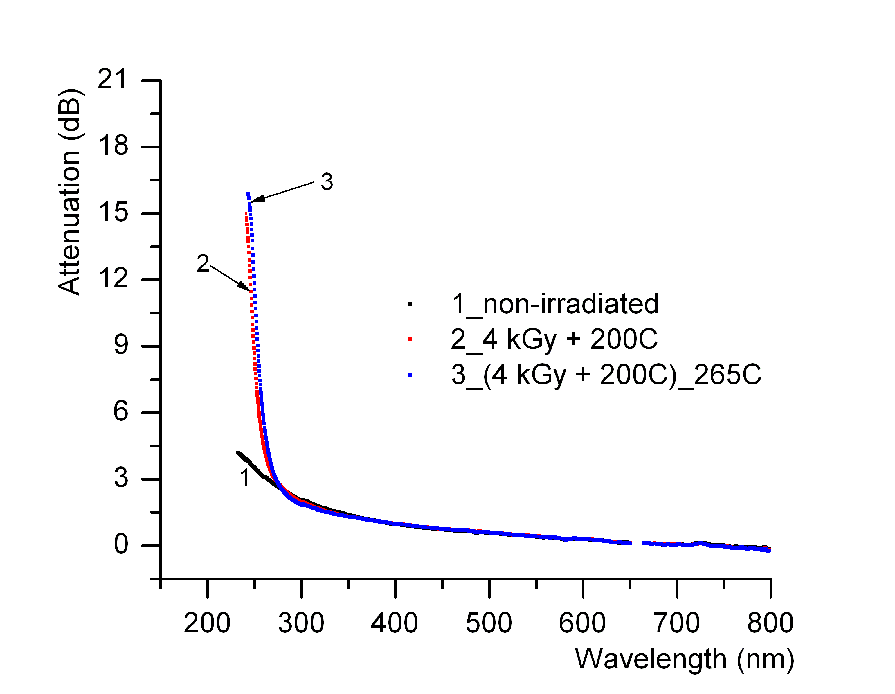
Figure 27. The optical attenuation for the sample S17_5. |  |  |  |  | Figure 28. The optical attenuation for the sample S17_5a.
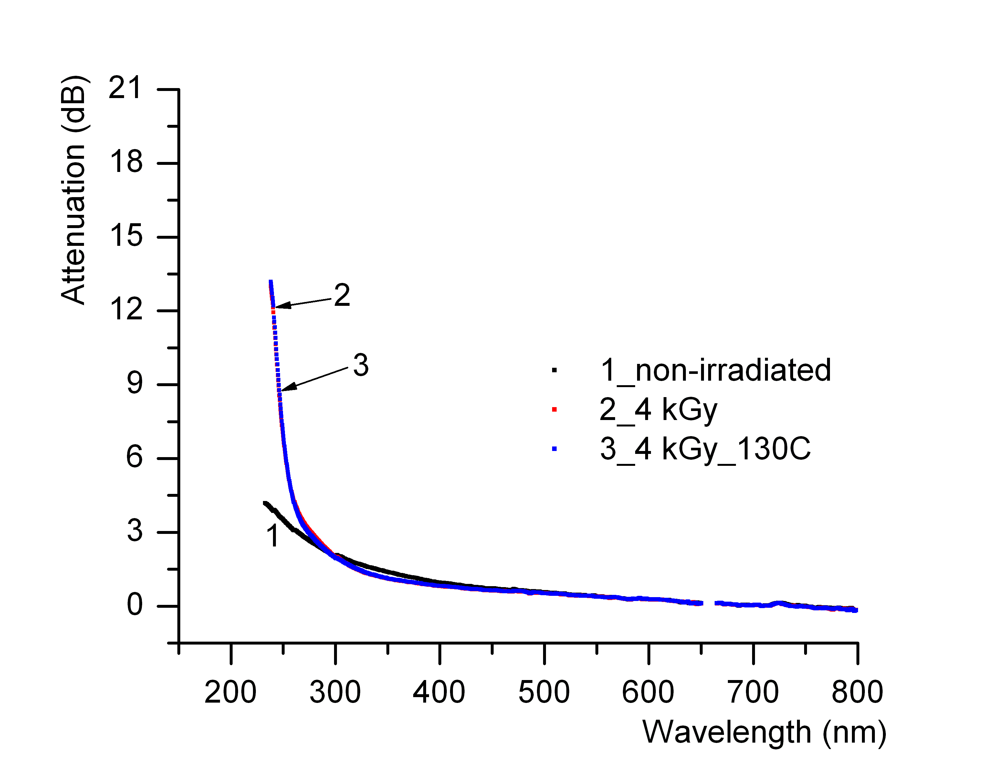 |  |  | 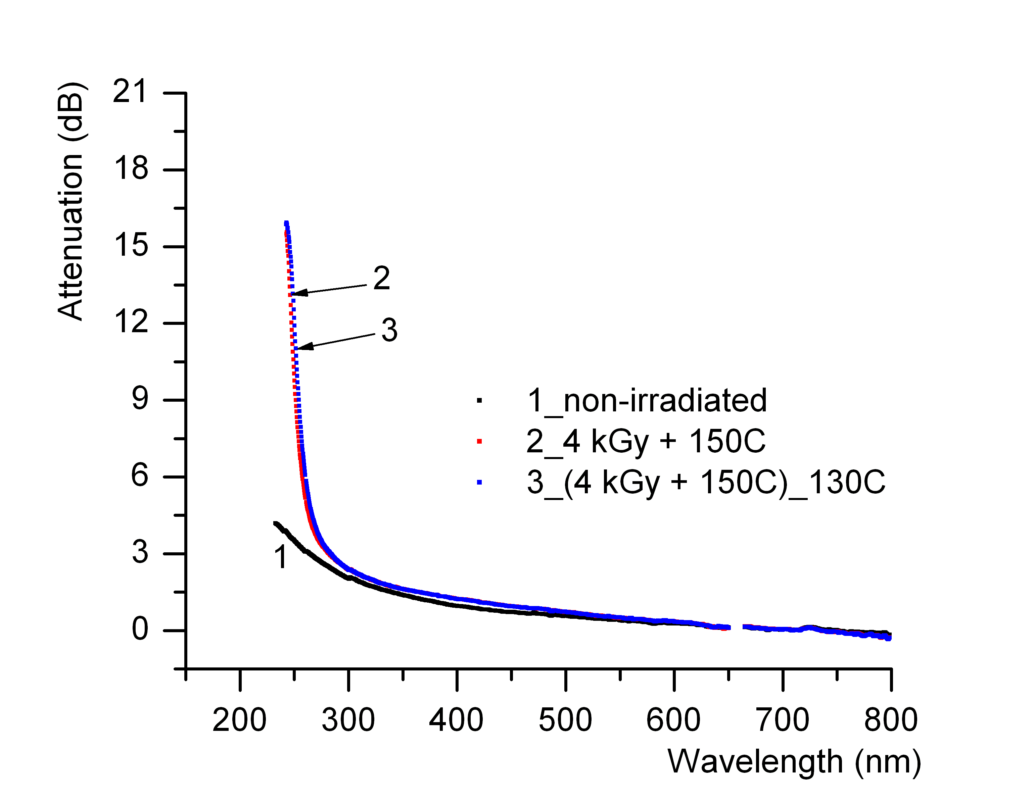
Figure 29. The optical attenuation for the sample S17_6. |  |  | Figure 30. The optical attenuation for the sample S17_6a.
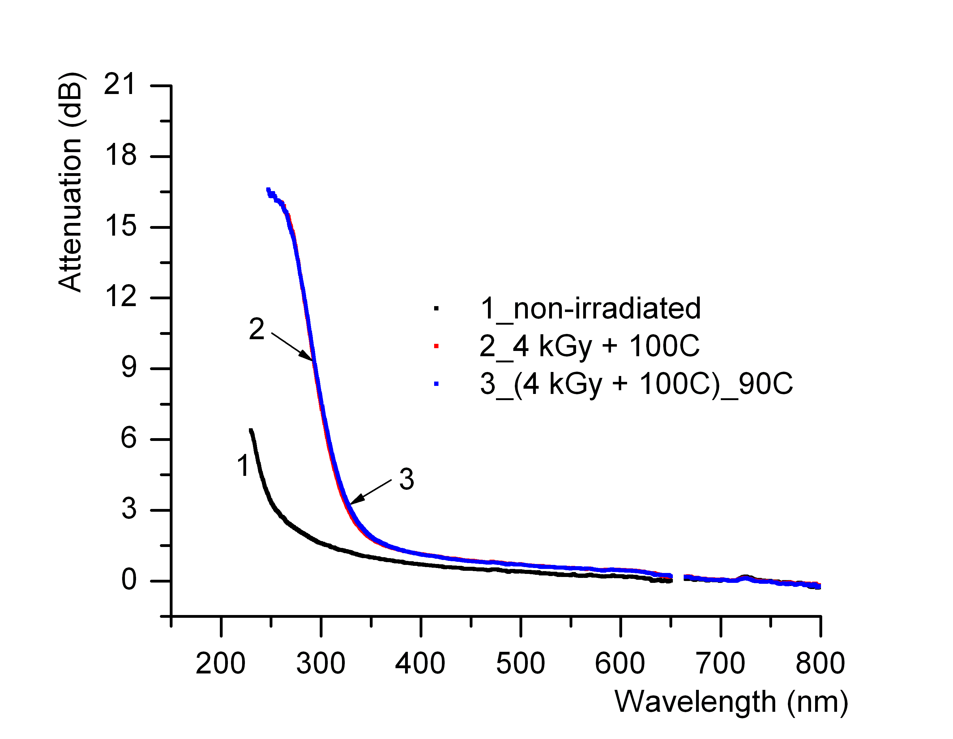 |  |  | Figure 31. The optical attenuation for the sample S17_7.

3.3. Complementary measurements
In addition to the investigations carried out in relation:
- to the presence of the radioluminescence in electron bema irradiated optical fibers
- to the post irradiation temperature produced recovery of the optical attenuation,
we tried to localise some colour centres through electron paramagnetic resonance (EPR) investigations and fluorescence measurements.
Below are reproduced the results obtained in Romania. There are preliminary results as we try to improve the set-up and to refine the measuring methods in order to be as close as possible to the Italian team whom is much experienced in this field. We plan to make basic measurements in Romania and only the special ones in Italy. In the mean time, the measurements in two facilities can contribute also to the reducing of the measurement uncertainties through some sort of intercomparison. The operating conditions in Romania are described below. The characteristics of optical fibre samples investigated in Bucharest are presented in Table 3.
The spectra have been recorded using a MiniScope MS200 spectrometer, produced by Magnettech GmbH. It operates in the band X (9,3 – 9,55 GHz), has the rectangular resonance cavity TE102 and the frequency of the modulation field of 100 kHz. The amplitude of the modulation field can be modified between 0.5 μT and 1 mT. The magnetic field can be scanned in the region 0 – 450 T and it is controlled with a Hall sensor. The stability of the field is 2μT, and the homogeneity of the magnetic field at the sample location is ± 5 μT. The minimum power of the microwave field at which the spectrometer can operate is 100 μW (maximum – 50 mW). For the determination of the g factor values (of the operating frequency) the working standard used is Mn²⁺ embedded in ZnS.
Table 3. The optical fibre samples investigated in Bucharest by EPR.

Optical fibre sample | Type of the optical fibre | Treatment | Irradiation conditions
S27-1A | High OH content | - | Non-irradiated
S27-1B | High OH content | Without jacket | Non-irradiated
S27-2A | High OH content | - | In situ gamma: 34.7kGy
Optical fibre sample | Type of the optical fibre | Treatment | Irradiation conditions
S27-2B | High OH content | Without jacket | In situ gamma: 34.7kGy
S27-3A | Solarization resistant, H2 loaded | Without jacket | Non-irradiated
S27-3B | Solarization resistant, H2 loaded | Without jacket | Off-line gamma: 313 kGy
S27-4A | Solarization resistant, H2 loaded | Without jacket | Non-irradiated
S27-4B | Solarization resistant, H2 loaded | Without jacket | Off-line gamma: 313 kGy

The optical fiber samples were cut in pieces of ~ 2 cm and grouped in cuvettes of quartz having the exterior diameter of 5 mm. The measurements were performed at the room temperature. The Figures 32 - 36 presents the spectra obtained for the power of 100 μW and the modulation of 0,01 mT (E’ center). The maximum amplification of the equipment was selected. In order to have a good signal-to-noise ratio, four acquisitions of the spectrum have been made, with a scanning duration of 120 seconds.
Figure 32. Examples of the spectra obtained from the optical fiber samples S-27.
In the Figure 33 can be also observed the signal from the plastic cladding of the optical fibre after this one was irradiated. In order to locate H centre, the power was increased to 3.2 mW and the modulation to 4 G. In these conditions, no additional sigla was noticed in samples S27-2A and S27-2B, nor even the doublet characteristic for the H centres. In the other samples only one singlet can be observed (Figure 34). The peak width for these signals is ~ 2 G, and the factor g ~ 2, 006 (Figures 35 and 36). In Figure 34, the shape of the line of the E’ centre in the sample S27-2B is not the correct one due to the saturation and especially to the too high modulation. The amplification factor for this sample was nine times smaller than for the other samples.
Figure 33. Spectra detected for P = 5 mW, H_{modulation} = 0,5 G
Figure 34. Spectra detected for P = 3,2 mW, H_{modulation} = 4 G
Figure 35. Spectra detected for P = 10 mW; H_{modulation} = 1 G
Figure 36. Spectra detected for P = 10 mW; H_{modulation} = 1 G
Further work is in progress to correlate EPR and optical absorption spectra in order to understand the irradiation induced defects in these optical fibers.

- Conclusions
- Remarks on the Gaussian deconvolution:
- SAMPLE OF1 (enhanced UV response): a considerable change of the overall attenuation value can be observed at high gamma dose of 113 kGy as compared to those of 3 kGy or 13 kGy. In the mean time, at 113 kGy the optical attenuation associated to the colour centres corresponding to 260 nm (D_{o} colour centre) and 280 nm (oxygen vacancy colour centre) are increasing. The heating at 100 ^{O}C determines a small recovery. Some changes can be noticed for 230 nm (E’_{β} colour centre) and 240 nm (B_{2β} colour centre).
- SAMPLE OF2 (solarization resistant, H₂ loaded): referring to the in situ gamma irradiation, the peak associated to the colour centre corresponding to 280 nm (oxygen vacancy colour centre) increases as the total irradiation dose reaches the value of 14.96 kGy. The same optical fibre subjected to in situ proton irradiation has relatively small variations of the optical attenuation corresponding to the colour centre at 280 nm, as the total dose increases from 0.07 MGy to 0.04 MGy (Figure 10 and Figure 11).
- SAMPLE OF3 (solarization resistant, H₂ loaded): this optical fibre proved to be more radiation hardened than the optical fibre OF2 at higher gamma dose.
- Remarks on the post irradiation thermal treatment:
The post irradiation thermal treatment induces a recovery only when high temperatures are applied (curve 3 in the Figure 17, where the heating temperature was 265 ^{O}C). For all the other optical fibers, for which the jacketing material permitted only lower temperature treatments (90 - 100 ^{O}C), there is no difference between the in the optical attenuation for the optical fibers which were only irradiated and those subjected also to post irradiation thermal treatment.
- Acknowledgments
The authors would like to acknowledge the efforts made by Dr. S. Agnello and Dr. L. Nuccio from the University of Palermo who run the EPR and fluorescence measurements on the optical fibre samples irradiated and measured for the optical attenuation in Romania.
Conference papers:

[1] Sporea D., Sporea, A., “Comparative study on the irradiation induced degradation of large diameters optical fibers”, Conference on “Reliability of Optical Fiber Components, devices, Systems and networks III” – SPIE Symposium on Photonics Europe, Strasbourg, France, April 2006.

[2] Sporea, D., Sporea, A., “Radiation effects in sapphire optical fibers”, 10th Europhysical conference on Defects in Insulating Materials, Milan, Italy, July 2006.
[3] Sporea, D., Sporea, A., Agnello, S., Nuccio, L., “Study of the colour centres developed in irradiated silica optical fibers”, Proceedings of the International Conference Micro to Nano-Photonics – ROMOPTO 2006, Sibiu, Romania, August 2006.
[4] Sporea, D., “Laser and optical fibre metrology in Romania”, International Symposium on Photonics Technologies for the 7th Framework Program, Wroclaw, Poland, October 2006.

