MAGNET STRUCTURE AND INTEGRATION

TASK: UT2-2006

The development of MOD-TFA precursors for the deposition of thick YBCO films on metallic substrates for the superconducting coated conductors fabrication

T. Petrisor, Lelia Ciontea

Technical University of Cluj-Napoca, Cluj-Napoca

1. Introduction
The scaling up of the YBCO film deposition represents the main challenge in the field of second-generation coated conductors fabrication. Due to their composition versatility, wide flexibility in processing conditions, precise stoichiometric control and their relative simplicity (low cost non-vacuum method), the chemical solution deposition (CSD) methods for epitaxial thin films fabrication have gathered a constant scientific interest for the development of superconducting materials. In the early time, there were three commonly used methods applied for the YBCO deposition [1, 2, 3]: 1) sol-gel process using alkoxides and 2-methoxyethanol as reactant and solvent; 2) hybrid processes that use chelating agents such as acetyl acetone or diethanolamine to reduce alkoxide reactivity and 3) metal-organic decomposition (MOD) techniques that use high molecular weight precursors and water-insensitive carboxylates, 2-ethylhexanoates, etc. [4]. It has been demonstrated that the trifluoroacetate (TFA) precursors are most suitable for the epitaxial YBCO deposition [5]. In the TFA-MOD method, fluorine containing coating solution decomposes to fluorides that, in turn, undergo different chemical reactions during the high temperature firing process (700-800ºC) in controlled atmosphere to convert to oxides [6, 7, 8]. The main advantage of the fluorine-containing precursors for the superconducting YBa₂Cu₃O_{7-x} (YBCO) films consists in their carbonate free decomposition and, as a consequence, no barium carbonate occurs as an intermediate phase, which can interfere kinetically with the formation of the superconducting YBCO phase, altering its transport properties.
In this paper, we report on the structural and morphological characterization of epitaxial YBCO films grown, both on (001) SrTiO₃ single crystal substrates and Pd/CeO₂/YSZ/CeO₂ buffered biaxially textured Ni-W tapes, by the TFA-MOD method.

2. Experimental
The precursor solutions for YBCO were prepared by sonicating the mixture of Y (99.99%), Ba (99.999%) and Cu (99.9%) acetates in a 1:2:3 cation ratios with a stoichiometric quantity of trifluoroacetic acid (99.5+%) in de-ionized water (0.1 μS). The resulted solution was slowly dried at low temperature (50ºC), both in atmosphere and under vacuum, to form a glassy blue resin. Methyl alcohol was then added to dissolve the as obtained resin and to adjust the concentration of the metal ions to 1.52 mol/dm³ in the stock solution. The coating solution should contain only the metal trifluoroacetates and methanol, the water and the acetic acid being almost completely eliminated.

3. Results
3.1.Thermal analysis
The thermogravimetric (TG) and differential thermal analysis (DTA), both of the individual trifluoroacetate and the corresponding 1:2:3 mixture of the precursors, were carried out in air at a heating rate of 10ºC/min in the temperature range from room temperature (RT) to 700ºC. The results are presented in Figure 1 and Figure 2, respectively. Endothermic peaks observed in the DTA at about 145ºC for the individual precursors, as well as for the 1:2:3 mixture, are due to the evaporation of the solvent (methanol+water) trapped in the gels. As it can be seen from the TG analyses, the loss of the solvent takes place in the temperature range from 75 to 200ºC.

Figure 1. TG analyses of the individual trifluoroacetate and the corresponding 1:2:3 mixture of the precursors | Figure 2. DTA analyses of the individual trifluoroacetate and the corresponding 1:2:3 mixture of the precursors

The endothermic peaks observed at 180ºC for Y-trifluoroacetate and at 240ºC for the 1:2:3 trifluoroacetates mixture, respectively are not clearly understood at the present. The decomposition of the individual precursors occurs in the temperature range 250-350ºC. The broad exothermic peak of the copper-trifluoroacetate indicates a rather complex decomposition process. Similar to the individual precursors, the 1:2:3 looses the solvent in the same temperature range. At about 360ºC the trifluoroacetate mixture is completely decomposed. The observed weight loss between 150 and 350ºC is 38.8 wt.%, which is consistent with the calculated value of 39 wt.%, taking into account the following decomposition reactions: M(CF₃COO)_{x}→MF_{x}, where M = Y, Ba, Cu and x=2 for Ba and Cu and x=3 for Y. The fact that no more weight loss is observed from 400ºC to 600ºC indicates that the fluorides formed from the dried gel are stable and are not converted to oxyflorides.
3.2. Precursor film deposition
The precursor YBCO films were deposited on (100)SrTiO₃ single crystal substrates by spinning. Prior to the deposition the substrates were cleaned in ultrasonic bath, both in acetone and 2-isopropilic alcohols. In order to obtain films with different thickness, the 1.52 M stock solution was diluted with methanol to 0.4 M and 0.55 M metal ions concentration. All the films were deposited at a spinning rate of 4000 RPM for 120 s. As observed from Figure 3, the precursor film presents some of the typical spinning defects such as comets and striations.

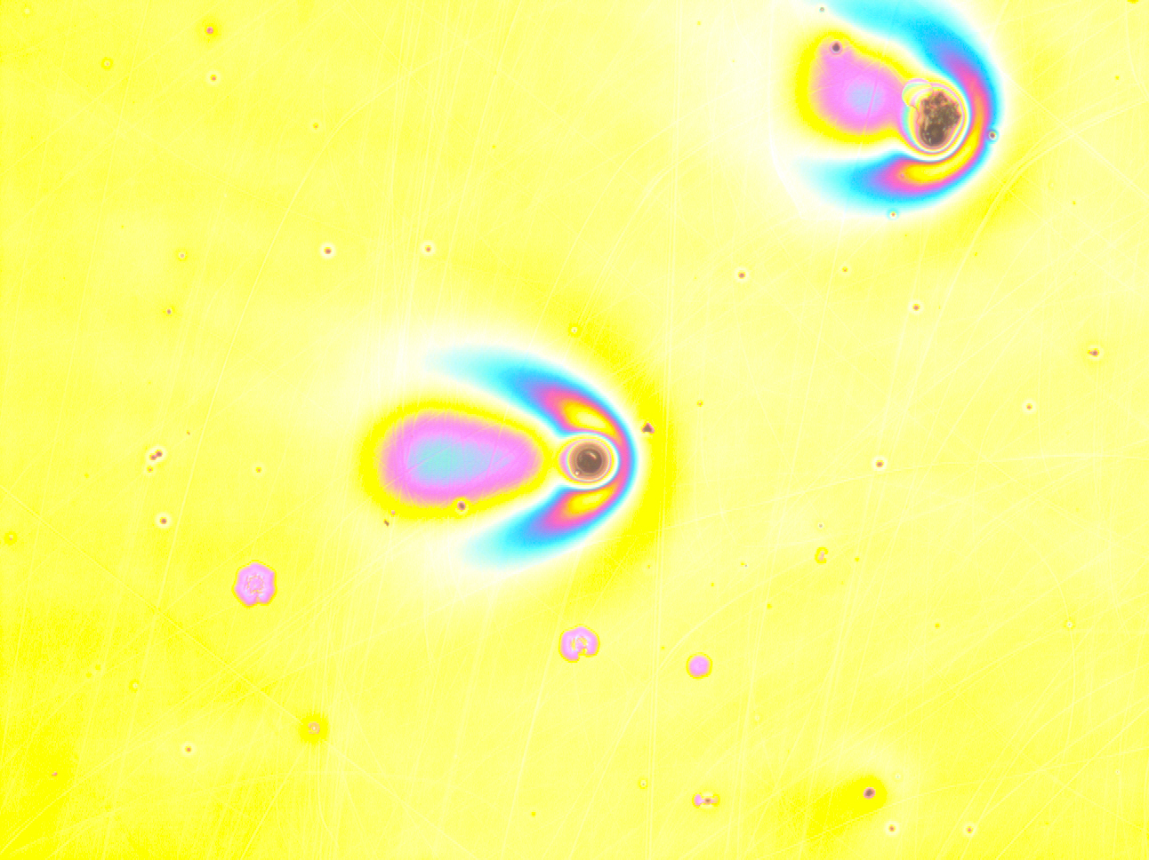 | 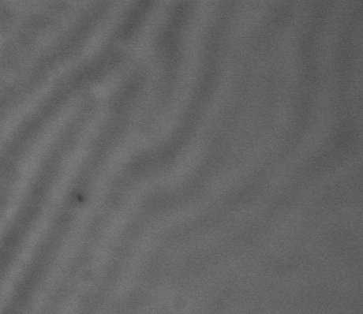
(a) | (b)
Figure 3. Spinning defects (a) comets and (b) striations

3.3. Thermal treatment and film formation
To obtain the YBCO epitaxial films the precursor films were heat treated in two stages. In the first stage, the precursor films were slowly heated at 400 °C in flowing humid oxygen atmosphere (the partial pressure of the water vapors was about 17 Torr) in order to decompose the organic precursors in metal oxy-fluorides. The heating profile of the calcining process is shown in Figure 4. The dry heat treatment up to 75 ºC prevents the gel film from absorbing humidity, which would deteriorate the film integrity. Humidified oxygen is introduced above 75 ºC to suppress the sublimation of (CF₃COO)₂Cu, which takes place due to its small molecular weight (298.58), as compared to Ba(TFA)₂ and Y(TFA)₃ (363.37 and 427.95, respectively). In order to understand the decomposition of the metal trifluoroacetates the electronegativities of the constitutive elements has to be taken into consideration. According to Pauling, the percent ionic character of a bond between A and B (A being the most electronegative) elements can be approximated by the expression
ionic character ={1-exp[-0.25(X_{A}-X_{B})²]}x100 (%),
where X_{A} and X_{B} are the electronegativities of the elements. The as derived ionic character of the bonds in the metal trifluoroacetate structure (M-O, C-O and C-F, where M is the metal) and fluoride (M-F) are presented in Table 1. Long calcining time between 200-250 ºC is necessary to break the covalent bonds C-C, C-O and C-F. The Cu-O bond has a stronger covalent character with respect to Y-O and Ba-O bonds. On the other hand, due to the rather small difference in the ionic character of the Y-O and Y-F, and Ba-O and Ba-F, respectively, the fluorine partially substitutes the oxygen forming the corresponding oxyfluorides. As a consequence, the pyrolyzed film consists in CuO nanocrystallites in a Cu-Y-Ba-O-F amorphous matrix.

Table 1 The ionic character of the bonds in the metal trifluoroacetate structure (M-O, C-O and C-F, where M is the metal) and fluoride (M-F)

Bond | Y-O | Ba-O | Cu-O | Y-F | Ba-F | Cu-F | C-O | C-F
X_{A}-X_{B} | 3.5-1.2 | 3.5-0.9 | 3.5-1.9 | 4.0-0.9 | 4.0-1.2 | 4.0-1.9 | 3.5-2.5 | 4-2.5
Ionic character (%) | 73 | 82 | 47 | 85 | 91 | 63 | 22 | 43

The as-resulted oxy-fluoride films were subsequently transformed in YBCO by thermal treatment at 800°C in flowing humid ($P_{H_{2}O}$of about 17 Torr ) nitrogen-oxygen
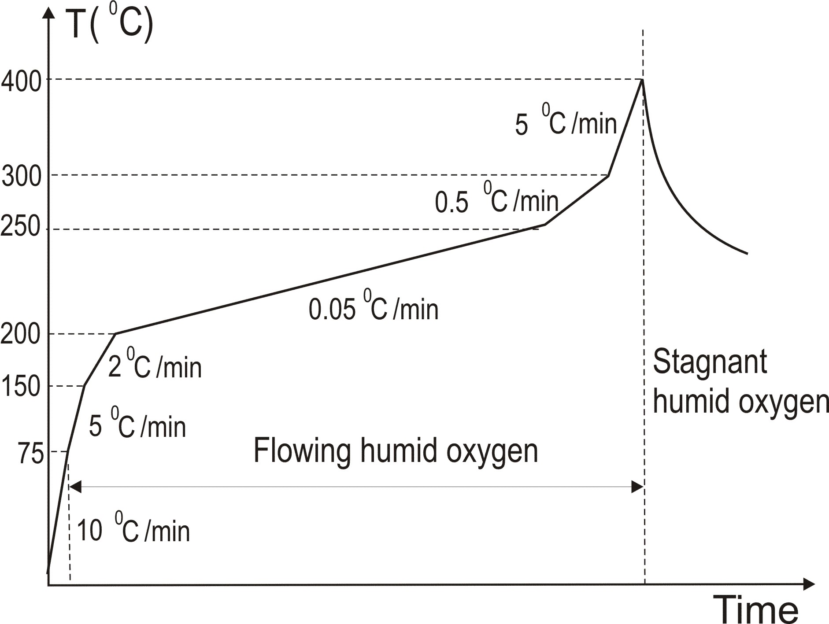 | 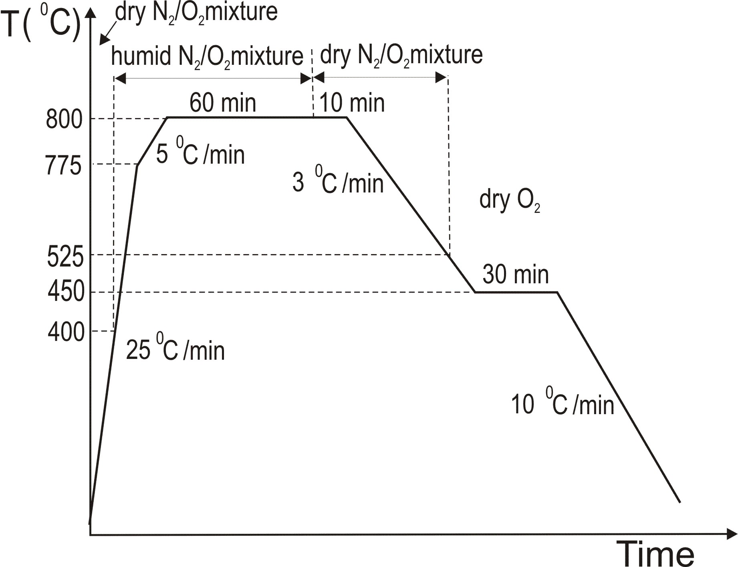
(a) | (b)
Figure 4. The pyrolisis (a) and (b) firing thermal treatment diagram

gas mixture with 1000 ppm oxygen. The heat treatment used in this work is similar to that reported in literature and a typical heating profile is shown in Figure 4b. Unlike conventional MOD process, in the TFA-MOD process the water vapors are necessary in order to convert the fluorides to oxides with the evolving HF, at temperatures above 650 ⁰C . YBCO is mainly formed during the firing at 800 ⁰C. It is generally agreed that the CuO nanocrystalites, formed during the calcination process, are essential for the formation and the epitaxial growth of the YBCO film. The amorphous matrix is Cu-poor close to the Cu nanocrystallites and Cu-rich elsewhere. The Cu-rich amorphous area becomes quasi-liquid at the firing temperature. The quasi-liquid network enhances the diffusion of water molecules from humid N₂/O₂ gas mixture towards the reaction front of YBCO and, at the same time, the diffusion of the HF to the film surface. CuO nanocrystalites are present in the resulting YBCO film. This can be explained by the slow diffusion rate of Cu in the quasiliquid and, as a result, the large CuO grains are not completely dissolved. Therefore, the pyrolysis time is a very critical parameter in order to avoid the formation of large CuO nanocrystallites.

3.4. Morphological properties of YBCO film
The surface morphology of the YBCO film grown on STO is shown in Figure 5a. Needle-like particulates represent a or b-axis oriented YBCO grains. These particulates are also observed in the YBCO films grown by PLD on single crystal substrate. A surface free of cracks, but with some holes can be seen. In spite of the voids, the c-axis oriented grains are well connected.

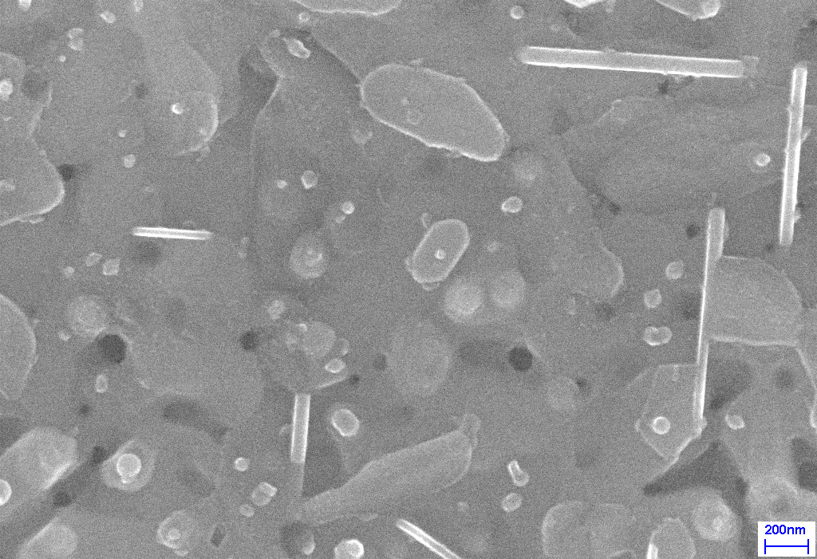  (a) | 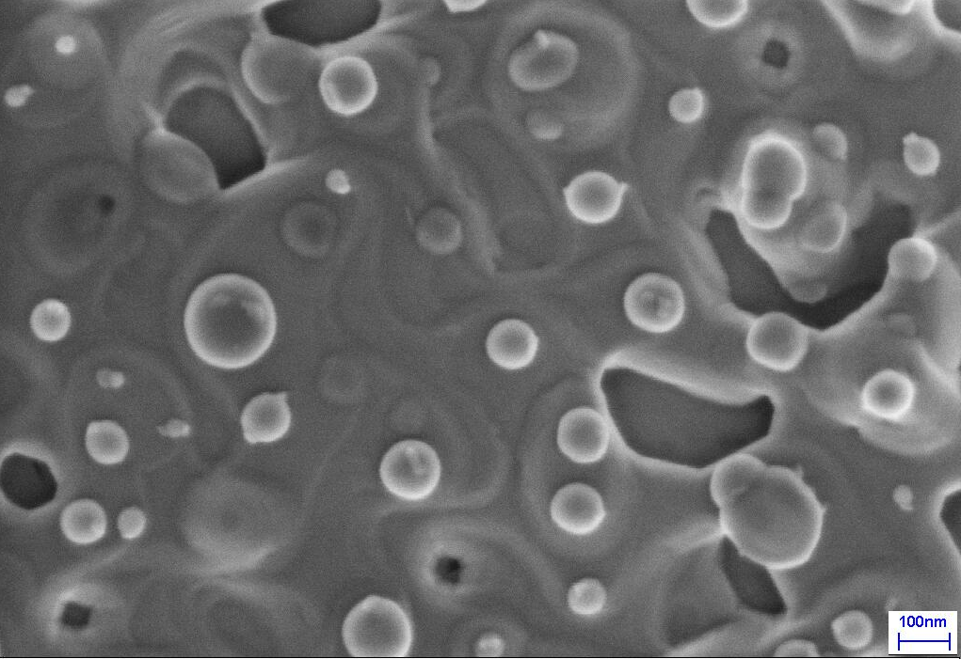  (b)
Figure 5. SEM image of (a) YBCO/STO and (b) YBCO/ CeO₂/YSZ/CeO₂/Pd/Ni-W film surface.
Furthermore, the YBCO grains are connected over pores. This explains the high value of the critical current density (J_{c}>1 MA/cm² at 77 K and zero magnetic field) of the YBCO/STO films. The spherical particulates are nanocrystallites of CuO. The morphology (Figure 5b) of the YBCO/CeO₂/YSZ/CeO₂/Pd/Ni-W films is very similar with that on single crystals. Nevertheless, the density of voids and spherical particulates is considerably greater. The high magnification SEM image reveals that the voids are at the surface of the YBCO film and, therefore, the film can be considered continuous.

3.5. Structural properties of YBCO film
The X-ray θ–2θ scans for the YBCO/STO film presents only (00l) peaks indicating that the film has a high degree of epitaxy with c-axis perpendicular to the substrate. The ω-scan of YBCO (005) peak has a full width at half maximum (FWHM) of 0.12°, close to that observed in the YBCO films grown by PLD. The XRD pattern of the θ–2θ scans for YBCO/ CeO₂/YSZ/CeO₂/Pd/Ni-W is presented in figure 6a. As for the YBCO/STO film, the XRD pattern exhibits only the (00l) YBCO peaks. No (h00) reflections, due to a-axis oriented grains, were observed. The (002) to (111) peak intensity ratio is of about 10² for both films. The peaks corresponding to Pd are not observed, indicating that Pd is completely diffused into the Ni-W substrate during the deposition at high temperature, both of the CeO₂ cap layer and the YBCO film. However, the formation of a superficial layer of Ni-W-Pd solid solution is confirmed by the peaks very close to the Ni-W (200) reflection. Due to the oxidation of the substrate, in the regions where the buffer layer was not deposited (under the clamps), NiO and NiWO₄ peaks are also observed.
The rocking curve (figure 6b) through the (002)Ni-W, (002)YSZ, (002)CeO₂ and (005)YBCO peaks have an out-of-plane FWHM of 8.8°, 4.2°, 3.8° and 3.4°, respectively. The small values of the FWHM for the YSZ and CeO₂ with respect to the Ni-W substrate is correlated with the Pd film. The pole figures have revealed the presence of a well-developed single component (100)[001] cube texture both for the Ni-W substrate and for the YBCO film. The in-plane crystallographic relationship of the structure is [100]YBCO||[110]CeO₂ ||[110]YSZ||[100]Ni-W. The FWHM of φ-scans of (113)YBCO, (111)CeO₂ , (111)YSZ and (111)Ni-W peaks are 6.1°, 6.3°, 6.4° and 7.5°, respectively.

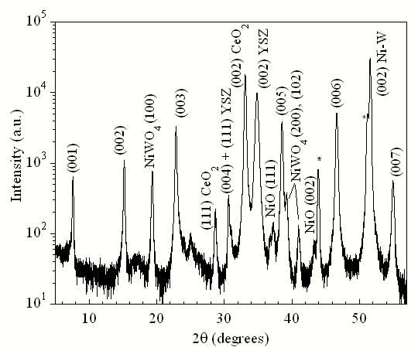
(a) | (b)
Figure 6. XRD pattern of θ–2θ scans for YBCO/ CeO₂/YSZ/CeO₂/Pd/Ni-W (a); Rocking curve through the (002)Ni-W, (002)YSZ, (002)CeO₂ and (005)YBCO peaks (b).

3.6. Superconducting transport properties
In figure 7a the (T) curves for two YBCO films deposited on STO starting from different TFA precursor solutions are reported. Both samples exhibit a linear decrease with RRR= (300 K)/  (100 K) > 3 and a very low resistivity close to the intrinsic value of the optimally doped YBCO. The high quality of the YBCO films is confirmed by the T_{c} values (90.7 K) and the reduced transition widths (T1.5 K) (inset from figure 7a). Accordingly, both samples show similar J_{c} values and magnetic field dependences. In figure 7b J_{c}(B) curves at three different temperatures for the YBCO TFA4/STO are plotted. The J_{c} values as high as 1 MA/cm² is reported at 84 K, reaching 2.7 MA/cm² at 77 K. The drop of the J_{c}(B) in the low field region is balanced by very high J_{c} values at higher fields. The YBCO films deposited on buffered Ni-W metallic substrates showed similar high T_{c} up 90.5K with slightly broader transitions (T2-2.5 K) still indicative of a remarkable homogeneity of the film.
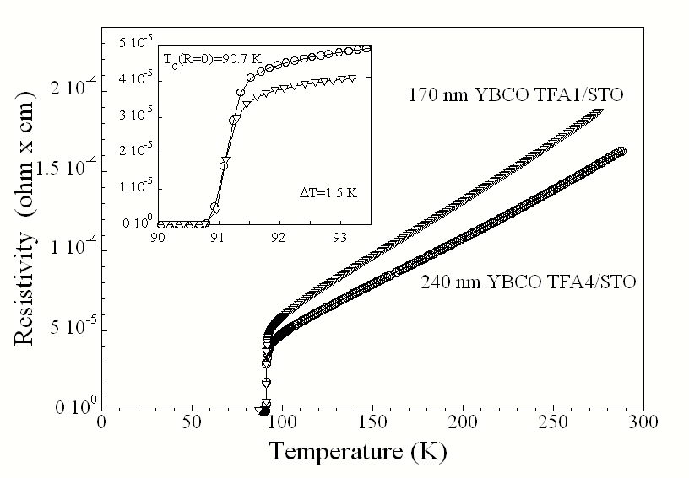 | 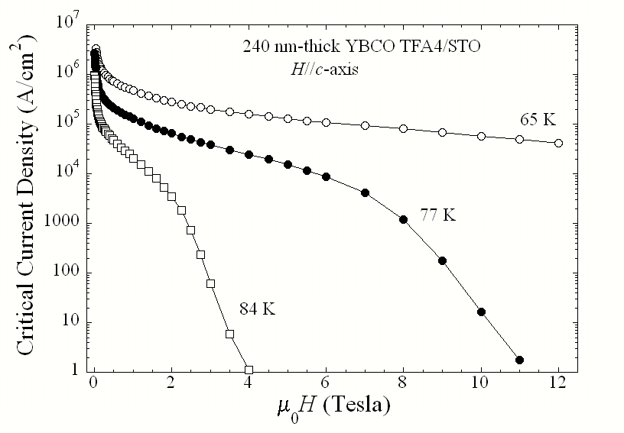
(a) | (b)
Figure 7. (a) RvsT plots for YBCO TFA obtained from two different solutions, TFA1 and TFA4, respectively and (b) J_{c}(B) curves at different temperatures for the YBCO TFA4/STO film.

4. Conclusions
The YBCO films with a high degree of epitaxy were grown by the TFA-MOD process, both on (100)SrTiO₃ single crystal and Pd/CeO₂/YSZ/CeO₂ buffered Ni-5at.%W. The X-ray study revealed that the Pd film has a better in-plane and out-of-plane texture with regard to the Ni-W substrates. This explains the excellent structural properties of the YBCO film grown on the as buffered substrate. The SEM investigations have revealed that the YBCO film on Ni-W has a good surface with well-connected c-axis oriented grains that suggests good transport properties. The present study has demonstrated that the CeO₂/YSZ/CeO₂/Pd buffer layer architecture is adequate for the manufacturing of long YBCO tapes on Ni-W substrates. The future activity will be focused on the preparation and electrical characterization of long YBCO superconducting tapes.

5. Foreseen activities and results for 2007
The following activities are to be performed in 2007:
-Adequate propionate-based coating solution with a long shelf life for 1 μm YBCO thick film deposition; Propionate-based precursor chemistry, preparation and characterization of the propionate based coating solutions; Optimisation of the as-prepared coating solution for the YBCO thick film deposit ion.
- Optimized and scalable thermal treatment for the deposition of high critical current density (>10⁶ A/cm² ) YBCO films on flexible metallic substrates for superconducting tape fabrication;
The deposition and characterization of the superconducting YBCO films on CeO₂/YSZ/CeO₂ buffered metallic substrates. Optimization of the deposition process and of the thermal treatment for a scalable technology

References
- Schwartz R.W., “Chemical Solution Deposition of Perovskite Thin Films,” in Chemistry of Materials, vol. 9, no. 11, pp. 2325-2340, 1997.
[2] Lange F.F., “Chemical Solution Routes to Single-crystal Thin Films,” in Science, vol. 273, no. 5277, pp. 903-909, 1996.
[3] Goyal A., “Next Generation HTS Confuctors, Non-fluorine Based Solution Technique to Grow YBa₂Cu₃O_{7-δ} Films-a Review,” Ed. M. Paranthaman, Plenum Publishing Corporation, 2002.
[4] Xu Y. and Shi D., “A Review of Coated Conductor Development,” in High Temperature Superconductors, vol.8,no.3, pp. 342-369, 2003.
[5] Gupta A., Jagannathan R., Cooper E.I., Giess E.A., Landman J.I., and Hussey B.W., “Superconducting Oxide-Films with High Transition-Temperature Prepared from Metal Trifluoroacetate Precursors,” in Appl. Phys. Lett., vol. 52, no.24, pp. 2077-2079, 1988.
[6] McIntrye P.C., Cima M.J., and Roshko A., “Epitaxial Nucleation and Growth of Chemically Derived Ba₂YCu₃O_{7-x} Thin Films on (001) SrTiO₃,” in J. Appl. Phys. vol. 77, no. 10, pp. 5263-5272, 1995.
[7] Smith J.A., Cima M.J., and Sonnenberg N., “High Critical Current Thick MOD-derived YBCO Films”, in IEEE Transactions on Applied Superconductivity vol. 9, no. 2, pp. 1531-1534, 1999.
[8] Araki T., Hirabayashi I., “Review of a Chemical Approach to YBa₂Cu₃O_{7-x}-coated Superconductors-Metalorganic Deposition Using Trifluoroacetates,” Topical Review in Supercond. Sci. Technol. vol. 16, pp. R71-R94, 2003.
[9] Rufoloni A., Augieri A., Celentano G., Galluzzi V., Mancini A., Vannozzi A., Petrisor T., Ciontea L., Boffa V. and Gambardella U., “YBa₂Cu₃O_{7-x} films prepared by TFA-MOD method for coated conductor application”, Journal of Physics: Conference Series 43 (2006) 199–202.

