TT-TRITIUM BREEDING AND MATERIALS
TV–Vessel/ In-Vessel

Manufacturing and characterization of Be/CuCrZr junctions using Cu-based and eutectic silver free
brazing alloys.

T. Petrisor, Lelia Ciontea

Technical University of Cluj-Napoca, Cluj-Napoca

1. Introduction
The development of joining technologies for the plasma facing components represents an important challenge in the field of materials for the experimental fusion reactor (ITER). Beryllium is the most attractive candidate for the plasma facing components [1-4]. The advantages of beryllium over the other candidates (tungsten and carbon-carbon composites) consist in the low atomic number, relatively high thermal conductivity, low tritium retention and low neutron activation. Low atomic number materials have led to significant improvements in plasma performance in present day tokamaks. The disadvantage of beryllium is its highly reactive nature with oxygen and its ability to form intermetallics with most of the elements. Several elements are compatible with beryllium, that is, they do not form intermetallic compounds and would thus provide a good base for filler metals or a compliant layer in contact with beryllium. Among these are silver, germanium, silicon, and aluminum. Silver has been successfully used by a number of investigators to join beryllium to copper by both brazing and diffusion bonding. However, precautions regarding the activation and transmutation products in the ITER neutron flux environment have led to the decision that silver is unacceptable for plasma facing components.
Lately, the Si based (Ti,Cr) eutectic alloys have been successfully used for the brazing of SiC/SiCf composites.The main advantage of the eutectic alloys are related to the eutectic temperature, which is the lowest melting temperature in the system and, on the other hand, to the liquidus and solidus line which are superposed. Therefore, several silver free eutectic alloys have been studied.
The prerequisites for a successful braze include (1) a braze alloy that wets the materials to be joined, (2) filler metals that are compatible with the substrate materials and the service environment, (3) materials that are compatible and do not form brittle intermetallics up to the flow temperature of the braze alloy, (4) surfaces that are clean and free of contaminants (such as oils, dirt, and oxides) and remain clean during the brazing process, and (5) a joint design that provides a close proximity between the two materials to be joined and designed for shear.

2. Experimental
2.1. Alloys and quasi-amorphous barzing foils preparation
The Ti-Cu, Cu-Sn-Mn-Ti and Cu-Sn-Ni-In silver free alloys have been prepared starting from 99,99% pure elements. Stoichiometric mixtures of the pure metals were melted in an argon plasma furnace with water cooled copper hearth. In order to obtain an homogeneous eutectic microstructure the samples were remelted several times. To study the role of manganese, the Cu-43at. % Ti alloys were doped with 0.5, 1 and 2at% Mn. Amorphous tapes were prepared by rapid quenching directly from the melt. The melt-spinning involves the continuous impingement of the molten alloy against a rapidly moving water cooled Cu surface.
2.2. Wetting experiments
The wetting properties of Ti-Cu-Mn, Cu-Sn-Mn-Ti and Cu-Sn-Ni-In alloys have been investigated on an ITER-GRADE ELBRODUR Cu-Cr-Zr alloy. For the wetting experiment bulk pieces of alloys were put on CuCrZr plates without applying any external pressure. Prior, both pieces of alloy and the CuCrZr plates were ultrasonically cleaned in acetone and 2-isopropanol. The general thermal treatment used for the wetting experiments is presented in figure 1. The samples were heated in a quartz tube furnace in high vacuum (10⁻⁷ Torr) to avoid the oxidation.
2.3.Thermal analysis
The eutectic temperature has been determined by means of Differential Thermal Analyses (DTA). The DTA analyses were performed at a heating rate of 10 ⁰C/min in a flowing Ar atmosphere to avoid the oxidation of the samples.
2.4. Structural and morhological caharacterisation
The crystalline structure of the eutectic alloys was investigated using a Rigaku diffractometer with copper K_{α1} (λ = 1.54050 Å) radiation.
Morphological characterization of the eutectic alloys was made by means of SEM (Scanning Electron Microscopy) and EDXS (Electron Dispersive X-ray Spectroscopy).

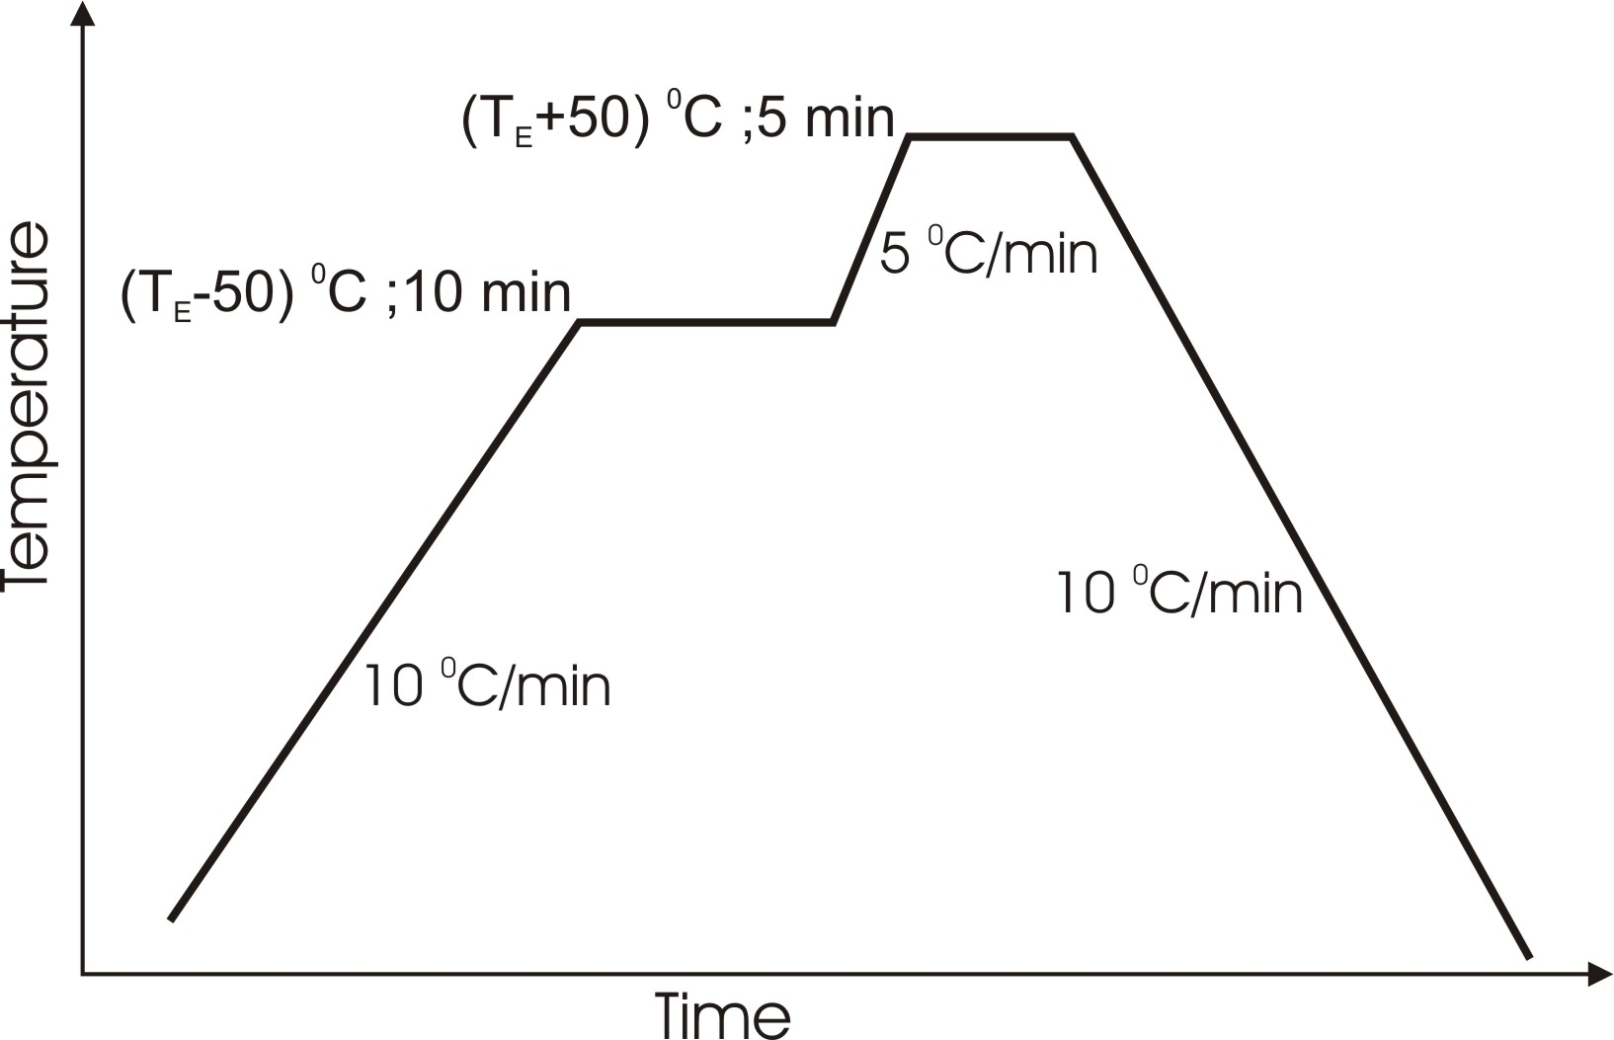

Figure 1. Temperature diagram of the wetting process, where T_{E} is the eutectic temperature determined by DTA analysis.

3. Results and discussion
3.1. DTA analysis
The melting temperature of the brazing alloy was determined by means of Differential Thermogravimetric Analysis (DTA). As an example, next it will be presented the DTA analysis for the CuSnNiIn and CuSnMnTi alloys.
3.1a. Cu₇₉Sn₁₃Ni₂In₆ alloy
The heating curve of the Cu₇₉Sn₁₃Ni₂In₆ alloy is presented in figure 2. The melting temperature can be more accurately observed in the DTA curve, presented in figure 2. The beginning of the endothermic reaction at 765 ⁰C represents the melting temperature. It is to be noted that this temperature is in rough agreement with the temperature reported in the Cu-Sn phase diagram for the nominal composition of about 20 at.% Sn. Simplifying, we can consider that the complex alloy Cu₇₉Sn₁₃Ni₂In₆ can be reduced at Cu-20 at.% Sn binary alloy, due to the chemical and electronic compatibility between Cu and Ni on one hand and, between Sn and In on the other hand.
Figure 2. Differential Thermal Analysis (DTA) of the Cu₇₉Sn₁₃Ni₂In₆ alloy.

3.1b. Cu₆₂Sn₃₀Mn₂Ti₆ alloy
The DTA curve for the Cu₆₂Sn₃₀Mn₂Ti₆ alloy is presented in figure 3. As can be seen, the DTA curve is very similar with that for the Cu₇₉Sn₁₃Ni₂In₆ alloy. It is to be noted that the melting temperature is shifted with about 30 ⁰C towards lower temperatures.
Figure 3. DTA analysis for Cu₆₂Sn₃₀Mn₂Ti₆. The arrows indicate the curves drown during the heating and cooling, respectively.

  - Wetting tests
The wetting experiments have demonstrated that Mn improves the wetting properties of Cu-Sn-Ti. It has been observed that the optimum wetting temperature decreases with the increase of Mn concentration up to 2at%Mn. The degree of spreading on the template is larger for higher Mn concentration. It is to be noted that, in the region of the junction, the brazing material is quite compact, uniform and free of cracks. This aspect is very important for a high quality brazing. The diffusion front can also be observed. Our study has revealed that for all Mn concentrations the thickness of the diffusion layer is strongly dependent on the wetting temperature and time. The wetting angle and the diffusion depth for the studied alloys are presented in the table below.

Table 1. Diffusion depth and wetting angle of several brazing aslloys
Brazing alloy | Diffusion depth | Wetting angle
Ti-43%at.Cu | 193.35µm | 22.26 º
(Ti-43%at.Cu)0.5%at.Mn | 449.78 µm | 12.79 º
(Ti-43%at.Cu)1%at.Mn | 353.46 µm | 16.49 º
(Ti-43%at.Cu)2%at.Mn | 329.41 µm | 22.47 º
Al-17.1%at.Cu | 175,03 µm | 21,1 º
(Al-17.1%at.Cu)0.5%at.Mn | 315,46 µm | 33,68 º
(Al-17.1%at.Cu)1%at.Mn | 396,89 µm | 21,85 º
(Al-17.1%at.Cu)2%at.Mn | 361,63 µm | 29,9 º
(Al-12.2%at.Si)0.5%at.Mn | 7.01 µm | 39.73 º
(Al-12.2%at.Si)1%at.Mn | 44.93 µm | 22.49 º
(Al-12.2%at.Si)2%at.Mn | 18.44 µm | 46.88 º
Cu-13%at Sn2%at Ni6%atIn | < 5 µm | 19.6 º
Cu-30%at Sn2%atMn6%atTi | 17.11 µm | 28.5 º
Cu-32%at Sn6%at Ti | 19.44 µm | 21.08 º

3.3. Brazing experiments
For the preliminary testing of the studied brazing alloys ITER-GRADE ELBRODUR Cu-Cr-Zr samples have been used. The joints have been prepared according to the “Standard Test Methods for the measurement of the Strength of Joints During manufacturing of the ITER First Wall” presented in Fig.4a. The joinings were performed both in vacuum 10⁻⁷ Torr and Ar+12%H₂ atmosphere, following the same temperature-time diagram as that for the wetting experiments (figure 1). The as obtained joinings have been characterized from a microstructural, chemical and mechanical point of view by SEM, EDXS and shear test, respectively.
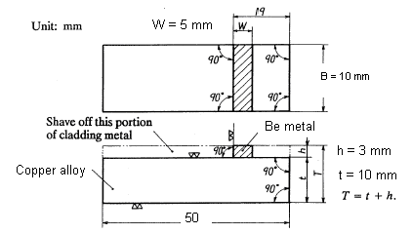 | 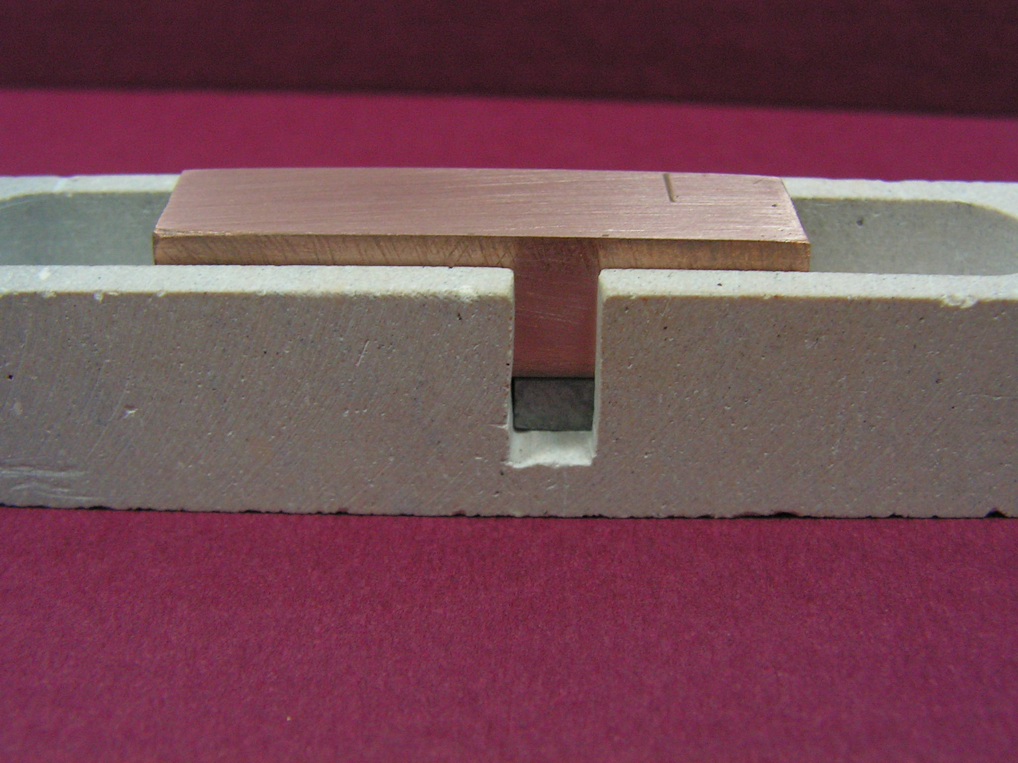
(a) | (b)

Figure 4 (a) The geometry of the CuCrZr-Be junction for the mechanical testing and (b) the ceramic device for the junction manufacturing.
The results of the shear stregth test are presented in Table 2. The CuSnNiIn and CuSnMnTi based junctions are under testing.

Table 2.Shear stregth of the CuCrZr-Be junctions.
Alloy | Shear strength [MPa] | Displacement [mm]
Ti-43 at.% Cu | 138.8 | 0.74
(Ti-43 at.%Cu)0.5 at.%Mn | 241.95 | 1.52
(Ti-43 at.%Cu)1 at.%Mn | 234.7 | 3.03
(Ti-43 at.%Cu)2 at.%Mn | 279.45 | 2.34

4. Conclusions
In the frame of TW5-TVM-BRAZE technology task the following activities have been performed:
      - Manufacturing of both amorphous and nanocrystalline Cu-Sn-Mn-Ti and Cu-Sn-Ni-In brazing alloys and foils (thickness of minimum 50 μm and 40 mm wide)
      - Determination of the liquidus and solidus temperatures by DTA-TG thermal analysis
      - Wettability study of the brazing alloys on the ITER-GRADE ELBRODUR Cu-Cr-Zr alloy.
      - Manufacturing of the Be/Cu-Cr-Zr junctions and shear strength testing.

References
[1] Odegard B.C. Jr., Cadden C.H., Watson R.D., Slattery K.T., A review of the US joining technologies for plasma facing components in the ITER fusion reactor, Journal of Nuclear Materials 258-263 (1998) 329-334
[2] Dadras P., Ting J.-M., Lake M.L., Brazing residual stresses in Glidcop-All2Si-Be, Journal of Nuclear Materials 230 (1996) 164-172
[3] Odegard B.C., Kalin B.A., A review of the joining techniques for plasma facing components in fusion reactors, Journal of Nuclear Materials 233-237 (I 996) 44-50
[4] Kalin B., Fedotov V., Sevryukov O., Plyuschev A., Mazul I., Gervash A., Giniatulin R., Be-Cu joints based on amorphous alloy brazing for divertor and first wall application, Journal of Nuclear Materials 271-272 (1999) 410-414
[5] Iseki T., Arakawa K., Suzuki H., “Joining of dense silicon carbide by hot pressing” J. Mater. Sci. Lett. 15 (1980), 149.
[6] Petrisor T., Neamtu B.V., Rufoloni A., Rauca M.C., Brandusan L., Synthesis of silver free eutectic alloys for Be and Cu_{99.32}Cr_{0.6} Zr_{0.08} brazing Presented at Matehn’06 and accepted for publication in Advanced Materials Research

