TT-TRITIUM BREEDING AND MATERIALS
Fuel Cycle

EFDA/05-1238; FU06-CT-2005-00065
Development of ITER PRM and Standard Parts Catalogues in CATIA V5 for Tritium-containing Systems and Components

A. Lazar*, S. Brad*, M. Zamfirache*, S. Soare*, N. Sofalca*, M. Vijulie*
S.Beloglazov**, M. Lux**, M. Glugla**, R.Wagner**, V. Weber**
*National Institute for Cryogenics and Isotopes Technologies (ICIT), Rm. Valcea, Romania
**Forshungszentrum Karlsruhe – Tritium Laboratory, Germany

1. Introduction
CATIA V5 is the software chosen to design and integrate in ITER both the systems: fluid and mechanical. The broad range of applications provides the ability to develop the design process from the functional 2D design (P&ID) to the 3D plant layouts and detailed design.
The Project Resource Management (PRM) is a framework of the project which on one hand gives a tool to customize the working environment and on the other hand it organizes the design process to ensure design compliance with established standards, specifications, industrial conventions, terminology and practice. A PRM (Project Resource Management) and Standard Parts Catalogues in CATIA V5 for Tritium-containing Systems and Components are required. The selected standard and specification were prepared and integrated into the PRM, in order to create 2D symbols and 3D parametrical part in CATIA V5. Catalogues for components as well as for standards and specifications are the main parts of the CATIA V5 PRM.
A Project Resource Management system will be able to:
- Control all resources of the Equipment and Systems (E&C) workbench in CATIA V5 for a certain project (ITER).
- Set and follow standards and design rules for a project.
Allows to:
- Set up the necessary functions and attributes into the Feature Dictionaries
- Define different object classes in the different Feature Dictionaries
- Set proper attributes on the object classes
- Build up the 2D symbols and 3D parametrical parts
- Logically relate the functional 2D design with the 3D parametrical parts
- Build up and manage 2D symbol catalogues
- Build up and manage 3D parts catalogues
- Manage parametric parts
- Offer only proper parts to the designer (e.g. correct size)
- Create reports

2. Updating of the Feature Dictionary
The elements of P&ID, pipes, piping parts, equipment and instruments carry attribute information such as fluid type, pressure rating, insulation or material. The list of attributes is defined in the Feature Dictionary and consists of the standard industrial and project specific attributes defined by Project Administration. The functional classes, physical classes and required functions for 2D symbols and 3D parts are also part of the feature dictionaries.
After consultations and reviewing the functions, attributes and classes with FZK-team, the following Feature dictionary have been developed during the project: CATPipingITR, CATEquipmentITR, CATInstrumentITR, CATTubingITR, CATWaveguideITR, CATHVACITR CATElectricalITR, CATRacewayITR [1, 2].

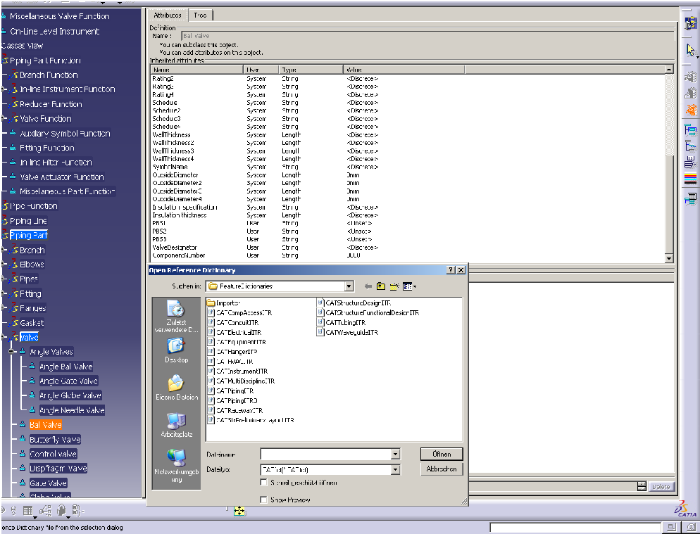
List of Feature Dictionary
Attributes for 3D parametrical Parts
3D Physical Classes

Figure 1. Feature dictionary for 3D components

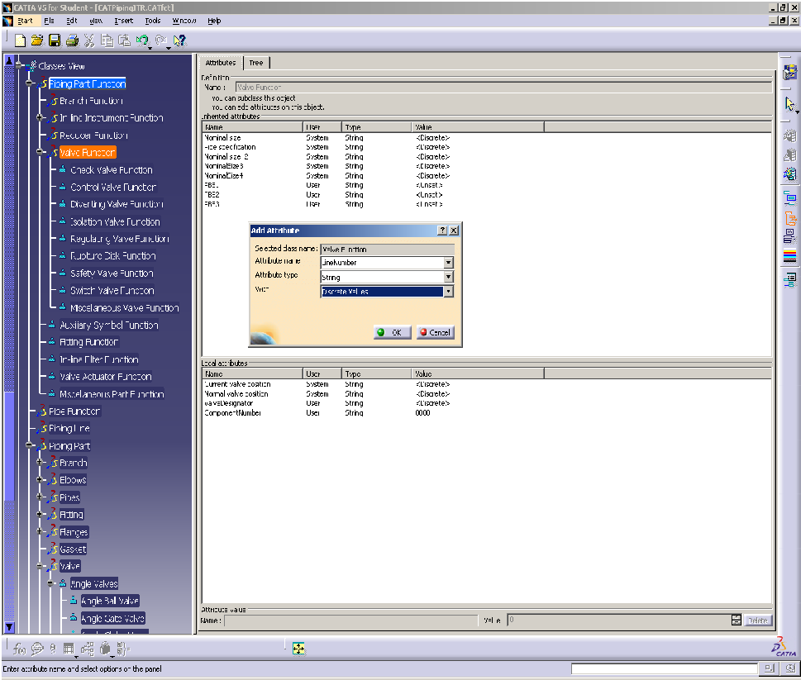
Specific attributes defined by Project Administration
Attributes implemented by default in CATIA V5
2D Functional Classes

Figure 2. Feature dictionary for 2D symbols

Users need to manage their resources in a way that is different from what they have been used to. Information such as directory paths for various resources without which the application cannot function - line list catalogs, user dictionaries, catalogs. The settings needed in the Feature Dictionary were made by FZK-team (Figure 1, 2).

3. Updating of the catalogues for the 2D symbols
According with the CATPipingITR classification, CATEquipmentITR classification and CATInstrumentITR classification [1, 2], and using the EN ISO 10628 standard [7], ISO 3511 (part I, II and IV) standard [7], DIN 28401 standard [7] and the settings from PRM, the 2D symbols for piping parts, equipments, process measurement control functions and instrumentation have been developed during the project.
The CATIA files that contain 2D symbols and all the catalogues were installed in PRM on CATIA SERVER at TLK-FZK
The 2D symbols for piping components, equipments and instrumentation installed in PRM have been embedded into a word document that presents the function, the subject group, the graphical representation and the description for all the symbols. The document has been done in close collaboration with FZK team.
All the symbols have been embedded in three catalogues: P&ID_PipingCatalog, P&ID_EquipmentCatalog, and P&ID_InstrumentCatalog. Those catalogues are linked to the main catalogue PID_Symbols (Figure 3). Also, the SymbolsAnnotatios catalogue was created in order to automatically place the notation for piping component, equipment components and instrumentation components in P&ID and PFD. The symbols and the catalogues for symbols were done after consultation with FZK team.

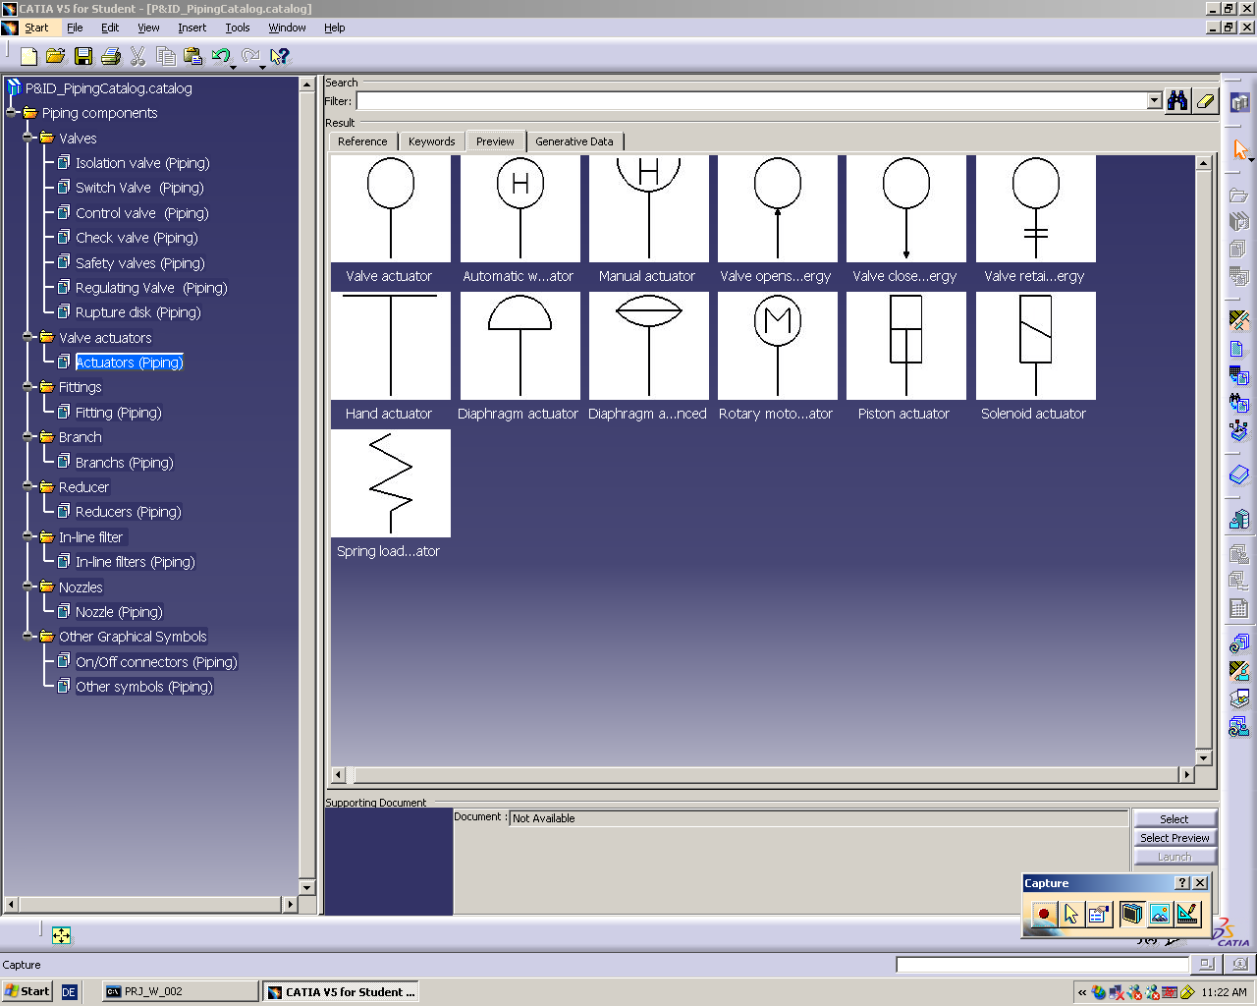
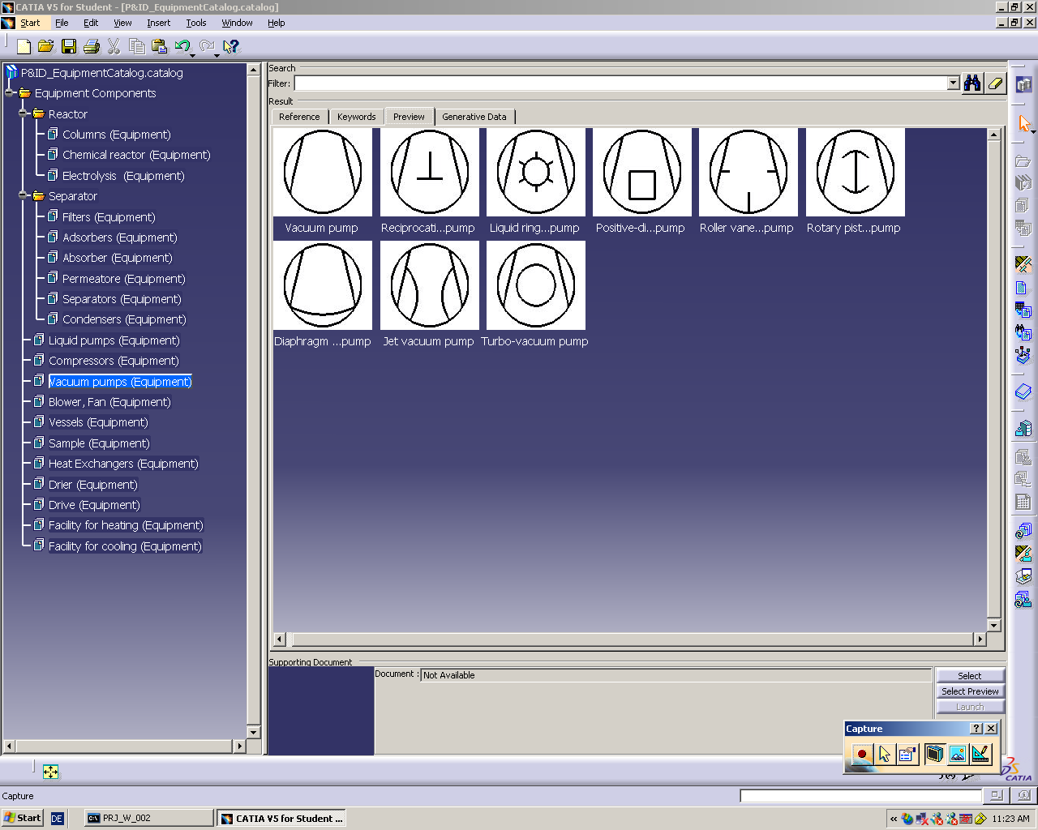
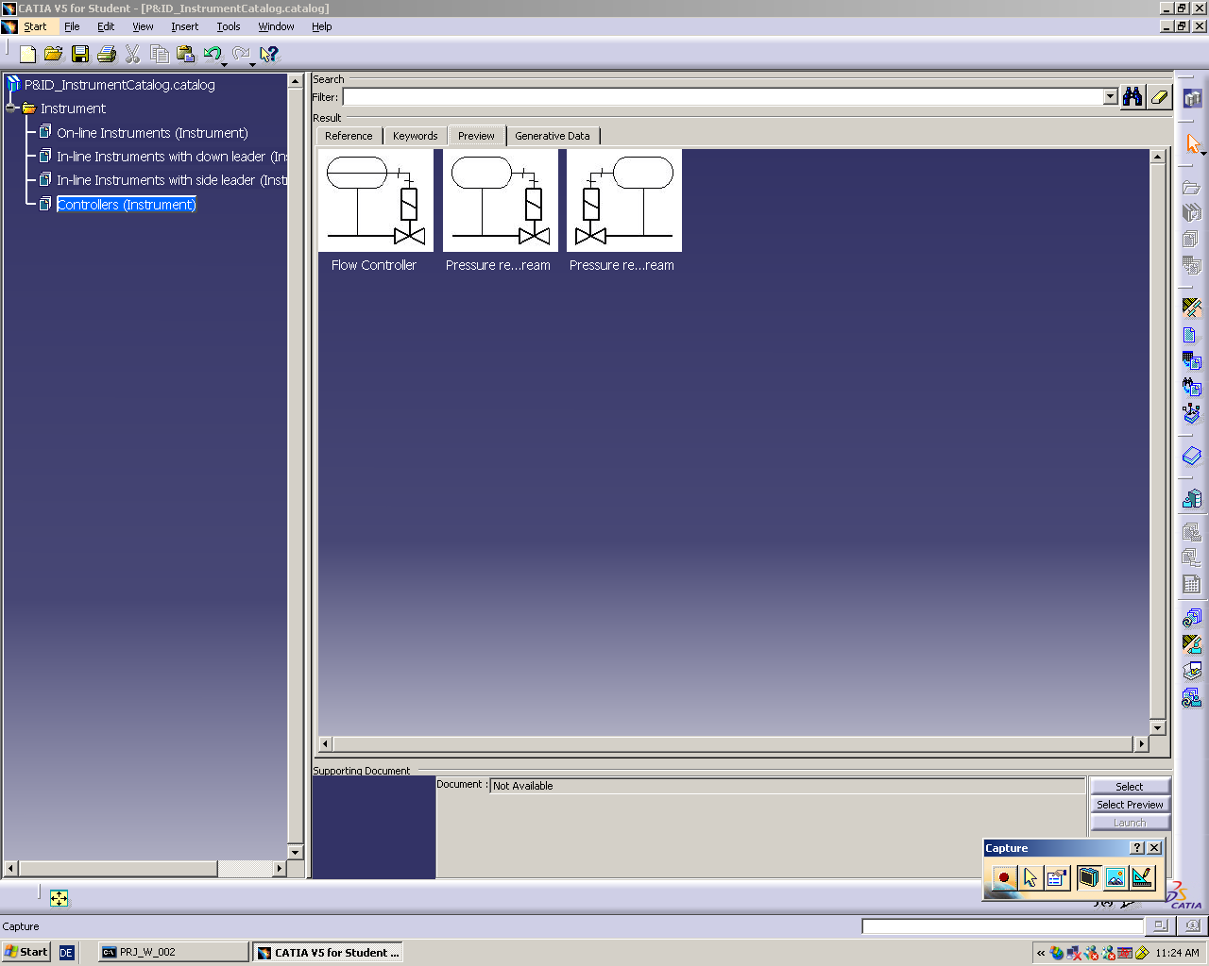
PID_Symbols
P&ID_PipingCatalogg
P&ID_EquipmentCatalog
P&ID_InstrumentCatalog

Figure 3. 2D Symbols Catalogue

To insert annotation into the P&ID text templates associated to the object attributes for valve symbols, equipment symbols, instrument symbols and piping line were created. Those text templates have been placed in the SymbolsAnnotatios catalogue. The templates and the catalogue for annotation were built together with FZK team.
All 2D symbols catalogues were intensively tested in Piping & Instrumentation Diagrams application. The designer can choose the 2D symbols for catalogues and insert them in the Process Flow Diagrams and Piping and Instrument Diagrams. Also, a P&ID for WDS was developed, split in three parts (one drawn by MEdC/ICIT team and the other two by FZK team). These three P&ID are connected to each other using the on-off sheet connectors inserted from PID_Symbols catalogue. The 2D test P&ID realized by MEdC/ICIT team is presented in Fig 4.
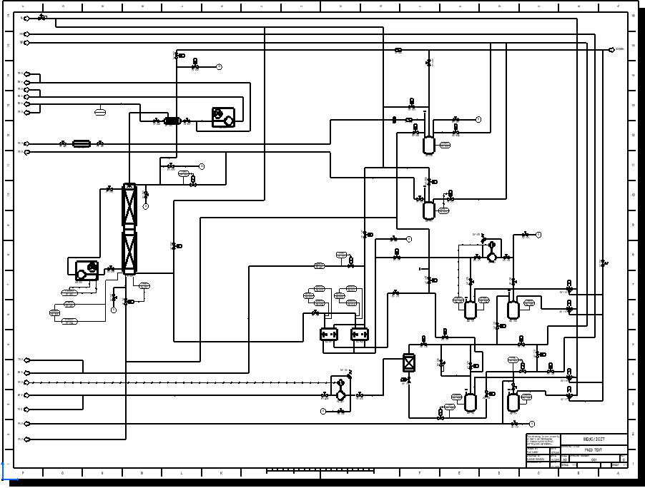

Figure 4. The test P&ID realized by MEdC/ICIT team

The 2D graphical elements of P&ID, pipes, piping parts and equipments have as attributes the information defined in the Project Resources Manager (PRM). This will by helpful for the designer to choose the right components from catalogues and to insert them into P&ID and PFD for WDS.
2D logical design and 3D models are logically related through the common functions definition in the PRM.
The designer can generate a report that displays the attributes of the components contained in P&ID (Figure 5). The report can be saved in HTML format, TXT format, XML format or XLS format.
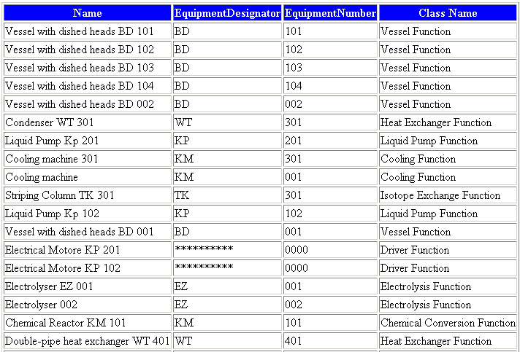
Figure 5. Report generated from P&ID

4. Updating of the catalogues for the 3D components
The 3D components needed to be designed using the “Part Design” module (that provides the tools for creating and managing the 3D components and also for creating parametrical parts). The 3D part was done parametrically in order to allow the designer to modify these parameters according to the design. The parameters were organized in sets and are described for each part. The shape and dimension for those parts were chosen from different company catalogues and literatures [4, 5, 6] available in library and on Internet. After consultations and reviewing the 3D parts with FZK-team, the 3D parts for piping components, equipments, process measurement control and instrumentation were developed during the project.
The 3D test catalogues created in the Catalog Editor application for the 3D parts are: EquipmentParts catalogue, PipingPart catalogue and InstrumentParts catalogue (Figure 6). The catalogues were built, after consultation with FZK team, to be tested prior to they’re embedding in PRM. The test procedure was done according to the IKARUS-Project Instructions [3] developed by FZK-team.
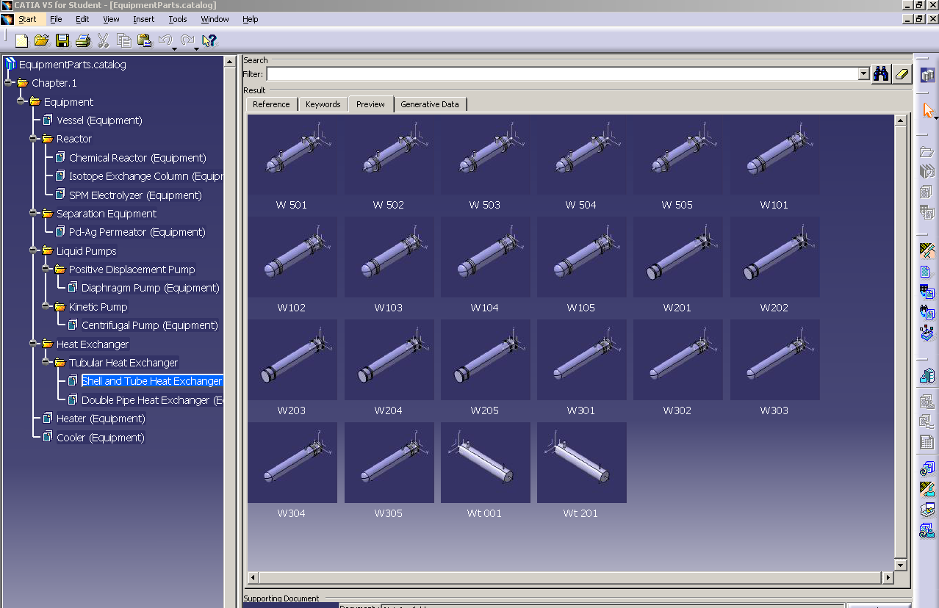
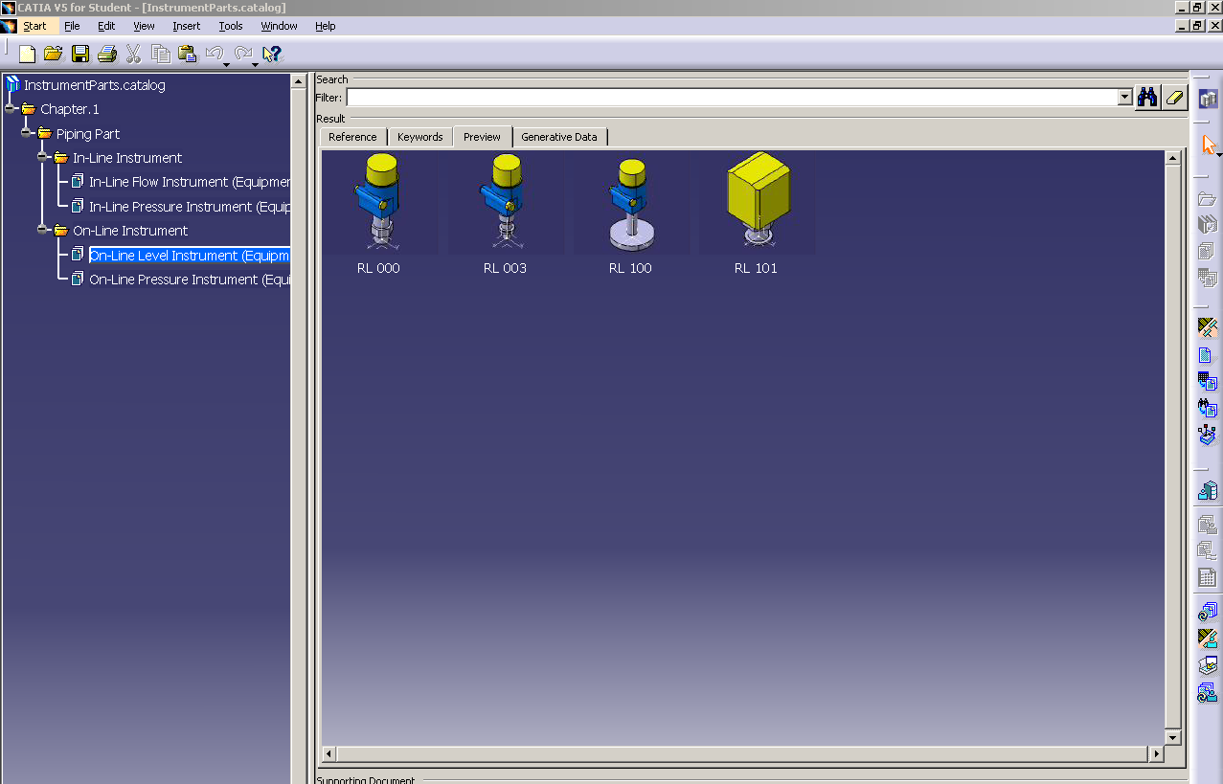
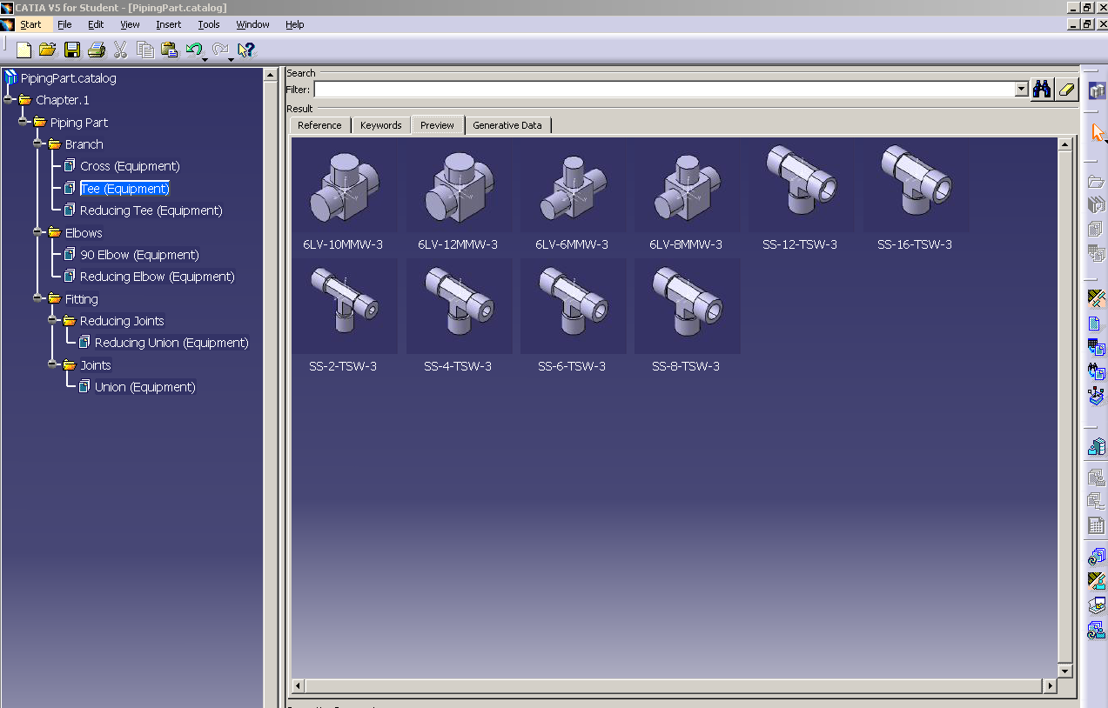
InstrumentParts catalogue
PipingPart catalogue
EquipmentParts catalogue

Figure 6. 3D Parts Catalogue
The designer places the 3D components from the catalogues referring to the element from P&ID (Figure 7). It may be necessary to further complete specific characteristics of the 3D parts through attributes.

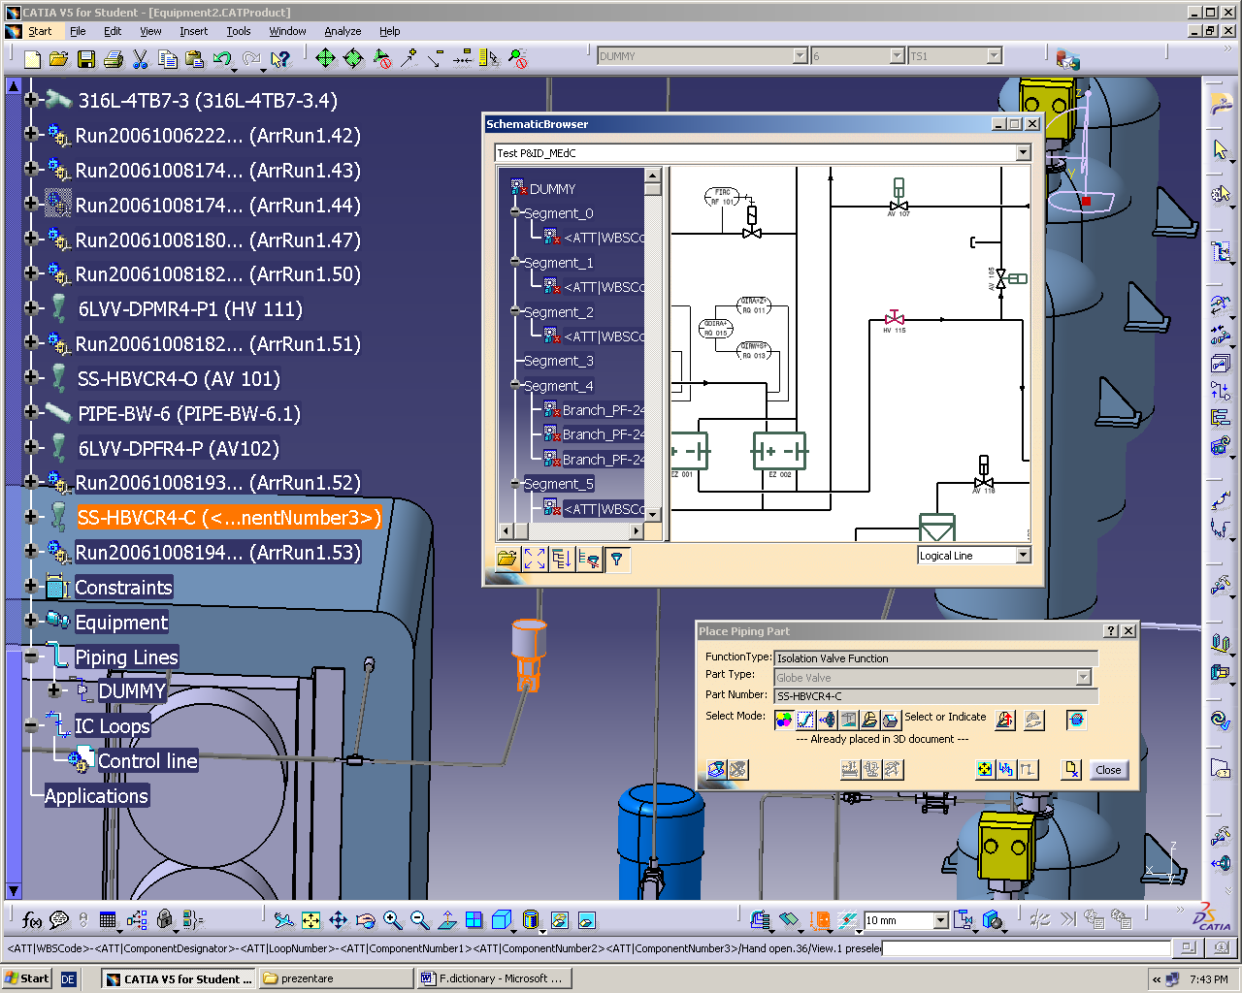

Figure 7. Placing the 3D components referring to the elements from P&ID

The criteria obtained from the Feature Dictionaries, Standards and Specifications are used to select the proper parts or to indicate to the designer what part can not be placed due lack of definition of Parts in the catalogue or due to the design rules. In case of nonconformity of the chosen criteria (by the designer) with the criteria from PRM, CATIA V5 generates an error messages (Figure 8).
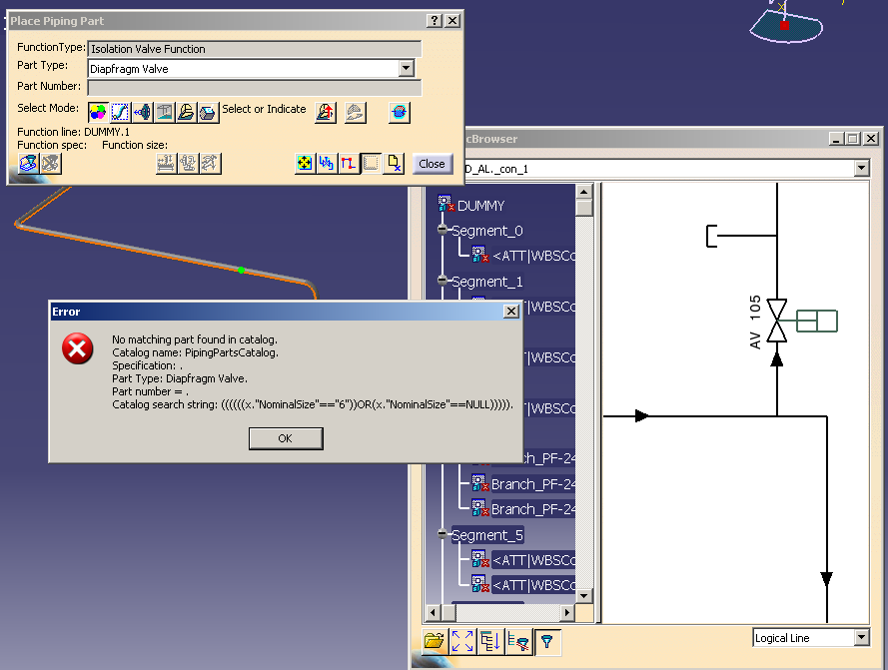

Figure 8. Error messages with the criteria that don’t were achieved.

A test layout was developed, in collaboration with FZK team, in order to test the 3D components and the collaborative work in CATIA V5 (Figure 9).

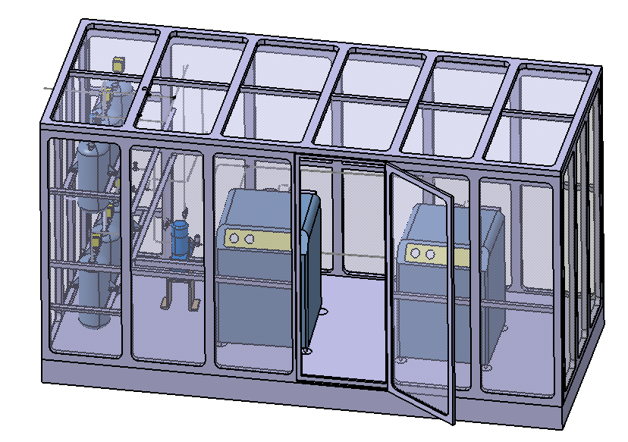
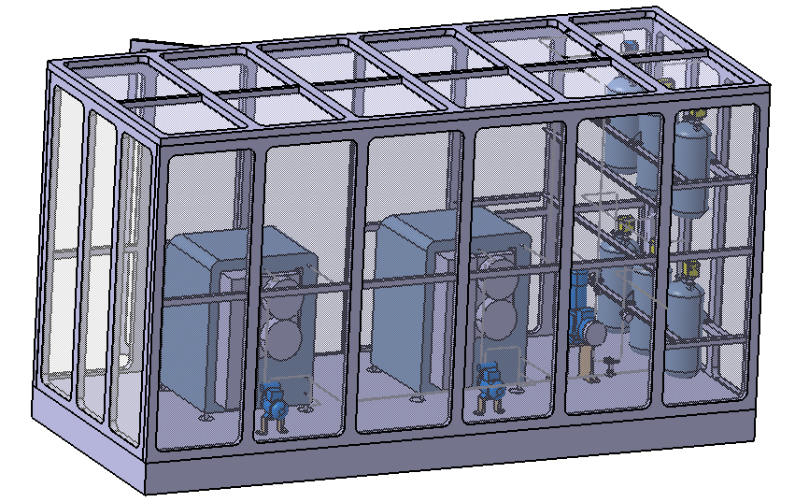

Figure 9. Test layout for 3D components

4. Collaborative work
Work related to these topics belongs to the task TW5-TTFD-TPI- 51 (Art.5.1b) from the EFDA Technology Work program 2006 and was done in collaboration with FZK Association team during the period January 2006 - December 2006.
Part of this work has been performed during the two-month Mobility Secondment of A. Lazar at Forshungszentrum Karlsruhe – Tritium Laboratory, Germany.

5. Conclusions
The following applications from CATIA V5 R 16 such as Piping & Instrumentation Diagrams, Part Design, Wireframe and Surface Design, Piping Design, Equipment Arrangement and Catalog Editor were used to develop the 2D symbols and 3D parts for piping, instruments and equipments components of a WDS system.
The 2D symbols for the equipment and piping components were developed in accordance with EN ISO 10628 standard [7], ISO 3511 (part I, II and IV) [7] standard and DIN 28401standard [7] and considering the classification and settings done in the PRM in order to ensure compliance with the established design standards. These symbols were inserted in 2D catalogues linked with the main catalogue installed in PRM on CATIA SERVER at TLK-FZK and intensively tested in Piping & Instrumentation Diagrams. The 2D graphical elements of P&ID, pipes, piping parts, instruments and equipments have attributed information that is defined in the PRM. Also, a P&ID for WDS was developed, split in three parts (one drawn by MEdC/ICIT team and the other two by FZK team) and a description for the 2D symbols development and typing procedure was written.
The 3D part for the equipment, instruments and piping components was developed according to the specifications, industrial conventions, terminology and literatures [4,5,6] available in library, Internet and practice. All parts were parametrically built in order to allow the designer to modify the part geometry according to the design. The 3D parts were typed in accordance with IKARUS-Project Instructions [3], inserted in 3D test catalogues and tested in Equipment and Systems workbench.
The PRM and the support documentation can be downloaded from http://fusioncadoffice.fzk.de.
References
[1] Beloglazov S., Wagner R., “TLK Classes Piping classification”.
[2] Beloglazov S., Wagner R., “TLK Classes Equipment classification”.
[3] Wagner R., “IKARUS-Project Instructions”.
[4] Vasaru G., “Tritium Isotope Separation”, CRC Press, Inc. (1993)
[5] Nelik L., “Centrifugal and Rotary Pumps. Fundamentals with Applications”, CRC Press LLC (1999)
[6] Kakac S., Hongtan L., “Heat Exchangers. Selection, Rating and Thermal Design”, CRC Press LLC (1998)
[7] European Standard, “EN ISO 10628”, “EN ISO 3511”, “DIN 28401”

