TW5-1.5; TW5-TPDC-IRRCER
Report on radiation-induced absorption of selected alternative radiation-resistent glasses following displament damage

B. Constantinescu, R. Bugoi, P. Ioan and D. Stan
“Horia Hulubei” National Institute of Nuclear Physics and Engineering, Magurele

1. Introduction
The present report is related to the research activities started in 2004 on the modifications induced in the optical transmission properties by the high-energy proton irradiation of some quartz glass samples - candidate materials for the future fusion reactor. Consequently, in 2006, we focused our activity on the preparation of new irradiation conditions – in-vacuum at temperatures up to 150 °C – and on first in-vacuum irradiations at different temperatures of three KS-4V and three KU-1 quartz glass samples.
The optical transmission components of the future thermonuclear reactor will be expected to maintain their transmission properties under high levels of ionizing radiations (≈ 5 Gy/s) during hundreds of hours [1]. For such applications, radiation-induced optical absorption imposes a severe limitation. It is therefore necessary to study the optical degradation of the suitable candidate materials, to assess the system lifetimes. KU-1 and KS-4V quartz glasses are among the main candidates insulator materials for the International Thermonuclear Reactor (ITER) project [2, 3], due to the fact that they are known to be radiation-resistant.

2. Experimental
The study of the proton irradiation-induced modifications of the UV transmission properties of KU1 and KS-4V quartz glasses started with irradiations performed in-air at the Bucharest 8 MV HVEC Tandem accelerator [4].
During the reported period, we focused on the realization of an in-vacuum irradiation facility for our samples, adapting an existing irradiation chamber – see figures 1, 2, and 3. We also made some adaptation of the target chamber - an electrical charge integrator and a temperature remote controller using the possible heating due to the bombarding beam, allowing temperatures up to 150 °C on the insulated targets.
The optical transmission properties (absorption, transmission) in the UV region were measured using a 100 Bio Cary VARIAN UV-VISible spectrophotometer, adapting the holder for our samples.
Three KS-4V samples were irradiated with 14 MeV protons at a total dose of 16.7 MGy, 3.7×10⁻⁶ dpa at 50 °C, 60 °C, respectively 110 °C.
The study of the proton irradiation effects on the ultraviolet transmission properties of other potential candidate materials for the ITER project was continued with the investigations on three KU1 quartz glass samples which were irradiated with 14 MeV protons at a total dose of 16.7 MGy corresponding to 3.7×10⁻⁶ dpa at 40°C, 70°C and 100 °C respectively.

3. Results
Before irradiation, the range of 12.6 MeV protons in SiO₂ and the number of the collision events - vacancies produced by the protons in target depth were calculated using the SRIM 2003 code [5].
The absorption spectra are presented in figure 4. For the 0.6 mm thick KS-4V samples irradiated with 14 MeV protons - energy on the target - the spectra show that the main absorption peaks are located at 215 nm (due to both electron and nuclear collisions stopping) and at 240 nm (due only to nuclear collisions). This is a normal situation, because at 14 MeV energy the incident protons have a range in quartz longer than the thickness of the irradiated sample (1160 μm compared to 600 μm), which means the main stopping power in this case is the electronic one.
The anomalous temperature behavior of the UV optical absorption for gamma irradiated KS-4V previously reported in [6] was also observed for proton irradiation: the height of the radiation induced optical absorption band is higher for higher irradiation temperatures.
The accepted model for the coloration curves in alkali halides based on the interstitial trapping, also successfully used for sapphire (Al₂O₃), implies that the height of the radiation induced optical absorption band associated with anion vacancies should be lower for higher irradiation temperatures. From our experiment it follows that this model does not work for the KS-4V quartz glass.
We also confirmed the previous [4] interesting results obtained for in-air irradiation consisting in the strong influence of the quartz sample roughness on the absorption phenomena. The presence of an ultraviolet (UV) absorption peak in the region under 200 nm is strongly dependent on the polishing procedure, only a very low roughness allowing the strong reduction of this UV absorption peak.
The polishing effect on absorption can be interpreted as a direct effect of Rayleigh scattering of surface (some roughness is still present due to imperfect polishing). As this scattering effect depends on the inverse of the fourth power of wavelength, then it is normal that this peak appears mainly near 200 nm.
As concerning the results on the three KU1 quartz glass samples which were irradiated with 14 MeV protons at a total dose of 16.7 MGy corresponding to 3.7×10⁻⁶ dpa at 40°C, 70°C and 100 °C respectively, a normal behavior with temperature – see figure 5 – was observed, i.e. the 215 nm peak decreased with the temperature, due to the annealing process which reduces the irradiation damage.

4. Conclusions
The study of the proton irradiation effects on the ultraviolet transmission properties of other potential candidate materials for the ITER project will be continued with investigations on KU1 and other quartz glass using the new in-vacuum irradiation facility. The dose, temperature and surface roughness dependence of the absorption behavior in UV and visible regions will be examined as a part of the efforts related to the selection of the most resistant insulator materials in various radiation fields.

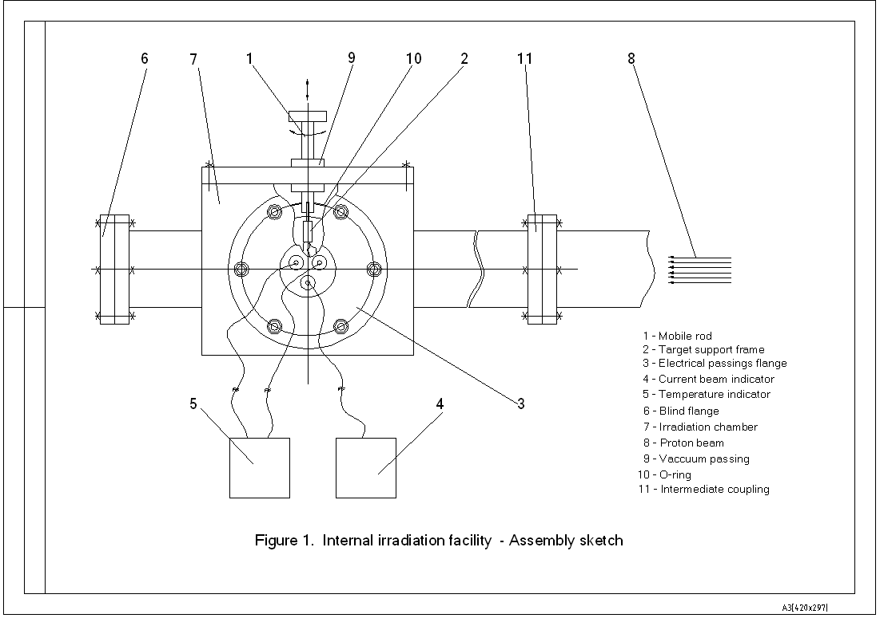
Figure 1. In vacuum irradiation facility – general assembly

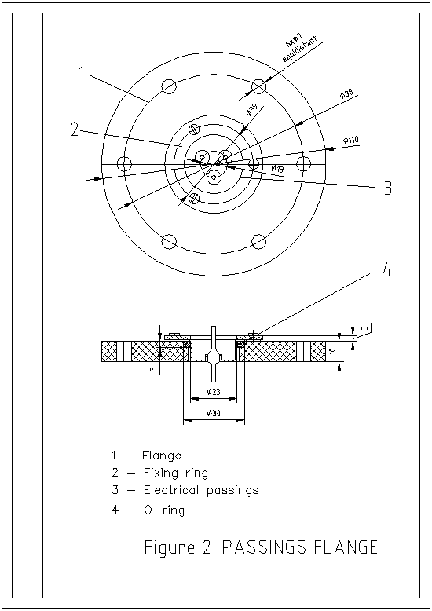
Figure 2. Passing flanges for the electrical signals – temperature control and electrical charge integration
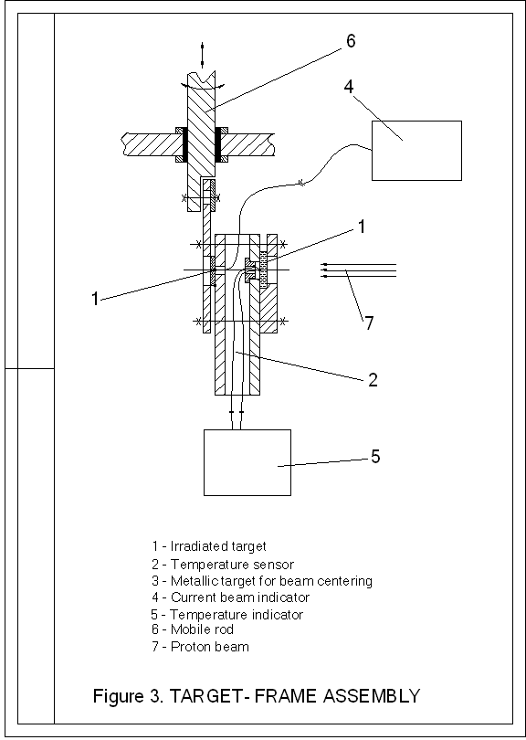
Figure 3. Target frame assembly
Figure 4. The absorption spectra of 14 MeV proton irradiated (16.7 MGy) KS-4V samples (0.6 mm thickness) - 50°C, 60°C, 110°C.

Figure 5. The absorption spectra of 14 MeV proton irradiated (16.7 MGy) KU-1 samples (0.8 mm thickness) - 40°C, 70°C, 110°C

References
[1] Hodgson E. R., Nucl. Instrum. Meth. Phys. Res. B 218 (2004) 29.
[2] Aymar R., Fusion Eng. Des. 55 (2001) 107.
[3] Aymar R., Barabaschi P., Shimomura Y., Plasma Phys. Control Fusion 44 (2002) 519.
[4] Constantinescu B., Bugoi R., Hodgson E. R., Vila R., Ioan P., J. Nucl. Mater., in press.
[5] http://www.srim.org/SRIM/SRIM2003.htm
Morono R. Vila and E. R. Hodgson, 329-333, J. Nucl. Mater. (2004) 1438.

