TPP – PLASMA EDGE

TW6-1.3; TW6-TPP-RETMIX

Provision of Be-coated W, Graphite and CFC specimenes for implantation/retention studies

C. P. Lungu, I. Mustata, A. Anghel, A. M. Lungu, P. Chiru, C. C. SurduBob, O. Pompilian
National Institute for Laser, Plasma and Radiation Physics, Magurele, Bucharest, Romania

1. Introduction
1.1 Objectives
According to the Individual Task Description (EFDA Reference JW5-TPP-RETMIX), two main objectives were developed. These are:
A. Coatings of W, graphite and NB31 CFC substrates using thermionic vacuum arc (TVA) technology
B. Surface morphology characterization by atomic force microscopy.
To accomplish these objectives, in order to optimise thermionic vacuum arc technology were prepared preliminary Be coatings on stainless steel small size samples (15 x 15 x 3 mm) and surfaces were characterized by atomic force microscopy (AFM).
Be coatings, using Thermionic Vacuum Arc (TVA) technology were performed at the National Institute for Laser, Plasma and Radiation Physics, Magurele using the vacuum equipment specially designated for Be coatings. Specialists of the Nuclear Fuel Plant (NFP) Pitesti insured technical assistance on TVA technology and handling of beryllium containing samples.
The measurements of the surface morphology were performed using AFM facilities and expertise of the “Al. I. Cuza University”, Iasi. The films were investigated by AFM in the taping mode with standard silicon nitride cantilever NSC21 having a force constant of 17.5 N/m, 210kHz resonance frequency and tip with radius of curvature less than 10 nm. The AFM measurements were performed at room temperature and ambient pressure. Scanned samples area were from 20 µm x 20 µm to 5 µm x 5µm with a 256 x 256 pixels image resolution.
The research activity was focused on the following objectives.
- The kind of material to be used for crucible
- Anode-cathode distance
- View angle for the sample
- Filament current
- Discharge voltage
- Discharge current
- Deposition rate.

2. Results and discussion
2.1 Background
Thermionic vacuum arc (TVA) technology is based on the electron-induced evaporation. [1-3]. A tungsten cathode filament surrounded by a Whenelt cylinder is heated by an external low voltage-high current. Thermo-electrons emitted from the tungsten filament are accelerated towards the anode. High evaporation rate of the anode material leads to high vapour density above the anode. The space density of these particles is high enough to lower the ionisation mean free path making it smaller than the cathode – anode distance. As a result, plasma is ignited in that region while the surrounding space is evacuated below 10⁻³Pa. Under these conditions high purity films of the anode material can be deposited onto substrates. High-energy ion bombardment of the growing layer leads to the formation of pure and a compact layers.
The usual obtained deposition rates were in the range of 0.1-2 nm/s. The heating currents for filament furnished by the low voltage sources of the machine was in the range of 80-100 A. The high voltage sources can ensure a maximum voltage of 5 kV on the anode and a discharge current of 0.5 -2 A which were sufficient for the purpose of Be coatings.
2.2 Be coating optimisation
2.2.1 The kind of material to be used for crucible.
In order to avoid any inclusions of the crucible material and based on the previous experience of our team, the evaporation of the beryllium material was performed using only a ingot of cylinder shape of pure Be material, settled on a tungsten holder.
Two kinds of Be cylinders were used:
- Be cylinder of NFF Pitesti, made from pressed Be flakes.
- Be cylinder of UKAEA, made from bulk Be.
The both Be ingots were analysed by electron dispersive (X-ray) spectrometry (EDX/ EDS). Data collection and analysis by EDS is relatively simple and rapid process due to the full spectrum of energies, which is simultaneously acquired. Typical resolution on the EDS detector was in the range of 70-130 eV, as function of the element, and the width of the peaks in the Wavelength dispersive X-ray spectroscopy (WDS) were in the range of 2-20 eV. Analysed by the microprobe of a Philips ESEM (Environmental Scanning Electron Microscope) the level of the impurities of the two materials was almost the same, then the both materials can be used as anodes.

2.2.2 Anode-cathode distance.
The distance between anode (the Be cylinder) and cathode (the Whenelt cylinder of the TVA gun, made by molybdenum was adjusted between 2 and 15 mm. An optimum distance of 8 mm was found in order to obtain efficient melting and evaporation of the beryllium cylinder, as well as the discharge voltage and the discharge current. During processing time and keeping constant the discharge current, the discharge voltage linearly increased, with the increasing of the anode-cathode distance due to continuously evaporation of the beryllium cylinder used as anode. I order to keep constant the discharge current and voltage, a mechanism was designed and realized in order to adjust the anode-cathode distance during the coating process.
2.2.3 The view angle of samples.
The substrates were settled at distance of 150 mm from the anode, on a holder in contact with a hot plate of 150 mm x 200 mm. The view angle was chosen as the samples to be settled at the viewing angles between 20 and 50 degree from the horizontal line. Figure 1 shows the Be plasma during deposition process. One can observe the oven capable to heat substrates at temperatures between 200 and 500 ºC.
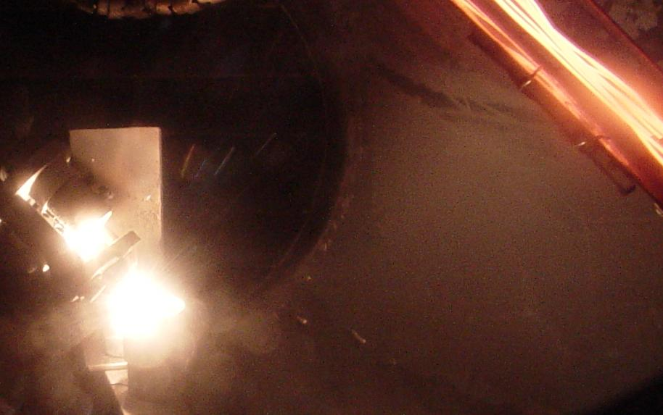

Figure 1. Photograph of the set-up during the Be coating process.

2.2.4 Electrical parameters of discharge.
Optimum electrical parameters of TVA discharge for Be deposition were found to be:
  - Filament current: 50 ± 2 A
  - Discharge voltage: 85 ± 2.5 V
  - Discharge current : 450 ± 20 mA
2.2.5 Deposition rate and adherence of the Be coatings
Using optimised parameters, deposition rate was found to be 3 ± 0.5 nm/s. The films were tested using adhesive tape. (Some films non-optimised failed to this test). After optimisation tested films passed this test.
Pulling test: A 5 diameter rod was stuck on the Be films and a pulling force was applied perpendicularly to the coating. Forces up to 50N (called detaching force) do not removed Be films, but the adhesive resin used was detached, the ratio between the detaching force and the area of the removed layer can be defined as Detaching Specific Load (DSL). The DTS was found to be higher than 2.5 MPa.
2.3 Coatings with beryllium layers of 20-200 nm.
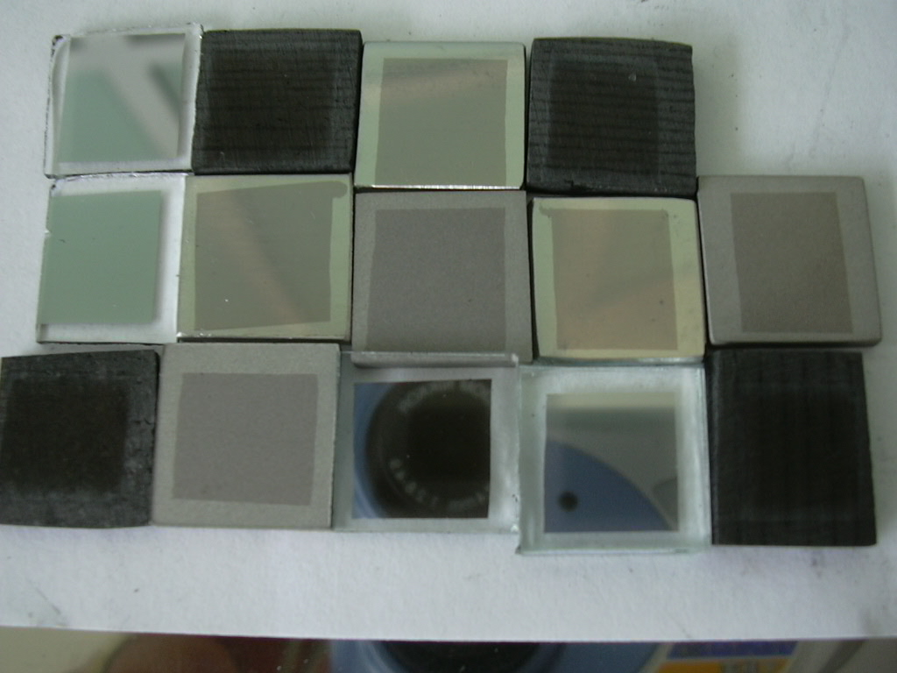
Using optimised parameters Be films of 20-200 nm were deposited on glass, stainless steel (polished and rough), silicon, graphite and carbon fibber composite (CFC). After depositions some samples were chemically etched in order to produce a “step” on the sample surface. The step thickness was measured by a stylus profilometer and AFM in contact mode.

Figure 2. Be coatings on glass, CFC, stainless steel rough, stainless steel smooth, graphite

2.3.1 Atomic force microscopy analysis of the deposited films.
The film surfaces morphology was investigated at “Al. I. Cuza University” Iasi by AFM in the taping mode with standard silicon nitride cantilever NSC21 having a force constant of 17.5 N/m, 210kHz resonance frequency and tip with radius of curvature less than 10 nm. The AFM measurements were performed at room temperature and ambient pressure. Scanned samples area was from 20 x 20 to 5 x 5µm with a 256 x 256 pixels image resolution.
Polished stainless steel substrates were coated with smooth Be films with peak to- valley roughness less than 300 nm. Contrarily, graphite and CFC with larger roughness, kept this characteristic also after Be coatings. The Be film followed the surface morphology of the substrates, figures 3 - 7 showing 3D AFM images of Be coating on polished stainless steel smooth, stainless steel rough, graphite, and glass, respectively.
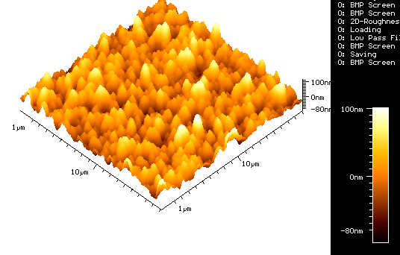

Figure 3. AFM image of a polished stainless steel sample. Peak-to-valley roughness: 190nm

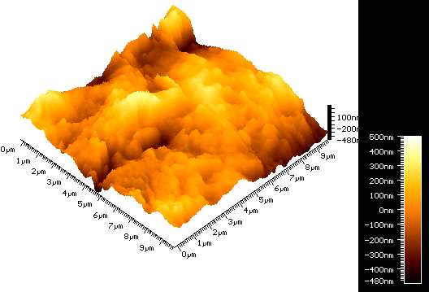

Figure 4. AFM image of a rough stainless steel sample. Peak-to-valley roughness: 980nm

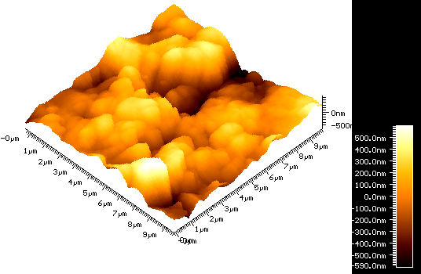

Figure 5. AFM image of a graphite sample. Peak-to-valley roughness: 1000nm

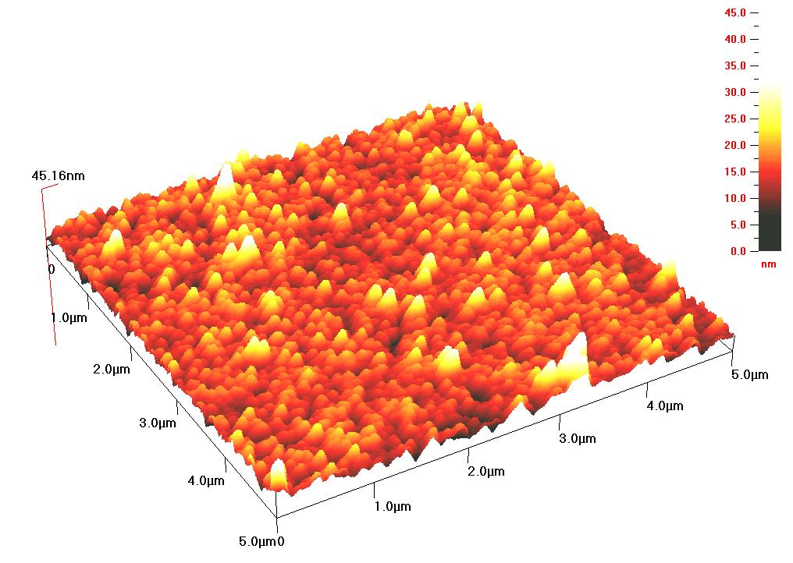

Figure 6. AFM image of a sample having glass as substrate. Peak-to-valley roughness: 45 nm

2.4 Structural analysis by X-ray diffractometry
Structural analysis of the prepare films was performed by X-ray difractometry (CRD). The utilized apparatus was a DRON-2 diffractometer computer controlled, having the following parameters:
- radiation: CoKα, λ=1.78890 Å;
- filter : Nichel
- time constant: 2 sec
- achizition mode: continuum
- 2θ accuracy: 0.01 grades.
Were studied 7 samples of Be films deposited on different substrate materials: „CFC”, glass, graphite, stainless steel smooth, stainless steel rough, etc. By XRD investigations was performed the qualitative phase samples analysis i.e., identification of Be prepared using different preparation conditions (anode-cathode distance, the kind of substrate material). The phase nature was performed having as reference the diffraction database: International Centre for Diffraction Data - Joint Committee on Powder Diffraction (ICDD-JCPDS).
The analysed samples presents generally a polycrystalline structure and have a multiphase composition.
Besides Be, samples contain BeO, even if the depositions were made in high vacuum conditions.
As well as, due to the important massic influence of the substrate, the crystallographic structure of the substrate appears in the majority of analyses in the XRD pattern.
This is particularly valuable for the Be coating on glass where the influence of substrate is evidentiated in the case of a thin Be film, by presence of a background specific to amorphous structures.
On all samples, the presence of Be is low, in some cases, (samples CFC-1 and SSS-A 2-2) even non-decelable. Contrarly, the BeO in different allotrope forms is present in all cases.
In some samples (SSR-A 2-1 and GRAPHITE-1) the presence of Be appears to be higher reported to the other analysed samples.
The results obtained by XRD studies are presented as form of tables and graphs. For the every identified phase, was identified the structure type (according with ICDD-JCPDS cards)

Table 1. XRD analysis of sample CFC-1 (Be deposited on CFC)

Experimental values |  |  | Literature values

CFC-1 sample
2θ (º) | d (Å) | I (u.a.) | PDF | d (Å) | I | h k l
37.95 | 2.3709 | 2.9 | BeO/18-0224 | 2.3700 | 100 | 101
38.47 | 2.3401 | 2.9 | BeO/03-0926 | 2.3400 | 100 | 100
38.61 | 2.3319 | 2.9 | BeO/78-1555 | 2.3320 | 859 | 100
38.67 | 2.3284 | 2.9 | BeO/78-1556 | 2.3281 | 865 | 100
38.76 | 2.3232 | 2.9 | BeO/78-1557 | 2.3237 | 862 | 100
41.17 | 2.1926 | 2.9 | BeO/78-1561 | 2.1925 | 543 | 002
41.32 | 2.1850 | 2.9 | BeO/78-1555 | 2.1852 | 555 | 002
42.65 | 2.1199 | 11.6 | BeO/18-0224 | 2.1200 | 80 | 111
43.87 | 2.0637 | 9.2 | BeO/78-1561 | 2.0633 | 999 | 101
44.01 | 2.0575 | 9.2 | BeO/78-1555 | 2.0574 | 999 | 101
44.09 | 2.0539 | 10.1 | BeO/78-1556 | 2.0538 | 999 | 101
44.17 | 2.0504 | 10.6 | BeO/75-0575 | 2.0507 | 999 | 101
44.18 | 2.0500 | 10.6 | BeO/78-1557 | 2.0498 | 999 | 101
44.21 | 2.0486 | 10.6 | BeO/75-1543 | 2.0487 | 999 | 101
44.27 | 2.0460 | 11.6 | BeO/78-1559 | 2.0458 | 999 | 101
42.26 | 2.1386 | 8.7 | BeO/75-0575 | 2.1385 | 527 | 002
54.77 | 1.6760 | 6.3 | BeO/18-0224 | 1.6760 | 40 | 211
58.51 | 1.5775 | 3.4 | BeO/75-0575 | 1.5776 | 204 | 102
69.86 | 1.3464 | 2.9 | BeO/78-1555 | 1.3464 | 310 | 110
69.99 | 1.3442 | 2.9 | BeO/78-1556 | 1.3441 | 317 | 110
70.14 | 1.3417 | 2.9 | BeO/78-1557 | 1.3416 | 310 | 110
70.24 | 1.3400 | 2.9 | BeO/75-1543 | 1.3400 | 279 | 110
70.31 | 1.3389 | 2.9 | BeO/78-1559 | 1.3388 | 305 | 110
76.88 | 1.2400 | 3.4 | BeO/03-0926 | 1.2400 | 70 | 103
76.94 | 1.2392 | 3.4 | BeO/78-1561 | 1.2394 | 264 | 103
77.22 | 1.2354 | 5.3 | BeO/78-1555 | 1.2355 | 266 | 103
77.38 | 1.2332 | 9.2 | BeO/78-1556 | 1.2331 | 270 | 103
77.51 | 1.2315 | 12.1 | BeO/75-1543 | 1.2317 | 239 | 103
77.57 | 1.2307 | 12.6 | BeO/78-1557 | 1.2306 | 266 | 103
77.74 | 1.2284 | 11.6 | BeO/78-1559 | 1.2284 | 261 | 103
80.99 | 1.1871 | 3.4 | BeO/18-0224 | 1.1870 | 30 | 202
82.43 | 1.1700 | 3.4 | BeO/03-0926 | 1.1700 | 40 | 200
84.18 | 1.1501 | 4.8 | BeO/03-0926 | 1.1500 | 60 | 112
84.92 | 1.1419 | 3.4 | BeO/78-1557 | 1.1420 | 172 | 112
85.01 | 1.1410 | 3.4 | BeO/75-0575 | 1.1410 | 172 | 112
86.01 | 1.1302 | 3.4 | BeO/03-0926 | 1.1300 | 40 | 201
90.02 | 1.0900 | 2.9 | BeO/03-0926 | 1.0900 | 20 | 004
96.91 | 1.0300 | 2.9 | BeO/03-0926 | 1.0300 | 40 | 202

The structure type of Be deposited on CFC:
BeO/75-0575: Hexagonal, Primitive
BeO/78-1556: Hexagonal, Primitive
BeO/75-1543: Hexagonal, Primitive
BeO/18-0224: Tetragonal
BeO/78-1561: Hexagonal, Primitive
BeO/78-1559: Hexagonal, Primitive
BeO/78-1557: Hexagonal, Primitive
BeO/78-1555: Hexagonal, Primitive
BeO/03-0926: Hexagonal, Primitive

Figure 7. XRD pattern of sample CFC-1 (Be deposited on CFC)

Table 2. XRD analysis of sample GLASS-A 4-1 (Be deposited on glass)

Experimental values |  |  | Literature values
GLASS-A 4-1 sample
2θ (º) | d (Å) | I (u.a.) | PDF | d (Å) | I | h k l
38.59 | 2.3331 | 61.5 | BeO/75-2074 | 2.3330 | 868 | 100
43.95 | 2.0602 | 53.8 | BeO/75-2074 | 2.0605 | 999 | 101
44.09 | 2.0539 | 53.8 | BeO/78-1556 | 2.0538 | 999 | 101
44.16 | 2.0508 | 53.8 | BeO/75-0575 | 2.0507 | 999 | 101
44.21 | 2.0486 | 53.8 | BeO/75-1543 | 2.0487 | 999 | 101
50.69 | 1.8009 | 53.8 | Be/72-2381 | 1.8000 | 252 | 002
52.70 | 1.7369 | 53.8 | Be/72-2381 | 1.7370 | 999 | 101
57.64 | 1.5992 | 50.0 | BeO/75-2074 | 1.5992 | 193 | 102
57.95 | 1.5914 | 53.8 | BeO/78-1556 | 1.5915 | 211 | 102
Experimental values |  |  | Literature values
GLASS-A 4-1 sample
58.05 | 1.5889 | 57.7 | BeO/75-1543 | 1.5889 | 189 | 102
69.69 | 1.3492 | 46.2 | BeO/75-0575 | 1.3492 | 328 | 110
69.98 | 1.3441 | 46.2 | BeO/78-1556 | 1.3441 | 317 | 110
77.38 | 1.2332 | 42.3 | BeO/78-1556 | 1.2331 | 270 | 103
78.61 | 1.2170 | 38.5 | BeO/75-0575 | 1.2170 | 259 | 103
84.62 | 1.1452 | 38.5 | Be/72-2381 | 1.1450 | 124 | 110
84.96 | 1.1415 | 42.3 | BeO/75-1543 | 1.1415 | 139 | 112
85.01 | 1.1410 | 42.3 | BeO/75-0575 | 1.1410 | 172 | 112

The structure type of Be deposited on glass:
Be/72-2381: Hexagonal, Primitive
BeO/78-1556: Hexagonal, Primitive
BeO/75-2074: Hexagonal, Primitive
BeO/75-1543: Hexagonal, Primitive
BeO/75-0575: Hexagonal, Primitive

Figure 8. XRD pattern of sample GLASS-A 4-1 (Be deposited on glass)

Table 3. XRD analysis of sample GRAPHITE-1 (Be deposited on graphite)

Experimental values |  |  | Literature values
Sample GRAPHITE-1
2θ (º) | d (Å) | I (u.a.) | PDF | d (Å) | I | h k l
38.52 | 2.3371 | 2.6 | BeO/04-0843 | 2.3370 | 91 | 100
38.53 | 2.3365 | 2.6 | BeO/72-0290 | 2.3364 | 864 | 100
38.58 | 2.3336 | 2.6 | BeO/72-2444  BeO/72-2397 | 2.3339  2.3339 | 854  854 | 100  100
38.61 | 2.3319 | 2.6 | BeO/78-1555 | 2.3320 | 859 | 100
40.98 | 2.2023 | 2.6 | BeO/78-1564 | 2.2025 | 549 | 002
41.12 | 2.1952 | 2.6 | BeO/72-2444  BeO/72-2397 | 2.1950  2.1950 | 543  543 | 002  002
Experimental values |  |  | Literature values
Sample GRAPHITE-1
41.24 | 2.1891 | 2.6 | BeO/72-0290  BeO/04-0843 | 2.1886  2.1890 | 549  60 | 002  002
41.32 | 2.1850 | 2.6 | BeO/78-1555 | 2.1852 | 555 | 002
43.65 | 2.0736 | 5.2 | BeO/78-1564 | 2.0736 | 999 | 101
43.93 | 2.0610 | 6.2 | BeO/72-2444  BeO/72-2397  BeO/72-0290  BeO/04-0843 | 2.0608  2.0608  2.0611  2.0610 | 999  999  999  100 | 101  101  101  101
44.01 | 2.0575 | 6.8 | BeO/78-1555 | 2.0574 | 999 | 101
46.58 | 1.9498 | 3.1 | Be/03-1119 | 1.9500 | 40 | 100
50.69 | 1.8009 | 3.6 | Be/03-1119 | 1.8000 | 20 | 002
50.71 | 1.8002 | 3.6 | Be/72-2381 | 1.8000 | 252 | 002
52.70 | 1.7369 | 3.1 | Be/72-2381 | 1.7370 | 999 | 101
52.93 | 1.7298 | 3.1 | Be/03-1119 | 1.7300 | 100 | 101
57.65 | 1.5989 | 3.1 | BeO/72-2444  BeO/72-2397 | 1.5989  1.5989 | 192  192 | 102  102
69.24 | 1.3569 | 2.6 | BeO/78-1564 | 1.3570 | 294 | 110
69.71 | 1.3489 | 2.6 | BeO/72-0290  BeO/04-0843 | 1.3489  1.3490 | 306  29 | 110  110
69.80 | 1.3474 | 2.6 | BeO/72-2444  BeO/72-2397 | 1.3475  1.3475 | 283  283 | 110  110
69.86 | 1.3464 | 2.6 | BeO/78-1555 | 1.3464 | 310 | 110
77.07 | 1.2374 | 3.6 | BeO/72-0290 | 1.2375 | 259 | 103
84.33 | 1.1484 | 3.6 | BeO/72-0290 | 1.1483 | 168 | 112
84.64 | 1.1450 | 3.1 | Be/72-2381 | 1.1450 | 124 | 110
98.19 | 1.0200 | 2.6 | Be/03-1119

The structure type of Be deposited on graphite:
Be/72-2381: Hexagonal, Primitive
Be/03-1119: Hexagonal
BeO/78-1564: Hexagonal, Primitive
BeO/78-1555: Hexagonal, Primitive
BeO/72-2444: Hexagonal, Primitive
BeO/72-2397: Hexagonal, Primitive
BeO/72-0290: Hexagonal, Primitive
BeO/04-0843: Hexagonal, Primitive

Figure 9. XRD pattern of sample GRAPHITE-1 (Be deposited on graphite)

Table 3. XRD analysis of sample SSR-A 2-1 (Be deposited on stainless steel rough)

Experimental values |  |  | Literature values
Sample SSR-A 2-1
2θ (º) | d (Å) | I (u.a.) | PDF | d (Å) | I | h k l
38.80 | 2.3209 | 54.3 | BeO/75-1543 | 2.3209 | 864 | 100
41.17 | 2.1926 | 56.7 | BeO/78-1561 | 2.1925 | 543 | 002
41.42 | 2.1800 | 59.1 | BeO/75-1543 | 2.1800 | 536 | 002
43.88 | 2.0633 | 88.4 | BeO/78-1561 | 2.0633 | 999 | 101
44.18 | 2.0500 | 72.0 | BeO/03-1035 | 2.0500 | 100 | 101
44.21 | 2.0486 | 72.0 | BeO/75-1543 | 2.0487 | 999 | 101
46.08 | 1.9698 | 63.4 | Be/01-1291 | 1.9700 | 20 | 100
46.58 | 1.9498 | 62.2 | Be/03-1119 | 1.9500 | 40 | 100
50.69 | 1.8009 | 71.3 | Be/03-1119 | 1.8000 | 20 | 002
51.03 | 1.7897 | 69.5 | Be/01-1291 | 1.7900 | 14 | 002
52.92 | 1.7302 | 63.4 | Be/03-1119  Be/01-1291 | 1.7300  1.7300 | 100  100 | 101  101
69.65 | 1.3499 | 65.9 | BeO/78-1561 | 1.3501 | 307 | 110
70.24 | 1.3400 | 67.7 | BeO/03-1035  BeO/75-1543 | 1.3400  1.3400 | 80  279 | 110  110
71.47 | 1.3200 | 68.3 | Be/03-1119 | 1.3200 | 20 | 102
75.92 | 1.2395 | 67.1 | BeO/78-1561 | 1.2394 | 264 | 103
77.50 | 1.2316 | 67.1 | BeO/75-1543 | 1.2317 | 239 | 103
77.62 | 1.2300 | 67.1 | BeO/03-1035 | 1.2300 | 80 | 103
85.10 | 1.1400 | 68.3 | Be/01-1291  BeO/03-1035 | 1.1400  1.1400 | 12  60 | 110  112
98.19 | 1.0200 | 68.9 | Be/03-1119 | 1.0200 | 20 | 103

The structure type of Be deposited on stainless steel:
Be/03-1119: Hexagonal
Be/01-1291: Hexagonal, Primitive
BeO/78-1561: Hexagonal, Primitive
BeO/03-1035: Hexagonal
BeO/75-1543: Hexagonal, Primitive

Figure 10. XRD pattern of sample SSR-A 2-1 (Be deposited on stainless steel)

2.5 D+ irradiation and evaluation of D retention
Be film quality prepared at NILPRP, the specialists of IPP Garching using Ion beam facilities performed irradiation and evaluation of D retention:
  - IPP High Current Ion Source (flux: ~ 3.0 x 1019 [/m²s]) , 600 eV D₃⁺ -> 200 eV / D (irradiated at R.T.)
Total amount of D retention was determined by Nuclear Reaction Analysis using:
  - 3He+ -> D (3He, p) 4He resonant nuclear reaction
2.5.1 Sample evaluation
The impurity concentration in the depth of the prepared films was evaluated using Rutherford Backscattering Spectroscopy (RBS); a typical spectrum of RBS analysis is shown in Fig. 11 The depth profile of film composition so shown in Figure.

Figure 11. Typical spectrum obtained using RBS technique | Figure 12. Depth profile of a Be layer deposited on graphite

The RBS analysis shows that oxygen concentration is high only at the top surface (~30 at.%) and interface (~ 10 at. %). O concentration in the layer is ~ 1.0 at. %.
In order to determine the D concentration profile in deeper layers, the computer program SIMNRA [4] was used for the deconvolution of the proton yields measured at different 3He ion energies. A deuterium depth distribution was assumed, taking into account the near-surface depth profile obtained from the particles spectrum, and the proton yield was calculated as a function of incident ³He energy. The form of the D depth profile was then varied using an iterative technique until the calculated curve matched the measured proton yields [5].

Figure 13. Retained fluence of D retention in Be deposited on different substrates (graphite, CFC and W)

- D retention in Be layer on Graphite / W saturates at: ~ 7±1 x 10²⁰ D/m²
- Most of D in Be layer
- Be on CFC -> no saturation
- D retention in Be12W layer saturates at ~ 3 x 10²⁰ D/m²

3. CONCLUSIONS
Using thermionic vacuum arc technology, were prepared high quality beryllium films on stainless steel, graphite and CFC in order to be studied further for hydrogen retention.
Analysed by atomic force microscopy, the morphology of deposited Be was strongly dependent on the substrate surface.
The XRD analysed samples presents generally a polycrystalline structure and have a multiphase composition. Besides Be, samples contain BeO, even if the depositions were made in high vacuum conditions.
Be film quality prepared at NILPRP and the specialists of IPP Garching using Ion beam facilities evaluated D retention:
  - IPP High Current Ion Source (flux: ~ 3.0 x 1019 [/m²s]) , 600 eV D₃⁺ -> 200 eV / D (irradiated at R.T.)
Total amount of D retention was determined by Nuclear Reaction Analysis using:
  - ³He+ -> D (³He, p) ⁴He resonant nuclear reaction
Was found that D retention in Be layer saturated, except for CFC substrate.
  - Saturation level of the Be layer ~ 7.0 x 10²⁰ D/m²
  - D retention in Be₁₂W – almost saturated at ~ 3.0 x 10²⁰ D/m²

References
[1] Lungu C. P., Mustata I., Musa G., Lungu A. M., Zaroschi V., Iwasaki K., Tanaka R., Matsumura Y., Iwanaga I., H. Tanaka, Oi T., Fujita K.: Formation of nanostructureed Re-Cr-Ni diffusion barrier coatings on Nb super alloys by TVA method, Surf and Coat. Techn, Vol.200, 399-402, 2005.
[2] Lungu C. P., Mustata I., Musa G., Zaroschi V., Lungu Ana Mihaela and Iwasaki K.: Low friction silver-DLC coatings prepared by thermionic vacuum arc method, Vacuum, 76, Issues 2-3, 127-130, (2004).
[3] Lungu C.P., Mustata I., Zaroschi V., Lungu A.M., Chiru P., Anghel A., Burcea G., Bailescu V., Dinuta G., Din F., “Optical emission diagnostic of thermionic vacuum arc plasma during beryllium film formation”, Proc. of 33rd European Physical Society Conference on Plasma Physics, 19-23 June, Roma, Italy, 2006.
[4] Mayer M., SIMNRA User’s Guide, Tech. Rep. IPP 9/113,Garching, 1997.
[5] Alimov V.Kh., Mayer M., Roth J., Differential cross-section of the D(³He, p)⁴He nuclear reaction and depth profiling of deuterium up to large depths, Nucl. Instrum. And Meth. 234 (2005) 169.

