JET FUSION TECHNOLOGY

PLASMA FACING COMPONENTS

JW5-FT-JET-A; JW5-FT-3.26
Assesment of detritiation with a small Ar plasma torch

G. Dinescu, E. R. Ionita
National Institute for Lasers, Plasma and Radiation Physics, Magurele, Bucharest

1. Introduction
In the previous work, described in the Scientific Report Year 2005 a small size plasma torch was designed and its operation at atmospheric pressure in argon was demonstrated. Continuing that work the present report describes the results regarding:
- The operation of the plasma torch in nitrogen at atmospheric pressure
- The characterization of the plasma torch in argon and nitrogen (electrical characteristics, plasma species and temperature field)
- Tests on carbon material removal
- Optimised plasma torch set-up
- Assessment on the feasibility of detritiation tests at JET Beryllium Handling Facility

2. Description of the torch operation at atmospheric pressure
The phenomena associated with the extension of source operation at atmospheric pressure are related to constriction of discharge with the pressure increase due to the thermal instabilities. Such as, the volumetric plasma filling the interelectrodic gap transforms into a thin fast movable column (filament) of around 1mm diameter, which at intermediate pressures (~400 mbar for nitrogen) is stabilized by flow with one end on the inside of the nozzle hole. The column remains anchored in this position up to atmospheric pressure and even higher, constituting the ionising source for the incoming gas flowing through the nozzle. The observation that at high pressure the plasma volume does not make use of the whole interelectrodic space opens the way to realize small diameter sources, by designing configurations centered on the constricted plasma column axis. Nevertheless, there are other constraints, which have to be considered in realizing a small size plasma source. The most important is related to heat dissipation, as a part of the injected power is dissipated via the plasma resistance and by recombination and processes at electrodes. Beside of choice of refractory electrode materials, ceramic or quartz tubing for insulator wall, a design considering active cooling of the discharge space is mandatory. Experiments were performed with a small size, 22 mm diameter source manufactured in copper and with an external water jacket
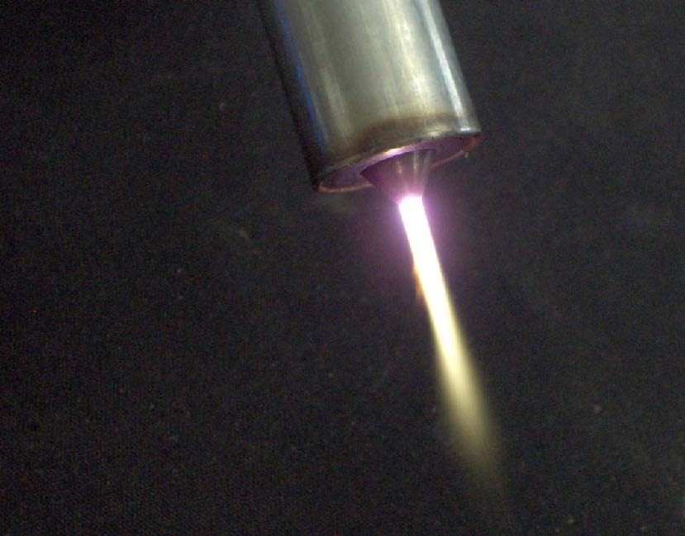
Figure 1. Image of the small size plasma torch working in nitrogen (300 W, 8000 sccm)
Figure 2. Current voltage and current Power characteristics (argon, plasma torch 20 mm diameter, 1500 sccm)

surrounding the insulating tube and the expansion nozzle. In this arrangement the source could operate stable in argon at atmospheric pressure, without electrode damage up to forwarded power values of 100 W. For stable operation at higher power active cooling of the internal electrode was included. The image of plasma torch of 20 mm diameter, made in stainless steel and with internal and external-cooling circuits, working in nitrogen at atmospheric pressure, is presented in figure 1. The torch has the RF electrode made from tungsten, the nozzle from stainless steel and an alumina insulating tubing.
Breakdown aspects and electrical characteristics of the plasma torch discharge
One of the problems associated with the atmospheric pressure discharges is the difficult breakdown. The Paschen curves representing the breakdown voltage V_{b} upon pd (pressure multiplied by the interelectrodic gap) have, depending on gas, their minima around 3-8 mbar∙cm, and show that high voltages are necessary to produce breakdown directly at high pressure. This condition is partially relaxed at frequencies in the range 1-50 MHz, for such frequencies the breakdown decreasing with up to 20% as compared with the DC voltages. In addition, by choosing a small interelectrodic gap, one may move the minima towards high pressure; nevertheless a gap smaller than 1 mm does not let enough room for discharge development. Another solution, the breakdown at low pressure followed by gradual pressure increase is not practical, because requires an additional system for producing an initial vacuum. In spite of these unfavourable circumstances the breakdown of the presented plasma torch can be performed directly at atmospheric pressure. In Figure 2 the current-voltage (curve ABCD) and power-voltage (curve A'B'C'D') characteristics are presented, for the plasma torch of 20 mm diameter working in argon at a mass flow rate of 1500 sccm. The electrical measurements [1] were performed by using a Tektronix digital oscilloscope (type 2432A), with current and voltage probes (type P 6021 and P 6137) via a GPIB interface connected to a computer. Gradually increasing the RF power and recording the corresponding current and voltage values obtained the curves. The pairs of points (A, A'), (B, B'), (C, C') and (D, D') are homologues corresponding to the same state of discharge. Particularly, the points B and B' are important, they marking the breakdown. They separate the regions AB (respectively A'B') describing the flowing of current through the capacitance of the interelectrodic gap (displacement current, no discharge), from the regions CD (C'D') corresponding to discharge impedance (presence of plasma with both resistive and capacitive components). A significant aspect revealed by the curves is the low voltage and the corresponding low power (less than 200 W) necessary for breakdown. In order to explain this result a study of the breakdown dependence upon pressure and mass flow was performed on a discharge configuration as in the plasma torch in which the RF electrode and the plate were separated by 4 mm distance. The curves in Figure 3 show the pressure dependence of the breakdown power, at different flow values. They reveal that comparing with the static regime (no flow) the flowing of gas decreases considerably the breakdown threshold providing the present plasma torch with the capability to be switched on directly at atmospheric pressure.
Figure 3. Dependence of breakdown power on the pressure for various mass flow values

3.Characterization of the plasma jet
As it is expected that detritiation and material removal from surfaces be driven by both temperature and chemical effects the gas temperature of plasma jet and the content of reactive species are parameters of large importance. The temperature field in the jet was measured by means of a small chromel-alumel thermocouple inserted in the jet. The results are shown in Figure 4, where the temperatures at different distances from nozzle are shown for argon and nitrogen plasmas. The used mass flow and power values correspond to stable operation of the torch with 2 mm interelectrodic distance for operation in argon and respectively, 3 mm distance for nitrogen. The curves in Figure 4 show that plasma torch in argon works stable at lower power, and give 250-350 ºC at 8-10 mm distance from nozzle. The nitrogen plasma torch can be operated at larger powers and provides at the same distances temperatures about 800-1000 ºC, appropriate for stimulating detritiation by gas desorption.
Figure 5. Spectra emitted by the plasma torch in nitrogen

Figure 4. The dependence of temperatures in the plasma jet on position
In addition, Optical Emission Spectroscopy studies were performed to identify species in the plasma jet. The emission of plasma expansion was studied in the spectral range 200-600 nm with a set-up consisting of quartz optics, a medium resolution monochromator (SPM-2, Carl Zeiss, and grating 1200 mm⁻¹) photomultiplier (QB 9958) and data acquisition system. Typical spectra obtained from the jet are presented in Figures 5, with the light collected along the flowing axis and perpendicular on the axis. The spectra reveal the presence of emission bands in visible (mostly due to molecular nitrogen Second Positive Spectral System, N₂ (SPS)), but also in the ultraviolet region (Figure 7). The UV emission (see inset in Figure 5) is dominated by the NO and NO spectral systems, the NO radical being formed presumably by mixing of the excited nitrogen with atmospheric air. The occurrence of UV emission is of interest, because UV photons may stimulate the detritiation process.

4. Tests on carbon material removal
The ability of the plasma torch for surface cleaning was tested on graphite and CFC materials [2]. In a static experiment the plasma torch was kept fixed on the surface of a piece cut from a Tore Supra CFC tile. A deep crater was observed after one-hour exposure (Figure 6), which demonstrate clearly the effect of material removal following the plasma torch irradiation.
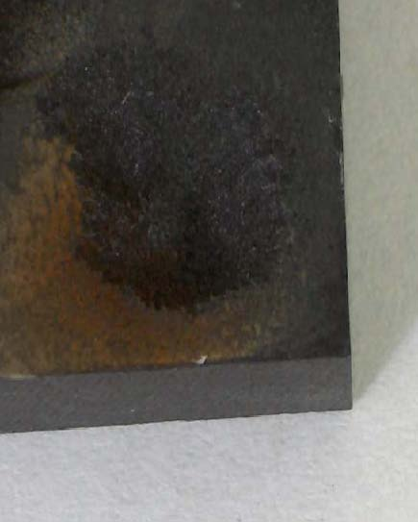
A scanning facility was used based on computer controlled stepper motors, allowing scanning of desired shapes on flat surfaces. An image of the plasma torch during scanning operation is presented in Figure 7a. The scanned samples were investigated by profilometry and mass gravimetry. The experiments showed that argon plasma alone produces only small effects on the surfaces, and that the treatments at higher power are affected by arcing. Comparatively, the nitrogen plasma torch was more stable in operation. In one set of experiments defined areas of polished graphite samples were scanned with the nitrogen torch for various increased times. The visual inspection indicates a clear modification of surface and the profilometric measurements show an increasing of roughness with the treatment time. In other set of experiments volume cut small pieces of CFC from Tore Supra tokamak tiles were scanned on the fresh cut surfaces for various increasing times. The scanned area was 170 mm² (17mm x 10 mm), with paths separated by 1 mm distance and a scanning speed of 5mm/sec. The mass changes were obtained by weighting the samples at different stages of treatment. Material removal is proved by mass decrease, as exemplified in Figure 7b, indicating a removal rate of 2.5 10-4 g/min. This corresponds to an erosion rate of the mentioned scanned surface with 0.5 m/min.
Figure 6. Crater formation after one hour exposure (nitrogen, 300 W, 2300 sccm, 8 mm distance)

8 mm large
1.5 mm deepness
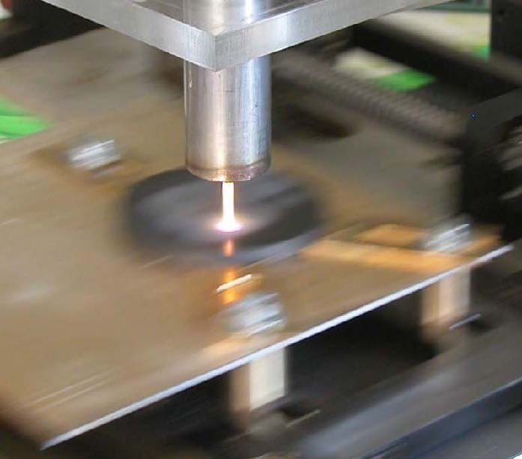
The gradual roughness evolution, as given by profilometry, shows that the mechanism of material removal is not based on particle extraction, but on a continuous process, as physical or chemical erosion. The sputtering threshold of graphite is high and at atmospheric pressure the ions cannot reach high energies required for sputtering because plasma is in collision regime. The only remaining chemical mechanism should be based on chemical reactions in which plasma generated radicals react with carbon surfaces leading to volatile molecules, easy to be removed with the effluent gas.
Figure 7a. Image of the plasma torch during scanning procedure
Figure 7b. Mass variation of a CFC sample with the treatment time

5. Optimized plasma torch set-up
5.1 Setup diagram and system control
The final version of the plasma torch set-up consists of a number of sub-systems, integrated in a manner convenient for operation, control and monitoring from a single computer. The main sub-systems are: 1) the plasma torch device; 2) the RF power supply sub-system; 3) the gas feeding sub-system; 4) the cooling sub-system and, 5) the scanning stage with motion control. The diagram of the plasma torch surface-cleaning set-up is presented in Figure 8.
1) The plasma torch device has been described in detail in the previous report. The device was rebuilt as a new assemblage, with a better fitting of the pipes and cables. The final used materials were quartz for the insulating wall, thorium-tungsten for the RF electrode and stainless steel for the nozzle.
2) The RF power supply sub-system consisted of the RF generator, the matching box and the cables for the power transfer. These parts were complemented in the reported period with cables for the control of power, operation mode and operation times, connecting the RF generator and the matching box to the computer.
3) The gas feeding sub-system was optimized, in order to allow operation with mixture of gases. Beside the operation in argon and nitrogen, the operation in argon-nitrogen mixtures was investigated now. The enlargement of the operation domain was possible by using the mixture of the gases.
4) A closed loop cooling system was built-up in order to insure a larger autonomy to the set-up operation. Also, it prevents excessive water consuming, and ensure adaptability for working in restricted area environment, like in Tokamak chamber where the liquid transport from the inside
PLASMA TORCH
M STEPPER
MOTOR
M STEPPER
MOTOR
MFC
MFC
SUPPLY AND CONTROL UNIT
COMPUTER
-GAS FLOW COTROL
-MOTION CONTROL
-TEMPERATURE CONTROL
-POWER CONTROL
-Z MEASUREMENTS
RF
GENERATOR
COOLING UNIT
(Pump + Temperature sensors)
MATCHING
BOX
X
Y
Ar
N
2
GAS CYLINDERS

Figure 8. The diagram of the plasma torch cleaning set-up

to outside must be avoided (necessary for the prevention of any possible radioactive leakage in the outer environment).
5) The scanning stage motion control was realized by connecting the power supplies of the stepper motors to the computer, allowing flexibility of movement along predetermined contours in the X-Y space.
A set of programmes, written in the Labview language allows the complete control and monitoring of the set-up. The start of the torch operation is possible from the computer. The following sequences are programmed: a) the switch on of the cooling system; b) the switch on of the mass flow controller and the setting of the gas mass flows at the starting values; c) the switch on of the RF generator and the setting of the RF power and operation mode (continuous, pulsed) to the starting values; d) the start of the scanning operation. The first experiments performed with the integrated compact plasma torch set-up revealed that, due to the limited resources of the computer, the commands in given sequences could be delayed. For example the motion of the stepper motors is slightly slowed when the computer will start to acquire the values of the mass flows or the power injected. This was avoided by the building -up of a microprocessor-based unit, which takes care separately of the stage motion, and is separately programmed. This approach ensures a very good and independent control of torch operation and of the stage motion. The software allows the change of the operating parameters of the set-up, they’re maintaining in a given interval of values and continuous recording of the values in dedicated files allocated in the computer memory. An example of the interface elaborated for the set-up control is shown in Figure 2.
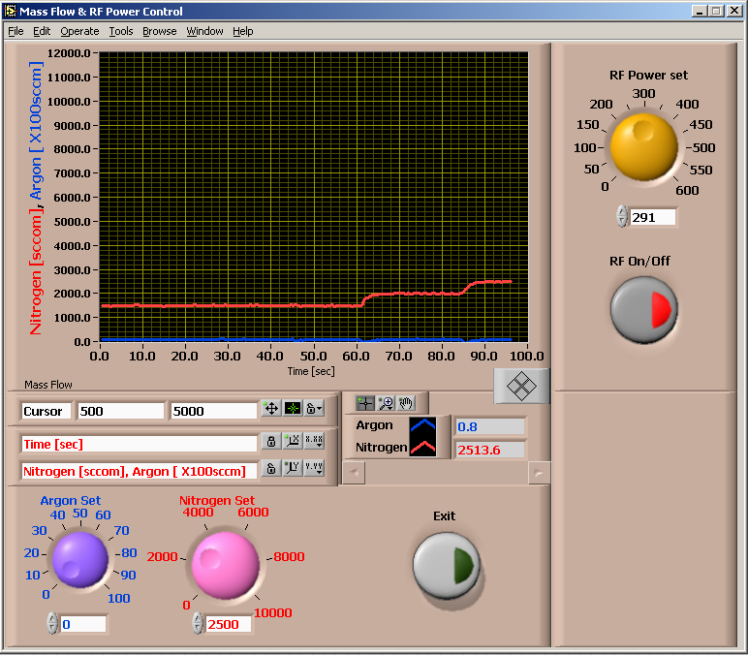
Figure 9. Example of interface dedicated to the torch control
5.2 The stability of torch operation
The operation stability was studied by electrical and optical measurements.
In the case of electrical measurements, in comparison with previous studies in which voltage and current Tektronix probes were used to collect the signals, in the present experiments the values of plasma impedance, and of its resistive and capacitive parts were extracted directly with a dedicated software from the matching box and were saved in the computer memory. These values were processed later and were plotted upon time coordinate. The operation stability is proven by the curves in Figure 10. Excepting the first few seconds after switching on, which are not presented in the graphs (they correspond to the transition from insulating to conducting states of the gas) the electrical characteristics of the discharge (resistive and reactive parts) are practically unmodified for more than half of hour operation, both for argon and nitrogen. It should be mentioned that the plasma resistance is higher for argon than for nitrogen (20 Ω compared to 7 Ω), and plasma reactance (capacitive part) is higher for nitrogen (54 Ω  compared to 42 Ω).
Figure 10. The plasma impedance remains constant during operation in both Nitrogen and Argon
Resistive part
The optical measurements were performed with a spectroscopic set-up, consisting of a monochromator, collecting optics and photomultiplier. The protocol of measurement was based on the time recording of the intensity of an emission line, for operation at constant set-up parameters. The results are presented in Figure 11.
Figure 11. After a short transitory period at breakdown the plasma emission remain almost constant
The results in Figure 11 proves a very good operation stability because, after a transitory period, necessary for breakdown, the emission intensity remains practically constant, whatever the spectral line or mass flow values were used.

6. Assessment on the feasibility of detritiation tests at JET Beryllium Handling Facility
The relevant issues regarding the compatibility of the plasma torch operation with the Beryllium Handling Facility were evaluated and discussed at Joint Experimental Tokamak, in Culham, UK, in view of tests on tritiated tiles. It was concluded that such experiments would be difficult, the BeHF being inadequate for small scale experiments (measurements of low tritium flows, expected to be created by scanning on contours or on limited surface with the plasma torch). In addition, tritiated castellated tiles are not available in present. Also, more development would be necessary for approaching in-situ detritiation experiments. It was concluded that a better approach would be to find means to assess the detritiation in laboratory scale experiments. As a matter of fact it was commented that the techniques of measurements of the detritiation are very limited and the field needs a special attention. As example, investigations based on optical spectroscopy, mass spectrometry should be developed in the future.

7. Conclusions
A possible approach for removal of co-deposited layers and detritiation in narrow places and gaps in Tokamaks is the wall cleaning with a plasma torch. The requirements for such a torch are small size for allowing access in hidden spaces, stability and easy handling, capabilities to affect the surface by physical and chemical processes, flexibility for mounting on robotic arms.
1. A flexible, small size plasma torch, working at atmospheric pressure, was designed and realized. The plasma torch is based on the expansion of a radiofrequency discharge. The plasma torch is manufactured in stainless steel, has 20 mm diameter and uses refractory materials inside.
2. The plasma torch works under stable conditions both in argon and nitrogen. Operation with powers up to 600 W was possible by means of adequate cooling. The breakdown of the discharge sustaining the torch can be realized directly at atmospheric pressure. Temperatures of 1000-1200 ºC were obtained in nitrogen in the nozzle vicinity, and in the range 800-900 ºC at 8-10 mm from the tip nozzle, almost twice the values in argon. Optical Emission Spectroscopy investigations showed the presence of UV radiation.
3. An integrated plasma set-up, consisting of the plasma torch and various assisting sub-systems was built-up. The integrated set-up has closed loop cooling system, and is fully computer controlled, with hardware and software elaborated during the project. The set-up was tested against stability in argon and nitrogen and stable operation has been proved.
4. Surface experiments realized with the nitrogen plasma torch on graphite and CFC tiles. In the case of graphite roughening of surface was measured by profilometry. The experiments with CFC tiles from Tore Supra indicate material removal with a rate of 2.5 10⁻⁴ g/min. The material removal is done by a chemical process and does not lead to dust formation.
5. Possible torch experimentation at Beryllium Handling Facility was discussed at Joint Experimental Tokamak, in Culham, UK, in view of tests on tritiated tiles. It was concluded that such experiments would be difficult. It resulted that a better approach would be to assess first the detritiation in laboratory scale experiments.

Future work
This part of the work was the last stage of the project. The project ended with a high quality torch device (realized along the entire project), a successful demonstration of the torch cleaning capability in the case of carbon surfaces (realized in the second project stage) and with an integrated set-up capable of stable operation in argon, nitrogen and their mixtures (last stage of the project). During a scientific visit at the Joint Experimental Tokamak, in Culham, UK, the continuation of the project was discussed in the light of possible experiments in Beryllium Handling Facility. Such experiments would be difficult, the BeHF being inadequate for small-scale experiments (measurements of low tritium flows, expected to be created by scanning of limited surface with the plasma torch). Instead, it was decided to design laboratory scale experiments, in the frame of further co-operation between the two partners.

References
[1] Ionita E.R., Luciu I., Dinescu G., Grisolia C. and JET EFDA contributors, “Flexible small size plasma torch for Tokamak wall cleaning”, Fusion Technology and Design, (2007) in proof.
[2] Ionita E.R., Dinescu G., “Radiofrequency plasma torches at low and atmospheric pressure for surface treatments”, 33rd EPS Conference on Plasma Phys. Rome, 19 - 23 June 2006 ECA Vol.30I, P-4.010 (2006)

