JET programme in support of iter

ITER-like Wall Project

JW5-TA-EP-BEW-02; JW5-AEP-MEC-03

Development of W-coatings for CFC tiles for the JET divertor

Cristian Ruset, Eduard Grigore, Ion Munteanu, Ion Tiseanu, Teddy Craciunescu, Rares Medianu, Teodor Julea
National Institute for Laser, Plasma and Radiation Physics, Magurele

1. Introduction
The primary ITER materials choice is Be for the main wall and W for the divertor, but this configuration was never tested on a tokamak. At the moment, the first wall at the largest tokamak in the world (JET) is made of CFC. A big project (ITER like Wall) was initiated with the aim to test on JET the wall configuration for ITER. The duration of the EFDA Task Agreement JW5-TA-EP-BEW-02, concerning R&D on W coating on CFC and bulk W tiles development in support of the ITER-like Wall project was from 22 May 2005 till 28 February 2006. The activities were carried out in 2006 for two months only. These activities were focused on the following aspects:
- Final testing and assessment of the optimized coated tiles in collaboration with the Technical Leader (Milestone M6d).
- ISO 9001 and ISO 14001 Certification of NILPRP for the coating technologies
- Demonstration of the capability for CMSII technology to be applied at the industrial scale
- Draft of the final report on the W coating (R&D phase) performed in the MEdC Association (Deliverable D8d)

2. Results and discussions
2.1. Final testing and assessment of the optimized coated tiles in collaboration with the Technical Leader.
One of objectives of the ITER-like Wall Project was the development of coating technologies able to produce on CFC tiles thin W coatings (4 μm and 10 μm) and thick coatings (200 μm), able to satisfy the specific requirements for tokamak operation. In order to minimize the risk for the project, five EURATOM Associations from Germany, Italy, France, Finland and Romania were involved in the project and 14 techniques of which 10 for thin coatings and 4 for thick coatings have been developed and applied to identical test samples (5 Off for each technique). These samples were tested at IPP Garching according to a well-established specification including high flux thermal loading up to 22 MW/m². The surface temperature during these tests exceeded in some cases 2,000 °C. Only samples coated with 10 μm by CMSII (proposed by MEdC) and those coated with 200 μm by VPS (proposed by IPP) survived to these tests. Consequently, these technologies were selected for coating at the industrial scale a number of ~ 1,600 tiles, of which ~ 1,100 tiles with 10 μm.
As far as concern the W coatings deposited by CMSII technology, the very good behavior at the high heat fluxes, including cycle thermal loading (200 pulses of 10.6 MW/m² for 5s) is mainly due to the nanostructure of the coating as it was later demonstrated. Other factors which improved the coating performances are: relative large mixing zone between the coating and the substrate, introducing of a Mo interlayer which attenuated the mismatch between the thermal expansion coefficients of the CFC and W and reduced internal stress within the coating produced by the high energy ion bombardment.
The samples, which were sent to IPP Garching for testing, are shown in Fig.1. Four samples have been coated perpendicular to the fiber planes and one sample parallel with the fiber planes.
Both optical microscopy and SEM have determined coating thickness. In Fig.2 a micrograph of a W coating of 11 μm with a Mo interlayer of ~ 2 μm is shown. The micrograph is taken at a location where the fibers run parallel with the surface. The fiber cores can be seen in circular cross sections, since they run perpendicular to the image plain. A SEM fracture micrograph revealing W coating and Mo interlayer is shown in Fig.3. As it can be seen, the W coating is very compact with an excellent adhesion to the Mo interlayer.
A TEM analysis of a W coating deposited on CFC substrate by CMSII under optimized deposition parameters indicates the grain size less than 10 nm (Fig.4). The structure has a preferred orientation of (200) plane parallel to the surface and (110) perpendicular to the surface, evidenced by the stronger (200) peak in XRD pattern (Fig.5) and brighter rings of (110) and (112) planes in SAED pattern (Fig.4).
Chemical composition within the coating and at the interface was determined by Optical Glow Discharge Spectrometry (OGDS) method using a titanium sample, which was coated in the same run with the CFC samples. Direct analysis on the CFC coated samples was not carried out because of the high roughness of the surface. Typical concentration depth profiles of the coating constituents are shown in Fig.6. As it can be seen the oxygen and carbon concentration within the coating is less than 1 at.%.
The first step in thermal testing of the coating was a thermal screening in ion beam GLADIS facility at IPP Garching. A number of pulses with power densities from 6.8 MW/m² to 22.1 MW/m² and duration from 10 s to 1 s have been applied. At the highest power density the surface temperature exceeded 2,000 °C. The second step was a cyclic loading of 200 pulses at a power density of 10.6 MW/m² and duration of 5 s.
Typical failure aspect of thin (4 – 10 μm) W coatings deposited by conventional PVD or CVD techniques is shown in Fig. 7. The 10 μm W coating deposited by CMSII passed successfully the steps one and two without delamination. Only random cracks with a width of ~ 1 μm could be detected by SEM analysis. The coating surface and the cross-section after cyclic loading are shown in Fig. 8 and Fig.2 respectively. As it can be seen the coating is well adherent to the surface even after 200 pulses at GLADIS. The last thermal test was performed with the electron beam facility JUDITH at FZ Jülich, Germany at a power density of 350 MW/m² for 1 ms on a surface area of 8 x 8 mm. The total number of pulses was 1,000 with a repetition rate of 0.3 Hz. Under these conditions, the coating was partially delaminated.

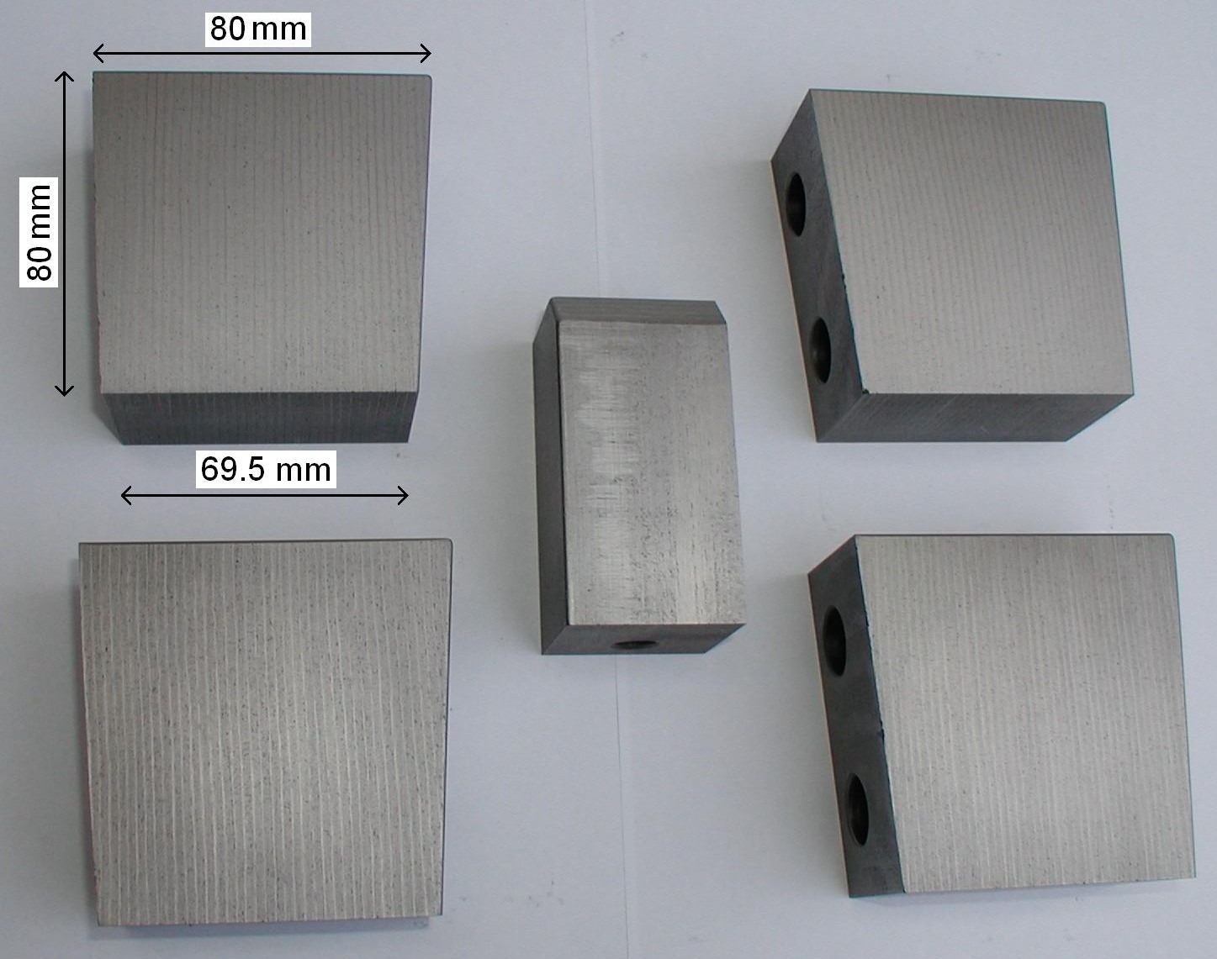 | 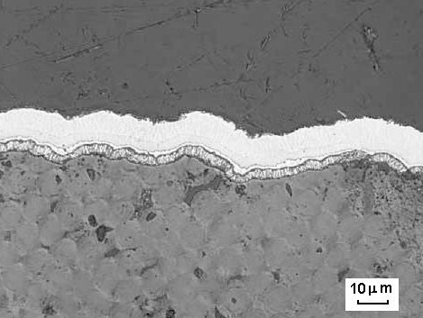
Figure 1. The CFC samples coated with 10 μm W by CMSII technology | Figure 2. Optical micrograph of a W coating deposited by CMSII after 200 pulses
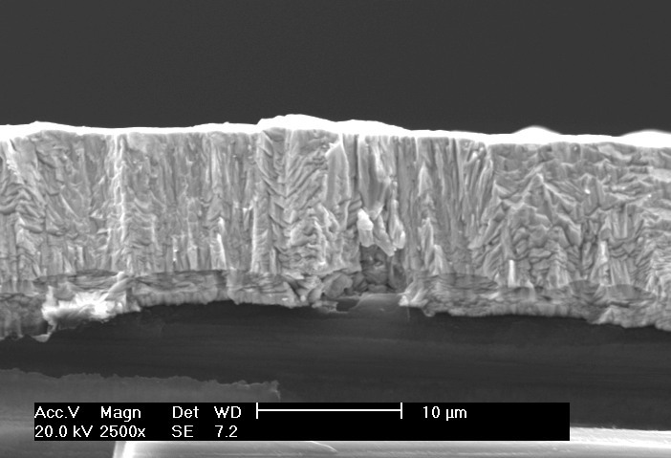 | 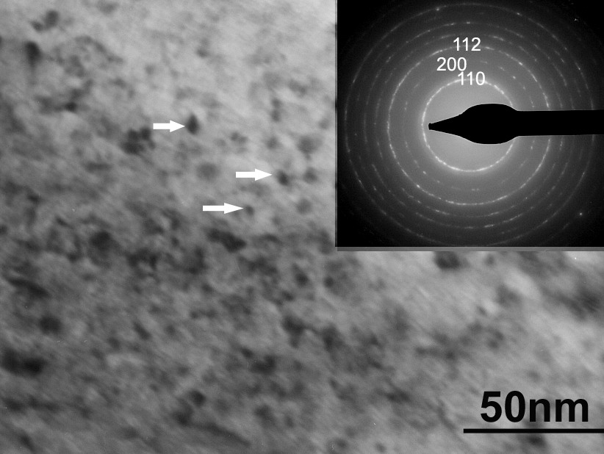
Figure 3. SEM micrograph of a W coating deposited by CMSII | Figure 4. TEM image and SAED pattern of the W coating deposited by CMSII
Figure 5. XRD pattern of the W coating deposited by CMSII | Figure 6. OGDS Depth profiles of W, Mo, C, O and Ti concentrations for the W coating deposited by CMSII
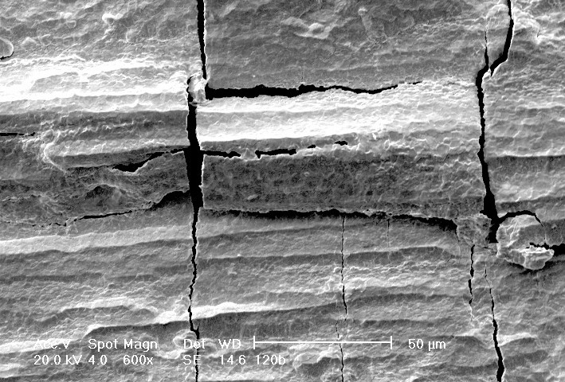 |  | 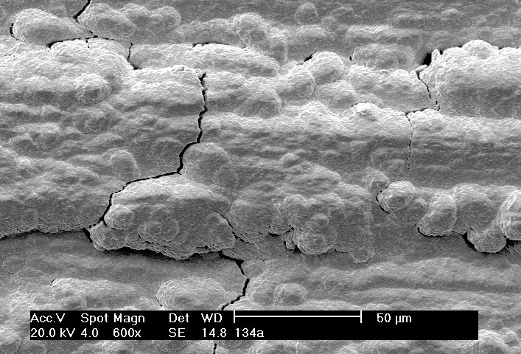
Figure 7. Typical failure pattern of W coatings deposited by conventional PVD or CVD techniques after cyclic thermal loading |  | Figure 8. SEM surface image of the coating deposited by CMSII after cyclic thermal loading
As far as concern the non-destructive tests (NDT) for the coated tiles to be installed in JET, the decision was as follows:
- Since “lock-in thermography” technique was unable to detect previously the coatings, which failed during the high heat flux tests, this technique was not taken into consideration any more as a NDT.
- The W coating supplier will measure the coating thickness and impurities and these values will be mentioned in the Inspection Reports. No other analyses will be carried out.
- 10% of the tiles coated with 10 μm and 100% of the tiles coated with 200 μm will be tested at high heat fluxes in GLADIS at IPP Garching.
2.2. ISO 9001 and ISO 14001 Certification of NILPRP for the coating technologies
The National Institute for Laser, Plasma and Radiation Physics has been certified according to ISO 9001 and ISO 14001 standards.
2.3. Capability of CMSII technology to be applied at the industrial scale
CMSII is a new deposition technique based on magnetron sputtering, but combined with ion implantation. It is well known that one of the advantages of the magnetron sputtering method is its capability to be relative easily up-scaled. Magnetron sputtering is already applied to industrial scale for many applications. The ion implantation is produced by a high voltage glow discharge sustained be a pulse generator. The High Voltage Pulse Generators based on former lines and high voltage transformers are quite reliable. Such a generator is used in Plasma Surface Engineering (PSE) Laboratory for 5 years (more than 1,500 hours) without significant problems.
The main assemblies of the CMSII – Pilot Unit are:
- Deposition chamber with three modules of two magnetrons each
- Power supply for the magnetrons
- High voltage pulse generator
- Vacuum system comprising a turbo molecular pump and a rotary pump (new equipment, bought in 2005)
- Gas admission with MFC and pressure control (new equipment, bought in 2005)
- Control unit
All the electrical equipment was designed and manufactured in PSE Lab., the maintenance being provided by our technicians. They can also provide technical assistance, including prompt repairing if necessary, during the production of the W coating. We have a good experience in vacuum technique as well.
2.3.1 Limitations of the existing CMSII – Pilot Unit
The usable volume of the existing chamber is Φ200 x 200 mm. Some of those 1,100 tiles which have to be coated with 10 μm W cannot be accommodated in this volume. On the other hand, the productivity of such a chamber is not enough to coat all the tiles in 12 months. Consequently, a new deposition chamber (NDC) must be designed and manufactured.
2.3.2. Up-grading of the CMSII – Pilot Unit
The inner diameter of the new chamber will be 800 mm and the height 750 mm. This will allow a usable volume of Φ450 x 360 mm. The chamber will be equipped with 8 modules of 3 magnetrons each mounted in the vertical position. This means 24 magnetrons in comparison with 6 magnetrons in the existing chamber. From these 8 modules, 4 will be loaded with W and the other 4 with Mo. They will work alternatively, initially for Mo interlayer deposition and then for W coating, using the same power supply.
A new power supply for magnetrons will be designed and manufactured.
The power of the High Voltage Pulse Generator will be increased by 50%.
2.3.3. Productivity of the up-graded Pilot Unit
Taking into account the geometry and the number of the components to be coated an average loading parameter of ~ 0.25 m²/run seems to a realistic value. An estimation of the number of runs for production (~ 1,100 tiles) with the new chamber gives a value of ~ 150 runs.
Due to the larger loads (up to 28 kg for a few cases), an increase of the out gassing time is expected. The duration of a cycle with new chamber is estimated to 24 hours. Forced cooling with dry nitrogen at the end of the cycle is envisaged. Under these conditions, the productivity is estimated to 5 runs/week that is 1.2 – 1.3 m²/week. This means approx. 30 weeks. The rest of the weeks is a reserve and will be used for maintenance of the equipment and unforeseen situations, including approval of various documents,
2.3.4. Reproducibility and the quality of the coatings produced with the new
chamber (coating uniformity, impurities);
In comparison with a reactive process, where hard compounds like TiN, T₂N, TiC, etc. are produced by a reaction between the atoms sputtered from the magnetron target and the atoms of the reactive gas (nitrogen, propane, etc.), the deposition of W coating is simpler. Only Ar is used in the treatment atmosphere and the atoms sputtered from the W target are deposited on the CFC substrate. This means that the critical parameter for a reactive deposition process, which is the reactive gas flow rate, does not exist any more in W coating process. This fact improves significantly the reproducibility of this process. Of course there are other factors, which might affect the reproducibility, but they are much easier to be controlled.
The coating uniformity will be ensured by a suitable arrangement of the magnetron modules. During the deposition process the load is rotating around the chamber axis. Special attention will be paid to the jigging system so that each tile to be in the uniform coating field.
In order to keep the impurities below the established limits, the load and the chamber wall will be out-gassed for a period, which will be experimentally established. The load temperature is about 150°C for a wall temperature of 60°C. For the samples, which were tested at IPP Garching, the out-gassing duration was 3 h. The out-gassing temperature must be correlated with the pressure inside the chamber. Five purges with Ar will reduce the oxygen partial pressure in the chamber as well. The chamber will be equipped with a turbo molecular pump, so the risk of contamination with the carbon bearing vapors will be very low. If it will be necessary, a mass spectrometer gas analyzer is available. The five samples, which were tested at IPP Garching, were coated using a diffusion pump and the impurities were OK. The procedure used for coating of the test samples for IPP Garching will be up-dated.
2.3.5. Witness Samples
In each coating run, three titanium witness samples with dimensions of 30 x 40 x 7 mm will be introduced at three levels (up, middle and down). They will be coated together with the tiles and then they will be analyzed to determine the coating thickness and the chemical composition. The results will be introduced in the Inspection Reports. After analyses, the witness samples, packed in the polyethylene bags, will be stored in a special cabinet.
2.3.6. Inspections
After coating, each tile will be dismounted from the jigging system and visually inspected using a magnifier with a magnification of 3 or 4. Any cracks or delaminated areas will be recorded in the Inspection Report.
Optical Glow Discharge Spectrometry (OGDS) will analyze the witness samples from each run (Preliminary W Coatings, Prototype W Coated CFC Tiles and Production) and the chemical composition (including O and C impurities) within the W coating will be determined. At the same time, the depth profiles of the concentrations for the coating constituents will be used to measure the thickness of the W coating. The W coating thickness will be determined by metallographic and SEM analyses for a number of samples. The same samples will be then analyzed by OGDS and a procedure to determine the coating thickness from the W depth profile will be established. This procedure will be applied for all witness samples.
2.3.7. Packing and transportation
After visual inspection, each W coated CFC tile shall be individually packed in new polyethylene bags and a label denoting the tile type and number shall be affixed to the outside of each packet. The tiles shall be packed and crated in such a way as to avoid damage during transportation. A layer of shock absorbing material shall completely surround each tile. The packaged W coated CFC tiles shall be packed firmly in wooden crating able to withstand normal conditions of transportation. The crates shall be sealed and secured with metal straps.
It is our intention to use for delivery of the W coated tiles the same crates that have been used when the tiles have been received for W coating.
A packing procedure will be issued.
2.3.8. Quality assurance and control
Based on the Quality Management Manual and System Procedures and in accordance with CD/S/C008 the Quality Program was issued.
  - Draft of the final report on the W coating (R&D phase) performed in the MEdC Association
The Final Report on the W coating (R&D phase) performed in MEdC Association was drafted and approved.

3. Conclusions
All the tasks of the MEdC Association for the period January – February 2006, in the framework of the Task Agreement JW5-TA-EP-BEW-02 were fulfilled.
At the 3rd Project Board Meeting (8th March 2006) CMSII technology was selected to coat approx. 1,100 off tiles with 10 μm for the JET wall.
A new Task Agreement was signed.

4. Activities to be performed in 2007
The activities, which will be carried out in 2007, are included in the new EFDA Task Agreement JW6-TA-EP2-ILC-01. This task concerns the “Manufacturing and testing of W-coated CFC tiles for installation in JET for the ITER-like Wall project”.

5. Collaborative actions
There were no visits of the specialists from MEdC Association to other Associations. However, a close cooperation with IPP Garching, CEA and JET on the subject of W coating characterization and testing was achieved. During the period 6 – 9 April 2006 we were visited by Hans Maier and Rudolph Neu from IPP Garching and Mike Hill from UKAEA Culham. The discussions have been focused on the characteristics of the W coatings deposited by CMSII technique and on the capability of this technique to be applied to industrial sale in accordance with relevant quality control standards.
The main results concerning the deposition of 10 μm tungsten on CFC substrates by CMSII method were communicated at the 11th International Workshop on Plasma-Facing Materials and Components for Fusion Applications, which was held on 10 – 12 October 2006 at Greifswald, Germany.

References:
[1] Ruset C., Grigore E., Maier H., Neu R., Li X., Dong H., Mitteau R., Courtois X., “W Coatings Deposited on CFC Tiles by Combined Magnetron Sputtering and Ion Implantation Technique”, 11th International Workshop on Plasma-Facing Materials and Components for Fusion Applications (PFMC-11), October 10 to 12, 2006, Greifswald, Germany, Phys. Scr. T128, 2007, 171 – 174.
[2] Hirai T., Maier H., Rubel M., Mertens Ph., Neu R., Gauthier E., Likonen J., Lungu C., Maddaluno G., Matthews G. F., Mitteau R., Neubauer O., Piazza G., Philipps V., Riccardi B., Ruset C., Uytdenhouwen I. and JET EFDA contributors, “R&D on full tungsten divertor and beryllium wall for JET ITER-like Wall Project” , 24th SOFT, 11-15 Sep 2006 Warsaw, Poland (will be published).
[3] Mitteau R., Missiaen JM., Brustolin P., Ozer O., Durocher A., Ruset C., Lungu C.P., Courtois X., Dominicy C., Maier H., Grisolia C., Piazza G., Chappuis P., “Recent Developments Toward the Use of Tungsten as Armour Material in Plasma Facing Components”, 24th SOFT, 11-15 Sep 2006 Warsaw, Poland, Fusion Engineering and Design, (in press).

[4] Maier H., Neu R., Greuner H., Hopf Ch., Matthews G.F., Piazza G., Hirai T., Counsell G., Courtois X., Mitteau R., Gauthier E., Likonen J., Maddaluno G., Philipps V., Riccardi B., Ruset C., EFDA-JET Team, “Tungsten Coatings for the JET ITER-like Wall Project”, 17th Int. Conf. on plasma surface interaction in controlled fusion devices, Hefei, China, 22-26 May, 2006, Journal of Nuclear Materials, Vol. 363-365, 2007, p 1246-1250
[5] Maier H., Hirai T., Rubel M., Neu R., Mertens Ph., Greuner H., Hopf Ch., Matthews G. F., Neubauer O., Piazza G., Gauthier E., Likonen J., Mitteau R., Maddaluno G., Riccardi B., Philipps V., Ruset C., Lungu C.P., Uytdenhouwen I. and JET EFDA contributors, “Tungsten and Beryllium Armour Development for the JET ITER-like Wall Project”, 24th SOFT, 11-15 Sep 2006 Warsaw, Poland, Nucl. Fusion, Vol. 47, 2007, pp. 222-227
[6] Neu R., Maier H., Gauthier E., Greuner H., Hirai T., Hopf Ch., Likonen J., Maddaluno G., Matthews G. F., Mitteau R., Philipps V., Piazza G., Ruset C., JET EFDA contributors, “Investigation of Tungsten Coatings on Graphite and CFC”, 11th International Workshop on Plasma-Facing Materials and Components for Fusion Applications (PFMC-11), October 10 to 12, 2006, Greifswald, Germany, Phys. Scr. T128, 2007, 150 – 156
[7] Matthews G. F., Edwards P., Hirai T., Kear M., Lioure A., Lomas P., Loving A., Lungu C., Maier H., Martens P., Neilson D., Neu R., Pamela J., Philipps V., Piazza G., Riccardo V., Rubel M., Ruset C., Villedieu E. and Way M., “Overview of the ITER-like wall project”, 11th International Workshop on Plasma-Facing Materials and Components for Fusion Applications (PFMC-11), October 10 to 12, 2006, Greifswald, Germany, Phys. Scr. T128, 2007, 137 – 143.

