ITER-like Wall Project

JW5-TA-EP-ILB-01; JW5-AEP-MEC-06

Development of beryllium marker tiles for the ITER-like Wall experiment project (ILW)

EFDA/05-1366; FU06-CT-2005-00355
ITER Wall Materials in JET : Development of Beryllium Markers

C. P. Lungu, I. Mustata, A. Anghel, A. M. Lungu, P. Chiru, C. C. SurduBob, O. Pompilian

National Institute for Laser, Plasma and Radiation Physics, Magurele, Bucharest, Romania

1. Introduction
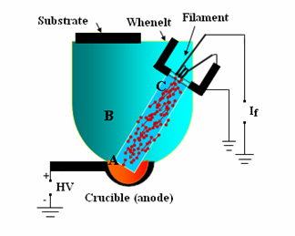
The basic principle of the thermionic vacuum arc (TVA) technique [1] is ignition of plasma in the vapours of the material to be deposited (Re, Ni, Cr, W, Be, etc.). The evaporation of the metal takes place in high vacuum conditions (about 10⁻² Pa and less) and no buffer gas is needed. An externally heated cathode (W filament) produces thermally emitted electrons at a current of about 100 mA. These electrons are accelerated and focused by a Whenelt cylinder to the anode that is biased to high positive voltage (1 – 6 kV). The electron bombardment creates space metal atoms above the anode at a local pressure of about 133 Pa. The TVA principle scheme is presented in Figure 1 where by I_{f} is designated an AC power supply providing the current for heating the cathode filament (0-120 A, at 0-24 V) and by HV is nominated the power supply able to provide high voltage (0-6 kV, at 0-5 A).

Figure 1. The scheme of the TVA principle

The thermo-electrons produced by the heated cathode are able to build up plasma by electron-metal atoms collisions in the space above the anode. The new electrons generated in the plasma together with the original ones emitted by cathode enhance once more the anode evaporation and produce high quantity of ions. Usually the cathode potential fall is in the range of 200-300 V and therefore the plasma potential in comparison with ground ensure generation of the high-energy ions, which collide the substrate.
Deposition rates of 0.1 to 2nm/s were obtained using this technique. The films are formed by both neutrals and fast ions (with energies of hundreds eV). The energetic ions are essential for the adherence and compactness of the films.
In the frame of the ITER-like Wall Project, part of the "JET programme in support of ITER", to be implemented on JET starting with we developed a method to prepare “smart” tiles, in order to assess the erosion rate of the thick Be wall tiles due to the plasma. An interlayer of Ni was used under a beryllium coating of a few microns, then the erosion rate can be determined by measuring the distance of the interlayer from the final surface. The “marker” tiles will be placed in the areas of interest such as Outer Poloidal Limiters (OPL) and Inner Wall Guard Limiters (IWGL).
The “marker” is a Be tile with a stripe of an easily detected heavy metal deposited on it as a thin interlayer, and with a few microns layer of the bulk-like Be on top of that. If the outer layer is eroded at the same rate as the bulk,
By using thermal evaporation method developed at the Nuclear Fuel Plant in Pitesti, Romania, beryllium coatings of 7-9 μm were deposited on inconel samples, in order to asses the possibility to coat over 1000 tiles to be used on the First Wall of JET.
The manufactured Be/heavy-metal/Bulk-Be samples and Be/inconel tiles were sent to FZJ, JET and TEKES for characterization: thickness of heavy metal and beryllium layers, uniformity and structure, purity, density and adherence.

2. Results and discussion
Heavy metals (W, Ni, combinations of Re-Cr-Ni) and Be coatings were prepared at National Institute for Laser, Plasma and Radiation Physics (NILPRP) and Nuclear Fuel Plant (NFP) using the original (TVA) [2] technique on small size (3 cm x 3 cm x 0.5 cm) samples of stainless steel, graphite, glass and silicon wafers in order to optimise the deposition parameters as follows:
  - Optimisation of main working conditions
2.1.1 The anode material/crucible for heavy metal depositions:
Tungsten was evaporated using a pure W rod of 8-10 mm in diameter and 150 mm in length, as shown in Figure 2.
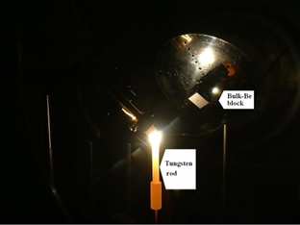

Figure 2. Tungsten evaporation using W rod

Tungsten is a very high melting point material (melting temperature 3382⁰C) and it has a low vapour pressure at this temperature (10⁻² mbar). In order to obtain the minimum vapour pressure necessary for the plasma ignition, a vapour pressure of 1 mbar is necessary. This vapour pressure is obtained at 4000⁰C. At this temperature, there is no material that can be used as crucible. One of the main assets of this original deposition technique is the capability to produce tungsten vapours of 1 mbar pressure without using a crucible.
This is possible due to a special design of the tungsten anode, which allows partial melting, and evaporation while the rest of the anode remains in solid state. Steady TVA plasma ignited in tungsten vapours can thus be obtained which can be run until the anode material is finished. The technique resembles the ignition of a candle.
The filament support was placed vertically in order to maintain a constant cathode – anode distance during consumption of the tungsten rod. The only drawback of the method is that of the tungsten atoms coming from the plasma on the filament, resulting in a lower electron emission coefficient. This phenomenon can be overcome by changing the filament from time to time.
Nickel was evaporated using a graphite crucible. In this case it was necessary to use a crucible because the nickel vapour pressure at the melting point (1453 ⁰C) is less than 10⁻³ mbar which is not sufficient for plasma ignition for used cathode – anode distance. The necessary pressure (around 1 mbar) was obtained for a temperature of about 2000⁰C. For this reason we used a graphite crucible which at the temperature of 2000ºC has a vapour pressure of 10⁻⁵ mbar.
It means that the carbon inclusion into the deposited nickel layer is five orders of magnitude smaller than the nickel one. Post deposition analysis shows no carbon inclusion into the deposited nickel layer that confirmed our supposition.

2.1.2. The anode material for Be depositions
For Be film deposition the anode was as cylinders shaped beryllium (B and A) placed on a tungsten holder, as shown in Figure 3. In this case we used the same technique as for the deposition of tungsten.
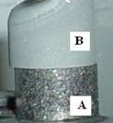

Figure 3. Be cylinders settled on the tungsten holder | Figure 4. The level of impurities of the two Be cylinders

Indeed, the beryllium melting point is 1284ºC having a vapour pressure at this temperature of about 10⁻¹ mbar. The needed temperature for 1 mbar pressure of beryllium vapour is around 1550ºC. Therefore we can locally heat the beryllium rod surface (the top of the B cylinder shown in Figure 3) up to this temperature while maintaining the lower part of the rod in the solid state. This is very important due to the fact that we can obtain very pure beryllium films with practically no atoms coming from the crucible material, especially when using a tungsten plate support.
In order to chose the most appropriate anode material, the purity of two Be cylinders, one made from pressed Be flakes (A, Figure 3) (NFP - Pitesti) and the other (B, Figure 3) made from bulk Be grade S65c Brush Wellman (UKAEA) were analysed by Wavelength Dispersive X-ray Spectroscopy (WDS).
Typical resolution of the energy dispersive X-ray detector (EDS) was in the range of 70-130 eV and the width of the peaks in the WDS were in the 2-20 eV range. Figure 4 shows the results of the WDS measurements. Excepting the Fe content, the level of the impurities was almost the same for the two materials. It was observed that the higher content of Fe did not influence the quality of the Be films which means that either of the Be cylinders can be used.
The beryllium rod, schematically presented in Figure 5, was fixed on a tungsten blade placed on an electrically insulated feed-through. The tungsten-supporting blade remained at a temperature at which vapour pressure of tungsten was very low, thus not influencing the purity of the deposited Be layer. The TVA gun with Mo Whenelt, anode structure and beryllium plasma are presented in Figure 6. The beryllium plasma was diagnosed by means of optical emission spectroscopy, the electron temperature being estimated at 0.7 - 0.8 eV [3].
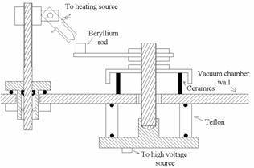 | 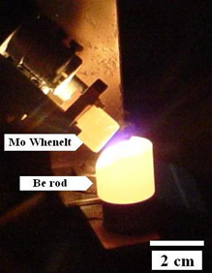
Figure 5. Scheme of the Be anode. | Figure 6. TVA gun and Be plasma

2.1.3 Anode-cathode distance:
The distance between anode (heavy metal/Be cylinder) and cathode (the Whenelt cylinder of the TVA gun) made of molybdenum was adjusted between 2 and 15 mm. An optimum distance of 5 ± 2 mm was found for W and Ni evaporation and an optimum distance of 8 ± 2 mm was found in order to obtain efficient melting and evaporation of the beryllium cylinder. As can be seen in Figure 7, for the Be deposition case during processing time and keeping constant the discharge current, the discharge voltage linearly increased, with the increasing anode-cathode distance due to continuously evaporation of the beryllium cylinder used as anode. Figure 8 shows the discharge voltage during processing, when the anode-cathode distance was increased after 10, and 25 minutes respectively after the process starting. In order to keep the discharge voltage constant during deposition, a special mechanism was designed and realized.
Figure 7. Discharge voltage variation as function of the anode-cathode distance | Figure 8. Discharge voltage during the deposition process.

2.1.4 The viewing angle:
The substrates were settled at distance of 150 mm from the anode, on a holder in contact with a hot plate of 150 mm x 200 mm. The viewing angle was chosen to be between 20 and 50 degrees from the horizontal line, as can be seen in Figure 9.
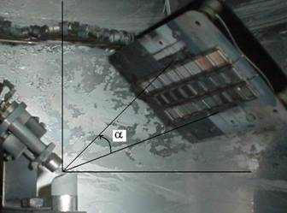

Figure 9. The viewing angle (α: 20º – 50º)

2.1.5 Electrical parameters of the discharges:
The Optimal electrical parameters, (the voltage and the current of the electrical discharge) are given in Table 1. We have to mention that this arc discharge cannot run independently, without the external electron beam. If the electron beam is suppressed the discharge is extinguished.

Table 1. Electrical parameters of discharges

Material | Discharge Voltage | Discharge current
W | 1500 ± 250 V | 1000 ± 100 mA
Ni | 1200 ± 200 V | 800 ± 100 mA
Be | 850 ± 250 V | 450 ± 20 mA

2.1.6 Deposition rate:
Using optimised parameters, deposition rate was found to be 1 ± 0.5 nm/s for W, 2 ± 0.5 nm/s for Ni and 5 ± 0.5 nm/s for Be.
2.1.7 Substrate temperature:
The optimum substrate temperature in order to obtain a good adherence of the layers was around 350 - 400 ºC for all materials. A Specially designed oven heated by Kanthal resistive elements was used in close contact with samples as can be seen in Figure 9. The substrate temperature was kept constant during deposition. After deposition the oven heating current was turned off. Venting of the deposition chamber was undertaken very slowly, at a speed of 10⁻⁵ mbar in 90 minutes.
2.2 Topography of the deposited films
2.2.1 Atomic Force Microscopy (AFM)
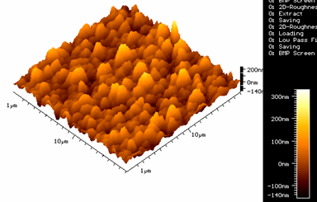
The contact mode AFM measurements, showed that the smoothness of the deposited films with peak to valley roughness was in the range of 300 ± 50 nm for Be coatings (Figure 10).

Figure 10. AFM image a typical Be coating on stainless steel.

2.2.2 Scanning Electron Microscopy (SEM)
The continuity of the deposited films was studied by SEM analysis. Be film morphology was measured using a PHILIPS ESEM XL 30 TM environmental scanning electron microscope and are shown in Figure 11. The film composition was analysed using an energy dispersive analyser of the X-ray radiation emitted at the electron beam impact with atoms of the films.
Substrate | SEM image 1000x | SEM image 5000x | SEM image 10000x
Stainless steel | 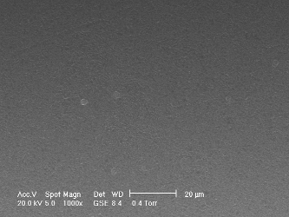 | 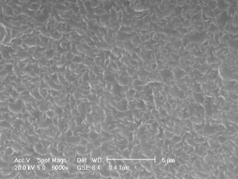 | 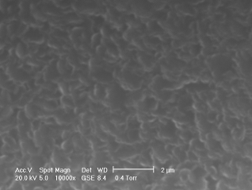
Glass | 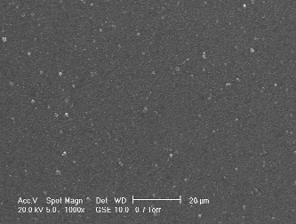 | 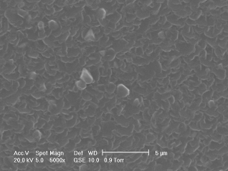 | 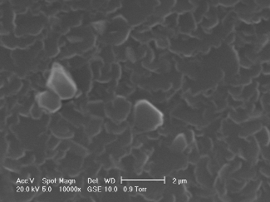
Silicon wafer | 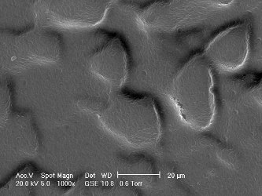 | 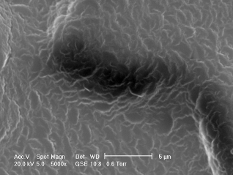 | 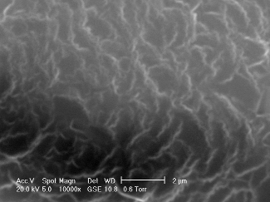
Figure 11. SEM images of Be coatings on various substrates

2.2.3 Crystallographic Structure of the deposited films
The crystalline structure of the deposited films was demonstrated by X-ray Diffraction (XRD) analysis. Figure 12 shows the XRD pattern of the Be coatings on a silicon substrate.

Figure 12. XRD pattern of the Be coating on silicon
2.3 Uniformity of the deposited films
The uniformity of the deposited films was checked by means of micro-radiography. A micro-tomography developed at NILPRP [4] was used to analyse the uniformity of Ni coatings on Be substrate. The uniformity is determined by absorption contrast of transmitted X-rays. In order to mitigate the beam hardening (due to the polychromatic character of the X-ray energy spectra) and scattering effects, two X-ray transmission measurements were performed: before and after coating. The useful result consists in subtraction of the two radiographies. Additionally, the sample radiography is offset and gain corrected. Offset correction means the subtraction of the “dark” image (image without X-ray exposure). The gain correction consists in the flattening of the detector response by a reference “white” image (image with X-ray exposure but without sample). The subtraction was performed after applying an image registration procedure for a perfect matching of the two radiographies (before and after coating).
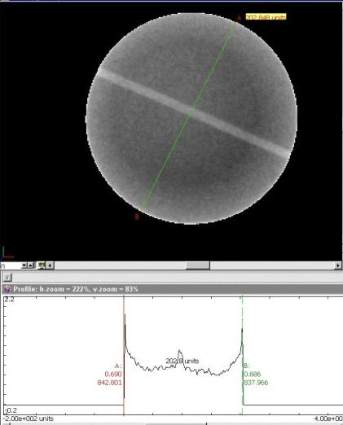
In the following, a description of the procedure used for the micro-radiography technique is given. A Ni film of 2.5 μm thickness was deposited by TVA on a Be disc of 20 mm diameter and 3 mm thickness in order to check the feasibility of ”marker” tile preparation. Over this, a Be outer layer of 7.5 μm was deposited. A copper wire of about 1 mm in diameter was used to attach the disc on the depositing holder. The copper wire was acting as a mask; the shadow produced by the wire was highlighted by microradiography (Figure 13).
Figure 13 shows the result of microradiography analysis using the NIPLRP tomography facility with the following measurement parameters: Microfocus X-ray source, 3 μm focus size, U=100 kV; I=75 μA, Cd pre-filter, Detector: a-Si flat panel, 100 μm pixel size.
Figure 13. Microradiography analysis of Ni/Be coatings on beryllium disc.
3. Manufacturing of optimised Be/heavy-metal/Bulk-Be samples by Thermionic Vacuum Arc (TVA) technique
TVA technique is characterized by producing plasma in the pure vapours of the metal to be deposited (Re, Ni, Cr, W, Be, etc.) without using any buffer gas. The evaporation of the metal takes place in high vacuum conditions (about 10⁻² Pa and less) ensuring the high purity, compactness, adherence and crystalline structure of the coatings.
Using this technique there was prepared coatings on the Bulk-Be blocks, (as a first step to obtain “smart” tile) (20 mm x 26 mm x 30 mm) provided by UKAEA in order to be tested by researchers from JET and FZJ and TEKES Associations.
3.1 Bulk-Beryllium blocks
In Figure 14 are presented the shape and dimensions of the Bulk-Be blocks to be coated with a heavy metal interlayer and a beryllium overlay.
30 mm
26 mm
20 mm
30 mm
26 mm
28 mm
Face to be coated
Face to be coated
Bulk-Be block for HHF testing with a hole for thermocouple
Figure 14. The dimensions and shape of the Bulk-Be blocks to be coated with heavy metal interlayer and Be overlay.

3.2 Heavy metal coatings
During the optimisation phase of the project Re, W, Ni and Re_Ni-Cr films were tested for the highest suitability as interlayer. Due to the closest thermal expansion coefficient (CTE) of Ni to that of Be used as substrate and overlay, Nickel was chosen as the intermediate layer. (CTE: Ni = 13.1 x 10⁻⁶/K, W = 4.4 x10⁻⁶/K, Re = 6.2x 10⁻⁶/K, Cr = 6.2 x 10⁻⁶/K and Be = 11.5 – 16.5 x 10⁻⁶/K, depending of temperature interval – at 20º = 11.5 x 10⁻⁶/K, at 250º = 14.5 x 10⁻⁶/K, at 500º = 16.5 x 10⁻⁶/K)
The large-scale TVA deposition of the Bulk-Be blocks was performed using a six-place holder. One of the samples in a batch was used to test thickness and other properties as impurity inclusions. The Bulk-Be blocks holder was in close contact with an electrical oven, capable to heat the samples at 350-400ºC. A shutter was also used to protect the surface of the samples against the debris formed during plasma ignition until stabilization. Because the “in situ” quartz monitor was designed to measure film thicknesses lower than 1 μm, we installed in front of the quartz gauge a rotating disc having a hole of 10 mm in diameter. The diameter of the hole and the length of circle on which the hole is made were chosen to be in the 1/ 30 ratio. In this case when the quartz gauge measured a layer thickness of 300 nm, the corresponding thickness of deposited layer on the substrates was 300nm times 30 that is 9 μm. The values of the layer thickness measured using the quartz oscillator were compared with those measured using a stylus profiler and we found a good correspondence (by a constant factor of 30). The photograph of the Bulk-Be blocks during Ni coating is shown in Figure 15. The blue colour of Ni plasma can be observed, too.
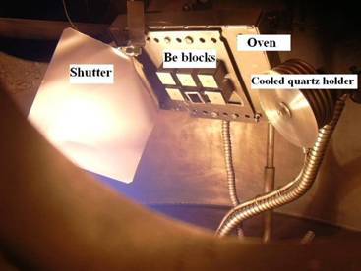 | 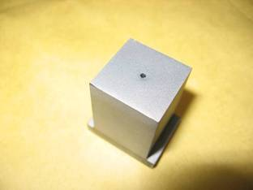
Figure 15. Photograph taken during Ni coating of the Bulk-Be blocks. | Figure 16. Bulk-Be block coated with Ni (2.5 ± 0.5 µm) and Be (7.5 ± 0.5 µm).

3.3 Beryllium coatings
Using the beryllium coating facilities developed at NILPRP Magurele, Bucharest, the Bulk-Be blocks previously coated with Ni interlayer were over coated with 7.5 ± 0.5 μm pure, bulk-like, compact beryllium [5].
The Bulk-Be blocks were placed into the specially designed holder with 6 locations as can be seen in Figure 15. The batch for coating was composed of four Bulk-Be blocks already coated with Ni interlayer. Two locations were reserved for witness samples on stainless steel and glass substrates (20 mm x 20 mm, having the same size as the Bulk-Be blocks). After every deposition process, witness samples were tested for adherence and thickness. The data obtained was recorded on the operator journal for further reference.
The beryllium Bulk-Be provided by UKAEA, were coated with Ni of 2.5 ± 0.5 μm thickness and after that with a Be film of 7.5 ± 0.5 μm thickness (Figure 16). During deposition, witness samples made of glass and smooth stainless steel were used.
3.4 Uniformity and density of the prepared films
The Bulk-Be blocks were tested by microradiography using the tomography facilities developed at NILPRP before and after depositions with Ni and Be, as described earlier. By dedicated software, the images were processed and information about film uniformity was obtained. The deposited films were uniform as can be seen in Figures 17-18. The gray values in the image are proportional to the coating thickness. The profiles are along the coloured horizontal lines.
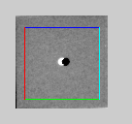 | 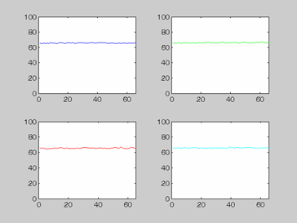
Figure 17. Typical micro-radiography of the beryllium block. | Figure 18. The densities of the layer on the designed directions shown in Figure 18

3.5 SEM analysis of the coated Be blocks
Bulk-Be block before coating | 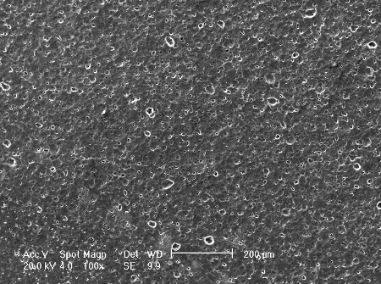 | 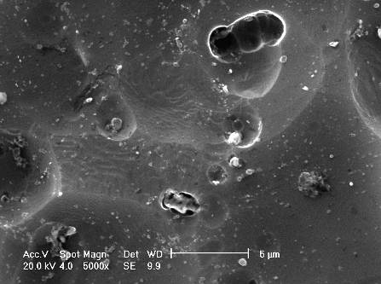
Bulk-Be block after coating | 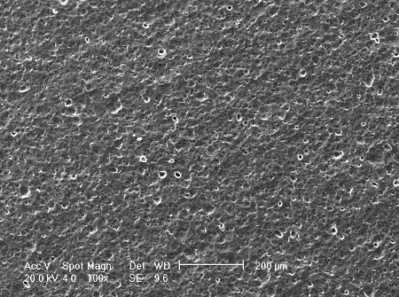 | 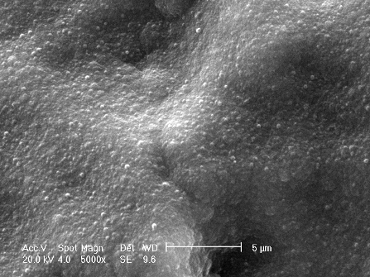
 | 100x SEM image | 5000x SEM image
Before and after coating, the Be blocks were analysed by scanning electron microscopy using a Philips ESEM XL 30 TM apparatus. Typical SEM images can be seen in Figure 19, where the surface morphologies are presented before and after Be coating.

Figure 19. Typical surface morphology of a Bulk-Be block before and after coating

The beryllium coatings were analyzed for impurity inclusions by WDS and flame spectrometry. By WDS, the relative concentration of the detected impurities were assesed, except for Be which can not be detected by this detector. The Be films analized by flame spectrometry showed a level of impurities below 0.2%.

4. Manufacturing of Be/inconel tiles by thermal evaporation in vacuum technique
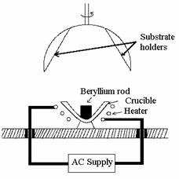
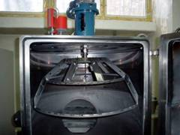
The coatings of inconel tiles were performed using the vacuum thermal evaporation equipment of the Nuclear Fuel Plant (NFP) in Pitesti. The surface of the samples was prepared before deposition by the standard sand blasting procedure used by the NFP. The schematic arrangement used for beryllium deposition by vacuum thermal evaporation method is schematically shown in Figure 20. The evaporation crucible was beryllium oxide and the heating component was a molybdenum wire of 3 mm diameter wounded around the evaporating crucible.

Figure 20. Schematic arrangement for thermal evaporation in vacuum | Figure 21. Photograph of the substrate holder

The inconel tiles were fixed on a rotating holder and the crucible position was chosen for maximum uniformity of the deposited layers. The shape of the rotating holder was semi spherical of 600 nm diameters. The substrates were mounted on the inner side of this calotte and the ensemble was rotated by an external electric motor during beryllium evaporation (See Figure 21)
The required layer thickness was obtained within 3 - 4 hours, all process being automatically driven. The thickness of Be coatings were about 7.5 ±0.5 μm which were satisfactory to the present goals. During deposition, zirconium alloy substrates were used as witness samples for SEM and WDS analysis.
The thickness of the Be films measured by beta backscattering on the witness samples placed at different locations on the semi spherical holder was around 7.5 ±0.5 μm for all samples.
4.1 Characterization of the Be-coatings on inconel tiles
The coated samples were checked for continuity, delaminating and chipping by direct observation and optical microscopy. The thickness of the films was measured by a stylus profiler and by beta backscattering method. Al samples were coated with Be films of 7.5 ± 0.5 μm thickness. Surface morphology of the deposited films was analysed using a PHILIPS ESEM XL 30 TM environmental scanning electron microscope and shown in Figure 22.
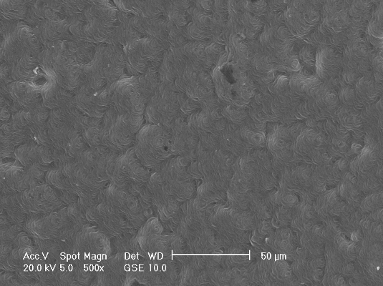 | 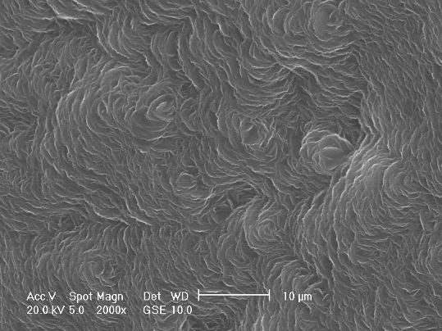
Secondary electron image taken in watervapors at 500x magnification | Secondary electron image taken in watervapors at 2000x magnification
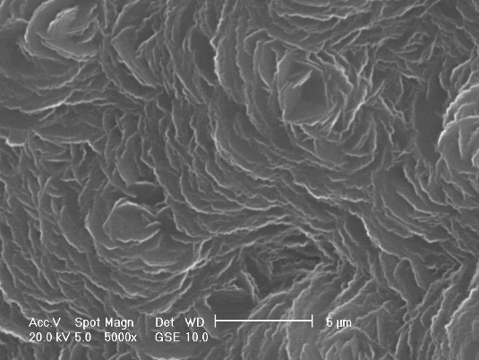 | 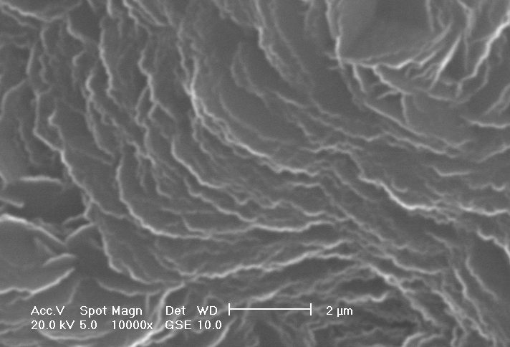
Secondary electron image taken in watervapors at 5000x magnification | Secondary electron image taken in watervapors at 10000x magnification
Figure 22. Surface morphology of an inconel tile coated with Be.

5. High heat flux tests on beryllium coating
5.1 High heat flux testing procedures
High heat flux (HHF) tests were performed at the electron beam facility, JUDITH [8], located in the Hot Cells of Forschungszentrum Jülich, aiming at the assessment of the performance under: (i) screening test to determine the energy density limit, (ii) thermal cycling at the energy density level of 10 MJ/m2, which is typical energy density deposited onto the cladding during a regular operation of JET: 0.5 MW/m² in 10-20 s corresponding to 5-10 MJ/m².
In JUDITH, electrons are accelerated to a voltage of 120 kV. Because of the high acceleration voltage, the relatively deep beam penetration causes heating in volume rather than surface heating. In case of Be, the energetic electron beam can penetrate beyond 100 μm in depth which is much larger than the Be coatings (thickness: ~10 μm). Consequently, the coatings were heated from beneath by the hot Inconel substrates. This fact would not influence significantly the interpretation of experimental results because the temperature gradient in the coatings is not serious concern during the loading due to the high thermal conductivity of Be (145 W/mK at 200 °C 106 W/mK at 500 °C [9]) and the long pulse duration (~11 s).
The tested samples (20 x 40 mm and 3.5 ~ 5 mm thick) were fixed to a copper plate then attached to an actively cooled copper stage. A 10 Hz infra-red (IR) camera was used to monitor the surface temperature. It was measured at a black-coloured surface (created by carbon spray for the temperature measurement) with an emissivity of 0.85.
5.2 Microstructures and chemical analysis of beryllium coating before thermal loads
Figure 23 shows microstructure of the top surface observed by a scanning electron microscope (SEM) and chemical analysis by means of Wavelength Dispersive X-ray Spectroscopy (WDS) and Energy Dispersive X-ray Spectroscopy (EDS) across the coating boundary. As shown in Fig.23, the bare Inconel surface (on the right side) showed rough morphology due to the casting process of Inconel and sandblasting. The Be coating surface (on the left side) had a rough morphology which reflects the Inconel surface. The element line-profiles crossing the coating boundary are shown in Fig. 23. The signal from Be indicates a large variation in the profile but it is connected to a morphological effect due to the surface roughness, causing the shadowing of X-ray generated from Be. There were small signals from oxygen and carbon at the Be coating surface. The intensities were significantly smaller than those signals from the bare Inconel surface. The oxygen profile had sharp spikes, which related to the peaking in the aluminium and silicon profiles. These oxygen spikes would be associated with contamination by Al₂O₃ and SiO₂ on the top surface probably originated from the molt materials during the casting process. Indeed, these elements are not detected on the Be coating but only on the bare Inconel surface. The contamination was trapped in deep valleys of the Inconel. Further EDS analysis at the different surface areas revealed that impurity elements existed as very localized particles (debris) or slurry on the coating. These impurity elements could be avoided in careful preparation processes of Be coating production.
Figure 24 (a) shows a magnified image of the Be coating. The coating consisted of Be platelets (around ~ 5 μm in diameter). After observation from the top surface, cutting and polishing in a wet condition prepared the cross section. Figure 24 (b) shows the cross section of the Be coating. The microstructure indicates that a dense Be coating deposited on the rough Inconel surface with a fairly uniform thickness (~10 μm) and good contact with the substrate. Analysis of the cross section detects only negligible amount of light element impurities in the coating. The interface was clearly identified by the transition of the composition, Be to Inconel composition. The coatings are of high purity and the presence of oxygen is detected only in a thin outermost layer [5-7]. It also adheres well to the substrate and no exfoliation has been observed during a long-term storage in air.

Figure 23. Microstructure at the coating boundary and the line-scan chemical analysis of the Be coating on the cast Inconel 625 (major composition: Ni, Fe, Cr ). | Figure 24. Microstructures of the Be coating, (a) SEM image at the original surface, and (b) SEM image of cross section of the coating and line analysis by EDS and WDS.

5.3 Microstructure of the coatings after thermal loading
The Be coating samples were exposed to stepwise-increased thermal loads from 4.4 MJ/m2 to 20 MJ/m2 (0.4 MW/m2 to 2.6 MW/m2). The tests were done at the starting temperature typically below 100 °C. The maximum surface temperature rose up to around 700 ~ 800 °C. The temperature distribution was fairly homogeneous at the loaded area and no local overheating was observed by the IR-camera.
The all HHF tested coatings were in contact with Inconel substrate and there was no sign of macroscopic destruction of the coating. The microstructure of the coating was observed by SEM. Figure 25 shows the surface morphologies of the coating after energy loadings, (a) 20 MJ/m2 (1.8 MW/m2 for 11 s), (b) 50 cycles of 10 MJ/m2 (1 MW/m2 for 10 s). Even in the high magnification, destruction of the coating and modification of the fine structure of Be coating were not observed. No local melting was found, thus indicating that there was no overheating of the coatings in the energy range of up to 20 MJ/m².
Figure 26 shows the cross section of the Be coating after the loading, (a) 20 MJ/m2 (1.8 MW/m2 for 11 s), (b) 50 cycles of 10 MJ/m2 (1 MW/m2 for 10 s). The coating was still fairly homogeneous. Thermal erosion of the coating, i.e. reduction of the coating thickness, was not observed in this energy density range. As proven by WDS analysis, there is a significant increase of oxygen content at the surface of Be coating and even in the Be coating.
In fact, oxidation of the coating surface was observed as nano-scale surface roughening of the platelets (see Figure 26 (b)). It shows the potential function of Be layer as an oxygen getter. The coating was in contact, however, two new phases (A) Be containing nickel-rich layer, (B) nickel denuded layer, were created at the interface. The thickness of the two layers was ~1 μm each after cyclic loading of 50 cycles at 10 MJ/m2. The impact of these phases on the performance of the coating after a large number of plasma pulses may be difficult to assess. Thermal effects rather than thermo-mechanical effects cause this, therefore, it needs to be examined by annealing tests at different temperatures.
Figure 25 Microstructures of the Be coating after high heat flux loading at the energy of (a) 20 MJ/m2 (1.8 MW/m2 for 11 s) and (b) 50 cycles of 10 MJ/m2 (1 MW/m2 for 10 s). | Figure 26 Cross section and line analyses by EDS and WDS of the Be coatings after thermal loads, (a) 20 MJ/m2 (1.8 MW/m2 for 11 s) and (b) 50 cycles of 10 MJ/m2 (1 MW/m2 for 10 s). Thin Platinum layer was deposited as a marker to indicate top surface of Be coating.

6. Conclusions
Heavy metals/Be coatings on Bulk-Be blocks as the first step to produce “smart” marker tiles were prepared successfully using an original TVA technique developed at NILPRP, Magurele, Bucharest, Romania.
It was decided that Ni has to be used as the heavy metal interlayer due to its thermal expansion coefficient close to that of Be. All depositions were made using pure metal vapour plasma ignited in high vacuum. Beryllium and tungsten were deposited without using a crucible, this eliminating the presence of impurities coming from the crucible material.
Be coatings on inconel samples were obtained using a standard vacuum evaporation method available on a production line at NFP Pitesti. The prepared Be films were of 7.5 ± 0.5 μm in thickness, as requested.
The Be coatings on Inconel substrates were tested at a high heat flux (HHF). Tests and coating characterizations were performed at the electron beam facility, JUDITH FZJ Juelich, Germany. The microstructures showed that the coating consisted of small platelets (~ 5 μm) and analyses indicated a coating of high purity. The layers have survived energy loads of the energy density of 20 MJ/m2 thus significantly exceeding the required level of 10 MJ/m2.
Be coating (~10 μm) on cast Inconel tiles was tested under heat flux and showed excellent performance, above the required power density.
The high purity and good adherence of the coatings before and after HHF testing created reasonable basis for the qualification of materials for application during the ITER-like Wall operation of JET

References:
[1] Lungu C. P., Mustata I., Musa G., Lungu A.M., Zaroschi V., Iwasaki K., Tanaka R., Matsumura Y., Iwanaga I., Tanaka H., Oi T., Fujita K.: “Formation of nanostructureed Re-Cr-Ni diffusion barrier coatings on Nb superalloys by TVA method”, Surf. and Coat. Techn. 2005, 200, 399.
[2] Hirai T., Maier H., Rubel M., Mertens Ph., Neu R., Gauthier E., Likonen J., Lungu C., Maddaluno G., Matthews G. F., Mitteau R., Neubauer O., Piazza G., Philipps V., Riccardi B., Ruset C., Uytdenhouwen I. and JET EFDA contributors, “R&D on full tungsten divertor and beryllium wall for JET ITER-like Wall Project”, Proc of 24th Symposium on Fusion Technology, 11-15 September 2006, Warsaw, Poland.
[3] Lungu C.P., Mustata I., Zaroschi V., Lungu A.M., Chiru P., Anghel A., Burcea G., Bailescu V., Dinuta G., Din F., “Optical emission diagnostic of thermionic vacuum arc plasma during beryllium film formation”, Proc. of 33rd European Physical Society Conference on Plasma Physics, 19-23 June, Roma, Italy.
[4] Tiseanu I., Craciunescu T. and Mandache B. N.: “Non-destructive analysis of miniaturized fusion materials samples and irradiation capsules by X-ray micro-tomography” Fusion Engineering and Design, 2005, 75-79, 1055.
[5] Lungu C. P., Mustata I., Zaroschi V., Lungu A. M., Anghel A., Chiru P., Rubel M., Coad P., Matthews G. F. and JET-EFDA contributors, “Beryllium Coatings on Metals: Manufacture and Characterization”, invited, 11th International Workshop on Plasma-Facing Materials and Components for Fusion Applications, PFMC 2006, October 10-12, 2006, Greifswald, Germany, Physica Scripta, in print (2006).
[6] Hirai T., Linke J., Sundelin P., Rubel M., Kühnlein W., Wessel E., Coad J.P., Lungu C. P., Matthews G.F., Pedrick L., Piazza G. and JET-EFDA contributors* “Characterization of Be/Inconel coating and the performances under high heat flux loading”, oral presentation, 11th International Workshop on Plasma-Facing Materials and Components for Fusion Applications, PFMC 2006 October 10-12, 2006, Greifswald, Germany.
[7] Hirai T., Linke J., Sundelin P., Rubel M., Kühnlein W., Wessel E., Coad J.P., Lungu C.P., Matthews F., Pedrick L., Piazza G. and JET-EFDA contributors, “Heat Flux Testing and Post-Mortem characterisation of Beryllium Coatings on Inconel”, poster presentation, 11th International Workshop on Plasma-Facing Materials and Components for Fusion Applications, PFMC 2006 October 10-12, 2006, Greifswald, Germany.
[8] Duwe R., Kühnlein W. and Münstermann H.: Proc. 18th Symposium on Fusion Thechnology (SOFT), Karlsruhe Germany, (1994) 355–358.
[9] ITER Material assessment report 2001 G 74 MA 10 01-07-11 W 0.2.

