JET COMPONENTS of the EFDA 2008 and 2009 WORKPROGRAMMES
Final Report on EFDA-JET Order
JW8-O-MEC-12
(Commission Nº: FU07-CT-2008-00214-002)
Association Euratom / MEdC
Head of Research Unit Dr F. Spineanu
Revision: 7
Date: 15.04.2010
Association Contact Person: Dr F. Spineanu
Scientific Contact Person: Dr F. Spineanu
Content
Part 1: EFDA-JET Experimental Campaigns C20-C27
Part 2: Key Contributions of MEdC to Campaigns C20-C27
Part 3: Involvement of MEdC in EFDA-JET Task Force work
Annexes
Annex 1: S/T Tasks of EFDA-JET Experimental Campaigns C20-C27
Annex 2: Role of MEdC staff in EFDA-JET Campaigns C20-C27
Part 1: EFDA-JET Experimental Campaigns C20-C27

Preamble
The EFDA-JET Order JW8-O-MEC-12 covers Scientific and Technical (“S/T”) work conducted at the JET Facilities during the Experimental Campaigns C20-C25 of 2008 and C26-C27 of 2009 (including High Level Commissioning). For each Associate staff member participating in Campaigns C20-C27, the Order includes an Individual Task Description (ITD) of the work to be carried out.
The present Final Report on EFDA-JET Order JW8-O-MEC-12 covers briefly the execution of Campaigns C20-C27 (Part 1, Section 2), the key contributions of Association Euratom / MEdC (hereafter MEdC) to the Campaigns C20-C27 (Part 2) and the involvement of MEdC in the EFDA-JET Task Forces (Part 3). Annex 1 contains a list of all S/T Tasks for Campaigns C26-C27 and Annex 2 contains the individual Work Reports of Associate staff.

JET Components of the EFDA 2008 and 2009 Workprogrammes
The elaboration of the JET Components of the EFDA 2008 and 2009 Workprogrammes (documents EFDA (07) 33/6.4 and EFDA (08) 37/3.6) is fully covered in Task Agreement JW8-TA-EXP-04A, which specifies the work to be carried out by the Associates under both S/T Orders and S/T Notifications. Work under the Task Agreement JW8-TA-EXP-04 includes: (a) the elaboration of the Experimental Campaigns of 2008-2009, including support for the commissioning of diagnostics and the on-site presence of some Task Force Leaders/Deputies; (b) the preparation and execution of the Experimental Campaigns of 2008 and the subsequent analysis of experimental data. For a complete list of C20-C27 S/T Tasks see Annex 1. The current report only covers the part of this work carried out under S/T Orders on the JET site.
The Task Force structure approved by the EFDA Steering Committee for 2005-2007 was maintained and Task Force Leaders were appointed for the 2008-2009 Campaigns in July 2007.

Experimental Campaigns C20-C25 of 2008
The Campaigns C20-C25 was running continuously from 9 April to 16 December 2008 when technical problems prevented further execution of JET experiments. C20-C25 was preceded by a two-week High Level Commissioning period. The 2008 part of the Order JW8-O-MEC-12 hence covers the period from 25 March to 19 December 2008.

Experimental Campaigns C26-C27 of 2009
There were two Campaigns during 2009, C26 and C27 separated by a three-month-long intervention to install ERFA. The 2009 part of the Order JW8-O-MEC-12 hence covers the periods from 12 January to 7 April 2009, 13 July to 14 August 2009 and 2 September to 23 October 2009.
Part 2: Key Contributions of MEdC to Campaigns C20-C27

Introduction
The main contribution of the MEdC Association to the JET Experimental Campaigns of 2008 and 2009 was related to activities co-ordinated by the Task Force Diagnostics. This contribution included an experiment which was for the first time scientifically co-ordinated by the MEdC Association, a substantial performance in the Control Room as diagnostics co-ordinator, and the development and successful application of new diagnostics techniques based on neutron detection and image processing. Related to activities co-ordinated by the Task Force M, the main contribution of the MEdC Association was connected to the modelling of the Resistive Wall Modes in JET.

Key Contribution 1

Determination of the neutron field characteristics in high performance discharges (S/T Task D.1.5.2)
The spatial distribution of the neutron fluence was measured with poloidal and toroidal resolution by means of detector arrays using up to 30 superheated fluid detectors (“bubble detectors”). The comparison of the area integrated fluence determined by means of a bubble detector array with the neutron flux determined by the time-of-flight spectrometer TOFOR has shown a good correlation factor of 0.99. The experimental spatial distribution of the neutron fluence validated the numerical results of the neutron transport simulation.
The broad-band (0.01 – 20 MeV) neutron energy distribution was measured on 41 JET high performance pulses by means of 5 bubble detector spectrometer sets (with a total of 108 detectors), in conjunction with simultaneous measurements by means of the TOFOR time-of-flight spectrometer and neutron activation. The experimental data have been processed by means of three different techniques ("uniform response”, “spectral stripping” and “expected energy distribution”) and produced the following main results:
-The presence of neutrons emitted from a deuterium plasma with an energy in the range 10-20 MeV was clearly shown. This confirms the emission of triton burn neutrons (energy 14 MeV) in high performance (high neutron yield) JET deuterium discharges.
-The fraction of low energy neutrons is in some discharges higher than that which could be explained by scattering processes. This could be explained by other neutron emitting reactions from the tokamak machine (such as photonuclear reactions, triggered by high energy electrons generated in a plasma disruption).
For this S/T Task (D-1.5.2) the MEdC Association provided all the necessary hardware and software components for the bubble detector neutron measurements.

Key Contribution 2
New developments in JET image processing
1. MEdC team has developed a package of tomographic methods for the reconstruction of neutron/gamma emissive distribution. The JET neutron profile monitor coverage enables tomographic reconstruction. However, due to the availability of only two projection angles and to the coarse sampling, tomography is a highly limited data set problem. We customized, implemented an evaluated appropriate methods for the JET tomographic problem: maximum likelihood (ML), maximum entropy (ME), Tikhonov regularization (TR) and a Monte Carlo backprojection algorithm (MCBP). We developed also a strategy to incorporate a priori information (magnetic data) in order to compensate for the lack of experimental information. One of the methods (ML) proved to be able to encompass the reconstruction, with a good quality, of all possible structures of the emissive distribution. The ML method provides the finest results in terms of shapes reconstruction and resolution and produces artefact free images. It is robust enough to work with low statistic data and consequently it can ensure a temporal resolution of ~100 ms. Therefore temporal evolution of neutron/gamma emissive distribution can be revealed. The method allows fast reconstructions. Therefore we used this method for inter-shot analysis during experiments (e.g. M-3.3.1, M-3.3.3) and also for post-processing of data obtained during JET campaigns. The ML method proved to provide useful information (e.g. tomography helped to reveal evidence of MeV 3He-ion redistribution during sawtooth crashes).
2. MEdC team has developed also an optical flow method for the characterization of the velocity field of relevant items of images provided by KL8 fast visible camera. The method may represent a useful technique for studying several fusion plasma relevant issues, including plasma wall interactions. First experimental tests (concerning pellet injection, plasma filaments and MARFEs) proved that the method is able to provide good results for JET fast-visible camera images which can be affected by saturation, discontinuous movement, reshaping of image objects, low gray-level in-depth resolution. The method is still under development for further refinements and optimization.

Key Contribution 3
Modelling of Resistive Wall Modes in the diverted tokamak configuration of JET
a) Due to the presence of the separatrix, the boundary conditions for the second-order differential equation governing external link mode stability can no longer be taken, as is usual, at the magnetic axis and at infinity. Therefore, we have to consider “natural” boundary conditions just at the plasma boundary [1]. On the advice of our JET colleagues we considered the shots no. 40523, 40418 and 40183 where the RWMs were present, while at shots performed during the S/T S2-2.3.1 the presence of RWMs was not evident. Considering discharges with low wave numbers m/n at the boundary (46.3676s – 46.993 s for shot # 40523) only, we have found that in the no-wall limit, discharges are not stable (Δ’ ≥ 0) but in the ideal wall limit (superconducting wall) are all stable.
b) To take into consideration the wall answer, the vacuum field given by the normal component of the perturbation field at the JET separatrix, generated by an external kink mode has been calculated, by using our model of surface currents [2]. The influence of the wall on the boundary conditions of the external kink mode equations is now under consideration for a 3D wall with holes [3].
For this modelling task, the MEdC staff provided both theoretical and numerical tools.

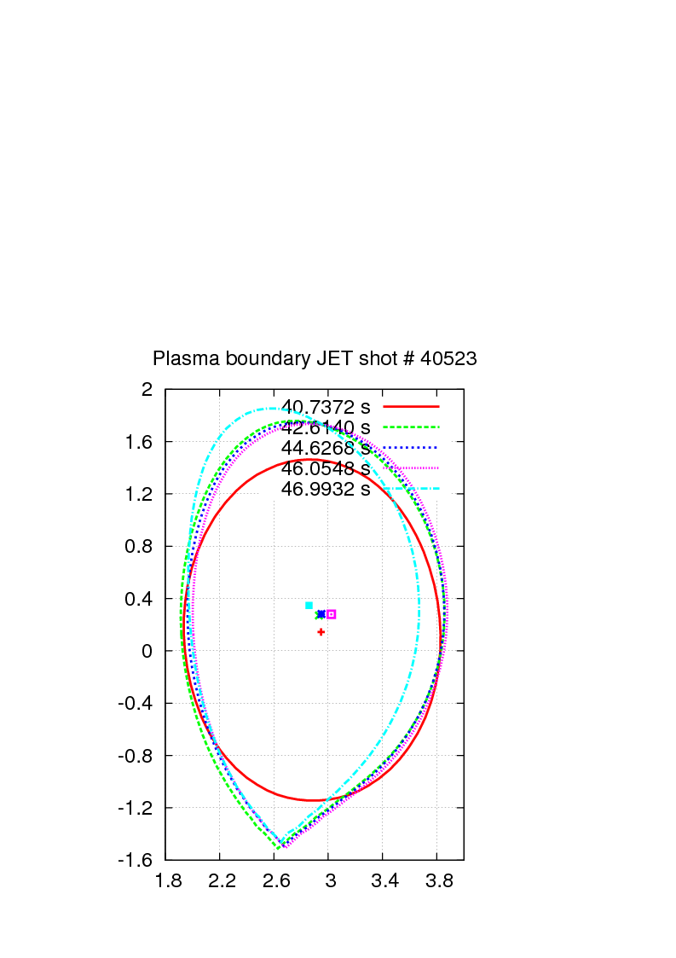 | 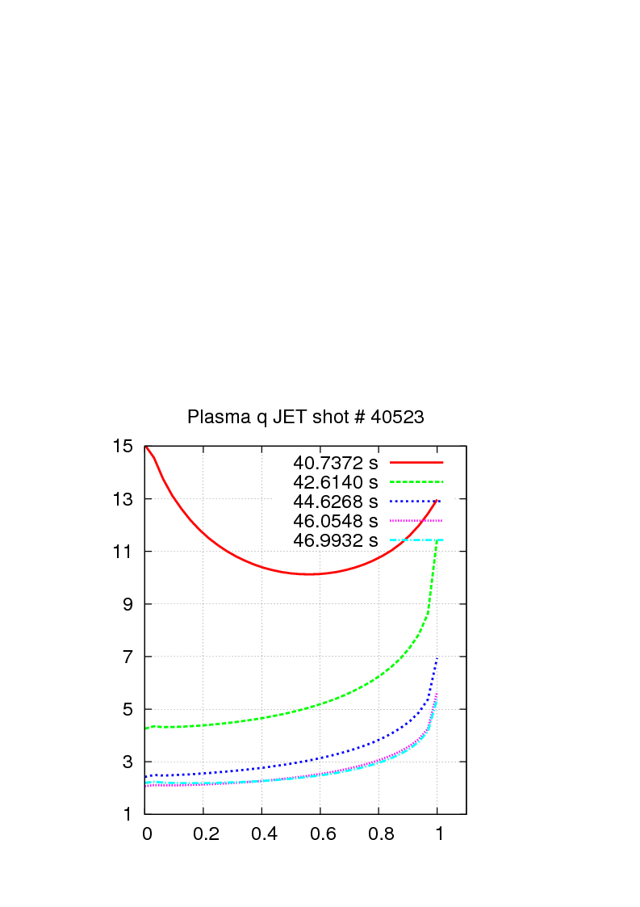 | 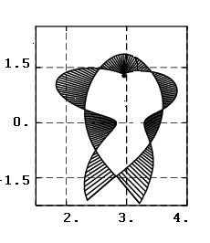
a) | b) | Fig.2 The surface charge distribution along the plasma boundary for a flux perturbation Y_{3/1}. Shot # 40523.
Fig. 1 Time dependencies of different plasma parameters for the considered shot # 40523: a) plasma boundary, b) safety factor q, Other considered parameters: plasma pressure p, plasma current Ipl, toroidal magnetic field Bt and internal plasma inductivity li
[1] C.V. Atanasiu, A.H. Boozer, L.E. Zakharov, A.A. Subbotin, Phys. Plasmas 6, 2781 (1999).
[2] C.V. Atanasiu, S. Günter, K. Lackner, A. Moraru, L.E. Zakharov, A.A. Subbotin, Phys. Plasmas 11, 5580 (2004).
[3] C.V. Atanasiu, A. Moraru, L.E. Zakharov, APS Plasma Meeting, Atlanta, USA, 2-6 November 2009.
Acknowledgements: The discussions with S. Gerasimov and M. Gryaznevich are greatly appreciated.

Part 3: Involvement of MEdC in JET Task Force work

Summary

Involvement by MEdC under S/T Orders in EFDA-JET Campaigns C20-C27

Number of MEdC staff involved in C20-C27 | Total number of days MEdC staff spent at JET under Orders | Number of Control room shifts
Number of MEdC staff involved in C20-C27 | Total number of days MEdC staff spent at JET under Orders | SC | SL | DC | Other
4 | 497 | 14 | 0 | 18 | 0

Number of publications by MEdC staff as a result of work under S/T Orders in EFDA-JET Campaigns C20-C27

Presentations in TF meetings | Conferences |  | Peer reviewed papers
Presentations in TF meetings |  |  | Submitted |  | Published
1st Author only | 1st Author | Co-Author | 1st Author | Co-Author | 1st Author | Co-Author
5 | 5 | 14 | 1 | 3 | 4 | 6

Involvement of MEdC in Specific Task Forces

TF-D
    - Summary
Task Force Leader | A. Murari
Association Responsible Officer | V. Zoita
EFDA-CSU Responsible Officer | M. Tsalas
S/T Tasks | D-1.3.3, D-1.5.10, D-1.5.2, D-3.1.1, D-3.3.1
Participating Staff | T. CRACIUNESCU, M. GHERENDI, V. ZOITA
Competencies Provided by Participating Staff | DC, LCPD, NEUT, SC
    - Publications as a result of MEdC staff involvement in TF-D.
      - Presentations in TF-D meetings
1) “Super-heated fluid detectors (“bubble detectors”) for neutron measurements at JET”, V. Zoita et al., 29/01/2008
2) “The Maximum Likelihood Reconstruction Method for JET Neutron Tomography”, T. Craciunescu et al. 02/07/2008
3) “Determination of neutron field characteristics for high performance discharges (Experiment D-1.5.2)”, V. Zoita et al., 27/11/2008
4) “Bubble detector measurements on the neutron energy distribution at the of the end of the JET KM11 Line-of-Sight”, V. Zoita et al., 05/03/2009
5) "Application of the Optical Flow method to Visible Imaging at JET", T. Craciunescu et al. 10/09/2009
      - TF-D Conference and Seminar Contributions
  - “Neutron Fluence Measurements on the JET Tokamak by Means of Super-Heated Fluid Detectors “, V. Zoita et al., 36th International Conference on Plasma Science, ICOPS, San Diego, USA, 31st May – 5th June 2009.
  - “Reconstruction Methods for JET Neutron and Gamma Tomography”, T. Craciunescu et al., 15th Conference "Progress in Cryogenics and Isotopes Separation" Calimanesti-Caciulata, Valcea, Romania, 28-30 October 2009.
  - “Neutron measurements on the JET tokamak by means of bubble detectors”, M. Gherendi et al., 15th Conference "Progress in Cryogenics and Isotopes Separation", Calimanesti-Caciulata, Valcea, Romania, 28-30 October 2009.
Co-authors in 7 presentations in conferences and seminars.
      - TF-D Related Peer-reviewed Publications
- T. Craciunescu et al., Nuclear Inst. and Methods in Physics Research, A, 595 (2008), 623–630.
- M. Gherendi et al., “Super-heated fluid detectors for neutron measurements at JET”, J. Optoelectronics Advanced Mat., 10 (2008) 2092-2094.
- T. Craciunescu et al., Nuclear Inst. and Methods in Physics Research, A, 605 (2009), 373-384.
- T. Craciunescu et al., "Application of Optical Flow Method for Imaging Diagnostic in JET", J. Nucl. Mater. (2010), doi:10.1016/j.jnucmat.2010.03.005.
Co-authors in 5 published papers.
Co-authors in 2 submitted papers.

TF-H
    - Summary
Task Force Leader | J. Ongena
Association Responsible Officer
EFDA-CSU Responsible Officer | F. Rimini
S/T Tasks | H-1.1.1, H-1.1.3, H-1.2.3, H-1.2.4, H-1.2.6
Participating Staff | V. ZOITA
Competencies Provided by Participating Staff | DC, NEUT
    - Publications as a result of MEdC staff involvement in TF-H.
      - Presentations in TF-H meetings
1) “Super-heated fluid detectors (“bubble detectors”) for neutron measurements at JET”, V. Zoita et al., 29/01/2008
      - TF-H Conference and Seminar Contributions
Co-author in 3 presentations in conferences and seminars.
      - TF-H Related Peer-reviewed Publications

TF-M
    - Summary
Task Force Leader | R. Koslowski
Association Responsible Officer
EFDA-CSU Responsible Officer | C. Perez Von Thun
S/T Tasks | M-3.3.1, M-3.3.3
Participating Staff | C.V. ATANASIU, T. CRACIUNESCU, V. ZOITA
Competencies Provided by Participating Staff | DC, LCPD, MAGN, NEUT, RWME
    - Publications as a result of MEdC staff involvement in TF-M.

      - Presentations in TF-M meetings

      - TF-M Conference and Seminar Contributions
1.“Response of a resistive wall with holes to an external kink mode in a tokamak”, C.V. Atanasiu, et al., presented at the 21st International Conference on Numerical Simulation of Plasmas, Lisbon, Portugal, 6-9 October 2009.
2.“Influence of a Nonuniform Resistive Wall on the RWM Stability in a Tokamak”, C.V. Atanasiu, et al., presented at the American Physical Society Plasma Meeting, Atlanta, USA, 2-6 November 2009.
Co-authors in 4 presentations in conferences and seminars.
      - TF-M Related Peer-reviewed Publications
C.V. Atanasiu, et al., submitted to IEEE Transactions on Plasma Science

Co-authors in 1 published papers.
Co-authors in 1 submitted papers.

TF-S1
    - Summary
Task Force Leader | G. Saibene
Association Responsible Officer
EFDA-CSU Responsible Officer | G. Sips
S/T Tasks | S1-2.1.2
Participating Staff | T. CRACIUNESCU
Competencies Provided by Participating Staff | NEUT
    - Publications as a result of MEdC staff involvement in TF-S1.
      - Presentations in TF-S1 meetings
      - TF-S1 Conference and Seminar Contributions
      - TF-S1 Related Peer-reviewed Publications
1. T. Craciunescu et al., "Application of Optical Flow Method for Imaging Diagnostic in JET", J. Nucl. Mater. (2010), doi:10.1016/j.jnucmat.2010.03.005.

  - ERFA HLC
    - Summary
Project Leader | F. Crisanti/F. Rimini
Association Responsible Officer
EFDA-CSU Responsible Officer | F. Rimini
S/T Tasks | HLC-1.1.1, HLC-1.1.3
Participating Staff | V. ZOITA
Competencies Provided by Participating Staff | DC

All scientific and technical outcome of ERFA HLC will be reported in the Final Report of the PCU Phase 2 Project.

