Contributions of MEdC Association to EFDA PWI – 2010

EFDA Task | Title of the MEdC contribution | MEdC Coordinator | Page
WP10-PWI-01-01-01/MEdC/BS | Providing W coated CFC samples for fuel retention measurements | Cristian RUSET | 3
WP10-PWI-01-02-01/MEdC/BS  WP10-PWI-01-02-02/MEdC/PS | X-ray micro-tomography studies CFC samples for porosity network characterization | Ion TISEANU | 8
WP10-PWI-05-02-01/MEdC/BS  WP10-PWI-05-02-02/MEdC/PS | X-ray microbeam absorption/fluorescence method as a non-invasive solution for investigation of the erosion of W coatings on graphite/CFC | Ion TISEANU | 12
WP10-PWI-02-04-01/MEdC/BS | Removal of codeposited material from gaps with a plasma torch | Gheorghe DINESCU | 16
WP10-PWI-02-04-02/MEdC/BS | Laboratory models for the co-deposited layers | Gheorghe DINESCU | 19
WP10-PWI-02-04-03/MEdC/BS | Production of controlled laboratory co-deposited layers for fuel removal studies | Gheorghe DINESCU | 22
WP10-PWI-04-04-01/MEdC/BS | Experimental investigations and and numerical studies (ERO) of chemical erosion of low-Z materials for plasmas at low temperatures is one of the experiments in Pilot-PSI / Magnum-PSI. | Claudiu COSTIN | 24
WP10-PWI-06-01-01/MEdC/BS and WP10-PWI-06-01-02/MEdC/PS | TVA gun electron beam irradiation influence on mixed films prepared using TVA method | Cristian LUNGU | 27
WP10-PWI-06-02-01/MEdC/BS and WP10-PWI-06-02-02/MEdC/PS | Study of D-retention in mixed materials containing H, D and He | Cristian LUNGU | 29

WP10-PWI-01-01-01
Providing W coated CFC samples for fuel retention measurements

EFDA WORKPROGRAMME 2010, Plasma Wall Interaction
Deliverable under Base- Line Support
Reference: | Task Force: Plasma Wall Interaction  Area: Fuel retention as a function of wall materials foreseen for ITER  Task: WP10-PWI-01-01-01/MEdC/BS
Document: | Task Title : Providing W coated CFC samples for fuel retention measurements  Task Coordinator: S.Brezinsek
Author(s): | Cristian Ruset, Association EURATOM – MEdC Romania
Date: | 31.12.2010
Distribution list: | (Task Co-Ordinator): S.Brezinsek  (Task Force Leader): Rudolf Neu  (CSU Responsible Officer): Roman Zagorski  (CSU Group Leader): Klaus Schmid
Content: | A number of 16 samples (12 for experiments and 4 reserves) with dimensions of 59 x 10 x 5 mm and a special geometry have been manufactured from CFC material. Twelve samples have been W coated with 10-15 µm and 20-25 µm both parallel and perpendicular to the fiber planes. The lot of 6 samples coated with 20-25 µm is shown in Fig.1. The coating thickness and impurity concentrations were measured by Glow Discharge Optical Spectrometry (GDOS) on witness samples coated in the same run with CFC samples. Four samples cut parallel and perpendicular to fibers remained un-coated as reference. All samples have been sent to FZ Jülich and installed on the roof-like test limiter in TEXTOR to be exposed to plasma. Their arrangement is shown in Fig.2.  The W coating and the Mo interlayer are very compact as it can be seen in Fig.3. In the region of the carbon fibers the coating surrounds the ends of the fibers penetrating between them for tens of microns (Fig.4). In this way, the adhesion is improved. However, it is well known that CFC is a porous material. W coating can close small pores, but the large pores with dimensions of tens of microns remain open to the atmosphere. The fuel (deuterium/tritium) can penetrate through these pores to the CFC substrate. Due to this effect the fuel retention could not be reduced very much.  On the other hand in the case of carbon wall machines, a large amount of fuel seems to be retained in the carbon coatings deposited on the walls during the operation. This effect should be significant reduced in JET with the ITER-like wall since carbon should not be directly exposed to plasma.
  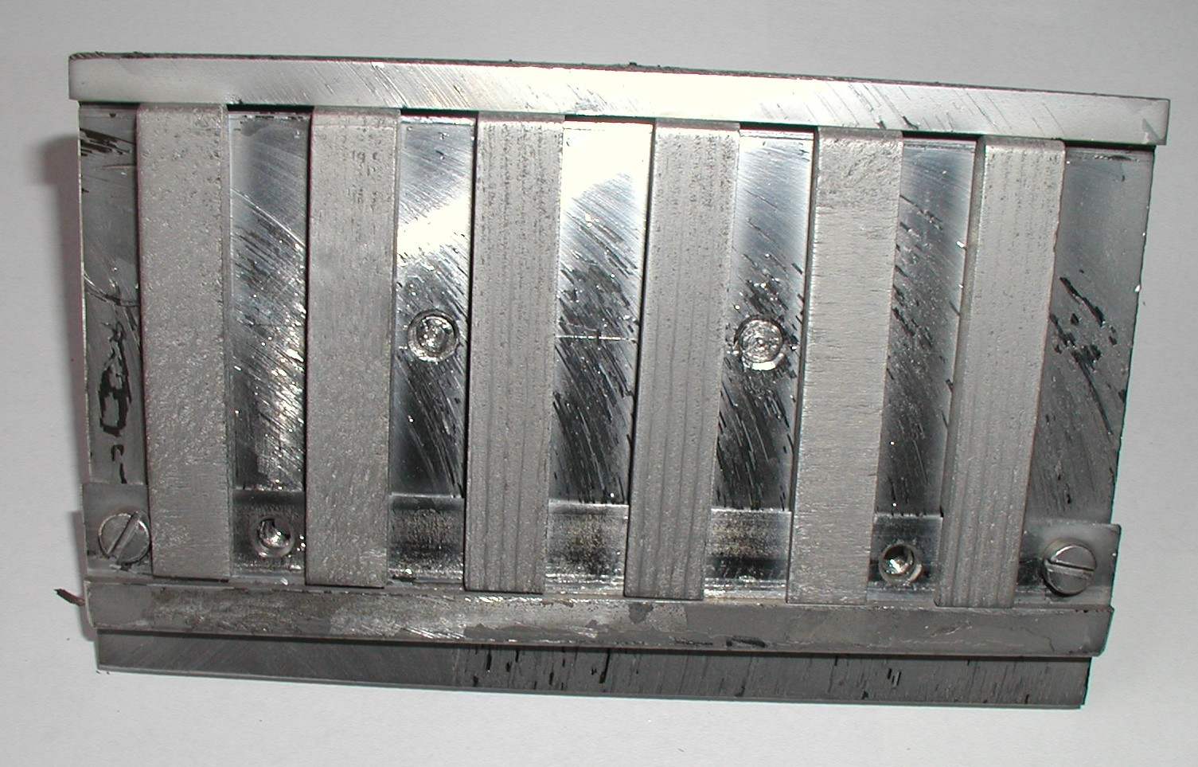 | 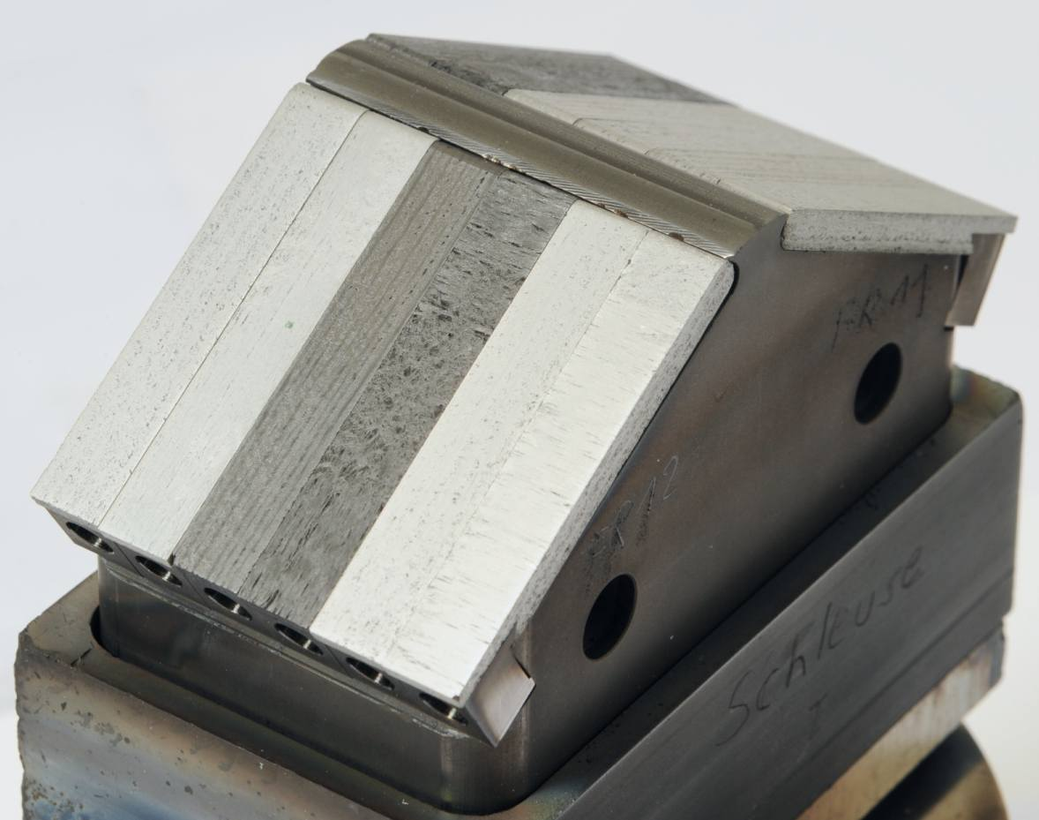
  Fig.1 Lot of 6 CFC samples coated with 20-25 µm tungsten. | Fig.2 W coated and uncoated samples installed on the roof-like test limiter of TEXTOR
  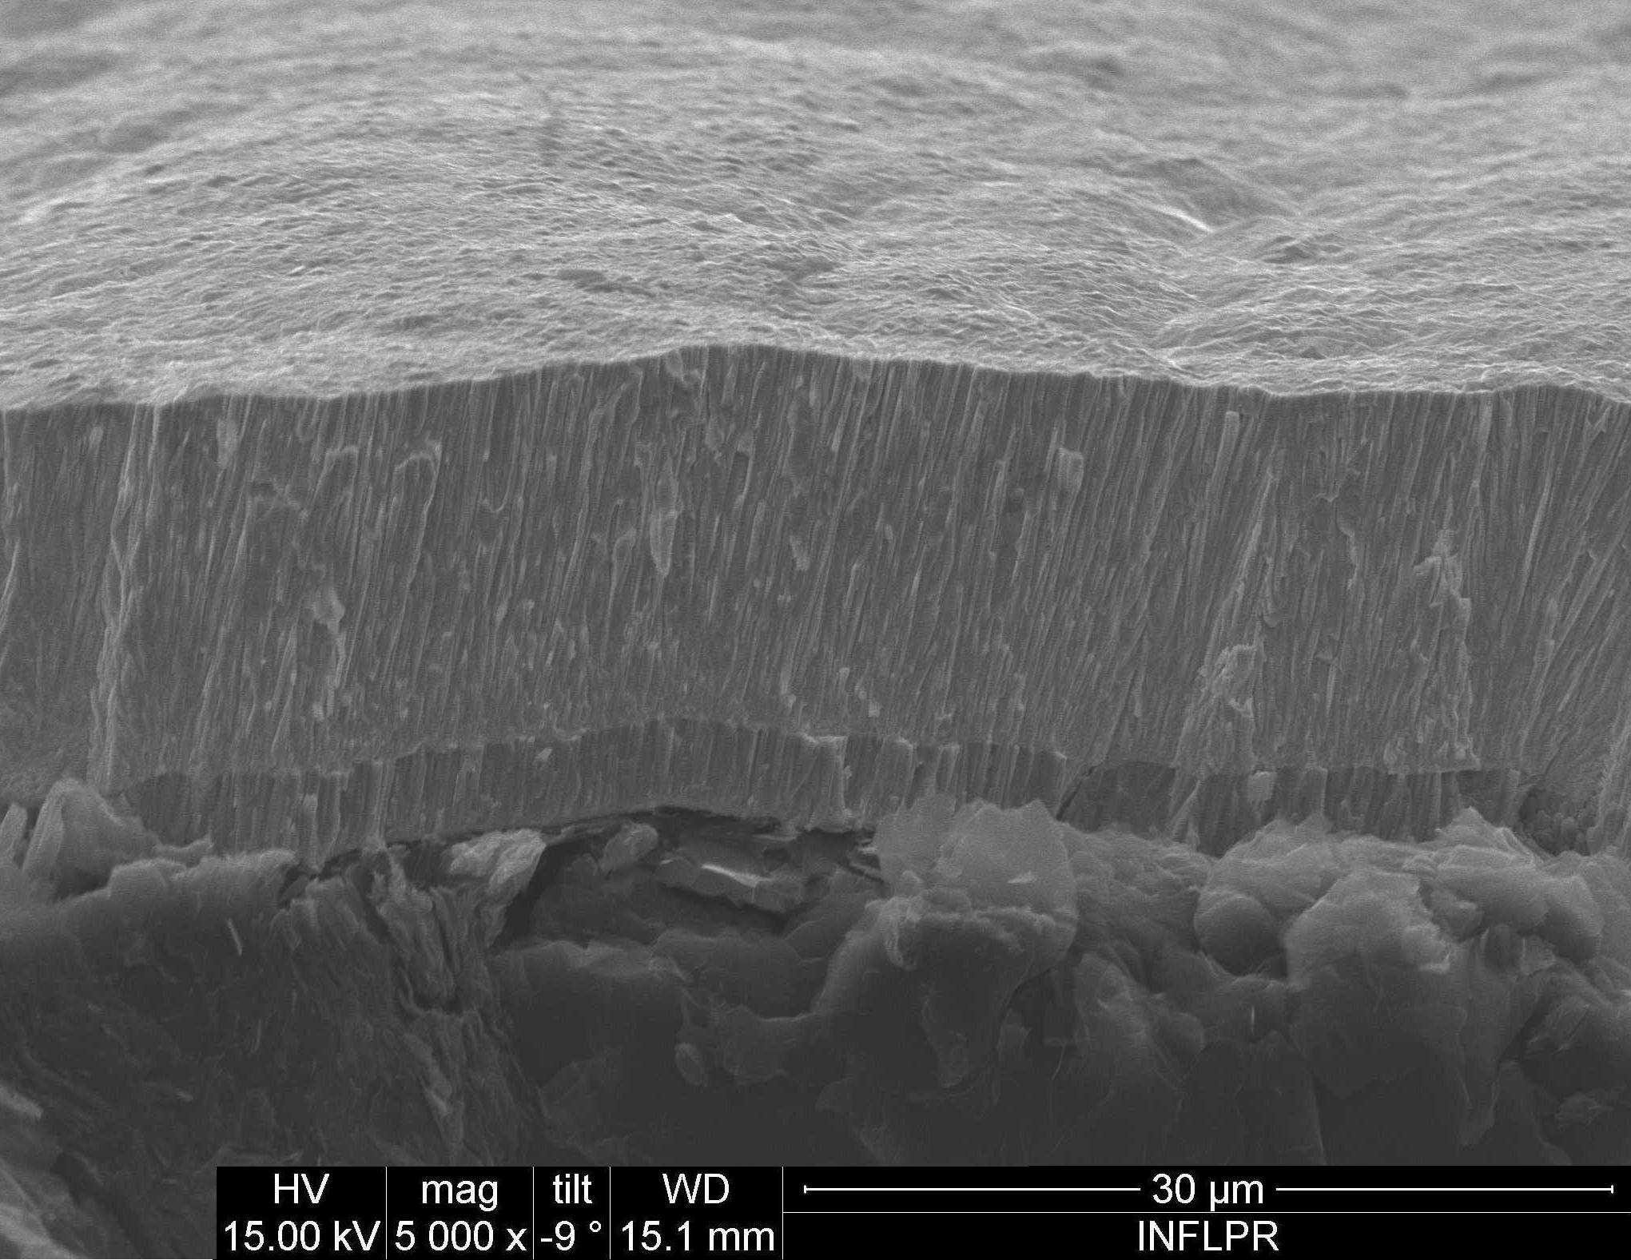 | 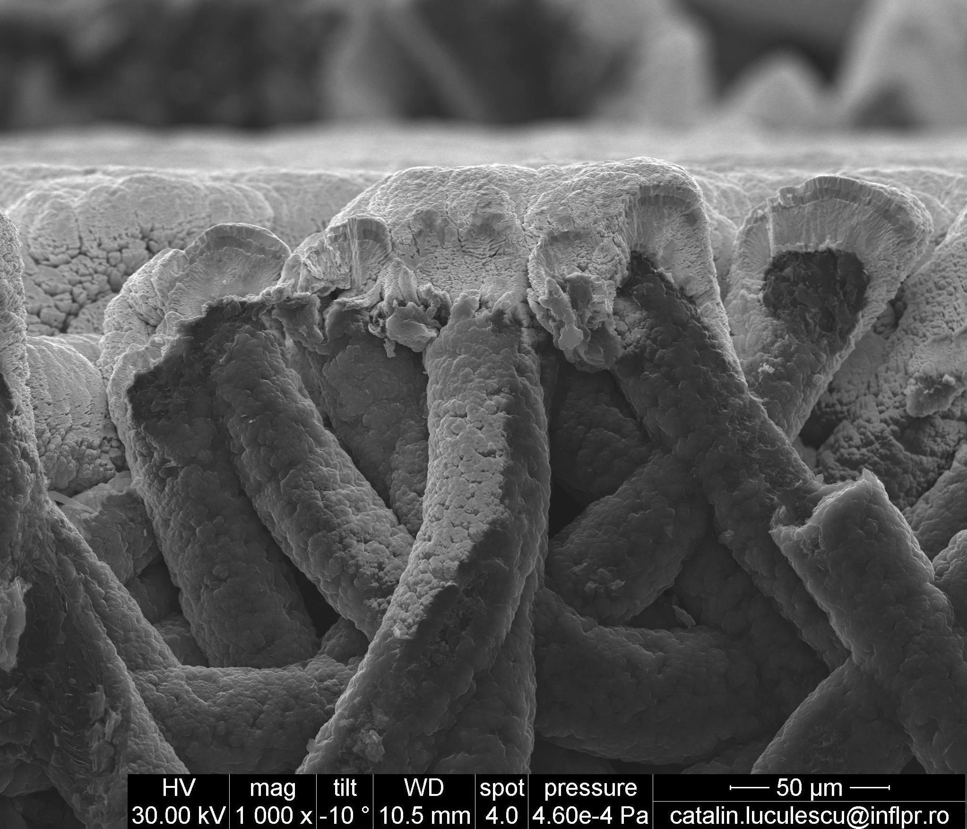
  Fig.3 SEM image of the typical structure of W/Mo coating on the graphite zone | Fig.4 SEM image of the W/Mo coating in the carbon fibres zone
Revision No 1: | Changes:
 | Written by: | Revised by: | Approved by:
 | RUSET Cristian | Ion MORJAN  General Director, INFLPR | Florin Spineanu  HRU – MEdC Association

Objectives

In the framework of the ITER-like Wall project about 1,800 CFC tiles from the new JET wall are coated with W layers of 10-15 µm and 20-25 µm using Combined Magnetron Sputtering and Ion Implantation (CMSII) technology. The change from carbon to metallic wall is expected to result into a decrease of the fuel retention. The W coatings deposited by CMSII technique are very dense, pore-free and have a nano-crystalline structure. The fuel retention was never measured on this type of coatings. Since a significant proportion of the ITER-like wall consists of W coatings it was defined as objective for the present project determination of the fuel retention for this type of coatings. The role of MEdC in the project is to provide W coated CFC samples for fuel retention measurements. The samples should be exposed in TEXTOR and then analyzed at FZ Jülich in comparison with non-coated samples exposed under the same conditions.

Achievements
Two lots of six samples were coated with 10-15 µm and 20-25 µm of W using the same technology which was used for ITER-like Wall project at JET.
The samples were cut both parallel and perpendicular to fiber planes. They have been characterized after coating in terms of thickness, impurities and structure by GDOS and SEM. The samples have been sent to FZ Jülich for exposure to plasma and analyses.
The MEdC tasks in the project were accomplished. The results concerning the deuterium retention for 10-15 µm and 20-25 µm of W deposited parallel and perpendicular to fiber planes are expected from FZ Jülich.

Shortcomings
The number of samples was too small. Maybe the experiment should be repeated with more samples and different plasma exposure conditions to have a better statistics.

Conclusions and General perspectives

- MEdC provided the type and quantity of samples necessary for measurement of deuterium retention using TEXTOR for plasma exposure. Determination of the fuel retention when not only the front of the samples but also the back and the sides are coated would be interesting as well.
- Using different machines and conditions for plasma exposure would provide more information on the subject.
- Helium seeding into the D plasma could change the D retention as well as the properties of the W coatings. This effect needs also to be investigated.
- This is particular important in connection with a new D-T experiment envisaged for JET in 2015.

References (to Conference paper/poster, Meeting, Publication)

- No paper has been published yet.
WP10-PWI-01-02
X-ray micro-tomography studies CFC samples for porosity network characterization

EFDA WORKPROGRAMME 2010, Plasma Wall Interaction
Deliverable under Base-Line and Priority Support
Reference: | Task Force: Plasma Wall Interaction  Task: WP10-PWI-01-02-01/MEdC/BS and WP10-PWI-01-02-02/MEdC/PS
Document: | Task Title : X-ray micro-tomography studies CFC samples for porosity network characterization
Author(s): | Ion Tiseanu, Association EURATOM – MEdC Romania
Date: | 31.12.2010
Distribution list: | (Task Force Leader): Rudolf Neu  (CSU Responsible Officer): Roman Zagorski  (SEWG Group Leader): Klaus Schmid
Content: | Work carried out:  Characterization of the porosity structure of CFC materials by high resolution X-ray micro-tomography (µXCT):  µXCT provides useful information pertaining to the in-depth fuel migration into carbon tiles function of the CFC material structure.  Investigated materials: 3D-NB31, JET-DMS780, Tore Supra N11 and recently: 3D-NB41.  Tomography measurements with space resolution up to 2.5 microns/voxel were performed at the NanoCT facility, INFLPR (http://tomography.inflpr.ro/).  A new procedure for the quantitative evaluation of the CFC porosity factor by post-processing of the 3-D computed tomography images has been applied.  Results  Tomography measurements were performed on relatively large volumes (5x5x5 mm³). Porosity factors for four CFC materials relevant for fusion technology are presented in the table below.  For the first time we have analysed by X-ray laminography the DMS780 CFC coated by tungsten realized within the ITER-like wall project. The characterization of the initial porosity of the new CFC ITER reference material NB41 has been carried out.  All objectives of the subtask were fulfilled.
  Material | NB31 | DMS780 (JET) | N11 (TS) | NB41 (ITER)
  Porosity factor (%) | 8.1 | 9.4 | 10.5÷12 | 6.4
Revision No 1: | Changes:
 | Written by: | Revised by: | Approved by:
 | Ion TISEANU | Ion MORJAN  General Director, INFLPR | Florin Spineanu  HRU – MEdC Association

Objectives
- Participation at the Deuterium Inventory in Tore Supra (DITS) post mortem analysis by providing high resolution tomography measurements on CFC samples
- Qualification of the initial porosity of the new CFC ITER reference material

Achievements
- Tomography reconstructions on macroscopic CFC samples at spatial voxel resolution of 2.5 µm
- Pores connectivity and, in case of heat sink region of the TS PFC, long penetration of metallic structures along fibre interspaces.
- A procedure for the quantitative evaluation of the CFC porosity factor has been introduced and validated.

Shortcomings - None

Conclusions and General perspectives
High resolution cone beam micro-tomography was optimized for the analysis of CFC samples (spatial voxel resolution of 2.5 μm) . A procedure for the quantitative evaluation of the sample porosity factor has been introduced and tested. This procedure has been utilized on all CFC materials relevant for the fusion technology. It is proved that the tomographic analysis provides useful information about the pores connectivity and, in case of heat sink region of the DITS CFC PFC, the penetration of metallic structures along fibre interspaces. For the first time we have analyzed by 3D tomography the DMS780 CFC coated by tungsten realized within the ITER-like wall project The characterization of the initial porosity of the new CFC ITER reference material NB41 has been carried out.
Improvement of the space resolution would be possible pending the financial support for the upgrade of the X-ray detection system. Also the development of a procedure to evaluate separately the open and the closed porosity factors will be addressed.

References (to Conference paper/poster, Meeting, Publication)
- Ion Tiseanu, Emanuelle Tsitrone, Arkadi Kreter, Teddy Craciunescu, Tierry Loarer, Bernard Pégourié, Timo Dittmar , X-Ray Micro-Tomography Studies on Carbon Based Composite Materials for Porosity Network Characterization, presented at the 26th Symposium on Fusion Technology (SOFT), September 27 September – 01 October, 2010, in Porto, Portugal
- I. Tiseanu, X-ray micro-tomography studies CFC samples for porosity network, Monitoring Meeting of the EU TF PWI Special Expert Working Groups on “Gas balance and fuel retention”, Garching, July 19- 20, 2010
- I. Tiseanu, T. Craciunescu, C. Dobrea, A. Sima, WP10-PWI-01-02-02: “X-ray micro-tomography studies CFC samples for porosity network characterization”, Interim Report January-June 2010, EURATOM-MEdC Association, Romania
- I. Tiseanu, T. Craciunescu, C. Dobrea, A. Sima, WP10-PWI-01-02-02: “X-ray micro-tomography studies CFC samples for porosity network characterization”, Interim Report July-December 2010, EURATOM-MEdC Association, Romania
- I. Tiseanu , T. Craciunescu, N.B. Mandache, F. Gherendi, C. Dobrea, A. Sima, - Advanced X-ray Imaging techniques for Non-destructive analysis of Fusion Materials, presented at The 15th International Conference on Plasma Physics and Applications (CPPA2010) and at the 6th EURATOM-MEdC ASSOCIATION DAYS MEETING, Iasi, 1-4 July, 2010.
- I. Tiseanu, X-ray micro-tomography studies on CFC samples for porosity network characterization, DITS project : progress report 16/12/2010

WP10-PWI-05-02
X-ray microbeam absorption/fluorescence method as a non-invasive solution for investigation of the erosion of W coatings on graphite/CFC

EFDA WORKPROGRAMME 2010, Plasma Wall Interaction
Deliverable under Base- Line and Priority Support
Reference: | Task Force: Plasma Wall Interaction  Task: WP10-PWI-05-02-01/MEdC/BS and WP10-PWI-05-02-02/MEdC/PS
Document: | X-ray microbeam absorption/fluorescence method as a non-invasive solution for investigation of the erosion of W coatings on graphite/CFC
Author(s): | Ion Tiseanu, Association EURATOM – MEdC Romania
Date: | 31.12.2010
Distribution list: | (Task Force Leader): Rudolf Neu  (CSU Responsible Officer): Roman Zagorski  (CSU Group Leader): Giorgio Maddaluno
Content: | An instrument and associated measuring methods have been developed and qualified as a non-invasive solution for investigation of the erosion of W coatings on carbon materials substrates. Tomo-Analytic is a combined X-ray fluorescence (XRF) and cone-beam tomography (3D-CT) system for the non-invasive 3-D morphology and composition mapping. http://tomography.inflpr.ro/  ASDEX Upgrade fine grain graphite tiles were coated with tungsten of typical thicknesses (0÷1.5 µm). The coating uniformity analysis was performed using the X-ray transmission XRT and the XRF mapping.  The XRT ensures fast and high resolution analysis. The coating uniformity images are obtained for a scanning time of approximately two hours on a 70 x70 pixels matrix. For each image pixel one has averaged the transmission values over an area of 1.0 mm² in order to reduce the effect of the coating/substrate roughness.  In case of XRF mapping the peak intensities of the tungsten characteristics lines L_{α} (8.40 keV) and L_{β} (9.67 keV) are very sensitive to the coating thickness. However this technique is limited to W layers not thicker than ~4 µm due to the high self-attenuation of the low energy of the W characteristic lines.  The Compton peak intensities are also very sensitive to the coating thickness values and therefore the mapping of the coating thickness in absolute values it is possible within the X-ray backscattering procedure without using thickness standards.  Line profiles of the W/Ni coatings were measured with the purpose to assess the erosion/redeposition in the all-tungsten divertor of ASDEX Upgrade. The Ni/W thickness absolute values could be derived and they are in good agreement with the measurements carried out by SIMS and RBS. The erosion profiles along the poloidal and toroidal directions as measured by the X-ray backscattering technique applied to the corresponding Ni stripes. In all measurements it is possible to detect redeposition of Ni/W on non-coated graphite stripes.  In case of tungsten coated CFC materials one has to take into account the influence of the substrate morphology. This has been done by digital radiography of a NB31 ITER like reference CFC material and a microbeam backscattering profile. The line profiles display variations of the substrate back-scattering intensity of up to 20%, which should be compensated for in the X-ray backscattering procedure for the absolute determination of the W thickness.  Finally a concept for a portable measuring head for XRT/XRF measurements has been elaborated.  The objectives of the subtask were fulfilled.
Revision No 1: | Changes:
 | Written by: | Revised by: | Approved by:
 | Ion TISEANU | Ion MORJAN  General Director, INFLPR | Florin Spineanu  HRU – MEdC Association

Objectives
Quantitative evaluation of the thickness/uniformity/erosion/deposition of the tungsten coatings on graphite tiles from ASDEX Upgrade and of the tungsten coatings on ITER-like CFC tiles. Marker probes of Al C Ni W will be also measured.

Achievements
X-ray transmission XRT and the X-ray micro-beam fluorescence mapping coating uniformity analysis of tungsten coated (0÷1.5 µm) ASDEX Upgrade fine graphite tiles. Determination of absolute coating thickness.
Assessment of the erosion/redeposition in the all-tungsten divertor of ASDEX Upgrade by measuring line profiles of the Ni marker coating.
It was proved that for relatively thin coating layers both fluorescence and backscattering methods are very sensitive.
Shortcomings - None
Conclusions and General perspectives
All objectives of the subtask were fulfilled.
The results obtained open the possibility to construct a compact/low cost instrument based on X-ray micro-fluorescence to be used in high productivity coating analysis. Development towards “in-situ” coating analysis technique will be evaluated. Both tasks are dependent on financial support.

References (to Conference paper/poster, Meeting, Publication)

Ion Tiseanu, Matej Mayer, Teddy Craciunescu, Antti Hakola, Seppo Koivuranta, Jari Likonen, Cristian Ruset, Cosmin Dobrea, ASDEX Upgrade team, X-ray microbeam transmission/fluorescence method for non-destructive characterization of tungsten coated carbon materials, presented at the Twelfth International Conference on Plasma Surface Engineering, September 13 - 17, 2010, in Garmisch-Partenkirchen, Germany
- Ion Tiseanu, X-ray microbeam absorption/fluorescence method as a non-invasive solution for investigation of the erosion of tungsten coatings on graphite/CFC, Monitoring Meeting of the EU TF PWI Special Expert Working Groups on “High-Z and liquid metals”, Garching, July 21- 23, 2010
- Ion Tiseanu, T. Craciunescu, C. Dobrea, A. Sima, WP10-PWI-05-02-02/MEdC/BS/PS: “X-ray microbeam absorption/fluorescence method as a non-invasive solution for investigation of the erosion of tungsten coatings on graphite/CFC”, Interim Report January-June 2010, EURATOM-MEdC Association, Romania
- Ion Tiseanu, T. Craciunescu, C. Dobrea, A. Sima, WP10-PWI-05-02-02/MEdC/BS/PS: “X-ray microbeam absorption/fluorescence method as a non-invasive solution for investigation of the erosion of tungsten coatings on graphite/CFC”, Interim Report July-December 2010, EURATOM-MEdC Association, Romania
- Ion Tiseanu , T. Craciunescu, N.B. Mandache, F. Gherendi, C. Dobrea, A. Sima, - Advanced X-ray Imaging techniques for Non-destructive analysis of Fusion Materials, presented at the 6th EURATOM-MEdC ASSOCIATION DAYS MEETING, Iasi, 1-4 July, 2010.
- C. Dobrea, I. Tiseanu, T. Craciunescu, E. Grigore, Non destructive analysis of large area metallic coatings of fusion materials,
presented at The 15th International Conference on Plasma Physics and Applications (CPPA2010) and at the 6th EURATOM-MEdC ASSOCIATION DAYS MEETING, Iasi, 1-4 July, 2010.

WP10-PWI-02-04-01
Removal of codeposited material from gaps with a plasma torch

EFDA WORKPROGRAMME 2010, Plasma Wall Interaction
Deliverable under Base- Line Support
Reference: | Task Force: Plasma Wall Interaction  WP10-PWI-02-04-01/MEdC/BS
Document: | Removal of codeposited material from gaps with a plasma torch
Author(s): | Gheorghe Dinescu, Association EURATOM – MEdC Romania
Date: | 31.12.2010
Distribution list: | (Task Force Leader): Rudolf Neu  (CSU Responsible Officer): Roman Zagorski  (SEWG Group Leader): Karl Krieger
Content: | The improvement of plasma torch removal efficiency and of the cleaning of carbon and mixed carbon/metal layers, in relationship with the employing metals (tungsten, beryllium) for next JET experiments and ITER were approached by experiments with reactive gases. Apart from nitrogen which was the normal cleaning gas, the experiments focused on the investigation of torch operation with oxygen, air, argon/ammonia, argon/hydrogen, argon/oxygen, and nitrogen/oxygen. In order to limit the torch damage by the enhanced plasma reactivity, changes were made over the plasma torch components (on the RF electrode materials and on its cooling). The operation domains (RF power, gas flow rates, and ratio of gases in the mixtures) and torch stability in those gases were studied, resulting in establishing the optimum working parameters of the plasma torch with reactive gases. The new designed plasma source components are more robust. The torch is more compact and easier to be integrated on a robotic arm, being compatible with cleaning of the co-deposited layers in gaps.  The effectiveness of cleaning experiments over graphite substrates, performed with plasmas generated in reactive gases, has been assessed by profilometry measurements. Plasmas in argon and argon hydrogen have a low effect on surfaces; when these gases are admixed in nitrogen or argon gases a quenching effect appears, which decreases the plasma length and diminishes the active species arriving at surface. The oxygen plasma is the fastest in removal of laboratory made co-deposited layers; nevertheless, the operation with oxygen or mixtures with high oxygen concentration leads to instabilities and to severe shortening of torch lifetime, which are unacceptable drawbacks. The important finding is that plasma torch operated with nitrogen/oxygen mixtures, with about 10% oxygen, at high powers (400 W) and moderate gas flow rates (3000 sccm nitrogen) presents a very high removal rate (up to 10⁻² g/min), which is up to ten times higher than the rates obtained until now.  The cleaning experiments performed on gaps coated with a-C:H/metal layers showed the same behaviour, previously observed with simple carbon layers: the cleaning goes deep inside gaps up to 20 mm, is faster at the top margin of the gaps, and it is very effective on its bottom. The AFM experiments proved the roughening of surface, while EDAX proved that the metal phases becomes dominant on surface, thus being less removed compared to carbon phases.
Revision No 1: | Changes:
 | Written by: | Revised by: | Approved by:
 | Gheorghe DINESCU | Ion MORJAN  General Director, INFLPR | Florin Spineanu  HRU – MEdC Association

Shortcomings
The work has been completed.
References (to Conference paper/poster, Meeting, Publication)
1. E.R. Ionita, C. Stancu, T. Acsente, B.Mitu, G. Dinescu, C. Grisolia, Plasma torch cleaning of carbon layers from deep gaps at atmospheric pressure, 26 th Symposium on Fusion Technology (SOFT 2010), Porto, Portugal, 27 September – 1 Octomber, 2010.
2. E.R. Ionita, C. Stancu, M. Teodorescu, T. Acsente, G. Dinescu, Extension of plasma torch operation with reactive gases for wall cleaning purposes, 6th Euratom MEdC Association Days Meeting, 2nd July, 2010, “Alexandru Ioan Cuza” University, Iasi, Romania
3. G. Dinescu et al. Removal of codeposited materials from gaps with a plasma torch, presentation at Joint Meeting of EFDA Taskforce Walls Interactions SEWGs and Emerging Technology System Integration (ETS) 8-11 June 2010, Garching, Germany
4. C. Stancu, M. Teodorescu, A. C. Galca, G. Dinescu, Carbon layers cleaning from inside of narrow gaps by a RF glow discharge, poster at Twelfth International Conference on Plasma Surface Engineering”, PSE 2010, Garmisch-Partenkirchen, Germania, 12-17septembrie 2010, paper submitted to Surface and Coatings Technology.
WP10-PWI-02-04-02
Laboratory models for the co-deposited layers

EFDA WORKPROGRAMME 2010, Plasma Wall Interaction
Deliverable under Base- Line Support
Reference: | Task Force: Plasma Wall Interaction  WP10-PWI-02-04-02/MEdC/BS
Document: | Removal of codeposited material from gaps with a plasma torch Laboratory models for the co-deposited layers
Author(s): | Gheorghe Dinescu, Association EURATOM – MEdC Romania
Date: | 31.12.2010
Distribution list: | (Task Force Leader): Rudolf Neu  (CSU Responsible Officer): Roman Zagorski  (SEWG Group Leader): Karl Krieger
Content: | Laboratory models for co-deposited layers were realized on tungsten and silicon substrates as mixed a-C:H/W materials using a sequential deposition method (by alternatively exposing the substrate to two plasma sources mounted on the same deposition chamber: a magnetron for W incorporation and a PECVD source, using a mixture of Ar and C₂H₂ for a-C:H deposition. The influence of deposition parameters over the layers properties (morphology, structure and composition - SEM, XRD, EDAX) was marked out through a systematically study, resulting that the deposited material has a typical composite structure, consisting of a a-C:H matrix incorporating W particles. Tuning of the mixed layers properties was possible by proper setting the values of the substrate exposure time to each of the plasma sources (this method avoid the magnetron target poisoning).  A setup for monitoring the sequential deposition process was implemented. It is based on monitoring the evolution in time of the 401.12nm W, Halpha (656.21nm) and Ar (738.69nm) optical emission lines using a low cost optical multi channel analyzer. Evolution in time of the W emission line during MS deposition step revealed the optimum value of the transport time process parameter for deposition in reasonable time intervals (few hours) of micron thick mixed layers containing a minimum WC phase concentration. The optical monitoring method is a valuable tool for verifying the repeatability of the deposition cycles during one sample deposition and for comparing deposition processes of different samples. Thus, reproducible layers with controlled composition and morphology can be obtained.  A setup for in-situ monitoring of optical transmission of co-deposited layers containing a substitute of Be (a-C:H/Al mixed layers, Al used as Be substitute) was realized in order to elucidate the cause of chemical transformation of such films when exposed to ambient, expressed as fast change of colour followed by severe delaminating. The effect of different atmospheric air components (O₂, N₂, Ar) was studied by monitoring the evolution of optical transmission of a-C:H/Al layers deposited on glass substrates. It resulted that the degradation of these layers is only slightly induced by O₂; Ar do not induce any effect, while N₂ seems to stabilize the mixed layer on the substrate. Similar experiments performed with ambient atmospheric air and Ar mixed with water vapours led to the conclusion that the chemical transformation of such materials is induced by the presence of water vapours.
Revision No 1: | Changes:
 | Written by: | Revised by: | Approved by:
 | Gheorghe DINESCU | Ion MORJAN  General Director, INFLPR | Florin Spineanu  HRU – MEdC Association

Shortcomings
The work has been completed.
References (to Conference paper/poster, Meeting, Publication)
1. Acsente, E. R. Ionita, C. Stancu, C. Luculescu, G. Dinescu, Properties of composite a-C:H/metal layers deposited by combined RF PECVD/Magnetron sputtering techniques, Thin Solid Films, accepted
2. T. Acsente, E. R. Ionita, C. Stancu, M. D. Ionita, G. Dinescu, OES monitoring of combined deposition of C/W layers by PECVD/Magnetron Sputtering techniques, poster at Twelfth International Conference on Plasma Surface Engineering”, PSE 2010, Garmisch-Partenkirchen, Germania, 12-17septembrie 2010, paper submitted to Surface and Coatings Technology.
3. T. Acsente, E. R. Ionita, C. Stancu, G. Dinescu, Laboratory made codeposited layers for fuel removal studies, 26 th Symposium on Fusion Technology (SOFT 2010), Porto, Portugal, 27 September – 1 Octomber, 2010 (poster presentation).
WP10-PWI-02-04-03/MEdC/BS
Production of controlled laboratory co-deposited layers for fuel removal studies

EFDA WORKPROGRAMME 2010, Plasma Wall Interaction
Deliverable under Base- Line Support
Reference: | Task Force: Plasma Wall Interaction  WP10-PWI-02-04-03/MEdC/BS
Document: | Production of controlled laboratory co-deposited layers for fuel removal studies
Author(s): | Gheorghe Dinescu, Association EURATOM – MEdC Romania
Date: | 31.12.2010
Distribution list: | (Task Force Leader): Rudolf Neu  (CSU Responsible Officer): Roman Zagorski  (SEWG Group Leader): Karl Krieger
Content: | Using the sequential deposition method and the studies performed in the frame of WP10-PWI-02-04-02/MEdC task, there were deposited samples of mixed a-C:H/W (having 4μm thickness and containing 40 at% W) on W and graphite substrates and mono-component layers (pure W and pure a-C:H) on W substrates. The samples were submitted for plasma cleaning experiments to the following partners: CIEMAT Spain, Madrid (F. Tabares,), CNRS Toulouse (L. Pitchford), M. Redolfi (Paris). They were used also for plasma torch cleaning experiments at MEdC (G. Dinescu).  Apart from the optical absorption spectroscopy studies performed over the interaction of mixed layers a-C:H/Al (models of codeposited layers containing Be) with Ar, N₂, O₂ and ambient air (in the frame of the WP10-PWI-02-04-02/MEdC task), complementary studies were performed by Fourier Transform Infrared Spectroscopy (FTIR) in the frame of the present task. The FTIR spectra of the mixed layers were recorded after their exposure to the mentioned gases in controlled atmosphere. The obtained results showed that the exposure to ambient leads to OH bands vibrations appearance and enhancement, confirming that the water vapours are responsible for the chemical instability of the a-C:H/Al mixed layers.
Revision No 1: | Changes:
 | Written by: | Revised by: | Approved by:
 | Gheorghe DINESCU | Ion MORJAN  General Director, INFLPR | Florin Spineanu  HRU – MEdC Association

Shortcomings - The task was completed.
References (to Conference paper/poster, Meeting, Publication)
G. Dinescu et al. Laboratory models for the co-deposited layers; production of laboratory co-deposited layers for fuel removal studies presentation at Joint Meeting of EFDA Taskforce Walls Interactions SEWGs and Emerging Technology System Integration (ETS) 8-11 June 2010, Garching, Germany
2.T. Acsente, E.R. Ionita, C. Stancu, M. Teodorescu, B. Mitu, G. Dinescu, Deposition of mixed carbon/metal layers for the assessment of wall cleaning techniques, 6th Euratom MEdC Association Days Meeting, 2nd July, 2010, “Alexandru Ioan Cuza” University, Iasi, Romania

WP10-PWI-04-04-01
Experimental investigations and and numerical studies (ERO) of chemical erosion of low-Z materials for plasmas at low temperatures is one of the experiments in Pilot-PSI / Magnum-PSI.

EFDA WORKPROGRAMME 2010, Plasma Wall Interaction
Deliverable under Base- Line Support
Reference: | Task Force: Plasma Wall Interaction  WP10-PWI-02-04-02/MEdC/BS
Document: | Experimental investigations and and numerical studies (ERO) of chemical erosion of low-Z materials for plasmas at low temperatures is one of the experiments in Pilot-PSI / Magnum-PSI.
Author(s): | Claudiu Costin, Association EURATOM – MEdC Romania
Date: | 31.12.2010
Distribution list: | (CSU Responsible Officer): Roman Zagorski  SEWG leader "Material Migration": Sebastijan Brezinsek  SEWG leader "ITER material mix": Karl Krieger
Content: | A multi-probe system with 61 collectors (tungsten wires of 0.89 mm in diameter, disposed in 4 concentric circles) was placed in the centre of Pilot-PSI (the magnetized linear plasma device at FOM, The Netherlands) target for monitoring the time-space (2D) distribution of edge plasma parameters characterising the plasma that reaches the target: (i) the floating potential and (ii) the current collected by the grounded target. The measurements were performed for 3 different magnetic field strengths (0.4, 0.8 and 1.2 T) and for different currents of the cascaded-arc source (80, 100, 120 and 140 A). Knowing the 2D distribution of the charged particle flux measured by the grounded probes is important because in many experiments the target of Pilot-PSI is grounded. Good cylindrical symmetry was noticed on both 2D distributions of current and floating potential, showing a cylindrical symmetric plasma column. Stronger radial gradients were measured on the current distributions (0.4-1 A/mm). The multi-plane probe system was melted at 1.6 T as a consequence of the high current density determined by the confinement of the plasma beam. Cross-correlation analysis was applied to study the rotation of the plasma column via the time-correlation between the current intensity signals measured on different probes. A plasma rotation velocity of a few km/s was obtained. An ion energy electrostatic analyzer with 3 grids was used to obtain the ion energy spectrum (the thermal energies were spread into less than 1eV) only at B = 0.4 T and low discharge current (< 120 A).  These results will serve as input data for modelling of chemical erosion and sputtering (ERO code running on Pilot/Magnum data by Forschungszentrum Juelich, Germany). Also, the investigation aims the correlation of plasma parameters with target modifications (target temperature, erosion, gas retention, etc).
Revision No 1: | Changes:
 | Written by: | Revised by: | Approved by:
 | Claudiu COSTIN | Prof. Dr. Gheorghe Popa | Florin Spineanu  HRU – MEdC Association

Shortcomings
The full 2D distribution of the ion flux at the target could not be simultaneously measured because of the difficulty to simultaneously bias 61 probes at least at -100 V and in the same time to measure the current through each probe. We managed to locally measure the ion saturation current either on separate probes or using different combinations of two probes in double-probe configuration. It is expected to solve this task next year by using capacitors for individual biasing of the probes instead of multiple power-supplies.

References (to Conference paper/poster, Meeting, Publication)
[1] M. L. Solomon, V. Anita, C. Costin, I. Mihaila, L. Sirghi, G. Popa, M. J. van de Pol, R. S. Al, G. J. van Rooij, J. Rapp, “2D distributions of current and floating potential at the target surface in Pilot-PSI”, 37th European Physical Society (EPS) Conference on Plasma Physics, 21-25 June 2010, Dublin, Ireland (poster presentation P5.132)
[2] M. L. Solomon, V. Anita, C. Costin, I. Mihaila, L. Sirghi, G. Popa, M. J. van de Pol, G. J. van Rooij, J. Rapp, “Current and floating potential distributions measured by a multi-probe system at the end plate surface in Pilot-PSI”, 15th International Conference on Plasma Physics and Applications (CPPA), Iasi, Romania, 1–4 July 2010 (poster presentation P6-07)
[3] M. L. Solomon, V. Anita, C. Costin, I. Mihaila, G. Popa, H. J. van der Meiden, R. S. Al, M. van de Pol, G. J. van Rooij, J. Rapp, “Multi-channel analyzer investigations of ion flux at the target surface in Pilot-PSI”, Contrib. Plasma Phys. 50(9), 898-902 (2010)
WP10-PWI-06-01
TVA gun electron beam irradiation influence on mixed films prepared using TVA method

EFDA WORKPROGRAMME 2010, Plasma Wall Interaction
Deliverable under Base-Line and Priority Support
Reference: | Task Force on Plasma Wall Interaction  Area: SEWG ITER Material Mix  Task: TA PWI 2010, Chapter 6: Determination of expected alloys and compounds in ITER relevant conditions and their influence on PWI processes and fuel retention  Sub-task: WP10-PWI-06-01-01/MEdC/BS and WP10-PWI-06-01-02/MEdC/PS: TVA gun electron beam irradiation influence on mixed films prepared using TVA method
Document: | Report: 50-200 nm Be/C, Be/W and C/W coatings on graphite and silicon.
Author(s): | Cristian Lungu, Association EURATOM – MEdC Romania
Date: | 10.06.2010
Distribution list: | Task Coordinator: K. Krieger  EFDA Responsible Officer: R. Zagorski
Content: | 150-200 nm as well as 5nm - 20 nm Be/C, Be/W and C/W multilayer coatings on graphite, silicon and tungsten were prepared using thermionic vacuum arc (TVA) method. The morphology and the film composition on the surface and the depth were determined by Scanning Electron Microscopy (SEM), Energy Dispersive Spectrometry (EDS), Atomic force Microscopy (AFM), X-ray Photoelectron Spectroscopy (XPS) and Rutherford Backscattering Spectroscopy (RBS). The deuterium implantation and release were studied using Nuclear Reaction Analysis (NRA) and Thermal Desorption Spectrometry (TDS) with the support of IPP Garching.
Revision No 1: | Changes:
 | Written by: | Revised by: | Approved by:
 | Cristian LUNGU | Ion MORJAN  General Director, INFLPR | Florin Spineanu  HRU – MEdC Association

Shortcomings - None
References (to Conference paper/poster, Meeting, Publication)
- A. Anghel, C. Porosnicu, C. P. Lungu, K. Krieger, K. Sugiyama, J. Roth, 19th International Conference on Plasma Surface Interactions, PSI 2010, May 24-28, 2010, San Diego, USA
- A. Anghel, C. Porosnicu, C. P. Lungu, K. Sugiyama, C. Krieger and J. Roth, Thermal Treatment Influence on Be/C Mixed Material Formation and Fuel Retention, E-MRS 2010, Spring Meeting, Strasbourg, France, June 7-11 2010
- Cristian P. Lungu, Characterization of Beryllium Containing Compounds Prepared Using TVA Method, Report on task agreements: WP10-PWI-06-01-02/MEdC/PS, WP10-PWI-06-02-02/MEdC/PS, Joint SEWG Meetings, Material Migration and Material Mixing, FZJ Juelich, Germany, 30.06.-02.07.2010.
- Cristian P. Lungu, TVA gun electron beam irradiation influence on mixed films prepared using TVA method, Report on task agreement WP10-PWI-06-01-02/MEdC/PS at TF-PWI annual Meeting, 3-5 Nov 2010, Vienna, Austria
- A. Anghel, C. Porosnicu, C. P. Lungu, K. Sugiyama, C. Krieger, J. Roth, Influence of Thermal Treatment on Beryllium/Carbon Formation and Fuel Retention, J. Nucl. Mat, accepted
- C. P. Lungu, I. Mustaţă, C, C.Porosnicu, I. Jepu, A. Anghel, Caracterizarea filmelor compozite combinatoriale obţinute prin metoda arcului termoionic în vid, Bucureşti, Editura Academiei Oamenilor de Ştiinţă din România, 2010, ISBN 978-606-92500-1-3 (book in Romanian).

WP10-PWI-06-02
Study of D-retention in mixed materials containing H, D and He

EFDA WORKPROGRAMME 2010, Plasma Wall Interaction
Deliverable under Priority Support
Reference: | Task Force on Plasma Wall Interaction  Area: SEWG ITER Material Mix  Sub-task: WP10-PWI-06-02-01/MEdC/BS and WP10-PWI-06-02-02/MEdC/PS
Document: | Task Title : Study of D-retention in mixed materials containing H, D and He
Author(s): | Cristian Lungu, Association EURATOM – MEdC Romania
Date: | 10.06.2010
Distribution list: | Task Coordinator: K. Krieger  EFDA Responsible Officer: R. Zagorski
Content: | Using thermionic vacuum arc (TVA) method were deposited 50-200 nm in thickness Be-C-W ternary system films with different relative concentrations of the three elements (Be, C and W) on graphite and silicon substrates using the thermionic vacuum arc method developed at NILPRP. Oxygen, deuterium and helium gases were co-deposited during the Be-C-W growing films.  The samples were analyzed in Romania by SEM (Scanning Electron Microsopy), EDS (Electron Dispersion Spectroscopy), AMS (Accelerator Mass Spectrometry) and XPS (X-ray Photoelectron Spectoscopy).  During research stages at IPP Garching Germany the prepared samples were analyzed using RBS (Rutherford Backscattering Spectrometry) and NRA (Nuclear Reaction Analysis) techniques.
Revision No 1: | Changes:
 | Written by: | Revised by: | Approved by:
 | Cristian LUNGU | Ion MORJAN  General Director, INFLPR | Florin Spineanu  HRU – MEdC Association

Shortcomings -

References (to Conference paper/poster, Meeting, Publication)
- C. Porosnicu, A. Anghel, K. Sugyama, K. Krieger, J. Roth, C. P. Lungu, Influence of beryllium carbide formation on deuterium retention and release, PSI 2010, May 24-28, 2010, San Diego, USA
- C. Porosnicu, A. Anghel, C.P.Lungu, K. Sugiyama, K. Krieger, J. Roth, Beryllium Concentration Influence on Deuterium Retention and Release in Be/C Composite Films, E-MRS 2010, Spring Meeting, Strasbourg, France, June 7-11 2010
- Cristian P. Lungu, Characterization of Beryllium Containing Compounds Prepared Using TVA Method, Report on task agreements: WP10-PWI-06-01-02/MEdC/PS, WP10-PWI-06-02-02/MEdC/PS, Joint SEWG Meetings, Material Migration and Material Mixing, FZJ Juelich, Germany, 30.06.-02.07.2010.
- Cristian P. Lungu, D-retention in mixed materials containing H, D and He, Report on task agreement WP10-PWI-06-02-02/MEdC/PS at TF-PWI annual Meeting, 3-5 Nov 2010, Vienna, Austria
- C. Porosnicu, A. Anghel, K. Sugyama, K. Krieger, J. Roth, C. P. Lungu, Influence of beryllium carbide formation on deuterium retention and release, J. Nucl. Mat, accepted
- C. P. Lungu, I. Mustaţă, C, C.Porosnicu, I. Jepu, A. Anghel, Caracterizarea filmelor compozite combinatoriale obţinute prin metoda arcului termoionic în vid, Bucureşti, Editura Academiei Oamenilor de Ştiinţă din România, 2010, ISBN 978-606-92500-1-3 (book in Romanian)

